Chapter One: Introduction, Materials and Design Concepts

1.1 Introduction

Concrete and reinforced concrete are used in structural and non structural members in various civil engineering applications such as buildings of various types, bridges, under ground structures, water tanks, offshore oil explorations and production structures, dams, among others.

Concrete is obtained by mixing aggregate, cement and water and some times admixtures to obtain workable mixture. Concretes in a wide range of properties can be obtained by appropriate adjustment of the proportions of the constituent materials. Properties of concrete depends on the amount and type of cement, on the amount of fine and coarse aggregate, on water cement ratio, on curing of concrete and on temperature and humidity during moulding.

Concrete has excellent formability, high fire and weather resistance, and high compressive strength. On the other hand it is a relatively brittle material with less tensile strength which prevents its economical use in structural members that are subjected bending, shear and tension.

Steel is also one of the most important construction materials, which has high tensile strength and much greater ductility and toughness. But it is susceptible to corrosion and has low fire resistances.

Steel is used in two different ways in concrete structures: as reinforcing steel and as prestressing steel. Reinforcing steel is placed in the forms prior to casting of the concrete. Stresses in the steel as in hardened concrete, are caused only by the loads on the structures. In contrast, in prestressed concrete structures, large tension forces are applied to the reinforcement prior to letting it act jointly with the concrete in resisting external loads.

Reinforced concrete is a strong durable building material which can be formed in to many varied shapes and sizes ranging from a simple rectangular column to a slender curved dome or shell. Reinforced concrete structures are obtained by combining concrete, which is strong in compression and steel reinforcement, which is used primarily to resist tensile forces.

Reinforced concrete structures may be cast-in-place concrete, constructed in their final location, or they may be pre-cast concrete produced in a factory and erected at the construction site.

1.2 Materials

a) Reinforcing Steels

The most common types of reinforcement are hot-rolled round deformed bars. The closely spaced rib shaped surface deformations of the reinforcing bars provide a high degree of interlocking of the two materials (see Fig. 1.1). Reinforcing bars varying in size 6 to 35mm in diameter are available in which most are surface deformed except φ6. Some bar sizes and areas for design purpose are given below.

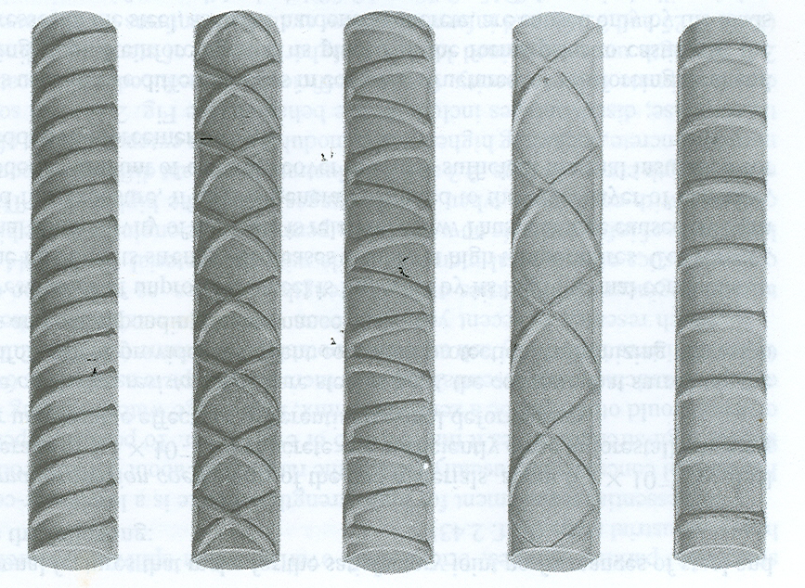
Fig. 1.1 Types of deformed reinforcing bars

Diameter(mm) | 6 | 8 | 10 | 12 | 14 | 16 | 18 | 20 | 22 | 24 | etc.
Area (mm²) | 28 | 50 | 78.5 | 113 | 154 | 200 | 254 | 314 | 380 | 450 | etc.

The most important structural properties of steel are yield strength and ultimate strength, modulus of elasticity, shear modulus, poisons ratio, coefficient of thermal expansion and its density.

The yield strength of ordinary reinforcing steels in tension as well as in compressions about 15 times the compressive strength of common structural concrete, and well over 100 times its tensile strength.

Reinforcing bars are available in different grades with f_{y} ranges between 220MPa to 550MPa, with 300MPa common in Ethiopia. According to ASTM (American Society for Testing Materials) specification, reinforcing bars are available in three grades with yield strengths of 40, 50 and 60 ksi, referred to as Grades 40, 50 and 60 steels respectively. Of these, the third is most commonly used in buildings and bridges. High strength deformed bars with yield strength of 75 or 80 ksi have been used as reinforcement in lower-story columns of high-rise buildings.

Stress-Strain Relation

The structural performance under load depends to a large degree on the stress-strain relationship of the materials from which the structure is made, under the type of stress to which the material is subjected in the structure.

The two important characteristics that determine the character of steel are its yield point (generally identical in tension and compression) and its modulus of elasticity E_{s}. The typical stress-strain curves for Grades 40, 60 and 75 reinforcement are shown in Fig. 1.2
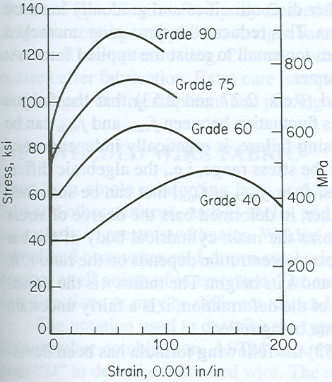
Fig. 1.2 Typical stress-strain curves for
reinforcing bars

From the Figure:
- Grade 40 bars display a pronounced yield plateau.
- Grade 60 bars have much shorter yield plateau
- Grade 75 and 90 bars do not have well defined yield point, which may be obtained by a 0.2% strain offset line.

The slope of stress-strain curve in the elastic region gives the modulus of elasticity or Young’s modulus, E. The modulus of elasticity for steel has values ranging from 190 to 210 GPa. The modulus of elasticity doesn’t vary appreciably for the different grades of steel used in the construction, and a value of 200 GPa is often used for design.

b) Concrete

The most important properties of concrete in reinforced concrete structures are its strength and mechanical properties, its shrinkage, creep and thermal volume changes properties, and its durability.

Stress-Strain Diagrams

Although concrete is a very variable material having a wide range of strengths and stress-strain diagrams, the typical compressive stress-strain curves for concretes of various strengths are as shown in Fig. 1.3
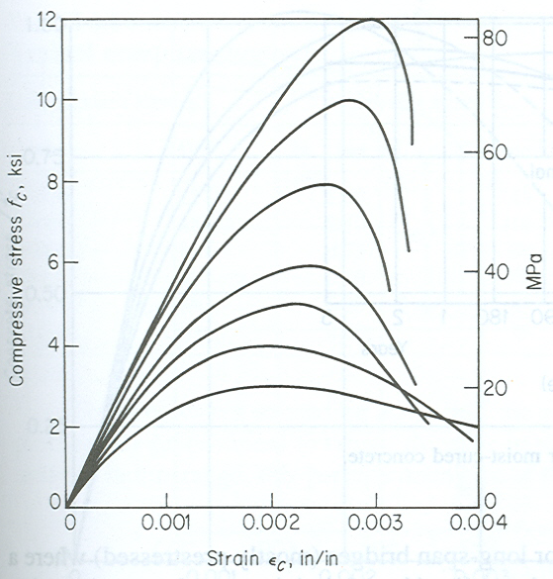
Fig. 1.3 Typical compressive stress-strain curves for concrete

From the Figure:
- The modulus of elasticity, E_{c}, i.e., the slope of the initial straight portion of the stress strain curve, increases with an increase in compressive strength. The modulus of elasticity of concrete for various strengths can be computed based on the following empirical equation given by EBCS 2:
$$E_{\text{cm}}=9\text{.}5{\left(f_{\text{ck}}+8\right)}^{1/3}$$
Where: E_{cm} is secant modulus in GPa
f_{ck} is characteristic cylinder compressive strength in MPa
- The strain ε_{o} at maximum stress increases with an increase in concrete strength.
- The maximum strain ε_{cu} decreases with an increase in concrete strength. For most structural concrete, ε_{cu} tends to be a constant value of 0.0035.
- The compressive strengths, which are the maximum stresses, lie at a strain that ranges from 0.002 to 0.003 for normal weight concrete.

Time-Dependant Volume Changes

Concrete undergoes three main types of volume changes which may cause stresses, cracking, or deflections, which in turn affect the serviceability behavior of reinforced concrete structures. These are shrinkage, creep and thermal movement.

Shrinkage:

Shrinkage is the reduction in volumes as the concrete hardens. If the change in volume of concrete is allowed to take place freely with out restraint, there will be no stress change with in the concrete. If restrained, shrinkage strains can cause cracking of concrete and will generally cause the deflection of structural members to increase with time. Fig. 1.4 shows the increase in shrinkage strain with time. The shrinkage occurs at a decreasing rate with time. The final shrinkage strains vary greatly, being generally in the range 0.0002 to 0.0006 but sometimes as much as 0.001.
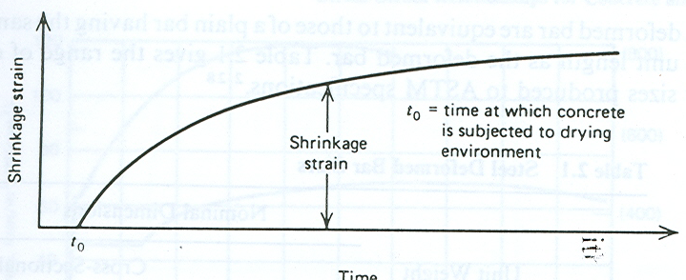

Fig. 1.4 Typical shrinkage curve for concrete

Thermal movement:

Just like other materials, concrete expands with increasing temperature and contracts with decreasing temperature. The effects of such volume changes are similar to those caused by shrinkage. Therefore, codes of practice specify minimum quantity of reinforcement in a member for this purpose.

Although the coefficient of thermal expansions and contraction varies some what, depending up on the type of aggregate and richness of the mix, a value of 10 x 10⁻⁶ per ºC may be used for the calculation of stresses and deformations caused by temperatures changes.

Creep

Creep is a continuous deformation of a member under sustained load and it is pronounced in concrete. The nature of creep process is shown schematically in Figure 1.5.

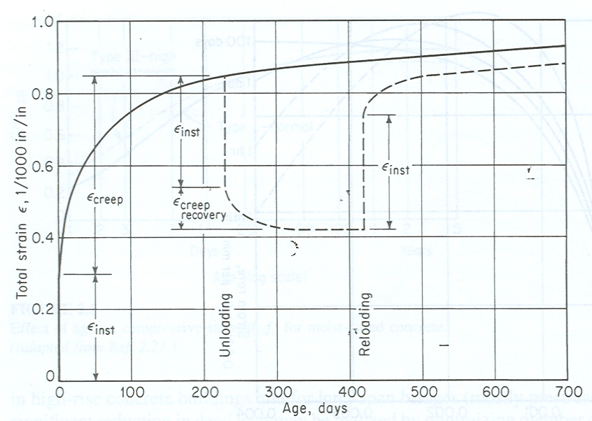

Fig. 1.5 Typical creep curve

The characteristics of creep are:
- The deformations are roughly proportional to the intensity of loading (to the magnitude of the applied loads) and to the inverse of the concrete strength (high strength concrete shows less creep than low strength concrete).
- The creep strains, ε_{c}, are on the order of one to three times the instantaneous elastic strains.
- The creep coefficient,φ, which is the ratio of the creep strain to elastic strain, is affected by the ratio of the sustained stress to the strength of concrete, the humidity of the environment, the dimensions of the element, and the composition of the concrete.
- If the load is removed, most of the instantaneous elastic deformation will recover.

Durability

Concrete can be exposed to a wide rang of conditions such as soil, sea water, stored chemicals or others. And a durable concrete should perform satisfactorily in its intended environment for the life of the structure. The durability of concrete depends on the quality of concrete and the environmental conditions to which the concrete will be exposed. Accordingly, the severity of the exposure governs the type of concrete mix required and the minimum cover to the reinforcing steel.
1.3 Design Procedure

There are a number of phases in a design process - from inception to detailing and quantity estimation.

Functional Planning: It is the development of a plan that will enable the structure to fulfill effectively the purpose for which it is to be built. If the structure is a building, for example, the designer must create a plan which is adapted to the site; which provides a suitable arrangement of rooms, corridors, stairways, elevator, etc.; which will be aesthetically acceptable, and which can be built at a price the client is prepared to pay.

Structural Planning: It is the planning of the structural scheme, arrangement of the structural elements such as columns and beams to meet the functional planning.

Structural Analysis: It involves modeling the loads and the structural framework to obtain internal forces and desired deflections.

Design: It involves proportioning the members of the structural system so that they will be able to withstand, with an appropriate margin of safety, the forces which the structural analysis has disclosed.

Loads
One of the most important factors to be considered in design of structural member is the assessment of the loads that the member must support or resist. Some of the most common kinds of loads are:

Dead Loads: those which are constant in magnitude and fixed in location throughout the life time of the structure. Usually the major part of the dead load is the weight of the structure itself. It will comprises the forces due to the static weights of the structure as well as attachment to the structures such as walls, partitions, floors, roofs and finishes, together with any other permanent construction. Dead loads can be calculated from the unit weights given in EBSC 1 (reproduced here as Tables 1 & 2).

Live loads/Imposed loads: these are gravity loads acting when the structure is in service, but varying in magnitude and locations with respect to time. These are loads assumed to be produced by the intended occupancy or use of the structures. Examples of live loads are human occupants, furniture, stored goods in buildings and traffic loads in bridges. EBCS 1 gives the various types of imposed load for different types of buildings and components (see from Table 4 up to 10).

Wind Loads: All structures are subjected to wind load, but it is usually only those more than three or four stories high for which consideration of wind is required. Wind exerts pressure on the windward sides and suction on the leeward side, as well as either uplift or downward pressure on the roof. Most building codes specify design wind pressure. Factors considered in the standards include probable wind velocity, exposure (urban vs. open terrain), height of the structure, the importance of the structure(I.e., conseconces of failure) (See Appendix A of EBCS 1).

Earthquake loads: An earthquake consists of horizontal and vertical ground motions, with the vertical motions usually having much the smaller magnitude. Since the horizontal motion of the ground causes the most significant effect, it is that effect which is usually thought of as earthquake load. Seismic forces may be found for a particular structure by elastic or inelastic dynamic analysis, considering expected ground accelerations, and mass, stiffness and damping characteristics of the structure. However, often the design is based on equivalent static forces calculated from codes provision (see EBCS 7).
  - Design Philosophies (Methods)

The object of reinforced concrete design is to achieve a structure or part structure that will result in a safe and economical solution.
Structural design should be performed to satisfy three criteria: strength, serviceability, and economy.
Strength pertains to the general integrity and safety of the structure under extreme load conditions. The structure is expected to withstand occasional overloads without severe distress and damage during its lifetime.

Serviceability refers to the proper functioning of the structure as related to its appearance, maintainability, and durability under normal, or service load conditions, deflection, vibration, permanent deformation, cracking, and corrosion are some design considerations associated with serviceability.

Economy concerns the overall material and labor costs required for the design, fabrication, erection, and maintenance processes of the structure

As a result of the various design criteria, two major design methods have evolved in practice for the design of reinforced concrete structures.

For a given structural system, the design problem consists of the following steps:
- Idealization of structure for analysis (dimension of members, support condition of structure and etc.)
- Estimation of loadings.
- Analysis of idealized structural model to determine stress-resultants (axial forces, shear forces, torsions & bending moments) and their effects (deformations).
- Design of structural elements (if assumed dimensions are adequate).
- Detailed structural drawings and schedule of reinforcing bars.
To achieve safe and economic structures, three philosophies of design had been adopted by codes of practices. These are:
    - Working Stress Design (WSD) or Elastic Design Method
    - Ultimate Strength Design (USD) Method, and
    - Limit State Design (LSD) Method.

- Working Stress Design (WSD) method: -WSD is the oldest and simplest method of design used for reinforced concrete structures. It is based on the assumption that concrete is elastic, steel & concrete together act elastically. Also, the stresses developed in concrete & steel are not exceeded the respective allowable stresses any where in the structure when structure is subjected to the worst combination of service design loads. The allowable stresses of materials are determined dividing material strengths by a factor of safety. Safety factors specified by British standard are 3 for concrete and 1.8 for reinforcing steel. These safety factors are obtained from many years of practical experience and engineering judgment. The safety factors specified by codes are assumed to cover all uncertainties existing in estimations of service design loads and material strengths.

The sections of members of structure are designed in accordance with elastic theory of bending assuming that both materials obeying Hooke’s law. The elastic theory assumes a linear variation of strain & stress from zero at neutral axis to a maximum at the extreme fibers of section of member; and the maximum stress developed any where in properly designed element of structure not to exceed the allowable stress of the materials.
Thus, design format used in WSD method may be expressed as:
$f (\text{stress} \text{due} \text{to} \text{service} \text{design} \text{loads}) ≤ f_{\text{allow}} (\text{material} \text{strength})$
The main drawbacks of WSD method are as follows:
- Concrete is not elastic material. The inelastic behavior of concrete starts right from very low stresses. The actual stress distribution of concrete in section can not be described by a triangular stress diagram.
- Since factor of safety is applied on the strength of materials, there is no way to account for different degrees of uncertainty associated with different types of loadings.
- It is difficult to account for creep and shrinkage by computations of elastic stresses.

Beside these drawbacks, the method does not ensure consistence safety of structure and also provide uneconomical section.
- Ultimate Strength Design (USD) method: -Design of structure or part of structure in USD method is based on ultimate load theory; and it is made to resist the desired ultimate (collapse) loads using idealized strength model (either parabola or parabola-rectangle stress block) just before failure of section plastically. In ultimate load theory, it is assumed that the section of member of structure failed plastically when the maximum compressive strain of concrete reaches the ultimate compressive strain of concrete specified by codes (may be about 0.3 to 0.35%). The desired ultimate loads are obtained by increasing sufficiently the service loadings using specified factors. These factors are called over-load factors. Separate over-load factors are applied for different loadings considering uncertainties existing in estimation of different loadings. Design format used in USD method may be expressed as:
$$\begin{aligned} \text{strength} \text{provided} ≥ \text{action} \text{due} \text{to} \text{ultimate} \text{loads} \\ (\text{stress} \text{block}) (\text{analysis} \text{of} \text{structure})\end{aligned}$$
A major advantage of USD method over WSD method is that total safety factor of structure thus found to be nearer to its actual value. Further, structures designed by USD method require less reinforcement than those designed by the WSD method.

The main draw backs of USD method are as follows:
- Since load factor is used on the service loads, there is no way to account for different degrees of uncertainty associated with variation in material strengths.
- There is complete disregard for control against excessive deflections.

- Limit State Design (LSD) method: -Limit state design method has developed from ultimate strength design method in order to apply in service load and ultimate load conditions. Design of structure in limit state is made to achieve an acceptable probability that structure or part of it will not become unfit for use for which it is intended during expected life. That is, it will not reach any of the specified limit state. The limit state of structure is the condition of its being not fit for use. A structure with appropriate degrees of reliability should be able to withstand safely all possible combinations of design loads that are liable to act on it throughout its life and it should also satisfy the serviceability requirements, such as, limitations on deflection and cracking. Further, it should be able to maintain the required structural integrity during and after accidents such as fires, explosions and local failure. In other words, all relevant limit states must to be considered in design to ensure an adequate degree of safety and serviceability. These limit states which must be examined in design are broadly classified in to two major limit states. These are:
- Ultimate strength limit state (Limit state of collapse), and
- Serviceability limit state

- Ultimate strength limit state: -which deals with the strength and stability of the structure under the maximum over load it is expected to carry. This implies that whole of the structure or part of it should not fail under any combination of expected over load. Ultimate load theory is generally applicable for ultimate strength limit state. Ultimate strength limit state may include ultimate limit state for:
-flexure
-shear
-compression
-torsion
-tension
-stability of structure for over-turning & sliding
- Serviceability limit state: -which deals with conditions such as deflection, cracking of structure under service loads, durability, excessive vibration, fire resistance, fatigue, etc. Elastic (working stress) theory is generally applicable for serviceability limit state.

When dealing with the most economical structure associated with safety and serviceability requirements, the variability exists between construction materials and the construction process itself. We should be able to state a design philosophy to cope with the various criteria required to define the serviceability or usefulness of any structure in a rational manner.

The various criteria required to define the serviceability or usefulness of any structure can be described under the following headlines. The effects listed may lead to the structure being considered 'unfit for use'.
- Collapse: failure of one or more critical sections; overturning or buckling.
- Deflection: the deflection of the structure or any part of the structure adversely affects
the appearance or efficiency of the structure.
- Cracking: cracking of the concrete which may adversely affect the appearance or efficiency of the structure.
- Vibration: vibration from forces due to wind or machinery may cause discomfort or alarm, damage the structure or interfere with its proper function.
- Durability: porosity of concrete.
- Fatigue: where loading is predominantly cyclic in character the effects have to be considered.
- Fire resistance: insufficient resistance to fire leading to 1, 2 and 3 above.

When any structure is rendered unfit for use for its designed function by one or more of the above causes, it is said to have entered a limit state. The Code defines the limit states as:
- Ultimate limit state: the ultimate limit state is preferred to collapse.
- Serviceability limit states: deflection, cracking, vibration, durability, fatigue, fire resistance and lightning.

The purpose of design then is to ensure that the structure being designed will not become unfit for the use for which it is required, i.e. that it will not reach a limit state. The essential basis for the design method, therefore, is to consider each limit state and to provide a suitable margin of safety. To obtain values for this margin of safety it was proposed that probability considerations should be used and the design process should aim at providing acceptable probabilities so that the structure would not become unfit for use throughout its specified life.

Accepting the fact that the strengths of construction materials vary, as do also the loads on the structure, two partial safety factors will now be used. One will be for materials and is designated γ_{m}; the other, for loading, is termed γ_{f}. These factors will vary for the various limit states and different materials. As new knowledge on either materials or loading becomes available the factors can be amended quit easily without the complicated procedures to amend one overall factor used in previous Codes.

The normal procedure is to design for a critical limit state and then to check for the other limit states are satisfied. The critical state for reinforced concrete structures is usually the ultimate limit state. However, water-retaining structures and prestressed concrete is usually designed at the serviceability limit state with checks on the ultimate limit state.

The limit states failure criteria can be summarized as follows:
(Design load effects Q_{d}) ≤ (Deisgn resistance R_{d})
$γ_{f}Q_{n} ≤ \frac{f_{k}}{γ_{m}}$
Where Q_{d} = design load effects = γ_{f} Q_{n}
Q_{n} = nominal load
γ_{f} = partial safety factor for loads
R_{d} = design resistance = f_{k}/γ_{m}
f_{k} = characteristic material strength
γ_{m} = partial safety factor for materials

