CHAPTER 5

FLUID DYNAMICS
5.1 Introduction
In discussing about hydrostatics we were concerned with forces (pressure forces) which are acting on an object for a liquid at rest and when we deal with kinematics of fluid flow phenomena related with space time variation (velocity and acceleration) with out considering the effect of force. But in dealing with dynamics of fluid flow, all forces that affect the phenomenon are considered.

The dynamics of fluid motion deals with kinetics, which relates the kinematics with the forces responsible for causing the motion. This relation ship of fluid motion is established by the use of laws of nature.
- The principle of conservation of mass (the continuity relation ship)
- Newton’s laws of motion
- The 1st and second laws of thermodynamics
5.2 Equations of motion
The dynamic behavior of fluid motion is governed by a set of equations, which is known as equations of motion. These equations are obtained by using the Newton’s second law, which may be written as F_{x} = m.a_{x}
Where, F_{x} is the net force acting in the x-direction upon a fluid element of mass m producing an acceleration a_{x} in the x-direction.

The forces which may be present in fluid flow problems are gravity forces F_{g}, pressure force F_{p}, force due to viscosity F_{v}, force due to turbulence F_{t}, Surface tension F_{s}, and force due to compressibility of fluid F_{c}.

Gravity forces (F_{g}.) is due to the weight of the fluid. Its component in flow direction results in acceleration.

Pressure force (F_{p}): It is equal to the product of pressure intensity and cross sectional area of the flowing fluid. Acts normal to the surface under consideration and produces acceleration in the given direction.
Viscous forces (F_{v}): - Exists in real fluids. It is the shearing resistance generated when there is relative motion between two layers of fluids. It acts opposite to the direction of motion, and retards flow.

Surface tension (F_{s}): This force is important when the depth of flow is extremely small.
Force due to compressibility (F_{c}): for incompressible fluids, this becomes significant in problems of unsteady flow like water hammer. In most of flow problems, F_{s} and F_{c} are neglected.
Force due to turbulence (F_{t}): the continuous momentum transfer between layers in highly turbulent flow results in normal and shear stresses known as Reynolds's stress.
If the changes for the change in forces are small the forces can be taken negligible.
m.a_{x} = (F_{g})_{x}+(F_{p})_{x}+(F_{v})_{x}+(F_{t})_{x}

The presence of such a complex system of forces in real fluid flow problems makes the analysis very complicated. Therefore, mathematical analysis of problems is generally possible only if certain simplifying assumptions are made.
5.2.1 Energy and Head
A liquid in motion may possess three forms of energy.
- Potential energy /elevation /positional energy/ because of its elevation above datum level. If a weight w of liquid is at a height of z above datum
Potential energy = Wz
Potential energy per unit weight = z (meters) = Potential head
2. Pressure energy: When a fluid flows in a continuous stream under pressure it can do work. If the area of cross – section of the stream of fluid is a, then force due to pressure p on cross- section is Pa. If a weight w of liquid passes the cross section.
- Volume passing in cross section = W/ρg
Distance moved by liquid = $\frac{W}{ρ\text{ga}}$
W = F* S = $\text{Pa}∗\frac{W}{ρ\text{ga}} = \frac{\text{WP}}{ρg}$
Pressure energy per unit weight = $\frac{P}{ρg}$ = pressure head.
3. Kinetic energy
If a mass of fluid (m) moves at some velocity (v),
Kinetic energy = ½ mv² = ½ W/g v²
Kinetic energy pr unit weight = $\frac{v^{2}}{2g}$ = kinetic head
Total head = potential head + pressure head + velocity head = $Z+\frac{P}{γ}+\frac{v^{2}}{2g}$
Bernoulli’s theorem states that the total energy of each particle of a body of fluid is the same provided that no energy enters or leaves the system at any point. The division of this energy between potential, pressure and kinetic energy may vary, but the total remains constant.

In symbols $Z+\frac{P}{γ} + \frac{v^{2}}{2g} = \text{cons}\text{tan}t$

5.3 Bernoulli’s Equation
Consider a cylindrical element of stream tube having cross-sectional area d_{A} length ds unit weight γ as shown in motion along a streamline.
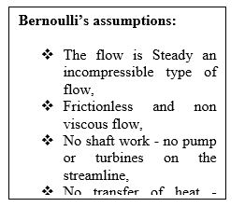
γdsdA
PdA
θ
ds
Z

Fig: 5.1 Pressure and gravity forces on a cylindrical element along a streamline

The normal forces on the side faces are in equilibrium and as the fluid is assumed non-viscous, there is no shear stress. The velocity varies along the streamline and there is acceleration. It is necessary to take into account force due to acceleration when considering the longitudinal balance of force.

But in the ease of steady flow the velocity doesn’t vary at a point so that local acceleration will be zero $\left(\frac{∂v}{∂t}=0\right)$ but for velocity variation with position convective acceleration will be different from zero$\left(V\frac{∂v}{∂s}≠0\right)$. The forces tending to accelerate the fluid mass are pressure force on the two ends of the element,

$[\sum{\text{Fs}} = {\text{ma}}_{s}]$ Summation of force in the arbitrary‘s’ direction.

$\text{PdA}−\left(p+\frac{\text{dp}}{\text{ds}}\text{ds}\right) \text{dA} =−\text{dp} \text{dA}$

Weight in the direction of motion,
$−ρ\text{gdsdA}\text{cos} θ=−ρ\text{gdsdA}\frac{\text{dz}}{\text{ds}}=−ρ\text{gdAdz}$
Applying Newton’s 2nd Law of motion F=ma
γdsdA
PdA
θ
ds
Z
$−\text{dPdA}−ρg \text{dA} \text{dz}=ρ\text{ds} \text{dAV}\frac{\text{dv}}{\text{ds}}$ $\text{as} a_{s} = \frac{∂v}{∂t} + \frac{∂v}{∂s} V$ $\frac{\text{dp}}{ρ}+\text{gdz}+\text{Vdv} =0$ One-dimension Euler’s equation
It can be applied for both compressible and incompressible flow.
$\frac{\text{dp}}{γ} + \text{dz}+\frac{V}{g}\text{dv} = 0$
For the case of an incompressible fluid γ may be treated as constant, the integration gives
$$\int{\frac{\text{dp}}{γ}} + \int{\text{dz}}+\int{V}\frac{\text{dV}}{g} = \text{Cons}\text{tan}t$$
$\frac{P}{γ} + Z+\frac{V^{2}}{2g} = \text{Cons}\text{tan}t$[Bernoulli’s Equation]
Under special conditions the assumption underlying Bernoulli’s equations can be waived.

- When streamlines originate from a reservoir,
- For unsteady flow with gradually changing conditions (E.g. Emptying a reservoir) the equation may be applied without appreciable error,
- It may be used for real fluids, by modifying the result experimentally.

The Bernoulli equation is the basis for the solution of a wide range of hydraulics problems. For two points along a streamline, the Bernoulli equation may be expressed in the form of:
$y_{1}+\frac{P_{1}}{γ} + \frac{v_{1^{2}}}{2g} = y_{2}+\frac{P_{2}}{γ}+\frac{v_{2^{2}}}{2g}$

5.3.1 Bernoulli’s Equation for real fluid
The Bernoulli’s equation expressed by $\frac{p}{γ}+Z+\frac{v^{2}}{2g}$ is determined for an incompressible ideal fluid without taking in to account the effects of some other forces as viscous, etc.
In case of real fluid these forces should be introduced so that the equation needs some modification.
A real fluid does possess viscosity and consequently it offers resistance to flow. In order to overcome this viscous resistance and other resistances due to surface roughness and turbulence, some part of the total energy of the flow is lost. [Energy is neither created nor destroyed but may be changed to heat energy increasing temp of the fluid]
The increase in temperature of the fluid causes an increase in the internal energy. The increase in internal energy and the heat transfer from the fluid represent a loss of useful energy. The total loss per unit mass of fluid is (u₂-u₁-q).
Energy loss per unit weight in overcoming resistance $h_{l}=\frac{u_{2}−u_{1}−q}{g}$(head loss)
The total energy of flow decreases in the flow direction, and consequently the energy line has a down ward slope.
Horizontal
2
1
V₂²/2g
h₁
P₂/γ
Z₂
V₁²/2g
Z₁
P₁/γ
Datum

The modified Bernoulli’s equation for up stream section (1) and downstream section (2)

$$\frac{V_{1}^{2}}{2g}+\frac{P_{1}}{γ}+Z_{1}=\frac{V_{2}^{2}}{2g}+\frac{p_{2}}{γ}+Z_{2}+h_{l}$$
h_{l} = head loss between the two sections.

Z₁

H_{L} = head loss
Z₂

HGL
EGL
Datum

Fig.5.2 Energy & hydraulic grade lines
5.3.2 Energy correction factor
The analysis of flow problems is usually based on the one-dimensional approach. The entire flow is considered to be taking through stream tube with average velocity V at center of each cross-section. The velocity distribution at any x-section in real fluid flow is non uniform, on account of the boundary resistance and consequently the kinetic energy per unit weight given by V²/2g doesn’t represent the kinetic energy across the section.
In order to compensate for the discrepancy a coefficient known as energy correction factor denoted by α is used. The multiplication of α with V²/2g yields the kinetic energy actually passing a section.
Velocity distribution
Real liquid flow
Ideal liquid flow
V_{avg}
dA

For the figure given,

The kinetic energy per unit time passing through on elemental area dA is ½ (ρdAu)u²
u - Velocity at that point
Total kinetic energy passing the section
$\int_{A}{\frac{1}{2}}{ρu}^{3}\text{dA}$ And the actual kinetic energy passed on average velocity V passing the section is equal to $α\frac{1}{2}{ρV}^{3}A$
From the two equation
$α=\frac{1}{A}\int{{\left(\frac{u}{v}\right)}^{3}}\text{dA}$
Kinetic energy correction factor α is a measure of viscous resistance generated in a given flow, the effect of which is reflected uniform nature of velocity distribution. For a given pipe, it can be shown that its magnitude is a function of the type of flow and its turbulent characteristics.

Laminar flow is purely a viscous flow; the value of α is maximum and equals 2.0. But in case of fully developed turbulent flow in pipes, α is independent of Reynolds number and may be considered to have almost constant value (1.01 to 1.15) depending on surface roughness and Reynolds number. Lower value is appreciable for velocity rough surface and high Reynolds number.
$α_{1}\frac{V_{1}^{2}}{2g}+\frac{p_{1}}{γ}+Z_{1}=α_{2}\frac{V_{2}^{2}}{2g}+\frac{p_{2}}{γ}+Z_{2}+h_{ℓ}$
For an identical velocity distribution at two sections, α₁ = α₂, and if accuracy is not required in non-uniform velocity distribution α = 1.

5.3.3 Practical Applications of Bernoulli’s Equation

Bernoulli’s equation is applicable in all problems of incompressible fluid flow where energy considerations are involved. In addition, it is practically applied for flow measurement using the following measuring devices.

1. Venturimeter (tube) (G.B Venturi (1746 –1822) Italian Eng)

It is a device used for measuring rate of flow in a pipeline and it consists of three components:
- A converging entrance cone of angle of about 20⁰
- A cylindrical portion of short length called the “throat”
- A diverging section known as diffuser, of cone angle 5⁰ to 7⁰ to ensure a minimum loss of energy, but where this is unimportant the angle may be as large as 14⁰.
The entrance tube and exit tube diameter are the same as that of the pipe line in to which it is inserted and the length of throat is equal to the throat diameter.
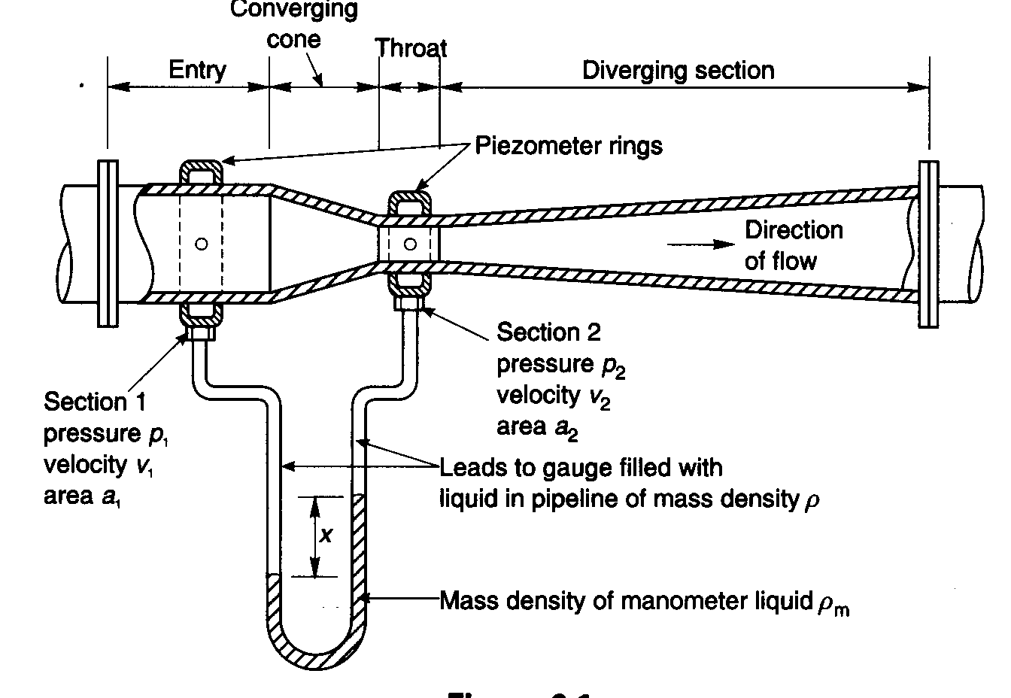
Fig.5.4 Horizontal Venturimeter
Assuming that the fluid is ideal (So that energy is not dissipated in overcoming frictional resistance) and that the velocities V₁ and V₂ at the inlet and throat respectively, are uniformly distributed over the cross section (so that the energy correction factor α is 1). Applying Bernoulli’s equation between points (1) and (2) on a central stream line and assuming no frictional resistance,
$\frac{V_{1}^{2}}{2g}+\frac{P_{1}}{γ}+Z_{1}=\frac{V_{2}^{2}}{2g}+\frac{P_{2}}{γ}+Z_{2}$
For an incompressible fluid, continuity of flow at section 1 and 2 is,
Q = A₁V₁ = A₂V₂
$V_{2}=\frac{A_{1}}{A_{2}}V_{1}$ ……………………….(a)
If A₁ > A₂, V1 < V₂ i.e. KE at section 2 (throat) > KE at section 1(the entrance)
P at throat < P at entrance
For a horizontal Venturimeter,
$\begin{aligned} \\ \frac{V_{2^{2}}−V_{1^{2}}}{2g} = \frac{P_{1}−P_{2}}{ρ g} \text{.}\text{.}\text{.}\text{.}\text{.}\text{.}(b) \\ \text{Substituting} \text{equ} (a) \text{in} \text{to} \text{eqn} (b) \\ \frac{V_{1^{2}}}{2g} \left[{\left(\frac{A_{1}}{A_{2}}\right)}^{2}−1\right] = \frac{P_{1}−P_{2}}{ρ g} \\ V_{1} = \sqrt{\frac{1}{{\left(\frac{A_{1}}{A_{2}}\right)}^{2}−1 }∗ 2g ∗ \left(\frac{P_{1}−P_{2}}{ρ g}\right)} \\ \end{aligned}$
$V_{1}=\frac{A_{2}}{\sqrt{A^{2_{1}}−A_{2}^{2}}}\sqrt{2g \frac{P_{1}−P_{2}}{ρg}}$
Theoretical Discharge
$\begin{aligned} \\ Q_{t} = A_{1} V_{1t} =\frac{A_{1}A_{2}}{\sqrt{A^{2_{1}}−A_{2^{2}}}}\sqrt{2g\frac{P_{1}−P_{2}}{ρ g}} \\ \\ \end{aligned}$
The theoretical discharge can be converted to actual discharge (Qa) by multiplying
$\begin{aligned} \\ Q_{a} = \text{Cd}∗Q_{t}={\text{CdA}}_{1} V_{1t} =\text{Cd}\frac{A_{1}A_{2}}{\sqrt{A^{2_{1}}−A_{2^{2}}}}\sqrt{2g\frac{P_{1}−P_{2}}{ρ g}} \\ \\ \end{aligned}$
The differential pressure is evaluated from manometry, and for figure.5.4
$\begin{aligned}\frac{P_{1}}{γ}s+\text{ys}−\text{xs}−s_{m}(y−x)=\frac{P_{2}}{γ}s \\ \frac{P_{1}−P_{2}}{γ}=x(\frac{s_{m}}{s}−1)\end{aligned}$
For vertical or inclined Venturi meter, the actual discharge can be computed similarly.

- Pitot tube (Total head tube) / (Henri Pitot)

Pitot tube is a device used for measuring velocity of flow at any point in a pipe or a channel. In its elementary form a Pitot tube consists of an L-shaped tube with open ends. Its may be aligned in open channel or pipe flow measurement as indicated below.

Stagnation pressure

For a figure below it has been seen that the central streamline terminates at B the entrance to the Pitot tube. This is on account of the inability of the streamline to take a sudden turn. The fluid flowing along the central streamline, therefore, stops moving as it reaches the point B. Hence the velocity of flow at this point is zero. This point is known as stagnation point.

Applying the Bernoulli’s equation at points A and B, we obtain
P_{B} = P_{O} = P_{A}+ρV_{A}²/₂. The pressure at the stagnation point is known as stagnation pressure composed of static pressure P_{A} and dynamic pressure ρV_{A}²/₂.

If the measurement is made on an open channel flow the surface will be exposed to the air and there is no static head from the surface, and if measurement is made on pipe flow there will be static head at A.
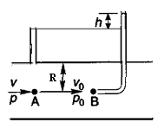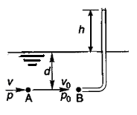
Fig.5.5 Simple Pitot tube in pipe flow and open channel flow
Applying Bernoulli’s equation to point A in the undisturbed flow region and the stagnation point B we have
$\begin{aligned}\frac{V_{O^{2}}}{2g} + \frac{P_{O}}{γ} + Z_{O} = \frac{V_{A^{2}}}{2g} + \frac{P_{A}}{γ} + Z_{A} \\ ⇒ \frac{P_{O}}{γ} = \frac{V_{A^{2}}}{2g} + \frac{P_{A}}{γ} \\ \frac{V_{A^{2}}}{2g} = \frac{P_{O}−P_{A}}{γ} \\ V_{A^{2}} = \frac{\left(P_{O}−P_{A}\right)}{γ}2g ⇒ V_{A}= \sqrt{2g (\frac{P_{O}−P_{A}}{γ})} = \sqrt{2\text{gh}} \text{sin}\text{ce} \frac{P_{O}−P_{A}}{γ}=h\end{aligned}$
A perfect Pitot tube should obey this equation exactly, but all actual instruments must be calibrated and a correction factor applied to make allowance for the small effects of nose shape and other characteristics.

Practically it is difficult to read h from a free surface. To overcome this difficulty, the static tube and the Pitot tube may combine in one instrument (differential U-tube).
For finding the velocity at any point in a pipe by Pitot tube, the following arrangements are adopted.
- Pitot tube along with a vertical piezometer tube as shown in Fig.5.6
- Pitot tube connected with piezometer tube as shown in Fig.5.7
- Pitot static tube, which consists of two circular concentric tubes one inside the other with some annular space in between as shown in Fig.5.8.
The outlets of these two tubes are connected to the differential manometer where the difference of pressure head is measured by knowing the difference of the levels of the manometer liquid h_{m}.

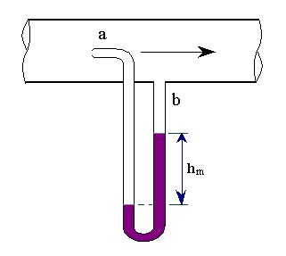
Pitot tube
Piezometer Tube
h

Fig.5.6
Fig.5.7
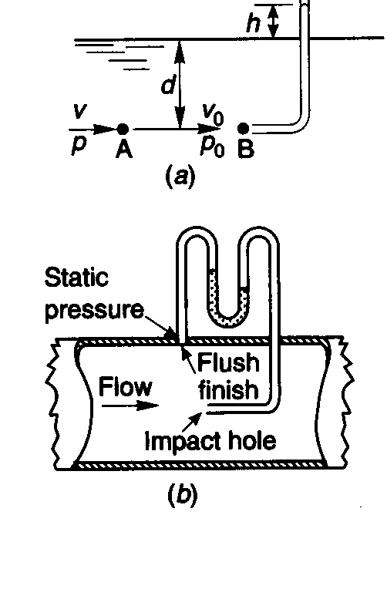

Fig.5.9
The Pitot tube measures the velocity of only a filament of liquid, and hence it can be used for exploring the velocity distribution across the pipe cross-section. If, however, it is desired to measure the total flow of fluid through the pipe, the velocity must be measured at various distances from the walls and the results integrated. The total flow rate can be calculated from a single reading only if the velocity distribution across the cross-section is already known.
The static tube measures the static pressure, since there is no velocity component perpendicular to its opening and the impact tube measures both the static and impact pressure (due to kinetic energy). Impact tube head = pressure head + velocity head.

- Orifices
An orifice is an opening (usually circular) in the wall of a tank or in a plate normal to the axis of a pipe, the plate being either at the end of the pipe or in some intermediate location and used for measuring rate of flow out of a reservoir (tank) or through a pipe.

a. Orifice flow in pipes, Orifice meter or orifice plate
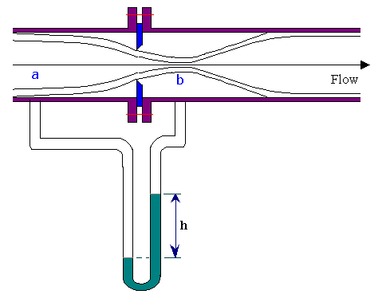
The Venturi meter described earlier is a reliable flow-measuring device. Furthermore, it causes little pressure loss. For these reasons it is widely used, particularly for large-volume liquid and gas flows. However, this meter is relatively complex to construct and hence expensive. Especially for small pipelines, its cost seems prohibitive, so simpler devices such as orifice meters are used.
The orifice meter consists of a flat orifice plate with a circular hole drilled in it. There is a pressure tap upstream from the orifice plate and another just downstream.
Fig.5.9 Orifice meter

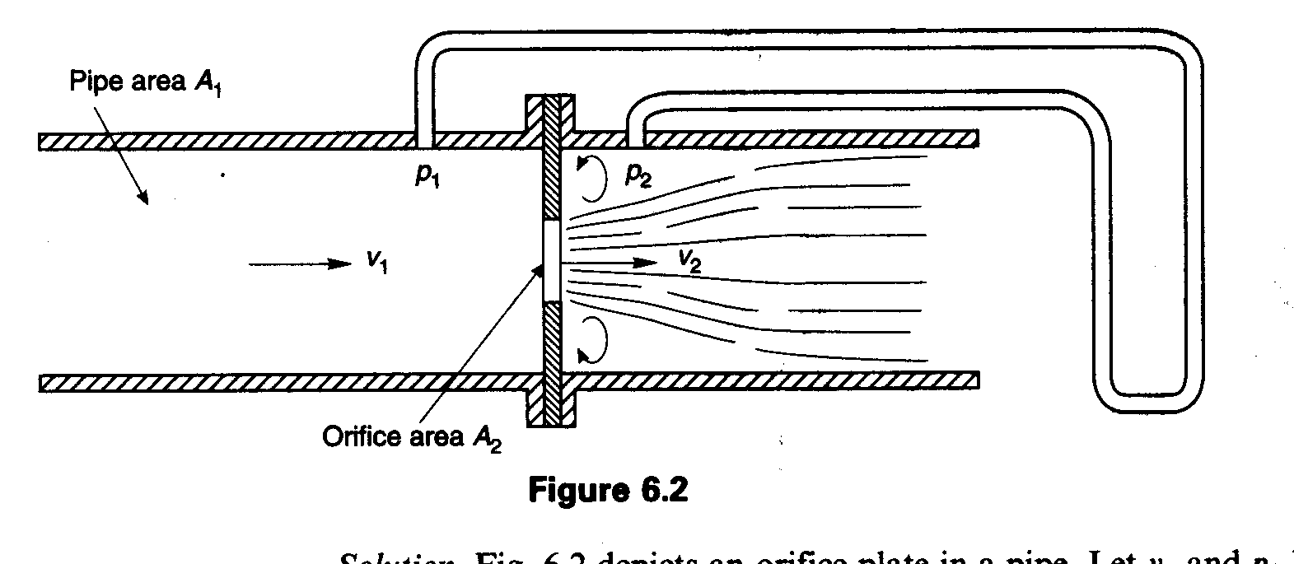

Fig.5.10 Orifice plate in a pipe

Applying the Bernoulli equation between at 1 (upstream of plate) and 2 (at the orifice)

$\begin{aligned}\frac{P_{1}}{γ} + \frac{V_{1^{2}}}{2g} = \frac{P_{2}}{γ} + \frac{v_{2^{2}}}{2g} \text{Since} \text{the} \text{orfice} \text{is} \text{horizontal} Z_{1}=Z_{2} \\ \frac{V_{1^{2}}−V_{2^{2}}}{2g} = \frac{P_{2}−P_{1}}{γ} \\ \text{Using} \text{continuity} \text{equation} A_{1}v_{1} = A_{2} V_{2} ⇒ V_{2} = \left(\frac{A_{1}}{A_{2}}\right) V_{1} \\ \frac{v_{1^{2}}−\left({A_{1}}/{A_{2}}\right) ^{2}v_{1^{2}}}{2g} = \frac{P_{2}−P_{1}}{γ} \\ v_{1^{2}} \left(\frac{1−({A_{1}}/{A_{2}})^{2}}{2g}\right) = \frac{p_{2}−p_{1}}{γ} ⇒ V_{1} = \sqrt{\left(\frac{p_{2}−p_{1}}{γ}\right)∗\frac{2g}{1−({A_{1}}/{A_{2}})^{2}}} \end{aligned}$

The theoretical discharge Q will therefore be,
Q = A₁V₁ =A₁ $\sqrt{\frac{\left(p_{2}−p_{1}\right)}{p}∗ \frac{2}{1−({A_{1}}/{A_{2}})^{2}}}$
The actual discharge will be less than the theoretical since the effective flow area near P₂ tapping will be less than A₂, the fluid forming a neck or vena contracta. In addition, there will be some loss of energy between point 1 and 2.
The actual discharge can be determined by determining coefficient of discharge.

b. Flow through a reservoir opening (orifice flow)
For a reservoir at water level h above orifice opening shown in the following figure. The reservoir is assumed to be very large as compared to size of the opening, so that the velocities of all points in the reservoir are negligibly small.

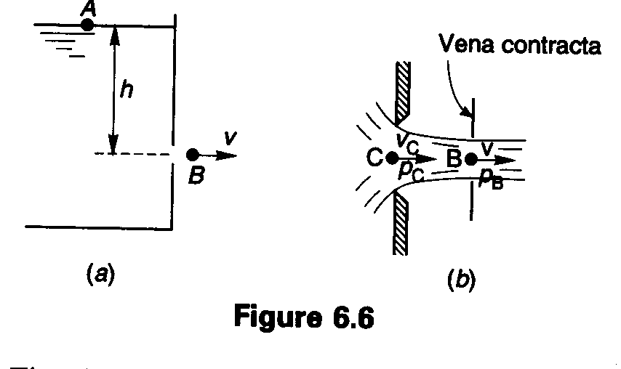
3
Fig. 5.11 Small orifice in the side of a large reservoir

Applying Bernoulli’s equation and neglecting losses between A and B (taking the datum level at the center of the orifice),
0 + 0 + h = $\frac{V^{2}}{2g} + 0 + 0$
V = $\sqrt{2\text{gh}}$(Theoretical velocity). Where h is the depth of center of orifice below the free surface. Evidently, the velocity of efflux is equal to the velocity of free fall from the surface of reservoir. This is known as Torricelli’s theorem. In real fluid flows, there is always some loss of energy due to viscous effects and accordingly the actual velocity will be less than the theoretical velocity.

Hydraulic Coefficients for flow through orifices
1) Coefficient of contraction, C_{c} = $\frac{\text{Area} \text{of} \text{jet} \text{at} \text{vena} \text{contracta}}{\text{Area} \text{of} \text{orifice}}$
2) Coefficient of velocity, C_{v} = $\frac{\text{Actual} \text{velocity} \text{at} \text{vena} \text{contracta}}{\text{Theoretical} \text{velocity}}=\frac{V}{\sqrt{2\text{gh}}}$
3) Coefficient of discharge, C_{d} = $\frac{\text{Actual} \text{disch}\text{arg}e}{\text{Theoretical} \text{disch}\text{arg}e}$
Theoretical discharge, Q_{t} = A_{o} $\sqrt{2\text{gh}}$
Where A_{o} = $\text{Area} \text{of} \text{orifice}$(Area of jet at C)
Actual velocity, V_{a} = C_{v} $\sqrt{2\text{gh}}$
As shown in the figure, the paths of the particles of the liquid converge on the orifice so that the area of the issuing jet is less than the area of the orifice. In the plane of the orifice, the particles have a component of velocity towards the center so that at C the pressure is greater than atmospheric pressure. It is only at B a little outside the orifice that the paths of the particles become parallel. The section at B is the least cross-section and hence of maximum contraction, is called the vena contracta.
Area of vena contracta, A_{B} = C_{c}A_{o} (The actual area of the jet is the area of the vena contracta not the area of the orifice.)

Therefore, Actual discharge Q_{a} = Actual area of jet * Actual velocity
$\text{Qa}=\text{CcAo}∗\text{Cv}\sqrt{2\text{gh}}$
It is customary to combine the two coefficients into a discharge coefficient C_{d}.
(C_{d} = C_{v} C_{c})
Qa = C_{d} A₀ $\sqrt{2\text{gh}}$

Determination of hydraulic coefficients of orifice
Determination of C_{d}
By measuring area A₀, the head h and the discharge Q_{a} (by gravimetric or volumetric means), C_{d} is obtained using the above equation. Determination of either C_{v} or C_{c} then permits determination of the other by the equation C_{d} = C_{v} C_{c}.

Determination of C_{c} and C_{v}
- Trajectory method

The equation for the trajectory may be obtained by applying Newton’s equation of uniformly accelerated motion to a particle of the liquid passing from the nozzle to point P, whose coordinates are (x, y) in time t. Then x = V_{xo}t and z = V_{zo}t - 1/₂gt². Evaluating t from the first equation and substituting in the second gives
$$z=\frac{V_{z0}}{V_{x0}}x−\frac{g}{2V_{{x0}^{2}}}x^{2}$$
If the jet is initially horizontal, as in the flow from a vertical orifice, V_{x0} = V₀ and V_{z0} = 0, the above equation is reduced in to;
V₀ = $x\sqrt{\frac{g}{2z}}$
Then C_{v} = $\frac{V_{0}}{V_{t}} = \frac{V_{0}}{\sqrt{2\text{gH}}} = \frac{x}{\sqrt{2z/g}\sqrt{2\text{gh}}} = \frac{x}{\sqrt{4\text{zh}}}$

- Pitot tube method
Pitot tube can be set at the vena contracta so that actual velocity V_{a} is determined.

- Calipers method
The diameter of the jet at the vena contracta can be approximately measured using an outside caliper. However, this method is not precise and is less satisfactory than other methods.

Types of Orifice

The following figure shows common types of orifice with their coefficient of discharge.

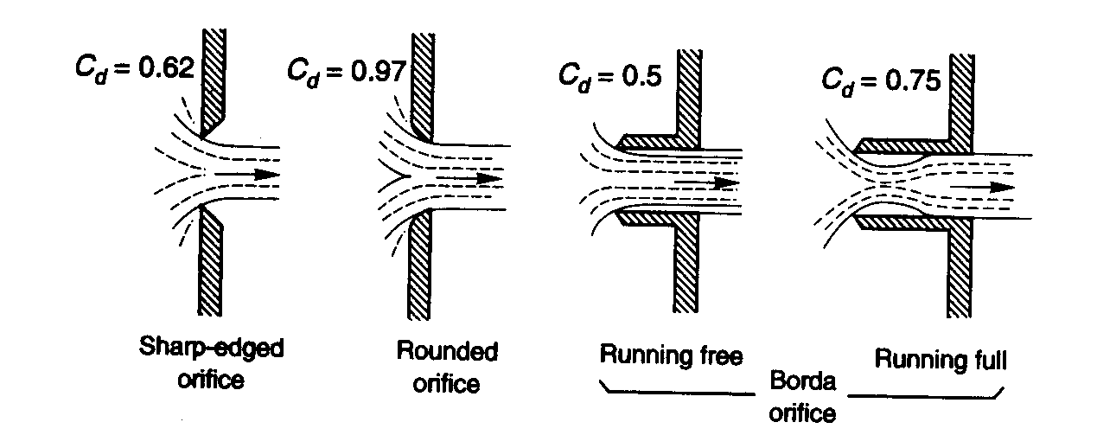

Fig.5.12 Types of orifice

The orifices are classified based on of their size, shape, nature of discharge and shape of the upstream edge.
- Depending upon their size: - small orifice and large orifice; If the head of liquid from the center of the orifice is more than five times the depth of the orifice, the orifice is called small orifice. If it less than five times it is known as large orifice.
- Depending upon shape: - as circular, triangular, rectangular and trapezoidal
- Depending upon shape of edge: - as sharp edged and round or bell mouthed orifice. (Fig.5.14)
- Depending up on the nature of discharge: - as free discharging & drowned or submerged orifice; the submerged orifices are further classified as fully submerged and partially submerged orifice

3. Unsteady orifice flow from reservoirs
The volume discharged from the orifice in time δt is Qδt, which must just equal the reduction in volume in the reservoir in the same time increment δt. A_{R}(-δy), in which A_{R} is the surface area of the reservoir at level y above the orifice.

y
δy

Fig 5.13 Unsteady flow from reservoir

Equating the two expressions:
$\begin{aligned}Qδt = A_{R}(−δy) \\ \text{Solving} \text{for} δt \text{and} \text{int}\text{egrating} \text{yields} \\ δt = \frac{A_{R}(−δy)}{Q} \\ \int{\text{dt}} = − \int{\frac{A_{R} δy}{Q}} \\ \text{but} Q = C_{d} \text{Ao} \sqrt{2\text{gy}} \\ ∴ t = \frac{−A_{R}}{C_{d} \text{Ao}\sqrt{2g}} \int{y^{{−1}/2}}δy \\ t = \frac{2A_{R}}{C_{d} A_{0} \sqrt{2g}}(y_{1}^{1/2} − y_{2}^{1/2}) {\text{This is the time for the liquid to fall from y}}_{1}{\text{ to y}}_{2}\text{.}\end{aligned}$
- Weirs
Open channel flow may be measured by a weir or obstruction in the channel that causes the liquid to back up behind it and flow over it or through it. There may be sharp crested or broad crested based on their length along the channel section.

a) Rectangular weir
The following figure shows rectangular notch of crest length (L) and working under a head H.
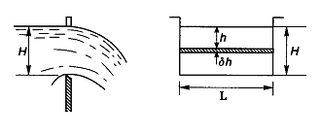
Fig. 5.14 Rectangular notch
By Torricelli’s theorem, the velocity of a particle discharged at any level h is $\sqrt{2\text{gh}}$ and will therefore vary from top to bottom of notch. Considering a horizontal strip at depth h and of thickness δh
Discharge through strip dQ = $\sqrt{2\text{gh}}$ * Lδh
Total discharge $Q_{t}=L\sqrt{2 g}\int_{0}^{H}{h^{1/2}\text{dh}} =\frac{2}{3}L\sqrt{2g}H^{3/2}$
This is the theoretical discharge through a rectangular notch.
The value of Q given by the above equation is too high because no account has been taken of energy lost and also because, as shown below there will be a substantial reduction in the width and depth of the notch cross section because of the curved path lines of the liquid.
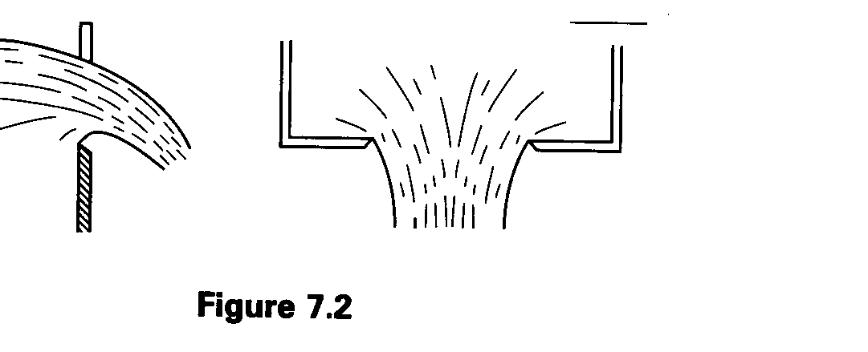
Fig 5.15 Effect of vena contracta in rectangular weir
Therefore, Actual discharge Qa, $\text{Qa}=\frac{2}{3}C_{d} L\sqrt{2g}H^{3/2}$
From experiment, C_{d} = 0.62
Qa = 1.831LH^{3/2}
b) Triangular weir (V-notch)
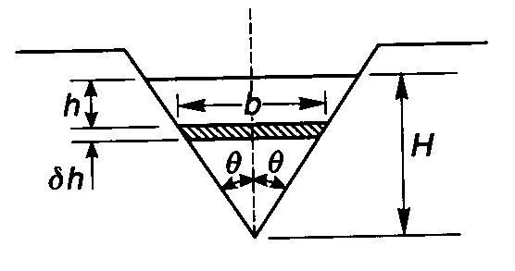
Fig. 5.16 Triangular weir

Since the velocity of flow through the notch varies from top to bottom, consider a strip of thickness δh at a depth h below the surface. If the velocity of approach is small:

Head producing flow = h
Velocity through strip = V = $\sqrt{2\text{gh}}$
If width of strip = b, Area of strip = bδh
Discharge through strip = δQ = Vbδh
The width b depends on h and is given by b = 2(H - h) tanθ

$\begin{aligned}δQ=\sqrt{(2g)}h^{1/2}x2(H−h)\text{tan}θ ∗δh \\ =2\sqrt{2g}\text{tan}θ({\text{Hh}}^{1/2}−h^{3/2})δh\end{aligned}$

Integrating between the limits h = 0 and h = H

$$\begin{aligned}Q=2\sqrt{2g}\text{tan}θ\int_{0}^{H}{({\text{Hh}}^{1/2}−h^{3/2})\text{dh}} \\ =2\sqrt{2g}\text{tan}θ{\left[\frac{2}{3}{\text{Hh}}^{3/2}−\frac{2}{5}h^{5/2}\right]}_{0^{H}} \\ =\frac{8}{\text{15}}\sqrt{2g}\text{tan}{θH}^{5/2}\end{aligned}$$

This is the theoretical discharge.
Actual discharge = C_{d*}Q = C_{d}$\frac{8}{\text{15}}\sqrt{2g}\text{tan}{θH}^{5/2}$
From experiment C_{d} = 0.58, Q_{a} = 1.37 tanθ H^{5/2},
For 90⁰ V-notch, Q_{a} = 1.37 H^{5/2}

  - Impulse-momentum theorem

It is often important to determine the force produced on a solid body by fluid flowing steadily over it. For example, the force on a pipe bend caused by the fluid flowing through it; the force exerted by jet of fluid striking against a solid surface; thrust on a propeller. All these forces are hydrodynamic forces and they are associated with a change in the momentum of the fluid.

The magnitude of such a force is determined by Newton’s second law of motion, by modifying the law to suit particularly to the steady flow of a fluid called the steady flow momentum equation. Only the forces acting at the boundaries of this space concern us, and use of momentum equation doesn’t require the knowledge of the flow pattern in detail. Moreover, the fluid may be compressible or incompressible and the flow with or without friction.
Consider a stream tube shown below with the following assumptions
- The c/s of stream tube is sufficiently small so that the velocity may be considered uniformly distributed
- The flow is steady i.e. the stream tube remains stationary with respect to the fixed coordinate axis.

Fig. Stream tube
Newton’s second law
F = m * a
F = m $\frac{\text{dv}}{\text{dt}}$
F * dt = m * dv

- Momentum principle expresses that the rate of change of momentum is equal to the net force acting on the fluid mass.

Momentum of fluid entering section 1 –1 in a time Δt in the x –direction
= ρ * dQ * Δt * V₁(x)
Momentum leaving section 2- 2 in time Δt
= ρ * dQ * Δt * V₂ (x)
From momentum principle

dFx = $\frac{P \text{dQ} Δt [v_{2}(x) − v_{1}(x)]}{Δt}$
dFx = ρdQ [V₂ (x) – V₁ (x)]
dFx = net force exerted on the fluid in the x –direction.
The total force in the x –direction is given by
$\begin{aligned}\text{Fx} = \int{\text{dFx}} = \int{ρ\text{dQ} v_{2}(x)−\int{ρ\text{dQ} v_{1}(x)}} \\ \\ = \int{ρ (v_{2}{\text{dA}}_{2}) v_{2} (x) − \int{ρ(v_{1}{\text{dA}}_{1}) v_{1}(x)}}\end{aligned}$

Assuming the fluid is incompressible
Fx = ρV₂ A₂ (V₂ (x) - PV₁A₁ V₁ (x)
Fx = ρ Q [V₂(x) – V₁(x)]
Similar equations for y and z directions may be written
Fy = ρQ [V₂(y) – V₁(y)]
Fz = ρQ [V₂(z) – V₁(z)]

Applications of momentum equations
1) The force caused by a jet striking a surface

A. Impact on a flat surface

i) Stationary plate:

A = area of jet
v₁ = velocity of jet
ρ = mass density

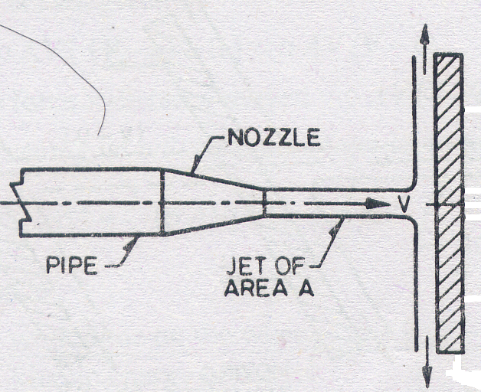

Fig. A jet hitting a vertical plate

Fx = ρQ(v₂ (x) – v₁(x))
= ρQ (0 – v₁) ➔ momentum normal to the plate is destroyed.
Fx = -ρAV² (force in the jet)
Force exerted on plate = ρAV² (Equal and opposite to the force exerted on the jet = Fx)

ii) Moving plate

Initial velocity of jet v_{1x} = V₁
Final velocity of jet = velocity of = v_{2x} = U = velocity of plate
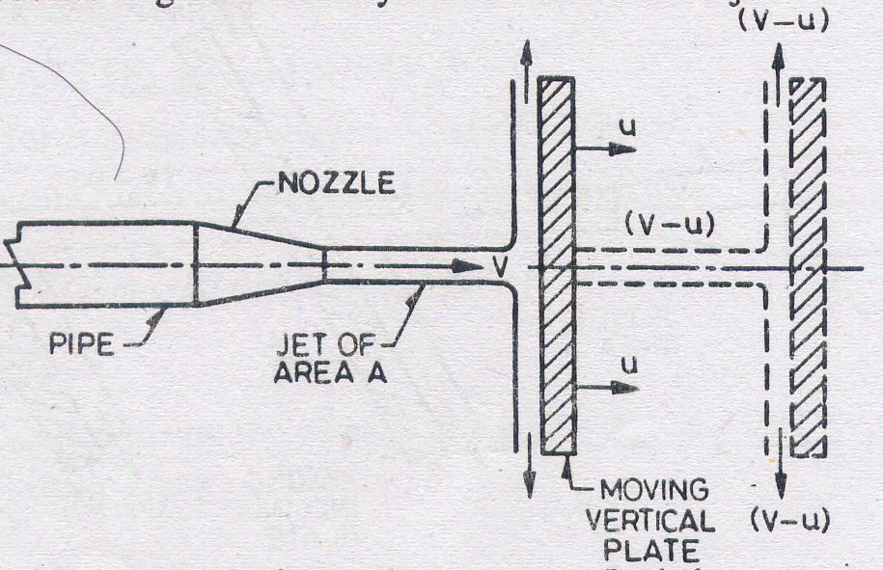
Fig. A jet hitting a moving vertical plate

The velocity with which jet strikes the plate = V – U
Mass of fluid striking plate/sec = ρA (V – U)
Force on plate = ρA (V – U) (V – U)
= ρA (V – U) ²

iii) Stationary inclined plate
Fig. A jet hitting an inclined plate

Initial velocity of jet v₁(x) = Vsinθ
Final velocity of jet v₂(x) = 0
Mass striking stationary plate = ρAV
Normal force on the plate = ρAV(Vsinθ) = ρAV² sinθ
Since the plate surface is smooth, there can be no force exerted by the plate on the fluid jet in the tangential direction.
Ft = ρQ₁V - ρQ₂ V – PQVcosθ = 0
Q₁ – Q₂ – Qcosθ = 0 (*)

Continuity equation Q = Q₁ + Q₂ ⇒ Q₂ = Q – Q₁

Substitute in (*) Q₁ = Q - Q₂

Q₁ – Q + Q₁ – Qcosθ = 0
2Q₁ - Q (1+ cosθ) = 0 Q – Q₂ – Q₂ – Qcosθ = 0
Q₁ = Q/2 (1 + cosθ) Q (1 - cosθ) – 2 Q₂ = 0
Q₂ = Q/2 (1- cosθ)
For a vertical plate, θ = 90º
Q₁ = Q/2 = Q₂

iv) Moving inclined plate
Fig. A jet hitting a moving inclined plate

Initial velocity of jet V₁(x) = Vsinθ
Final velocity of jet V₂(x) = Usinθ

Mass striking the moving plate per second = ρQ = ρA (V- U)
Normal force on the plate = ρA (V - U) (V sinθ - U sinθ)
= ρA (V – U) ² sinθ

Work done by this force = Fx * U = $\bar{F} n \text{sin} θ ∗u$

V) Series of flat plates

The force exerted by the impact of jet can be fruitfully utilized if the flat plates are mounted on the periphery of a wheel as shown below. The force exerted by the jet causes the rotation of the wheel. The flat plates thus occupy the bottom most position according to their turn.

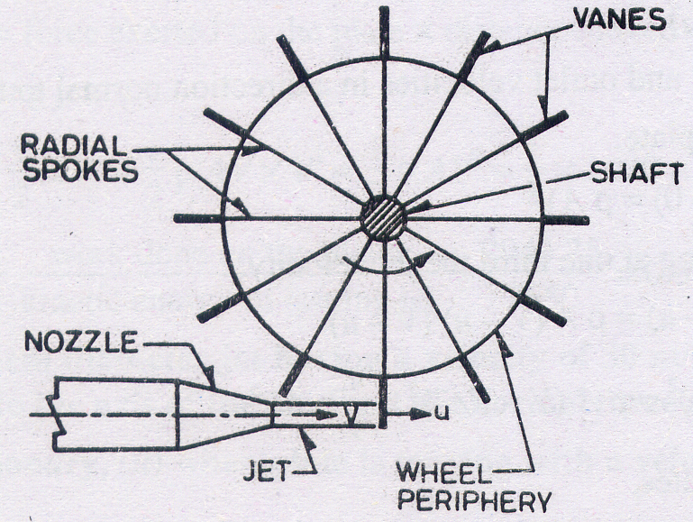
Fig. Flat plates mounted a wheel

The number and location of the plates is so arranged that no portion of jet goes waste without doing work on the plate.

Initial velocity of jet = V
Final velocity = velocity of plate = U
Fluid mass striking the plate per second = ρQ = ρAV
Force exerted on the plate by jet = ρAV(V – U)

Work done per second = Force * distance moved per second
= ρAV (V –U) *U

KE of jet per second = ½ (ρAV)V²

Efficiency of jet = $\frac{\text{Work} \text{done} \text{on} \text{plate}}{\text{KE} \text{of} \text{jet}} = \frac{ρ\text{AV}(v−u)u}{\frac{1}{2} ρ\text{AV} V^{2}} = \frac{2(v−u)u}{v^{2}}$

B. Force on curved vane
Consider a symmetrical curved vane having smooth surface. The jet strikes at the center and after impact it is deflected equally along the vane surface.

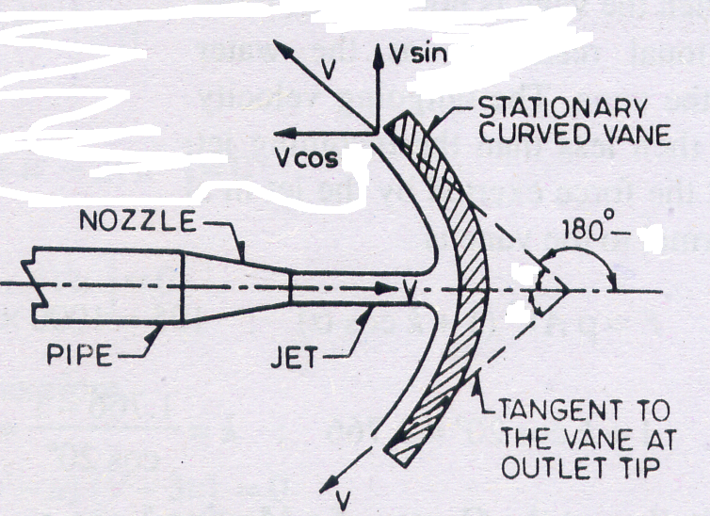
Fig. A jet hitting a curved vane
M_{in} = ρAV * V = ρAV²
M_{out} = - $ρ\frac{\text{Av}}{2} V\text{cos}θ − ρ \frac{\text{Av}}{2} v\text{cos} θ$
= - ρAV²cosθ
Force exerted by curved vane on the jet
Fx = M_{out} – M_{in}
= - ρAV²cosθ - ρAV² = - ρAV² (1+cosθ)
Force on curve vane by jet = ρAV²(1+cosθ)
For θ = 90⁰ – Flat plate at right angle to jet F = ρAV²
For θ = 0⁰ - semi–circular plate F = 2ρAV²

Curved vane moving in translation

Mass of fluid striking the vane = ρA(V- U)
M_{in} = ρA(V - U) ²
M_{out} = - ρA(V – U) ²cosθ
Force exerted by jet on the vane = Fx = ρA (V – U) ² (1+ cosθ)
Work done by jet = F_{x}U
KE of jet /sec = ½ (ρAV)V²

Efficiency, $η = \frac{\text{workdone} \text{by} \text{jet}}{\text{KE} \text{of} \text{jet}}$
$η = \frac{2 (1+\text{cos}θ) {\left(V−U\right)}^{2}U}{V^{3}}$

Curved vane mounted on a wheel

Let the wheel rotate with a tangential velocity U and a jet moving with velocity v strikes the wheel.

Fluid mass striking the wheel per second = PAV

M_{in} = ρAV(v –u) (Before impact)
M_{out} = ρAV(v –u)cosθ (After impact)
Force exerted by jet on the van = M_{in} – M_{out}
F = ρAV (v – u) (1+ cosθ)
W = F * U
KE = ½ ρAV² ➔ $η = \frac{2u (v−u) ( 1+\text{cos}θ)}{v^{2}}$

2. Force exerted on a reducing pipe bends
i. Bend in a horizontal plane.

Y

X

θ

Fig. Force on a horizontal reducing bend

Let F_{x} and F_{y} be the components of the force exerted on the fluid by the pipe bend.
Then momentum equation in the x–direction can be written as:
P₁A₁ - P₂A₂cosθ - F_{x} = ρQ(V₂cosθ - V₁)
Fx = ρQ (V₁ -V₂cosθ) - P₁A₁ + P₂A₂cos
Momentum equation in the y–direction can be written as:
F_{y} - P₂ A₂sinθ = pQ (V₂sinθ - V₁₎ (V₁ = 0)
F_{y} = P₂A₂sinθ + pQ(V₂sinθ)

ii. Bend in a vertical plane.
A reducing bend with deviation in the vertical plane is shown in Fig. below. Due to the hydrostatic and dynamic pressures a force is exerted by the fluid on the bend which has to be resisted by a thrust block or other suitable means. This force could be evaluated by plotting the stream lines and thus determining the pressure distribution. However, by a simple application of the momentum equation, and quite independently of any energy losses associated with turbulent eddying (real fluid), we obtain.

Z

Y

θ

Fig. Force on a vertical reducing bend
For the x direction:
P₁ A₁ - P₂A₂cosθ - Fx = pQ(v₂cosθ - v₁)
And for the z direction
F_{z} - W – P₂A₂ sin θ = pQv₂ sinθ
Where W is the weight of fluid between the reference sections.
From these equations, F_{x} and F_{z} may be determined and hence the resultant force, R:
$R = \sqrt{R_{z^{2}}+R_{z^{2}}}$
It is to be noted that the momentum equation gives no information concerning the location of the resultant, which necessitates an analysis involving forces and moments.
3. Force in nozzle
A nozzle, attached to a pipeline, and discharging to the atmosphere provides a good example of a rapid change in velocity. The fluid exerts a force on the nozzle and in accordance with Newton's third law there is a similar force, of opposite sign, exerted by the nozzle on the fluid. This is the force which the tension bolts must be designated to withstand. The force could be evaluated by an analysis of the pressures acting on the surface of the nozzle but this procedure would, to say the least, be extremely tedious. By contrast, a simple application of the momentum equation between upstream and downstream reference sections will yield a direct solution. In Fig below, the component forces are the hydrostatic forces P₁A₁ and P₂A₂ and the force Fx exerted by the nozzle on the fluid. The rate of change of momentum is $ρ$Q(V2 - V1) so that the momentum equation may be expressed as:

Fx = P₁A₁ - $ρ$Q(V₂ - V₁)

