Chapter – 3
3.0. HYDROSTATICS

3.1 Introduction

Hydrostatics deals with the study of fluids at rest or moving with uniform velocity as a solid body, so that there is no relative motion between fluid elements (or layers). There is no shear stress in a fluid at rest. Hence, only normal pressure forces are present in hydrostatics.

Engineering applications of hydrostatics principles include the study of forces acting on submerged bodies such as dam faces, gates & others and the analysis of stability of floating bodies.

  - Hydrostatics Pressure at a point :-

The pressure at a point is the limit of ratio of the normal force on infinitesimal area dA.

i. e P = $\frac{\text{dF}}{\text{dA}} = \text{lim} \frac{ F}{A→0,A} \text{.}\text{.}\text{.}\text{.}\text{.}\text{.}\text{.}\text{.}\text{.}\text{.}\text{.}\text{.}\text{.}\text{.}\text{.}\text{.}\text{.}\text{.}\text{.}\text{.}\text{.}\text{.}\text{.}\text{.}\text{.}\text{.}\text{.}\text{.}\text{.}\text{.}\text{.}\text{.}\text{.}\text{.}\text{.}\text{.}\text{.}\text{.}\text{.}\text{.}\text{.}\text{.}\text{.}\text{.}\text{.}\text{.}\text{.} (1)$

No tangential stresses can exist in a fluid at rest. At a point a fluid at rest has the same pressure in all directions. This is known as PASKAL’S LAW. This means that an element having very small area ($δ$_{A}) in the fluid, free to rotate about its center when submerged in a fluid at rest, will have a force of constant magnitude acting on either side of it, regardless of its orientation.

Consider a small wedged- shaped fluid element at rest. The thickness of the element perpendicular to the plane of the drawing is assume to be unity ($δ$z=1)

Fl=Pl.δ l
δw
y
Fx
θ
F_{y}

Fig.3.1 Small wedged- shaped fluid element
The weight of the fluid element is,
= (area of triangular element *depth)*specific weight
$δ$w = $γ\left(\frac{δx \text{.} δ y\text{.}1}{2}\right)$
F_{x} =Px* δ_{y}*1
F_{y} = Py* δ_{x}*1
δ _{X} = δ_{Y} = very small number
Since there is no shear force, the only forces acting on the wedge are the normal surfaces forces & gravitational force.
The fluid prism (element) is in equilibrium, i.e.

$$\begin{aligned}\sum{F_{x}}= 0 ⇒ P \text{.} δ_{y}∗1−P_{l}\text{.} δ_{l}\text{.} \text{Sin} θ = \left(\frac{δ _{x} \text{.} δ_{y} ∗1}{2}\right) ρ a_{x}=0 \text{.}\text{.}\text{.}\text{.}\text{.}\text{.}\text{.}\text{.}\text{.}\text{.}\text{.}\text{.}\text{.}3\text{.}2 \\ ( a_{x} = 0 ) \\ \sum{F_{y} = 0 ⇒ P_{y} \text{.}δ_{x}} ∗ 1 − P δ_{l} \text{.} 1 \text{cos} θ − γ \text{.} \frac{δ _{x}\text{.} δ_{y}\text{.}∗1}{2 } = \frac{δ_{x}\text{.} δ _{y}}{2}\text{.} 1 ρ \text{.} a_{y} = 0 \\ \left( a_{y} = 0\right)\end{aligned}$$

Using geometric relations:
.
$$\begin{aligned}δy=δℓ\text{sin}θ ⇒ δℓ = δ y/ \text{Sin} θ \\ \end{aligned}$$
δ x = δ $ℓ\text{.} \text{.} \text{cos} ⇒ δℓ = δx\text{/cos} θ$

We obtain:

P_{x.} δ _{y} - P$ℓ$. δ _{y} = 0 ------------------------------------------- 3.2a

P_{Y}.δ x - P$ℓ δ−γ \frac{δ \text{.} δ y}{2} = 0 \text{.}\text{.}\text{.}\text{.}\text{.}\text{.}\text{.}\text{.}\text{.}\text{.}\text{.}\text{.}\text{.}\text{.}\text{.}\text{.}\text{.}\text{.}\text{.}\text{.}\text{.}\text{.}\text{.}\text{.}\text{.}\text{.}\text{.}\text{.}\text{.}\text{.}\text{.}\text{.}\text{.}\text{.}\text{.}\text{.}\text{.}\text{.}\text{.}3\text{.}2b$
As $\left(δ x \text{.}δ y\right)$is infinitesimal of higher order, it may be neglected.

$$\begin{aligned}∴ P − Pℓ = 0 ⇒ \text{Px} = Pℓ \\ P − Pℓ = 0 ⇒ P = Pℓ \\ \end{aligned}$$
$⇒ P = \text{Py} = P → ( \text{pascals} \text{equation}) \text{.}\text{.}\text{.}\text{.}\text{.}\text{.}\text{.}\text{.}\text{.}\text{.}\text{.}\text{.}\text{.}\text{.}\text{.}\text{.}\text{.}\text{.}\text{.}\text{.}\text{.}\text{.}\text{.}\text{.}\text{.}\text{.}\text{.}\text{.}\text{.}\text{.}\text{.}\text{.}\text{.}\text{.}\text{.}\text{.}\text{.}\text{.}\text{.}\text{.}\text{.}3\text{.}3$,

It can also be proved that P_{Z} = P$ℓ$, by considering a three dimensional case. The results are independent of θ hence the pressure at any point in a fluid at rest is the same in all directions.

3.3 Basic Equation of Hydrostatics
The basic equation of Hydrostatics may be derived by considering the infinitesimal fluid parallepiped in a static fluid shown in fig. 3.2.Below.
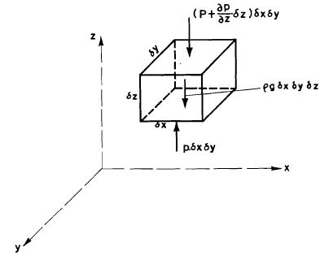
Fig 3.2 A rectangular fluid parallelepiped
Assuming the density of the fluid ρ in the infinitesimal cube to be constant, the mass of the fluid is ρ.dx.dy.dz. Let the pressure variation in the x, y and z directions be $\frac{∂p}{∂x},\frac{∂p}{∂y} \text{and} \frac{∂p}{∂z}$ respectively and let the entire fluid mass be subjected to acceleration of a_{x}, a_{y}, and a_{z}, in the x, y and z directions respectively.
Considering the equilibrium in the vertical (Z) direction:
This is reduced to
$$\frac{∂p}{∂z}=−ρ(a_{x}+g)$$
Similarly it can be shown that
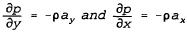
The total change in pressure is given by the total differential as follows:
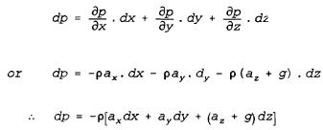 …………………. 3.4
Equation 3.4 is the basic equation of fluid statics applicable for both compressible and incompressible fluids.

3.3.1 Variation of Pressure with Elevation in a Static Incompressible Fluid
For a fluid at rest and subjected only to gravitational force, the accelerations ax, ay and az are zero. Eqn3. 4 thus reduce to:
……………………. 3.5
Equation 3.5 holds true for both compressible and incompressibile fluids. However for homogeneous and incompressible fluids, ρ is constant and eqn 3.5 may be integrated to give;
3. 6
where c is a constant of integration and is equal to the pressure at z = 0. In hydrostatics the law of variation of pressure with depth is usually written as;
3.7
In Equation 3.7, h is measured vertically downward ( i . e. h =-z) from a free surface, p is the pressure at a depth h below the free surface and p_{o}, is the pressure at the free surface.
Equation 3.7 shows that for a fluid at rest, the pressures at the same depth from the free surface are equal. Hence in a homogeneous continuous fluid a surface of equal pressures is a horizontal plane.
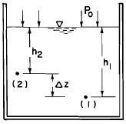
Fig 3.3
Consider two points (1) and (2) at a depth of h₁ and h₂ in a tank containing a liquid, with density ρ, at rest as shown in Figure 3.3. The pressure at (1) is p₁ = p₀ + pgh₁. The pressure at (2) is p₂ = p₀ + pgh₂. If h₁ = h₂, then p₁ = p₂.
For h₁ > h₂, the pressure difference between (1) and (2) is p₁ - p₂ = ΔP = ρgh_{l} - ρgh₂ = ρg(h₁ - h₂) = ρgΔz.
$Δz=\frac{Δp}{ρg}$ Is the pressure difference between (1) and (2) expressed as a height of the liquid. This difference is also refered to as the pressure head difference. Thus, by dividing a pressure by the specific weight γ = ρg of a fluid, the pressure can be expressed as height of fluid column.

3.3.2 Variation of Pressure with Elevation in Static Compressible Fluids
Since density varies with pressure in compressible fluids, the relation between density and pressure must be known in order to integrate the basic equation of fluid statics and obtain expressions for the variation of pressure with elevation in compressible fluids. The relation between pressure and density is dependent on the prevailing conditions. These conditions are; Constant temperature (i.e. isothermal), adiabatic and constant temperature gradient conditions.
Isothermal Condition: The relation between pressure, density and temperature for constant temperature condition is given by the perfect gas law: PV = mRT, $\frac{P}{ρ}=\text{RT}$. Where R is characteristics gas constant, the unit of R is $\frac{\text{Nm}}{\text{kgK}}\text{or} \frac{J}{\text{kgK}}$
Substituting this in the basic equation of hydrostatics i.e. Equation 3.5
:
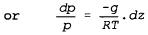
Integrating from p = p₁ where z =z₁ to p = p₂ where z = z₂
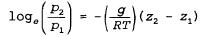
Or 3.8
Adiabatic Condition: Under adiabatic condition the relationship between pressure and density is given by p/ρ^{k} = constant = p₁/ρ₁^{k},
So that,
Substitution of the above in the basic equation 3.7 gives:
$$\frac{\text{dp}}{\text{dz}}=−(ρ_{1}g\frac{p^{\frac{1}{k}}}{p_{1}^{\frac{1}{k}}})$$

Integrating from p = p₁ when z = z₁ to p = p₂ when z = z₂,
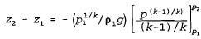

The above may be written as:
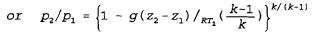 3.9
In the above equation, T is absolute temperature in ºk, R = 288J kg⁻¹ k⁻¹ = 288 m²/s² ⁰c, and k = 1.4 for adiabatic condition.
The temperature lapse rate
- the rate of change of temperature with altitude
- can be found for adiabatic conditions as follows:
Substituting the characteristic equation, ρ = p/RT in Equation 3.2 and rearranging,
Substitution and rearranging gives:
Differentiating the above,
Substituting the values of p and dp in the equation for dz,
Therefore, the temperature gradient is given by:
Constant Temperature Gradient Condition: Assuming that there is a constant temperature lapse rate (i.e. d_{T}/d_{Z} = constant) with elevation in a gas, so that its temperature drops by an amount δT for a unit change in elevation, then if T₁ = temperature at elevation Z₁, then T = temperature at elevation Z is given by:
Putting this in Equation 3.7 and noting that p/ρ = R T,
Substituting the above value of T,
On the average, there is a temperature gradient of about 6.5⁰C per 1000 m in the atmosphere i. e. δT = 6.5 ⁰c per 1000 m = 0.0065⁰c.m^{-l}.

3.4 Measurement of pressure

In practice, pressure is always measured by the determination of a pressure difference More usually the difference determined is that between the pressure of the filed concerned & the prevailing atmospheric pressure.

3.4.1 Absolute & Gage Pressure

Pressure values may be expressed with reference to any arbitrary datum (level) it is usually expressed w. r .t absolute zero (perfect vacuum & local atmospheric pressure). When the reference is absolute zero, the pressure is called Absolute pressure; if the pressure is measured w. r .t local atmospheric pressure it is called Gage pressure.
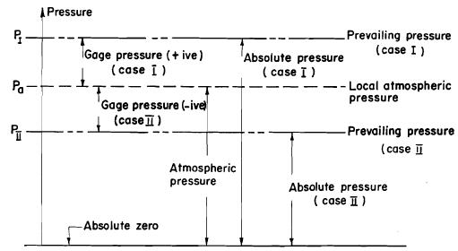
Fig 3.4 Pressure and Pressure datum

Absolute pressure is always positive, but gage pressure is positive if the prevailing is greater than p_{atm} & negative if prevailing pressure is less than p_{atm}

P_{abs} = P_{atm} + P _{gag} ……………. 3.10

Atmospheric pressure is also called Barometric pressure simple Barometer (mercury barometer) consists of an inverted tube closed at one end& immersed in a liquid with the open and down

If the air is completely exhausted from the tube, the atmospheric pressure on the surface of the liquid in the container forces the liquid to rise in the tube to a height y & the only pressure on the liquid surfaces in the tube is vapor pressure of the liquid, P_{v}

P₀ ₌ P_{A} = P_{tm} (from Pascal’s law)

From the condition of static equilibrium of the liquid above O is the tube of cross- sectional area A

P _{atm} A – P_{vapors}* A - γ A y = 0

$⇒$ P _{atm} = γ y + Pvap

But vapor is very small compared to P_{atm} & it can be neglected, Pv – for mercury is 0.173 P_{a} at 20_{c}⁰ but for water it shouldn’t be neglected because P_{v} – for water is 2.447 K P_{a} at 20⁰₂

Thus P _{atm} = γ y ……………………………………………….. 3. 11a

Y = P _{atm} / γ ………….. 3.11b
(Pressure head)

If the liquids with low specific weight are used, Y – shall be excess very high. For example for water barometer, Y = 10 .33 m at sea level and for mercury barometer, y = 0.76 m = 760 mm at s. e

This is the difference normally recorded by the pressure page & is known as gage pressure. There are so Many ways which pressure in a fluid may be measured

- Bourdon gage

This is a typical devices used for measuring gage pressures. Where high precision is no required a pressure difference may be indicated by the deformation of an elastic solid. It consists of a curved tube of elliptical cross- section at one end. The closed end is free to move while the open end through which the fluid enters is rigdely fixed to frame.
The reading zero (0) implies the is no difference in pressure in the atmosphere & liquid
- pressure greater than atmospheric straighten the tube for pressure less than atmospheric, the tube tends to coil again
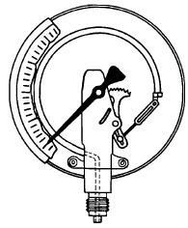

Fig. 3.5 Bourdon gage

- Piezometer

- It is used to measure moderate positive pressure of liquids it consists of a simple transparent tube open to atmosphere, in which the liquid can freely rises without over flowing. The height of the liquid will rises in the tube indicates the pressure head. To reduce capillary effect the diameter of the tube should be greater than 12 mm
- it the pressure of a flowing fluid is to be measured, the hole must be drilled absolutely normal to the interior surface of the wail, and the piezometer tube or the connection for any other pressure measuring device must not project beyond the surface Also, the hole should be small, preferably not larger than 3 mm diameter it γ is the sp. Wt of the liquid , then pressure at A gage pressure is

P_{A} = P _{atm} + γ h (gage reading)

= γ h (gage reading) but, P _{atm}=0 hence, the tube is open to the atmosphere

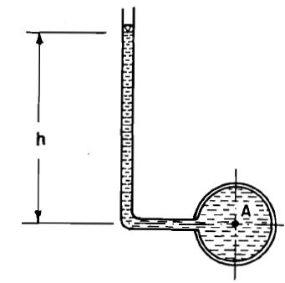

III. MANOMETERS: -

Simple Manometer
Manometers are devices in which columns of a suitable liquid are used to measure the difference of pressure between certain point& the atmosphere, or between two points neither of which is necessarily at atmospheric pressure. They are suitable of measuring high pressure differences, both positive and negative in liquids & gases.

Essentiality, a monometer is a piezometer with U bend tube in it in the bent, a denser fluid (usually mercury) is added.
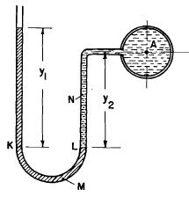
Fig 3.6 The Simple manometer
Since in a continuous homogeneous fluid the pressure is the same at any two points of equal level, the pressure at K & L are equal
When equilibrium condition is achieved: P_{K} = P_{L}

P_{k} = P_{atm} + γ_{M} y₁ = P_{L} = P_{A} + γ_{N} y₂
P_{A} = P_{atm} + γ_{M} y₁ - γ_{N} y₂

Differential Manometers:-

A differential manometer (U – the manometer) determines the difference in pressures at two points A & B when the actual pressure at any point in the system can’t be determined
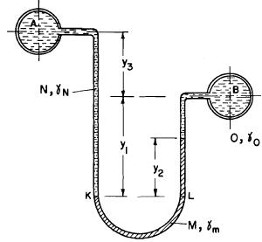
Fig 3.7 Differential manometer
At Equilibrium on K-L (horizontal plane)

P_{K} = P_{L}

P_{A} + γ_{N} y₃ + γ_{N} y₁ = P_{B} + γ_{O} (y₁-y₂) + γ _{m} y₂

P_{A} – P_{B} = γ_{O} (y₁-y₂) + γ _{m} y₂ – (γ_{N} y₃ + γ_{N} y₁)

Example 3.1
A closed tank is partly filled with water and connected to the manometer containing mercury (S = 13.6) as shown in the figure below. A gauge is connected to the tank at a depth of 4 m below the water surface.
If the manometer reading is 20 cm, determine the gauge reading in N/ m². What will be the gauge reading when expressed as head of water in m?
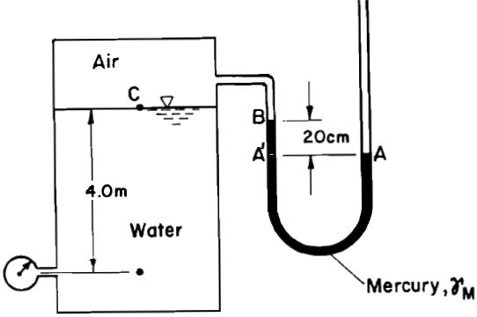
Solution
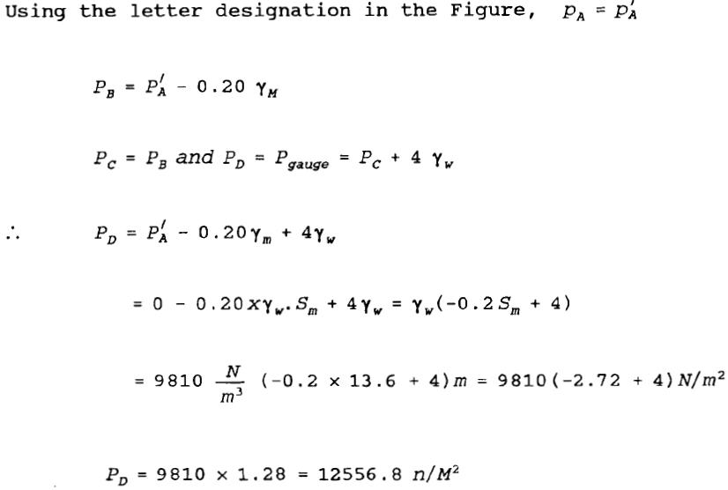
Therefore, the gauge reading is 12556.8 N/m²
When expressed as head of water, the gauge reading will be
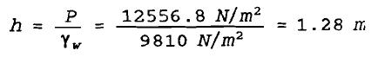

Example 3.2
A manometer is mounted in a city water supply main pipe to monitor the water pressure in the pipe as shown below. Determine the water pressure in the pipe.
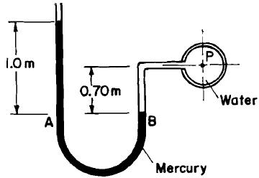

Solution

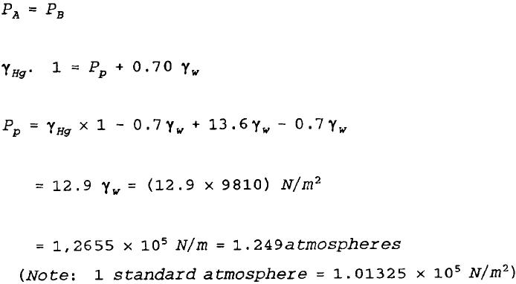

Example 3.3
Calculate the pressure difference between points A and B in the differential manometer shown in Figure below.
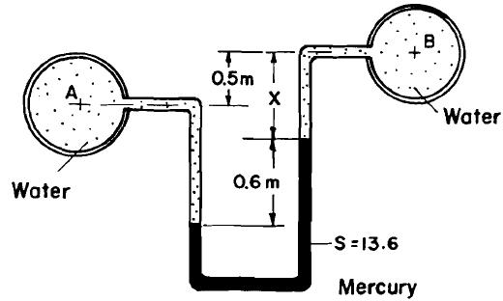
Solution
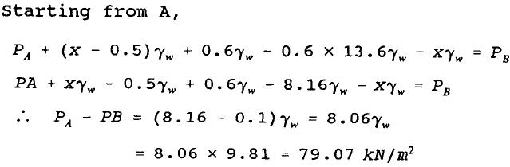
  - Hydrostatic Forces on Surfaces
Plane and curved surfaces, immersed fully or partly in liquids, are subjected to hydrostatic pressure forces. It is, therefore, essential to determine the magnitudes, directions and locations of the hydrostatic pressure forces on surfaces as a first step in the analysis of the stability of a body fully or partly immersed in a liquid and in the design of hydraulic structures such as dams and gates.

    - Hydrostatic Force on Plane Surfaces
- Horizontal Plane surfaces
The pressure intensity in a static fluid is the same at any two points in a horizontal plane surface. Therefore, a plane surface in a horizontal position at a depth h below the free surface in a fluid at rest will be subjected to a constant pressure intensity equal to γ.h, where γ is the specific weight of the fluid. The total pressure force on a small differential area is given by:
The total pressure force on the entire horizontal plane surface with area A will be
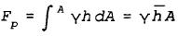
The force F_{p} acts normal to the surface and towards the surface.

Since the pressure intensity is distributed uniformly over the plane surface, the total resultant force F_{p} acts through the centroid of the area and h = where is the depth from the free surface to the centroid. Thus, for horizontal plane surfaces, the centre of pressure C coincides with the centroid G. The centre of pressure is the point on the immersed surface at which the resultant pressure force on the entire area is assumed to act.
- Vertical Plane Surface
Consider a plane vertical surface of area A immersed vertically in a liquid (Fig. 2.8). Since the depth from the free surface to the various points on the surface varies, the pressure intensity on the surface is not constant and varies directly with depth. Figure 2.8
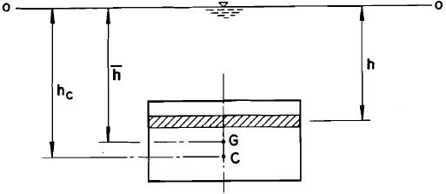
Fig 3.8
Consider also a narrow strip of horizontal area dA, shown shaded in Fig. 3.8, at a depth h below the free surface. The pressure intensity on this area dA is γ.h and is uniform. The total pressure force on one side of the strip is thus
Or
Where is the depth from the free surface to the centroid G of the area? Thus, as for a horizontal plane area, the magnitude of the resultant hydrostatic pressure force on a vertical plane area is obtained by multiplying the pressure intensity at the centroid G, i. e γby the total area A.
If the vertical area is not of a regular shape, the area may be divided into a finite number of small regular areas and the total hydrostatic pressure force determined as the sum of the pressure forces acting on these small areas.
The total pressure force F_{p} acts normal to the vertical plane area and towards the area through the centre of pressure C. Since the pressure distribution on the area is not uniform, the centre of pressure and the centroid will not coincide. The depth h_{c} to the centre of pressure may be obtained from the principle of moments. The moment of the elementary force dF_{P}, acting on the area dA (Fig. 3.8) about axis 0-0 on the free surface is
The total moment of all elementary forces on the whole area is:
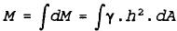
From the principle of moments, the sum of the moments of a number of forces about an axis is equal to the moment of their resultant about the same axis. Thus:
The term 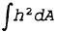may be recognized as the second moment of area about the free surface i.e. .
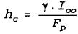
i.e, using the parallel axis theorem of second moment of area,
Where I_{G} is the second moment of area about the axis parallel to 0-0 and passing through the centroid G. Therefore,
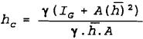
Or $h_{c}=\frac{I_{G}}{A\overset{−}{h}}+\overset{−}{h}$
Thus, the centre of pressure C for vertical plane area is below the centroid by an amount equal to:
The moment of F_{p} about the centroid is:
$F_{P}∗\text{GC}=ρg\overset{−}{h}A∗\frac{I_{C}}{\overset{−}{h}A}=ρ{\text{gI}}_{C}$, which is independent of depth of submergence.

- Inclined Plane Surface
The analysis of the hydrostatic force on an inclined plane surface will be made by considering a plane surface of arbitrary shape and total area A inclined at an arbitrary angle θ to the free surface as shown in Fig. 3.9. AB is the trace of the inclined surface the extension of which intersects with the free surface a 0. h_{c} and h_{p} are the depths from the free surface to the centroid C and centre of pressure CP of the area respectively. y_{c} and y_{p} are the corresponding distances from 0 to C and CP respectively, measured along the inclined surface. It is required to determine the magnitude, direction and line of action of the resultant hydrostatic force Fp acting on one side of the area.
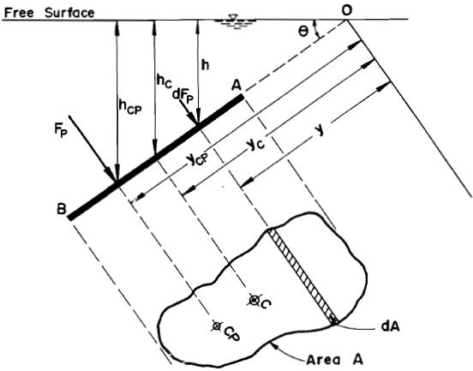
Fig 3.9 Hydrostatic force on an inclined plane surface

The magnitude of the force dF_{p} acting on an elementary area dA at a depth h below the free surface is given by
The force dF_{p} acts normal to the plane surface. The resultant hydrostatic force Fp is the sum of all elementary forces dF_{P} which are parallel to each other.
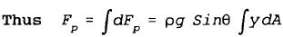
But 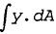is the first moment of area A about axis through 0 and is equal to y_{c}.A and since y_{c} Sin θ =h_{c} the above equation for F_{p} becomes:
γh_{c} is the pressure intensity at the centroid of the inclined plane area. This shows that the magnitude of the resultant hydrostatic force on an inclined plane area is equal to the product of the area and the pressure intensity at the centroid of the area. The force F_{p} acts normal to the plane surface and towards the surface.
The resultant force F_{p} acts through the centre of pressure CP of the submerged plane area. The location of CP is determined using the principle of moments for a parallel force system. In Fig. 3.9 let the axis through 0 coinciding with the free surface be the axis of moments.
The moment of force dF_{p} about this axis is equal to dM_{o} which is given by
The moment of the resultant force F_{p} about the axis of moments will be equal to the sum of all elemental moment dM_{o}. i.e.
Where is the second moment of the plane area about axis 0-0.
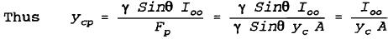
Using the parallel axis theorem,
Where I_{c} is the second moment of area about an axis parallel to 0-0 and passing through the centroid c.
Thus 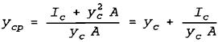
This shows that the centre of pressure is always below the centroid of the area. The same has been shown for vertical plane surfaces.
The depth of the centre of pressure below the free surface is h_{cp} = y_{cp} sinθ. Substituting this and the value of y_{c} = h_{c}/Sinθ, the following equation is obtained for the depth to the centre of pressure.
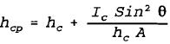
When the surface area is symmetrical about its vertical centroidal axis, the centre of pressure CP always lies on this symmetrical axis but below the centroid of the area. If the area is not symmetrical, an additional coordinate, x_{cp}, must be fixed to locate the centre of pressure completely.
Referring to Figure 3.10, and using moments,
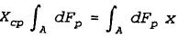
Or 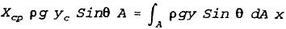
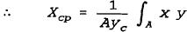
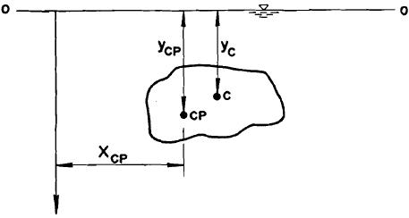
Fig 3.10 Centre of pressure of an asymmetrical plane surface
- Hydrostatic Force on Curved Surfaces
The total hydrostatic force on a curved surface immersed in a liquid cannot be directly determined by the methods developed for plane surfaces.
For plane surfaces, the pressure forces on elementary areas act perpendicular to the surface and hence are parallel to each other. Consequently, it is easier to obtain the resultant force by a simple summation of the elementary forces. In the case of a curved surface each elementary force acts perpendicular to the tangent of the elementary area and because of the curvature of the surface the direction of each elementary force is different.
As a result, the usual procedure is to determine the horizontal and vertical components of the resultant force and then add them vectorally to obtain the magnitude, direction and location of the line of action of the resultant hydrostatic force.
Consider the curved surface BC of unit width shown in Figure 3.11.
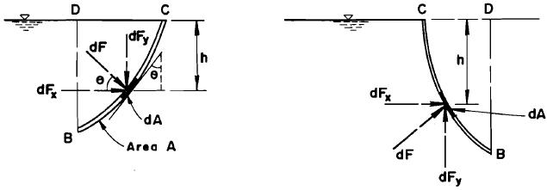
Fig 3.11 Hydrostatic force components on curved surfaces.
The elementary force dF acting on the elementary area dA has a horizontal component dF_{x} and a vertical component dF_{y}. The pressure intensity on dA is ρgh.
The total hydrostatic force on dA = dF = ρgh dA
The horizontal component of dF = dF_{x} = ρgh dA Cosθ
The vertical component of dF = dF_{y} = ρghdA Sinθ
But dA Cosθ = dA_{v} = the projection of dA on the vertical plane and dA sinθ = dA_{h} = The projection of dA on the horizontal plane.
The components of the total hydrostatic force in the x and y directions are Fx and Fy respectively and are given by:
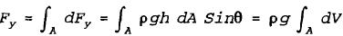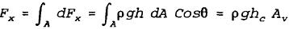
Where: A_{v} is the projection of the whole curved surface BC on the vertical plane, i.e. BD
dV is the volume of the water prism (real or virtual) extending over the area dA to
the free surface.
Thus :
The horizontal component, F_{x}, of the resultant hydrostatic force on a curved surface BC is equal to the product of the vertically projected area of BD and the pressure intensity at the centroid of the vertical area BD. The Force F_{x} passes through the centre of pressure of the vertically projected area BD.

The vertical component, F_{y}, of the resultant hydrostatic force on a curved surface BC is equal to the weight of the water (real or virtual) enclosed between the curved surface BC, the vertical BD and the free surface CD. The force component F_{y} acts through the centre of gravity of the volume.
The resultant force F is given by:
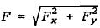
F acts normal to the tangent at the contact point on the surface at an angle a to the horizontal, where

  - Buoyancy and stability of floating bodies

3.6.1Buoyant force (Resultant fluid force in a body)

The buoyant force on a submerged body is the difference between the vertical components of pressure force on its underside and the vertical component of pressure force on its upper side. The buoyant force always acts vertically upward. There can be no horizontal component of the resultant because the projection of the submerged body or submerged portion of the floating body on a vertical plane is always zero.

h_{C}
h_{B}
O
x
P_{C}dA
P_{B}dA
P_{B}dA
P_{D}dA

Fig. Buoyant force on a submerged body

Assume a vertical cylindrical element of cross- sectional area dA. As dA is small, the pressure on the exposed ends of the cylinder may be taken as p₁ and p₂ .
Since p₂> p₁, there will be an upward force (p₂ –p₁) dA acting on the cylindrical element.

∴ dF_{B} = (p₂ – p₁ ) dA = γ(h₂-h₁) dA = γdv

Where dv = volume of the prism

The entire body may be considered to be made up of small cylindrical elements, then integrating over the complete body gives

$F_{B} = \int{dF_{B} = \int^{v}{γ\text{dv}} = γ\int^{v}{\text{dv}} = γV}$
γ = is assumed constant thought the volume
V= Volume of the body

The basic principle of buoyancy and flotation was first discovered and stated by Archimedes over 2200 years ago. Archimedes principle states that the up thrust or the buoyancy on a body immersed in a fluid is equal to the weight, of the fluid displaced. The up thrust will act through the center of gravity of the displaced fluid, which is called the center of buoyancy.

By applying Archimedes’ principle, volumes of irregular solids can be found by determining the apparent loss of weight when a body is wholly immersed in a liquid of known specific gravity. Specific gravities of liquids can be determined by observing the depth of flotation of a hydrometer. Further applications include problems of general flotation and of naval architectural design.

To find the line of action of the buoyant force, moments are taken about a convenient axis 0.
$γV \bar{x} =γ\int{x\text{.} \text{dv}}$ $\bar{x} =$ Is the distance from the axis to the line of the action.
Or
$\bar{x} = \frac{1}{v}\int{x\text{.}\text{dv}}$ (Is the Centroid of the displaced volume of fluid) i.e. B.

A body immersed in two different fluids;
Up thrust on body = weight of fluid displaced by the body (Archimedes principle.)
If the body is immersed so that part of its volume V₁ is immersed in a fluid of density ρ₁ and the rest of its volume V₂ in another immiscible fluid of mass density ρ₂,
Up thrust on upper part, R₁ = ρ₁gV1 acting through G₁, the centroid of V1,
Up thrust on lower part,R₂ = ρ₂gV₂ acting through G₂, the centroid of V₂,
Total up thrust = ρ₁gV₁ + ρ₂gV₂.
The positions of G₁ and G₂ are not necessarily on the same vertical line, and the centre of buoyancy of the whole body is, therefore, not bound to pass through the centroid of the whole body.

Hydrometers
Precise measurement of the specific weight of a liquid is done by utilising the principle of buoyancy. The device used for this, the hydrometer, is a glass bulb that is weighted on one end to make the hydrometer float in a vertical position and has a stem of constant diameter extending from the other end. The hydrometer is so designed that only the stem end extends above the liquid surface. Therefore, appreciable vertical movement of the hydrometer is required to change the buoyant force or displaced volume of the device. Because the buoyant force (equal to the weight of the hydrometer) must be constant, the hydrometer will float deeper or shallower depending on the specific weight of the liquid. Consequently graduation on the stem, corresponding to different depths of submergence of the hydrometer, can be made to indicate directly the specific weight or specific gravity of the liquid being measured.

Consider the following figure
V_{oγ}
W
Distilled Water
1.0
1.0
h
(V_{o}-ΔV)
Sγ
W

Fig. Hydrometer in water and in liquid of specific gravity S

In the distilled water, the hydrometer floats in equilibrium when V₀γ = W
In which V₀ is the volume submerged, γ is the specific weight of water, and W is the weight of the hydrometer. The position of the liquid surface is marked as 1.0 on the stem to indicate unit specific gravity S. When the hydrometer is floated in another liquid, the equation of equilibrium becomes
(V_{o}-ΔV)Sγ = W in which ΔV = aΔh. Solving for Δh with the above equations gives

$Δh = \frac{V_{o}}{a}\frac{S−1}{S}$

One common use of hydrometers is in checking the state of charge of a car battery. When a battery is fully charged the specific gravity of the acid in it is about 1.28, and during discharge this specific gravity falls. The instrument used to check the state of charge is called a battery tester and it consists of a small hydrometer inside a glass container.

Floating in salt water and in fresh water

Exercise: People find that it is easier to float in salt water than in fresh water. Explain
If an egg is placed in a tall vessel and water is added, the egg remains on the bottom, but if salt is added and the water is stirred, the egg rises and floats. Why?

3.6.2. Stability of submerged and floating bodies.

There are three possible conditions of equilibrium of solid body.

- Stable equilibrium – A small displacement from the equilibrium produces a righting moment tending to restore the body to the equilibrium position.
- Unstable equilibrium – A small displacement produces an over turning moment tending to displace the body further from its equilibrium position
- Neutral equilibrium - The body remains at rest in any position to which it may be displaced. No couple.
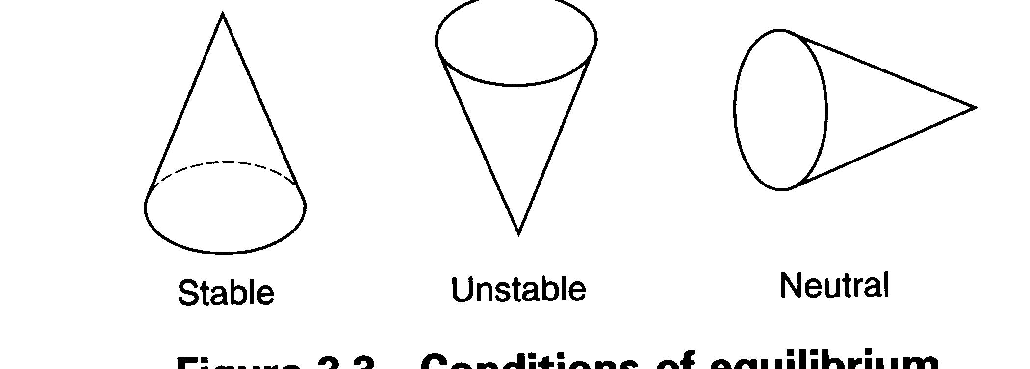
Fig. Conditions of equilibrium

- Submerged body

* B

* G
* G

* B
* B, G

B>G G>B G=B

Stable equilibrium (+ve stability) Unstable equilibrium (-ve stability) Neutral equilibrium (0 stability)

For a submerged body, the Centre of buoyancy remains constant. If an object is fully submerged, whether it is a balloon in air or a submarine in water, it must be designed that the Centre of buoyancy lies some distance above the Centre of gravity.

Exercise
Explain with example why the Centre of buoyancy and the Centre of gravity are located at different points for a fully submerged object.

- Floating body

The following figure shows a solid body floating in equilibrium (weight acts through G & the buoyancy through B). Both act in the same straight line. When the body is displaced from its equilibrium, weight continues to act at G. The volume of liquid displaced remains constant but the shape of this volume will change and the position of its G and B will move relative to the body.

The point at which the line of action of the buoyant force for the displaced position cuts the original vertical through the center of gravity of the body G is called metacenter, designated M stable equilibrium. Metacentric height is the distance GM.

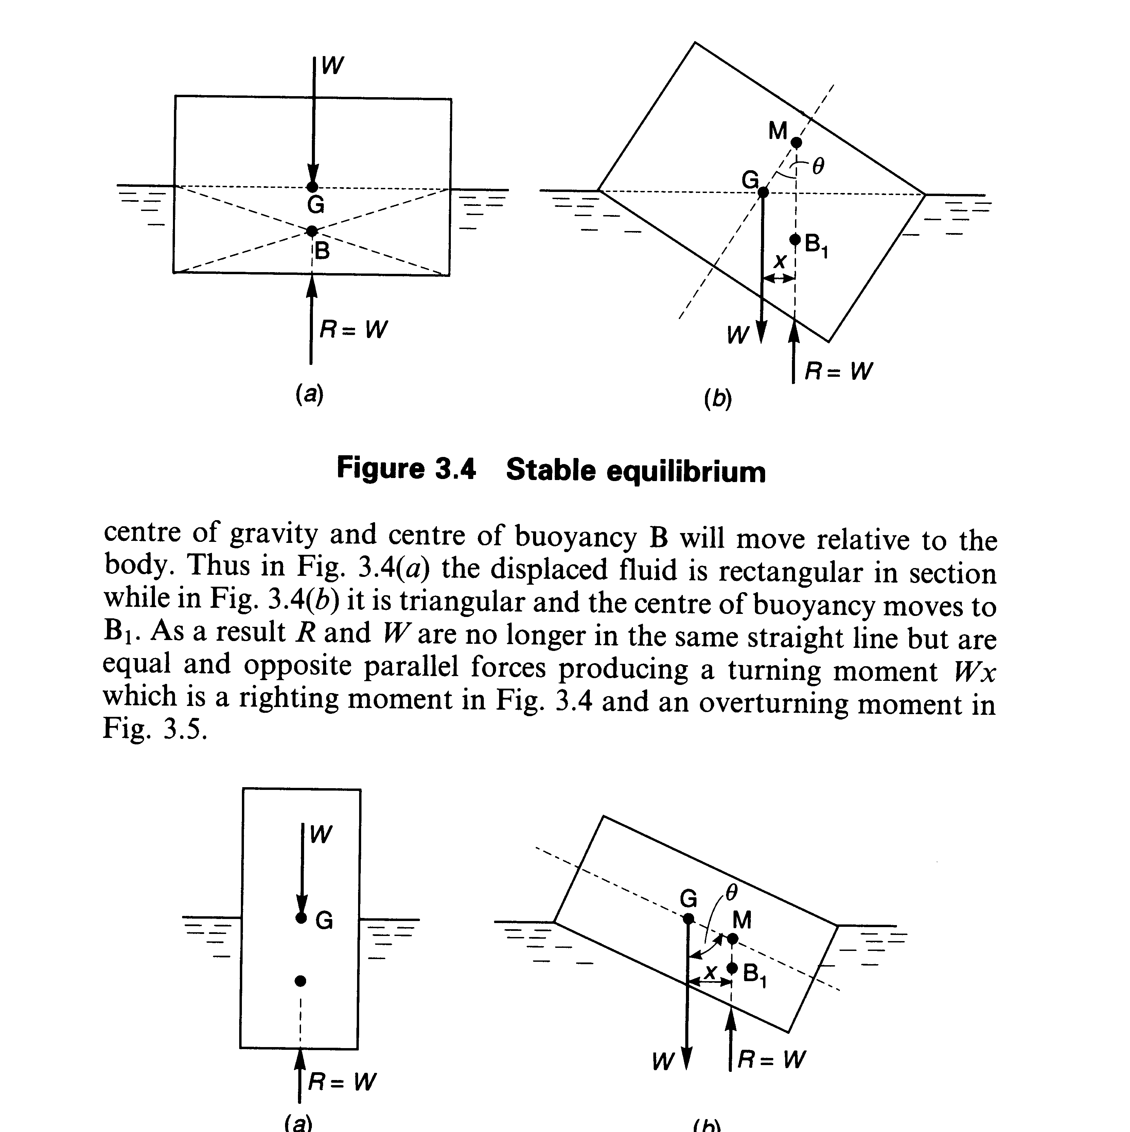

Fig. Stable equilibrium a) b)

The displaced fluid is rectangular in section (fig. a) but it is triangular in fig.b and the center of buoyancy moves to B₁. As a result F₈ and W are not in the same straight line producing a turning moment WX that is a righting moment.

Fig. Unstable equilibrium a) b)

Comparing the above figures, it can be seen that:

- If M lies above G a righting moment is produced, GM is regarded as positive, and equilibrium is stable.
- If M lies below G an overturning moment is produced, GM is regarded as negative, and equilibrium is unstable.
- If M and G coincide the body is in neutral equilibrium.

Evaluation of Metacentric height
a
a
G
d
B
c
a’
b’
B’
a
b
l
ΔF_{B}
ΔF_{B}
G
d
B
c
a
b
O
x
θ

O

Fig. X –Section and plan in upright position

Consider a non –prismatic floating object, such as a ship. Assume an outside force is applied causing the body to tilt through a small angleθ. The relative position of the G remains unchanged but B shifts from B to B’. The volume of fluid displaced is of course unchanged and in effect a wedge shaped volume of water represented by boa’ has shifted across the central axis to bob’. These wedges represent a gain in the buoyant force on the right side and a corresponding loss in buoyancy on the left side of c-d.

The buoyant force F_{B} acting through B’ may be considered as the resultant of the original buoyant force through B and the gain & loss of buoyant force.

Taking moment about B, we have

$F_{B}∗ B\bar{M} \text{sin} θ = {ΔF}_{B} ∗ ℓ$(Moment of resultant = ∑ moment of components.)

Consider an element of area dA in plan at a distance x, from O. The buoyant force acting on this element is γ x θ dA. θ << Small tan θ ≈ sin θ ≈ θ

F_{B} = γ * volume = γ x θ dA

Then ΔF_{B} = ∫ϒxθdA (integrated half of the water line)

Moment about O of this force
$\begin{aligned}Δ F_{B} ∗ ℓ/2 = \int{} γ x^{2} θ\text{dA} \\ Δ F_{B} ∗ ℓ = 2 \int{γ x^{2} θ \text{dA}}\end{aligned}$
Moment about O if the integration is performed over the entire area.

${ΔF}_{B} ∗ ℓ = \int^{A}{} \text{γθ} x^{2} \text{dA} = \text{γθ} \int^{A}{} x^{2} \text{dA}$
$\int^{A}{x^{2} \text{dA} = }$Moment of inertia I of a horizontal section of the body taken at the surface of the fluid.
$\begin{aligned}{ΔF}_{B} ∗ℓ = \text{γθ}I \\ F_{B} B\bar{M} \text{sin} θ = {ΔF}_{B} ∗ ℓ \\ W B\bar{M} θ = γ θI \\ B\bar{M} = \frac{γI}{W} = \frac{γI}{γv} = \frac{I}{V}\end{aligned}$
V = volume of water displaced by the vessel.

Metacentric height $\begin{aligned}G\bar{M} = B\bar{M} − B\bar{G} \\ = \frac{I}{V} − B\bar{G} \end{aligned}$
If the G is below B, then $G\bar{M} = \frac{I}{V} + B\bar{G}$
$\text{GM} = \frac{I}{V} ± B\bar{G}$

Time of oscillation

Consider a floating body, which is tilted through an angle by an overturning couple as shown below. Let the overturning couple is suddenly removed. The body will start oscillating. Thus, the body will be in a state of oscillation as if suspended at the meta- center M. This is similar to a case of a pendulum. The only force acting on the body is due to the restoring couple due to the weight w of the body force of buoyancy F_{B}.
M
F_{B}
θ
W
Y
Y
F_{B}
W

Fig. Tilted floating body

Restoring couple = W GM sinθ
Angular acceleration of the body, α=$\frac{d^{2}θ}{{\text{dt}}^{2}}$
-ve sign has been introduced as the restoring couple tries to decrease the angleθ.
Torque due to inertia = I_{Y-Y} ($\frac{d^{2}θ}{{\text{dt}}^{2}}$)
But I_{Y-Y} = (W/g) K²
Where W=weight of body, K=radius of gyration about Y-Y
Inertia torque = - (W/g) K² ($\frac{d^{2}θ}{{\text{dt}}^{2}}$)
Equating the above equations
W GM sinθ = -(W/g)K²($\frac{d^{2}θ}{{\text{dt}}^{2}}$) or GM sinθ = -(K²/)($\frac{d^{2}θ}{{\text{dt}}^{2}}$)
For small angleθ, sin θ =θ

GM θ = - (K²/g) ($\frac{d^{2}θ}{{\text{dt}}^{2}}$) or (K²/g) ($\frac{d^{2}θ}{{\text{dt}}^{2}}$) + GM θ = 0

⇒ $\frac{d^{2}θ}{{\text{dt}}^{2}}$+ $\frac{\text{Gg }θ}{K^{2}}=0$

This is second-degree differential equation, the solution is

$θ=C_{1} \text{sin}\sqrt{\frac{\text{GM g }}{K^{2}}}∗ t + C_{2} \text{Cos}\sqrt{\frac{\text{GM g }}{K^{2}}}∗ t$
Where C₁ and C₂ are constants value of integration.
The values of C₁ and C₂ are obtained from boundary conditions, which are
- at t=0, θ=0
- at t=(T/2), θ=0
Where T=time of one complete oscillation
Substituting the first boundary condition, C₂=0
Substituting the second boundary condition, we get 0=$C_{1} \text{sin}\sqrt{\frac{\text{M g }}{K^{2}}}∗ \frac{T}{2}$
But C₁ cannot be equal to zero and so the other alternative is
$$\begin{aligned}\text{sin}\sqrt{\frac{\text{GM g }}{K^{2}}}∗ \frac{T}{2}=0=\text{sin}\prod{}\sqrt{\frac{\text{GM g }}{K^{2}}}∗ \frac{T}{2}=\prod{ }\text{or} T=2\prod{\sqrt{\frac{K^{2}}{\text{GM g}}}}\end{aligned}$$
This gives the time period of oscillation or rolling of a floating body.

    - Relative Equilibrium

For fluid masses which do not have any relative motion between its particles are characterized by zero shear stress and are governed by the law of static fluids. This condition of fluid is called relative equilibrium, in relative equilibrium there is generally no motion b/n the fluid and the containing vessel. Generally there is an additional force acting to cause the acceleration. Lows of fluid static can still be applied by modifying to allow for effects of acceleration.
Uniform linear acceleration

Consider a fluid element of size dx dy and unit length. It is subjected to acceleration which has components ax and ay in x and y directions
Applying Newt is second law of motion in the x and y directions one obtains

$\sum{\text{FX} =m−\text{ax}}$
$\sum{\text{FY} = m \text{.}\text{ay}}$
$$\sum{\text{FX} = \left(P−\frac{2p}{2x} \text{.} \frac{\text{dx}}{2}\right)} \text{dy} −\left(p+\frac{2p}{2x} \text{.} \frac{\text{dx}}{2}\right) \text{dy}=−\frac{2p}{2x} \text{.} \text{dx} \text{dy}$$
$$\sum{\text{FY} = \left(P−\frac{2P}{2Y} \text{.} \frac{\text{dY}}{2}\right)} \text{dx} −\left(p+ \frac{2p}{2y} \text{.} \frac{\text{dy}}{2}\right) \text{dx} − \text{dx} −\text{dy} =−\frac{2p}{2y} − \text{dx} \text{dy} −r \text{dx} \text{dy}$$
In the x – din -$−\frac{2p}{2x } \text{.}\text{ax}$

$−\frac{2p}{2x} = \frac{r}{9} \text{ax}$In the y – din $−\frac{2p}{2y} − r =p \text{.} \text{ay}$

$−\frac{2p}{2y} − r =\frac{r}{9} \text{ay}\text{.}$
$−\frac{2p}{2y} = 2 \left(1 + \frac{\text{ay}}{9}\right)$
The pressure change dp may be expressed as
$$\text{dp} = \frac{2p}{2x} \text{dx} + \frac{2p}{2y} \text{.} \text{dy} = −\frac{r}{9} \text{ax} \text{dx} −r \left(1+\frac{\text{ay}}{9}\right) \text{dy}$$
Integrating p =$\text{pax} −r \left(1+ \frac{\text{ay}}{9}\right) y+c$
But for x = 0, y =0 p =c = p-_{origin}
$∴$ p = -pax. X –r $\left(1+ \frac{\text{ax}}{9}\right) y +$ p-_{origin}
And if the origin is taken at a point on the free surface, p_{o} = 0 (patm)
Thus p = - p ax x –r $\left(1 + \frac{\text{ay}}{9}\right) y$
Y= $−\frac{p}{r} \left(\frac{\text{ay}}{9} +1\right) − \frac{\text{pax} x}{r \left(\frac{\text{ay}}{9} + 1\right)} = \frac{−p}{r \left(\frac{\text{ay}}{9} + 1\right)} \frac{\text{pax} x}{p9 \left(\frac{\text{ay}}{9} +1\right)}$

Y =-$\frac{\text{ax}}{\text{ay} +9} x − \frac{p}{r \left(\frac{\text{ay}}{9} + 1\right)} y =\text{ax} + b$
$∴\text{The} \text{slope} \text{of} \text{the} \text{frce} \text{surface} \text{will} \text{be}$
$m= −\frac{\text{ax}}{\text{qx} + 9} \text{.}$
and y intercept $b = \frac{\text{ax}}{a\left(\frac{\text{ay}}{9} + 1\right) }$

If the acceleration is in the direction a_{x}=0

$\begin{aligned}\left(1 + \frac{\text{ax}}{9}\right) y \text{and} h \text{is} \text{measured} \text{from} \text{the} \text{water} \\ −p = r\left(1 + \frac{\text{ay}}{9}\right) h \end{aligned}$
If the acceleration is in the direction ax = 0
P = - p ax x and slope pf constant pressure surface
Can be $\frac{\text{dy}}{\text{dx}} = m = −\frac{\text{ax}}{9}$

Uniform Rotation about a vertical axis

When a fluid is rotated a bout a vertical axis at constant speed , every particle of it has the same angular velocity and the fluid moves c s if it were a solid. The is type of motion is known as a forced vortex. The rotation of a bucket or a cylinder containing water will produce a forced vortex causing the water to rese near the sides and depressing it near the axis of rotation.
A free vortex motion is characterized by velocity which varices inversely with the distance from the axis and must be disting used from a forced vortex
The forced vortex motion may analyzed by considering fluid in side a contains which is rotated about a vertical axis at constant angular velocity .The fluid mass is subjected radically in ward acceleration centripetal acceleration
Consider a circular ring element at a radius and of cross section dy dr considering unit element are along the direction and in r direction.
The fluid is subjected to an acceleration- rw² , the negative sign indicating racially in ware direction
From the Newton’s second low of motion in y direction
$\sum{\text{FY} = \text{may} \text{and} \text{ay} = 0}$
$\begin{aligned}\left(p− \frac{2p }{2y}\text{.} \frac{\text{dy}}{2}\right) \text{dr} − \left(p+ \frac{2p}{2y} \frac{\text{dr}}{2}\right) d r− \text{rdy} \text{dr} = 0 \\ \text{simplifing} \frac{2p}{2y} =y \\ \text{In} r \text{dircetion} \\ \sum{\text{Fr} =m , a r \text{and} \text{ar} = −\text{rw}} \\ \text{therefore} \left(p− \frac{2p}{2r} \text{.} \frac{\text{dr}}{2}\right) \text{dy} − \left(p + \frac{2p}{2r}\text{.} \frac{\text{dr}}{2}\right) \text{dy} =\frac{r}{g} \text{dr} \text{dr} \left(−\text{rw}\right) \\ \text{Simplifying} \frac{2p}{2r} = \frac{r}{g} \text{rw} \\ \text{The} \text{pressure} \text{change} \\ \\ \text{dp} = \frac{2p}{2r} \text{.} \text{dr} = − r \text{dr} + \frac{r}{g} \text{rw} \text{dr}\end{aligned}$
$$\begin{aligned} \\ \text{rdy} = \frac{r}{g} \text{rw} \text{dr}\end{aligned}$$

$\text{dp} = 0$
$\begin{aligned}\text{rdy} =\frac{r}{g} \text{rw} \text{dr} \\ \frac{\text{dy}}{\text{dr}} = \frac{r}{g} \text{rw} \\ \frac{\text{dy}}{\text{dr}} = \frac{\text{rw}}{g} \\ y = 2\frac{r}{2g}w + \text{const}\end{aligned}$
For surfaces of constant pressure, dp = 0 and we have
$\begin{aligned}\frac{\text{dr}}{\text{dr}} = \frac{\text{rw}}{\text{gr}} = \frac{\text{rw}}{g} \text{int}\text{egation} \text{yields} \\ y = \frac{r}{\text{29}} w + \text{cons}\text{tan}t \\ \text{on} \text{the} \text{free} \text{surface} \text{at} r = 0 , y = \text{ho} \text{and} \text{cons}\text{tan}t \text{is} \text{ho} \\ \text{thus} y = \frac{r}{\text{29}} w \\ \text{at} \text{the} \text{side} \text{of} \text{the} \text{containes} r = R \text{and} y = h 1 \\ \text{so} h \frac{r}{\text{29}} w + \text{ho} \\ h = h −\text{ho} \\ h = \frac{w}{\text{29}} r\end{aligned}$

-the distance to the centroid of the volume

din -$−\frac{2p}{2x } \text{.}\text{ax}$

$−\frac{2p}{2x} = \frac{r}{9} \text{ax}$In the y – din $−\frac{2p}{2y} − r =p \text{.} \text{ay}$

$−\frac{2p}{2y} − r =\frac{r}{9} \text{ay}\text{.}$
$−\frac{2p}{2y} = 2 \left(1 + \frac{\text{ay}}{9}\right)$
The pressure change dp may be expressed as
$$\text{dp} = \frac{2p}{2x} \text{dx} + \frac{2p}{2y} \text{.} \text{dy} = −\frac{r}{9} \text{ax} \text{dx} −r \left(1+\frac{\text{ay}}{9}\right) \text{dy}$$
Integrating p =$\text{pax} −r \left(1+ \frac{\text{ay}}{9}\right) y+c$
But for x = 0, y =0, p =c = p _{origin}
$∴$ p = -pax. X –r $\left(1+ \frac{\text{ax}}{9}\right) y +$ p _{origin}
And if the origin is taken at a point on the free surface, p_{o} = 0 (patm)
Thus p = - p ax x –r $\left(1 + \frac{\text{ay}}{9}\right) y$
Y= $−\frac{p}{r} \left(\frac{\text{ay}}{9} +1\right) − \frac{\text{pax} x}{r \left(\frac{\text{ay}}{9} + 1\right)} = \frac{−p}{r \left(\frac{\text{ay}}{9} + 1\right)} \frac{\text{pax} x}{p9 \left(\frac{\text{ay}}{9} +1\right)}$

Y =-$\frac{\text{ax}}{\text{ay} +9} x − \frac{p}{r \left(\frac{\text{ay}}{9} + 1\right)} y =\text{ax} + b$
$∴\text{The} \text{slope} \text{of} \text{the} \text{free} \text{surface} \text{will} \text{be}$
$m= −\frac{\text{ax}}{\text{qx} + 9} \text{.}$
and y intercept $b = \frac{\text{ax}}{a\left(\frac{\text{ay}}{9} + 1\right) }$

If the acceleration is in the direction a_{x}=0

$\begin{aligned}\left(1 + \frac{\text{ax}}{9}\right) y \text{and} h \text{is} \text{measured} \text{from} \text{the} \text{water} \\ −p = r\left(1 + \frac{\text{ay}}{9}\right) h \end{aligned}$
If the acceleration is in the direction a_{x} = 0
P = - p ax x and slope pf constant pressure surface
Can be $\frac{\text{dy}}{\text{dx}} = m = −\frac{\text{ax}}{9}$

Exercise
- A vertical rectangular gate AB shown in Figure below has a width of 1.5 m. The gate is hinged on its upper edge at A.
Determine the moment M at A required to just hold the gate from opening.
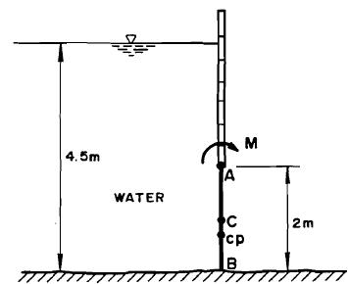
- The 2 m wide and inclined rectangular gate AB shown in Figure below is hinged at B. The gate is unifrom and weighs 24 kN.
Determine
a) The magnitude and location of the hydrostatic forces on each side of the gate.
b) The resultant of the hydrostatic forces.
c) The force F required to opening the gate.
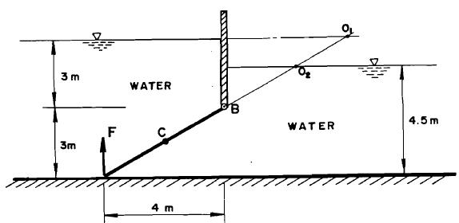
- A triangular opening in the form of an.isosceles triangle, with dimensions shown in Figure below and with its axis of symmetry horizontal, is closed by a plate. Water stands at 9 m from the axis of symmetry. Determine the resultant hydrostatic force on the plate and its centre of pressure.
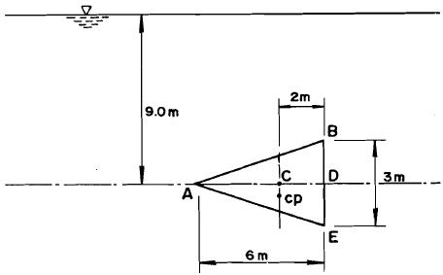
- A vertical, symmetrical trapezoidal gate with its upper edge located 5 m below the free surface is shown in Figure below,
Determine the total hydrostatic force and its centre of pressure.
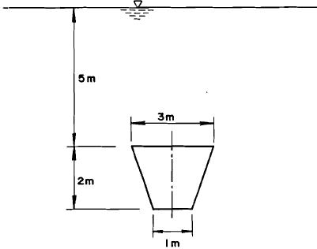
- An inverted semicircular plane gate shown in Figure below is installed at 45⁰ Inclination as shown. The top edge of the gate is at 3 m below the water surface. Determine the total hydrostatic force and the centre of pressure.
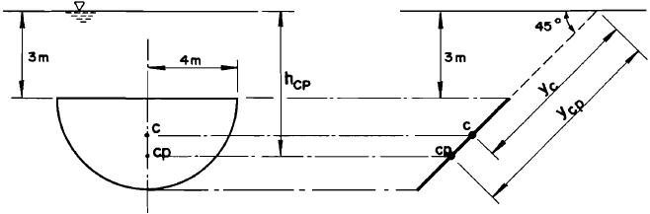
5. A log holds water as shown in Figure below. Determine
a) The force pushing against the obstruction (dam) per metre length of log.
b) The weight of the log per metre length
c) The specific gravity of the log.
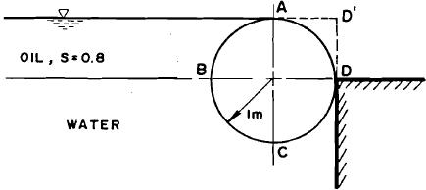

6.

7.

8.

