Chapter Four: Analysis and Design for Torsion

4.1 Introduction

Reinforced concrete members are commonly subjected to bending moments, to transverse shears associated with those bending moments, and in case of columns, to axial force often combined with bending and shear. In addition, torsional forces may act, tending to twist a member about its longitudinal axis. Such torsional forces are usually act concurrent with bending moment and transverse shear and some times with axial forces as well. It occurs quite frequently in structures but generally its importance is secondary to that of moment and shear.

Two types of torsion are commonly identified:

- Equilibrium torsion: where the torsional moment is required to maintain equilibrium of the structure. In such situation the external load has no other option but to be carried by torsion (see Fig. 4.1a).

Equilibrium torsion is of primary interest in design because failure of the member is inevitable if it has insufficient torsional strength.

- Compatibility Torsion: torsion caused due to the resultant of angular rotation induced by rigidly connected members. It arises from the requirement of continuity, i.e., compatibility of deformation between adjacent parts of a structure (see Fig. 4.1b).

Although such torsion may result in the formation of large cracks at the joint, more serious consequences are unlikely if the member possess adequate ductility to redistribute the torsional moments. For this reason compatibility torsion is generally of secondary interest in design and can often be ignored.

(a) Equilibrium torsion

(b) Compatibility torsion

Fig. 4.1 Torsional effects in reinforced concrete

4.2 Behaviours of Members with torsion

In a member subjected to torsion, a torsional moment causes shear stresses on cross sectional planes and on radial planes extending from the axis of the member to the surface (see Fig. 4.2).

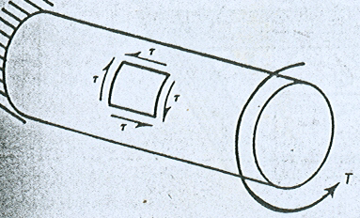

Fig. 4.2 Torsional shear stresses
The distribution of these stresses may vary according to the geometry of the cross section. Therefore the treatment of the case depends up on whether the section is solid or thin walled. Also a solid section may be circular or non-circular, where as thin walled section may be open or closed.

In a circular member, the shearing stresses are zero at the axis of the bar and increases linearly to a maximum stresses at the out side of the bar.
The maximum shearing stress in circular section is:
$$τ_{\text{max}}=\frac{\text{Tr}}{j}$$
Where: τ_{max} = maximum shearing stress
T = torsional moment
r = radius of the section
J = polar moment of inertia

For non circular member, the distribution of shear stresses is not so straight forward. The rectangular member for example, has the stress distribution shown when subjected to a torque T. Unlike in the circular member, the stress distribution in a rectangular member is non linear. The shearing stress at the corner of the section is zero indicating that the corners of the section are not distorted under torsion and the maximum shear stresses occur at the mid points of the long sides.

Analytical studies have shown that the maximum shearing stress in rectangular section is:
$$τ_{\text{max}}=\frac{T}{{αx}^{2}y}$$
Where: x is the shorter dimension of the rectangle
Y is the longer dimension
α varies from o.28 for y/x = 1.0 (square) to 0.33 for y/x = $∞$ (an infinitely wide plate).
A close approximation to α is, $α=\frac{1}{3+1\text{.}8y/x}$

For compound sections made up of a serious of thin rectangles such as T-sections, box sections, etc., torsional resistance may be considered as the sum of the capacities of individual rectangular sections and is given by:
$τ_{\text{max}}=\frac{T}{{\sum{x^{2}y}}/3}$, where the term x²y/3 is evaluated for each of the rectangle.

For thin-walled hollow section of any shape, the shear stress in the walls is reasonably constant and is:
$$τ=\frac{T}{2A_{o}t}$$
Where: A_{o} is the area enclosed by the centre line of the tube wall (shaded area)
t is the thickness of the wall where the shear stress is being calculated.

4.3 Equivalent hollow section

Extensive tests indicate that the presence of concrete at the centre of the member doesn’t have a very significant effect on its torsional resistance .Thus it is fair to assume that solid members can be designed as equivalent hollow members.

The torsional resistance of any section may be calculated on the basis of equivalent hollow section with thin walls as defined in the figure below.

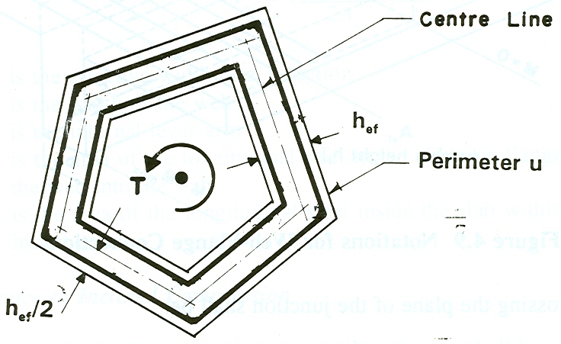

Fig. 4.3 Equivalent hollow section

The centre line of the longitudinal reinforcement are taken as the centre line of the walls of the equivalent hollow section having a thickness equal to h_{ef} and a mean perimeter equal to u_{ef} and enclosing an area A_{e}
_{f}.
h_{ef} = d_{ef}/5,
where d_{ef}, denotes the diameter of the largest circle which can be inscribed with in u.

However, h_{ef} ≤ A/u ≤ the actual wall thickness (for hollow sections), where u is the outer perimeter and A is the area of the cross section enclosed by the outer perimeter, including inner hollow area.

The critical sections for torque is at the face of the support

4.4 Principal Stresses due to Torsion

When the beam shown in Fig. 4.4 is subjected to a torsional moment, T, shearing stresses are developed on the top and front face as shown by the elements in Fig. 4.4a. The principal stresses on these elements are shown in Fig. 4.4b. The principal tensile stresses eventually cause cracking which spirals around the body as shown by the line A, B, C, D, E (see Fig.4.4c). Therefore, longitudinal bars in the corners and closed stirrups are required to control such spiral cracks.

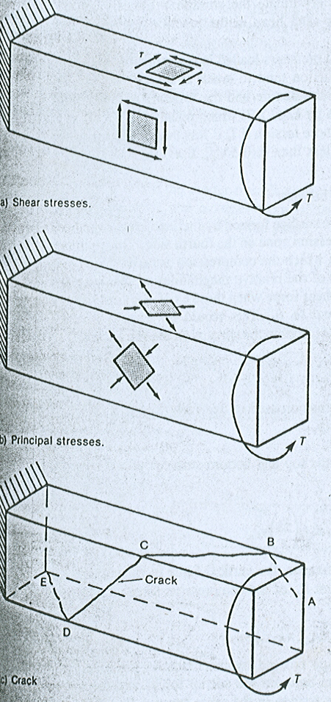
- b) c)
Fig. 4.4 Development of spiral cracks
4.5 Torsion in Reinforced Concrete Members

For the analysis of torsional resistance of members, consider the equivalent space truss model shown below. This is done by treating the member as a space truss consisting of spiral concrete diagonals that are able to take load parallel but not perpendicular to the torsional cracks, transverse tension tie members that are provided by closed stirrups, and tension cords that are provided by longitudinal reinforcement.

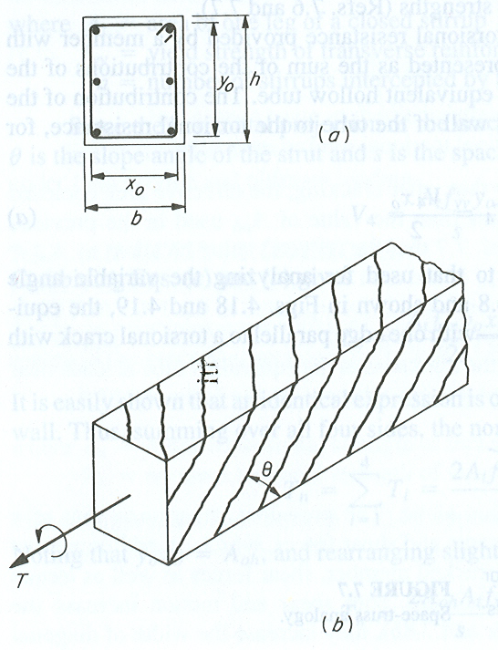
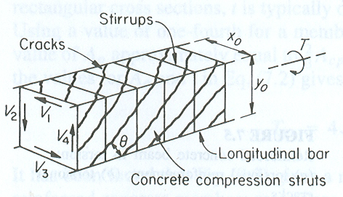

Fig. 4.5 Space-truss analogy

With reference to Fig. 4.5, the torsional resistance provided by a member with a rectangular cross section can be represented as the sum of the contributions of the shear in each of the four walls of the equivalent hollow tube. For example, the contribution of the shear acting in the right hand vertical wall of the tube to the torsional resistance is:
$T_{4}=\frac{V_{4}x_{o}}{2}$ (1*)

Consider the equilibrium of the section of the vertical wall, with one edge parallel to the torsional crack, (see Fig. 4.6a).

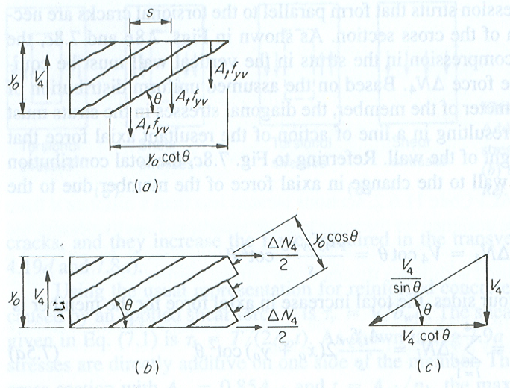

Fig. 4.6 Basis for torsional design

Assuming that the stirrups crossing the crack are yielding, the shear in the wall under consideration is:
V₄ = A_{t}f_{yv}n

Where At = are of one leg of a closed stirrup
f_{yv} = yield strength of transverse reinforcement
n = number of stirrups intercepted by torsional crack

Since the horizontal projection of the crack is y_{o}cotθ and n = y_{o}cotθ/s where θ is the slope angle of the strut and s is the spacing of the stirrups.
⇒ $V_{4}=\frac{A_{t}f_{\text{yv}}y_{o}}{s}\text{cot}θ$ (2*)
Combining Eqs. (1*) and (2*) gives:
$$T_{4}=\frac{A_{t}f_{\text{yv}}y_{o}x_{o}}{2s}\text{cot}θ$$
Summing over all sides (identical expression for each horizontal and vertical wall), the capacity of the section is:
$$T=\frac{2A_{t}f_{\text{yv}}y_{o}x_{o}}{s}\text{cot}θ$$
$T=\frac{2A_{o}A_{t}f_{\text{yv}}}{s}\text{cot}θ$ , since A_{o} = x_{o}y_{o} (3*)
The diagonal compression struts in the concrete (from equilibrium of the cross section) (see Fig. 4.6a &b) is:
${ΔN}_{4}=V_{4}\text{cot}θ=\frac{A_{t}f_{\text{yv}}y_{o}}{s}{\text{cot}}^{2}θ$
The total increase in the axial force of the member, (summing over all four sides), is:
$$ΔN=\frac{A_{t}f_{\text{yv}}}{s}2(x_{o}+y_{o}){\text{cot}}^{2}θ$$
$ΔN=\frac{A_{t}f_{\text{yv}}u_{o}}{s}{\text{cot}}^{2}θ$ (4*)
Where u_{o} is the perimeter of the area enclosed by A_{o}.
Combining Eqns. (3*) and (4*) gives:
$$ΔN=\frac{{\text{Tu}}_{o}\text{cot}θ}{2A_{o}}$$
Since ∆N = A_{sl}f_{yl};
$$A_{\text{sl}}f_{\text{yl}}=\frac{{\text{Tu}}_{o}\text{cot}θ}{2A_{o}}$$
⇒ $T=\frac{2A_{o}f_{\text{yv}}A_{\text{sl}}}{u_{o}\text{cot}θ}$
Taking θ = 45º, for pure torsion;
$$T=\frac{2A_{o}f_{\text{yv}}A_{\text{sl}}}{u_{o}}$$

4.6 EBSC 2 Provisions for Torsion Design

I. Limiting value of ultimate torque

In order to prevent diagonal compression failure in the concrete, the torsional resistance of a section T_{rd}, given below shall not be less than the applied torque T_{d}.
T_{rd} = 0.8f_{cd} A_{ef} h_{ef}
Where Aef is the area enclosed with in the centre line of the thin wall cross section

II. Torsional resistance of concrete:

The torque T_{c} carried by the concrete shall be taken as:
T_{c} = 1.2 f_{ctd} A_{ef} h_{ef}

Torsional effects may be disregarded whenever T_{d} < T_{c}. However, minimum web reinforcement may be provided in such a way that ρ_{min} = 0.4/f_{yk}; f_{yk} (Mpa) or the spacing of the stirrups shall not exceed U_{ef}/8. Moreover, at least one longitudinal bar shall be placed at each corner of the closed stirrups.

III. Design of torsional reinforcement

- Torsional reinforcement in the form of closed links and longitudinal reinforcement is required to carry the excess torque when ever the applied torque exceeds the concrete resistance, T_{c}.
- The volume of the longitudinal torsional reinforcement shall be chosen to be equal to the volume of the links (closed stirrups).
- The torsional resistance of the reinforcement T_{ef} is given by:
$$T_{\text{ef}}=\frac{2A_{\text{ef}}f_{\text{yd}}A_{s}}{s}$$
or $T_{\text{ef}}=\frac{2A_{\text{ef}}f_{\text{yd}}A_{l}}{u_{\text{ef}}}$
where A_{s} is the cross sectional area of the stirrups in the effective wall
A_{l} is the cross sectional area of the longitudinal reinforcement
u_{ef} is the mean perimeter enclosing the area A_{ef}

- The longitudinal reinforcement may be distributed evenly around the inside perimeter of the links or concentrated in the corners where there shall always be at least one bar.

IV. Combined action effects

Torsion and bending and/or axial stresses

- The longitudinal reinforcement shall be determined separately for torsion, flexure and axial loads.
- The area of reinforcement furnished shall be the sum of the areas thus determined.

Torsion and shear

- The limiting values of torsional and shear resistance are:
- torsion:
T_{rd, (com)} = β_{t}T_{rd} where $β_{t}=\frac{1}{\sqrt{1+{\left(\frac{{V_{\text{sd}}}/{V_{\text{rd}}}}{{T_{\text{sd}}}/{T_{\text{rd}}}}\right)}^{2}}}$

- shear:

V_{rd, (com)} = β_{v}V_{rd} where $β_{v}=\frac{1}{\sqrt{1+{\left(\frac{{T_{\text{sd}}}/{T_{\text{rd}}}}{{V_{\text{sd}}}/{V_{\text{rd}}}}\right)}^{2}}}$

- The torsional and shear resistance of the concrete are:
- Torsion:
T_{c, (com)} = β_{tc}T_{c} where $β_{\text{tc}}=\frac{1}{\sqrt{1+{\left(\frac{{V_{\text{sd}}}/{V_{c}}}{{T_{\text{sd}}}/{T_{c}}}\right)}^{2}}}$
- shear:

V_{c, (com)} = β_{vc}V_{c} where $β_{\text{vc}}=\frac{1}{\sqrt{1+{\left(\frac{{T_{\text{sd}}}/{T_{c}}}{{V_{\text{sd}}}/{V_{c}}}\right)}^{2}}}$

