Bahir Dar University

Institute of Land Administration



Cadastral Survey (Laad 333)

Lecture Note

Dec 2010

Chapter 1 Introduction

1.1 Definition of Cadastre
The international association of geodesists (FIG) statement on the cadastre states that a cadastre is normally a parcel based, and up-to-date land information system containing a record of interests in land (e.g. rights, restrictions and responsibilities). It usually includes a geometric description of land parcels linked to other records describing the nature of the interests, the ownership or control of those interests, and often the value of the parcel and its improvements. It may be established for fiscal purposes (e.g. valuation and equitable taxation), legal purposes (conveyancing), to assist in the management of land and land use (e.g. for planning and other administrative purposes), and enables sustainable development and environmental protection.
The cadastre is usually managed by one or more government agencies. Traditionally the cadastre was designed to assist in land taxation, real estate conveyancing, and land redistribution. The cadastre helps to provide those involved in land transactions with relevant information and helps to improve the efficiency of those transactions and security of tenure in general. It provides governments at all levels with complete inventories of land holdings for taxation and regulation. But today, the information is also increasingly used by both private and public sectors in land development, urban and rural planning, land management, and environmental monitoring.
A cadastre is a parcel-based system, i.e. information is geographically referenced to unique, well-defined units of land. These units are defined by the formal or informal boundaries marking the extent of lands held for exclusive use by individuals and specific groups of individuals (e.g. families, corporations, and communal groups). Each parcel is given a unique code or parcel identifier. Examples of these codes include addresses, co-ordinates, or lot numbers shown on a survey plan or map.
Graphical indices of these parcels, known as cadastral maps, show the relative location of all parcels in a given region. Cadastral maps commonly range from scales of 1:10,000 to 1:500. Large scale diagrams or maps showing more precise parcel dimensions and features (e.g. buildings, irrigation units, etc.) can be compiled for each parcel based on ground surveys or remote sensing and aerial photography. Information in the textual or attribute files of the cadastre, such as land value, ownership, or use, can be accessed by the unique parcel codes shown on the cadastral map, thus creating a complete Cadastre.
The cadastre forms part of the base data required in any public land information system. Since information about land parcels and land holdings is often needed by many different users, having a unified, standard cadastre for each jurisdiction helps to avoid duplication and assists in the efficient exchange of information. The cadastre is usually created and managed through a government organization. In some countries, cadastres may be the responsibility of local governments; in others it is a state or national responsibility.
Examples of the data of general interest to a wide user community, that is usually considered part of the cadastre, include:
- land parcels (e.g. location, boundaries, co-ordinates)
- land tenure (e.g. property rights, ownership, leases)
- land value (e.g. quality, economic value, tax value, value of improvements)
Other information can also be connected to land parcels through the unique parcel identifiers and through cadastral index maps. Such information may be of importance to specific user groups and includes:
- buildings and other improvements
- agricultural data (land capability classifications, land use)
- forestry data
- utilities (e.g. water, electricity, communications)
- fisheries (noting individuals holding rights in inland and coastal waters)
- environmental quality (particularly for site-specific analysis and monitoring)
- demography (population statistics, consumer marketing data, etc.)
The cadastre plays an important role in the regulation of land use. Land use regulations stipulate conditions for the initial establishment of a parcel (e.g. subdivision or amalgamation); the use to which the land will be put; parcel size; and the necessary access to water and sewerage, roads, etc. In land development, the Cadastre forms an essential part of the information required by the private developer, land owners, and the public authorities to ensure that benefits are maximized and costs (economic, social, and environmental) are minimized.

1.2 Classification of Cadastre
Most early societies developed basic types of cadastres to support taxation and other land administration activities. As societies evolved and property transactions became important, cadastral records began to take on a greater legal role. Today, cadastres often serve many functions and multiple users.
Through the centuries, many types of cadastral systems evolved and their differences often depend upon local cultural heritage, physical geography, land use, technology, etc. Cadastres may be classified in many ways, e.g. by:
- primary function (e.g. supporting taxation, conveyancing, land distribution, or multipurpose land management activities);
- the types of rights recorded (e.g. private ownership, use rights, mineral leases);
- the degree of state responsibility in ensuring the accuracy and reliability of the data (e.g. complete state mandate, shared public and private responsibility);
- location and jurisdiction (e.g. urban and rural Cadastres; centralised and decentralised Cadastres);
- the many ways in which information about the parcels is collected ( e.g. ground surveys tied to geodetic control, uncoordinated ground surveys and measurements, aerial photography, digitizing existing historical records, etc.)
All of these factors help to determine the required resolution and scale of graphical data (such as cadastral maps), the type and characteristics of data recorded in both the graphical and attribute files, and the organizational and professional responsibility for managing the data.
Other factors that will influence the format and management of the cadastre include:
- history, culture, and traditional land tenure arrangements;
- area;
- physical and economic geography;
- population distribution;
- level of technology;
- traditional public administration arrangements;
- land and property law arrangements;
- land policy priorities for the jurisdiction.
Types of cadastres
Depending on their use, type and quantity and quality of data, cadastres can be divided into three types: fiscal, legal and multipurpose cadastre.
Legal: Legal cadastre is a register identifying the legal owner and precise boundaries of each land parcel. Establishing a legal cadastre requires both fixing parcel boundaries through surveying and mapping, and fixing legal rights, which may involve negotiations among involved parties and a judicial determination of ownership (Adjudication). In other words the legal cadastre deals with rights to use land.
Fiscal: Fiscal cadastre is a record of information necessary for levying property taxes, which includes location and value of parcel. Frequently, the occupant of the parcel is identified for tax purpose, and no effort is made to determine the legal owner. Governments need income, which generally is generated through some sort of taxes. One major resource in a country that can be taxed is land and land related properties. Thus, a fiscal cadastre must include enough information to calculate a value using certain valuation methods.
Multi-purpose: A relatively new development that incorporates, at one source, the data concerning the legal and fiscal cadastre along with information on land use, infrastructure, buildings, soil and other factors. Each parcel must be assigned a unique identifier, so that all the information can be related to the same plot.

The basic information needed for development planning can be found from the legal or fiscal cadastres where they are kept up to date by concerned organizations. Instead of creating special information system for planning purpose it has in many cases proved favorable to develop cadastre into a multipurpose cadastre. The development of technology has made such activity possible.
In continental Europe, as in most countries worldwide, the responsibility for managing cadastral information has historically been divided among several government organizations and professions. Land registration has generally been the mandate for the courts and the legal profession. Mapping, parcel boundary delimitation, and maintenance of parcel data for fiscal, land use control, and land redistribution purposes have been the responsibility of the surveying profession. In regions such as North America, other professions have historically been responsible for land use planning and for land valuation and taxation.
One major consequence of the development of modern land information systems using computer technology has been the creation of closer coordination among organizations responsible for parts of the cadastral data. In some countries, the functions of legal and fiscal land recording, surveying, and mapping have been merged into one organization. In other countries, the information needed for the different purposes has been coordinated into one information system or arranged in such a way that different systems can easily exchange information.

1.3 Basic Components of Cadastre

1.3.1 Land Registration
Land registration and title certification improve tenure security in order to promote better land management and more investment. It is also hoped that farmers may start using the certified land as collateral for bank loans. Certification of land title is also expected to help in reducing conflicts over land boundaries and user rights among farmers.

When we are discussing legal rights of land, three methods of recording or registration are identified. These are: private conveyancing, in which the records and transfers of land are handled by private arrangements; Registration of deeds, in which copies of such records are maintained by officials or by state; and Registration of title to land, where a state organization maintains the records of land ownership.

1.3.2 Property Taxation
Land tax encourages municipal governments to develop and improve their cadastre. Similarly, property tax is the most common local tax and that it necessitates efficient administration, which basically mean a well-established land and land related information system or cadastre. Thus, property taxation, especially in urban areas, is used as a major source of revenue. The experiences of different countries show variation regarding their responsibilities of property tax administration. In cities such as Bogotá, Bombay, and Nairobi property tax assessment is freely administered at the local level, while in cities such as Lusaka, Manila, and Seoul it is regulated by higher level of government. Regarding the determination of tax rates, in all the above-mentioned cities, it is regulated by higher level of government.

1.3.3 Cadastral Surveying and Mapping
Cadastral surveying is a survey carried out for the purpose of providing information for the drawing of cadastral map. Closely related to the word cadastre is the term cadastral survey, which is simply defined as a survey of boundaries of land units. On the other hand, cadastral map refers to any map on scale large enough to show every field or plot of land and buildings. Especially a large-scale map sufficiently accurate for exact boundaries and (if necessary) the ownership of real property is refereed as cadastral map. There are three sets of complimentary techniques of cadastral surveying are common: field/ground surveying, photogrametry, and remote sensing; all of which are concerned with the discovery, recording, and presentation of spatially referenced data.

A cadastral survey generally results in two different kinds of map outputs, the parcel index map and the specific parcel map.

Parcel index map (PIM) – showing all parcels in particular jurisdiction. This map should reflect unique parcel identifiers which act as an index to various cadastral and land registrations attribute data.

Parcel map - showing details of dimensions (distance, azimuth) of the parcel boundaries the coordinates of the parcel corners, a short description of the monumentation of and other standard map data. This map serves us as a legal description for all registered parcels.

1.4 The Cadastre and Land Tenure
What types of land tenure are represented in the Cadastre? Land tenure is concerned with the rights, restrictions, and responsibilities people have with respect to the land. From a legal perspective, land may be defined as any portion of the earth to which rights of ownership, stewardship, or use may be exercised. Thus the land may include, for example, the surface area of the earth, buildings and permanently fixed improvements, surface and subsurface resources including water, and in some instances even well-defined units of air space (e.g. for power easements). Often the land and the buildings on the land are referred to as real estate and the various rights associated with land are called real property.
Any type of real property can be recorded in a Cadastre if the right or restriction can be associated with a definite unit of land. Different types of rights may be shown on different cadastral maps or layers of map data. Thus, for example, mineral rights may be shown on a separate map, even perhaps at a smaller scale than the surface rights.
The most important types of land tenure or real property identified in most Cadastral systems can be characterized as follows:
a) Ownership usually means the exclusive right to use the parcel and enjoy the yield from the land and improvements. It also includes the right to transfer the parcel to another person, to mortgage the property and to lease it. All of these rights may be more or less restricted by legislation.
It is common today that the legal rights of the land owner are restricted to using the parcel of land in a manner that is beneficial and appropriate from a community perspective. Restrictions may also include measures to protect the environment. Ownership of the land usually includes ownership of any buildings on the land, but in some jurisdictions land and buildings may be owned separately.
b) A lease gives the lessee or grantee the right to use the parcel (or part of a larger parcel) for a limited time, in accordance with the regulations stipulated not only in legislation but also in the contract with the lessor. The lessor may be a private landowner or a government authority. The time span of a lease varies from very short periods (e.g. several months) to periods of up to 99 years or longer.
Leasehold tenure is usually not transferable to a third party without the consent of the owner. It is not usually possible to use leaseholds as collateral for loans, unless the lease is for a considerable period. A lessee of land may own a building erected on that land and the building may be used as collateral. Leaseholds for buildings and land can also differ in time span.
c) An easement is a limited right for an owner of one parcel to use or prevent use of some kind on a neighbouring parcel. The right is usually connected to the parcel and exists in principle as long as the parcel exists. Special easements or rights-of-way may also exist for such uses as construction and access to utility lines. There may also be traditional public rights-of-way over certain parcels to provide access to rivers, the coast, roads, etc.
d) A mortgage is a limited right in which real property is pledged to secure money. If the property owner does not live up to the terms of the contract (e.g. does not meet monthly payments on the loan), then the lender has the right to recover any losses incurred by taking possession of the property. There may be more than one mortgage affecting a property and the right of recovery for losses will depend on the priority given to each mortgage.
In some jurisdictions, the lender actually acquires the title or ownership of the property at the time the mortgage contract is signed. In this case the property owner has the right of possession and use but the full ownership only transfers back when all the terms of the contract have been met (e.g. all payments have been met). In other jurisdictions, the lender only receives the right to repossess the property if the property owner defaults on the mortgage (e.g. does not make the payments required).
e) Communal or group rights are important in many countries, especially where land resources have been abundant and the land use of a group covers an extensive area. In such cases, the right to use the land and resources belongs to a group such as a family, a community, a clan, or a band, rather than individuals in the group. Such rights are often found in customary tenure systems, but not exclusively.
Different types of communal rights exist, with varying degrees of restrictions and control on the rights of individual members. When there is no traditional or legislative control on the individual, the common resources may become exhausted.
f) Other rights: It is common that land tenure is based on the fact that the land is used by someone for a certain purpose. Most customary or traditional land tenure systems are in some way based on this principle, although the content of the user right may vary considerably within different jurisdictions.

1.5 Cadastral Database
Since the Cadastre is a public land information system with the aim of providing information for public land administration, supporting the land market and protecting legal interests in land, the management of the Cadastre should preferably be supervised by the government, either through regulation or through actual operation of the Cadastre.
With deregulation of professions in some developed countries, together with anti-monopoly legislation and efforts to downsize public administration, new organizational arrangements are being considered. These range from partnerships and strategic alliances between government and the private sector for managing and improving cadastral systems to contracting out some services to the private sector. It is increasingly common, for example, for the private sector to be responsible for data capture and update, for surveying and mapping, and even for the running of the computer system, and for distributing information in some cases. Such arrangements require standards, guidelines, and at least sporadic checks by authorities to ensure that the standards are met.
The greatest benefits of a cadastral system or system reform can only be realized if this basic information system is used and coordinated with other types of land information. This nearly always involves coordination with other public and private organizations which are responsible for this data. To be successful, such coordination needs leadership, effective communication, commitment, and compromise. Coordination can be facilitated through legislation, establishment of standards, establishment of advisory groups, exchange of information etc.
The management of a cadastral organization includes the establishment and maintenance of good contacts with, not only the primary users of the Cadastre, but also with the growing group of secondary users and clients. An important goal of a cadastral organization must always be to provide good service to clients, i.e., to give fast, easy and relatively cheap access to reliable data. This is necessary not only to avoid the development of expensive duplicate systems, but also to be able to realize the full benefits of a cadastral reform.
Another important aspect of management is the creation of good conditions in which staff can develop their skills in line with rapid technological development. A final major aspect is the creation of financing arrangements (e.g. pricing strategies, private sector involvement, new market opportunities) that will allow the organization to invest in and develop new technology and new applications as the number of customers increases.
Data that may appear in a cadastre include geometric data (coordinates, maps), property addresses, land use, real property information, the nature and duration of the tenure, details about the construction of buildings and apartments, population, and land taxation values.

The diversity of data brings the complexity in data management and requires to be managed by using an advanced database management system (DBMS). A database may have special characteristics according to the structures of the data managed by, such as spatial databases which manage the geographical data. When the time constructs are considered in a spatial database, it is called spatiotemporal database. Database definition and modeling has an important role on database administration and optimizing data storage and processing. The complexity of spatial data structures and the advances in geographic data management together with a wide application of GIS have made spatial database modeling an interesting and challenging research area.
Computer technology today offers excellent opportunities for the automation of Cadastres and the creation of land information systems. Every attempt to modernize or introduce such systems should consider using computers. Computer systems can be designed to provide better access to information, better quality, and better legal and physical security than other systems and in the long-run are usually more cost-effective. They will greatly facilitate data exchange and coordination between different agencies.
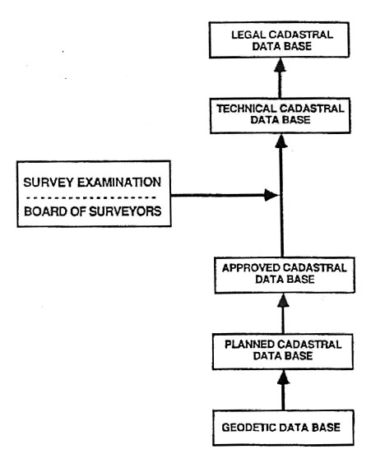
Figure 1.1 A digital cadastral database model
However computer systems are dependent on an infrastructure for maintenance and communication as well as access to well-trained operators. Graphical computer systems are more complicated and demanding on expertise than alphanumeric systems and require more complicated data management schemes.

1.6 Benefits of Cadastre
Appropriate investments in establishing a Cadastre and/or improving one (e.g. through computerization) provide both short and long term benefits. Such cadastral reforms should be based on a good understanding of user requirements and system constraints and on an achievable system design. Investigations show that cadastral reforms often have a higher cost-benefit ratio than is usual for governmental investments in general. Some of the benefits include:
- more security of land tenure
- better access to long-term credit
- increased productivity of land
- lower transaction costs on the real property market
- cheaper information for land administration
- more equitable and cost-effective collection of land taxes
- improved opportunities to implement land policies
- improved opportunities to plan for sustainable development of land and other natural resources
A cadastral system is an information system of land holdings and land use. Therefore it provides excellent opportunities for identifying problems associated with the development and implementation of land policies. The Cadastre can assist in monitoring and controlling matters regarding:
- the size of parcels, both maximum and minimum, for instance to prevent excessive fragmentation;
- the shape of parcels, to avoid uneconomical subdivision design or inefficient road and water systems etc.;
- reallocation of land rights to improve social and economic policies through subdivision, land consolidation, land reallotment etc.;
- land use, for instance agriculture or to ensure that low-cost public buildings are allocated to the right group of people;
- control and measures taken to implement social programs to improve access to land ownership by women and minority groups;
- valuation of land for the collection of government taxes and rates;
- collection of contributions to improve common facilities, such as water systems etc;
- the value of land as a result of development;
- acquisition of land for public or common purposes.

1.7 History of Cadastre in Ethiopia

1.7.1 Land Tenure and Registration
According to Pankhurst, the land situation throughout much of the Middle Age in Ethiopia was influenced by the absence of a permanent capital city, a factor that prevented to a greater extent the emergence of urban property in land until the establishment of Gonder around 1636. Several short-lived capitals such as Lalibela, Debrebrehan, etc. existed only for a few reigns. A real breakthrough came only after the establishment of Addis Ababa as the capital city of the country in 1886.

Recognizing the emergence of new urban land tenure structure after the establishment of Addis Ababa as a capital city, Pankhurst, indicated that it was Menilik II who issued the country’s first urban land related proclamation at the end of 1907, which brought legislation stating the change in ownership of the land in the city of Addis Ababa. Further emphasizing on the significance of this proclamation on the urban land tenure,the legal recognition of private ownership of urban land for the first time through the systematic land registration and issuance of title deeds was a radical departure from the past and giant step towards the privatization of urban land.

Afterwards, during Haile Sellasse I, both the 1931 constitution and the 1955 revised constitution further guaranteed all Ethiopians the right to keep the land they own.

Even though, there was a sporadic effort to establish a cadastral system sometime ago in Addis Ababa, as it is not updated for a long time, it is almost non-existent as a system until very recently. It was Emperor Menilik who issued a decree that brought legislation to initiate the country’s first cadastral survey in Addis Ababa in 1909. Thus, landowners were to be given a certificate refereed as “yrist woraqat” or “rist-paper” to be written in Amharic and French, with a map showing the boundaries of land.

Historically, urbanization in Ethiopia is traced back to the Axumite Kingdom. However, the emergence of modern city administration (municipalities) is a recent phenomenon, which started around 1942. Hence, registration of urban land without a responsible body was unthinkable. Thus, there was little effort by the centrally based Ministry of Interior, to register land and assess taxes for some urban centers in the country. Later on this responsibility was given to the Ministry of Urban Development and Housing. This sporadic attempt was carried out mainly for the purpose of assessing and collecting land and building tax. Thus, until recently registration of land was carried out by some municipalities, which have the capacity to do so. While, the Ministry of Works and Urban Development carried out assessment of building tax, except few urban centers.

1.7.2 Property Taxation
Even if there had been tax on land in Ethiopia for many years, this does not indicate the existence of a systematic land registration. However, in the absence of land registration the land tax used to constitute as the only link between people and government, since, the payment of this tax had been used as a proof for ownership. Emphasizing on this relationship between tax and ownership in the Ethiopian context, Hoben writes “…the payment of the land tax has traditionally been regarded as obligation of ‘rist’ holder and evidence of ownership…”.

In accordance with Menilk’s Decree regarding cadastre and land tax in the city of Addis Ababa, every landholder was to pay an annual tax of 5 per 1000 of the assessed value of the land (Pankhrust, 1966). Later on in 1932 Emperor Hile Selassie I took steps to improve the system of land taxation in Addis Ababa. For instance, the Decree of 1932 states that the land within the boundary of Addis Ababa should be taxed irrespective of whether it had title deed (Sisay, 1996).

Most scholars agree on that, especially in urban areas property taxes are essentially concerned with improvements to the land. Therefore, in urban areas land taxes should generally be based upon its valuation. However, in Ethiopia, due to the inefficiency and absence of basic information, its valuation is difficult. The formulation of land valuation method is also deemed to be difficult until now. Hence, land rent in the urban centers is simply paid based on its area and location or grade of land. Until recently, land rent in urban centers of Ethiopia is paid in accordance with Proclamation No.80 of 1976.

1.7.3 Surveying & Mapping
Land is the platform for all economic, political and social activities of mankind. Therefore, knowing the land in its totality is very important. In order to study the natural resource and the conditions of these resources, proper surveying and preparation of maps is needed. Moreover, cadastral system and land registration without cadastral surveying and cadastral map will be incomplete.

The Ethiopian Mapping Agency was created as a small drafting section under the Ministry of Education in 1954, for the purpose of mainly preparing geographical books, maps and atlases for the schools. Since then the institution has passed through several stages of organizational and technological development and finally named as Ethiopian Mapping Authority. Large-scale aerial photographs ranging from 1:8,000 to 1:20,000 covering major towns are available from EMA, which are used for large-scale mapping and other development studies. The previous Ministry of Works and Urban Development requests for large- scale maps for the preparation of master plans of towns. Accordingly, maps on scale 1:2,000, 1:2,500, 1:5,000 and 1:10,000 are produced for the Ministry.

Chapter 2 – Cadastral Surveying

2.1 Cadastral Surveys
Cadastral surveys are surveys whose aim is to demarcate or create, measure, define/describe and record the position of boundary land as property. Their ultimate purpose being to give unambiguous, graphical, numerical or descriptive information relating to location, extent, shape and size of land parcels. Such information is vital in the support of a register of titles for land ownership and transfer of rights in land.
Demarcation: is the process of physical marking (creating) boundaries on the ground to indicate the limits of a land parcel. The process often involves line clearing thorough out the entire lengths of the boundary lines together with the emplacement of boundary markers at all points where the boundary change direction. Boundary markers may also be required to be emplaced at all points where the boundary meets other features such as river, a shoreline, a road, a railway line, and other features which requires some kind of easement or right of way.
Location of the parcel: the general location of a surveyed piece of land is carried in the heading of the survey job and should be written on the respective survey plan. The heading describes the nature of the survey, giving the administrative name of the area where the land parcel situated. For example the name of district or village, block number or street name and so forth. In addition to this, neighboring surveyed land on the respective plan for the survey. The location of surveyed land may be facilitated by making use of a locality sketch.
Extent, shape and size: the shape of a piece of land is given by the nature and extent of its boundaries in direction which are referenced to a particular orientation line. In practice a coordinates system either local or national is established; and on it all surveys in a given area is related. Together with the coordinates system reference line of orientations is established so that any point in the area can be uniquely described in terms of linear and angular measurements. Indeed, it is this unique description that gives survey plans the recognition they have in land registration. With the parameters, direction and distance known for all boundaries, the size of a land parcel cane be determined with appropriate accuracy. For this reason distances, bearing, and areas are common information on cadastral plans.
Boundary: in general terms, a boundary is the extreme limit of something. As for land parcel, a boundary may be defined as the line, alone or together with others, which encloses or defines the limits of the land parcel. The word limit here has a divisive connotation as it divides between one land parcel and another. Such limits may be described in terms of numerical data, (such as bearings and distances or coordinate value), in which case this give rise to fixed boundaries e.g. boundaries that are numerically described. These limits may also be described by the location of a physical feature, (such as river, a ditch, a road, and a mountain range) on the ground. Sometimes this gives rise to what is known as general boundaries.
General Boundaries: a general boundary is one whose position is not usually determined. For this reason, such a boundary is said to be indeterminate or indefinite. A boundary of this type may be marked by some physical feature such as stream, a wall and a hedge or its position may be described relative to features such as wall, a road, a stream etc. and the boundary may be unmarked.
The use of general boundaries relies heavily on a number of things including the existence of a physical feature on the ground and permanence of such a feature with lapse of time. Above all, the acceptance of such a feature by all neighbors who are affected by its position and subsequent desire to maintain it in its proper position. Lost boundaries can be a source of headache to re-establish, particularly where the boundaries including all neighboring reference objects and features have been destroyed.
General boundaries are used with advantage in developed area where land parcel boundaries in the form of visible features exist on ground. In new areas being opened up, general boundaries can only be realized through the process of demarcation and adjudication followed by fencing or emplacement of appropriate artificial markers or planting hedges along the boundaries.
Fixed Boundary: this is a boundary line whose precise position has been created or determined and recorded by a survey operation. Fixed boundaries make use of markers which are emplaced on the ground and are defined in accordance with specified accuracies that will enable individual land parcels so surveyed to be readily and reliably identified or relocated. Such boundaries are usually linked to framework of geodetic horizontal control established over a country. Because coordinates are ultimately, or can be, computed for the boundary markers, the name coordinated boundary is often used for fixed boundaries.
Since markers are only emplaced at the turning points of the boundary lines, the boundary of pieces of land is deemed to be the straight line running from one marker to the next one. This give rise to what is also known as rectilinear boundary. It should be noted that in this type of boundary the entire length of the boundary line is not necessary marked on the ground. However, by employing appropriate techniques, the precise boundary points between any two markers can be determined. Since land owners are not adequately satisfied by the seemingly imaginary positions of the boundaries of their land, they resort to fencing the boundaries so that among other reasons, they are sure of the exact locations of the entire position and extent of their land parcels.
From the nature of their description, fixed boundaries give rise to accurate, clear, concise and complete boundary description which is vital prerequisite for any form of land dealing, conveyance and administration. This method of boundary creation and definition finds great application in areas where undeveloped or semi-developed land is to undergo initial parcellation.
The outstanding features of the fixed boundary include systematic boundary creation, comprehensive boundary description, straight forward location and identification of land parcels as well as accurate re-establishement of such boundaries in the event of their being lost or destroyed.
The unfortunate aspects of fixed boundaries relate to the ever rising cost and the time required to establish them. Prices of equipment like theodolite, electronic distance measurement (EDM), Total Station, GPS receivers, steel bands and materials like iron pins and cement keep rising with time.
Whether a fixed or general boundary is in use, some form of control is absolutely indispensable; this condition being more so fixed boundaries in which a control framework is a prerequisite for its success. The time required to establish a new point or to replace a lost point is affected considerably by the distribution, density and proximity of control points to the area of survey. Lack or presence of sparsely distributed control points delays completion of field work quite a lot.

2.2 The Role of Surveyor in Cadastre
The primary tasks of a cadastral surveyor include creation of new boundaries defining created or existing boundaries, and re-establishing lost boundaries. Creation of new boundaries is commonly encountered during the process of demarcation. Definition of boundaries, on the other hand, takes place when the surveyor prepares a record of;
  - Survey marks which have been established on the ground in the course of a demarcation work,
  - The position of physical features which are deemed to constitute the boundary (ies) of a piece of land.

To accomplish these tasks, the surveyor undertakes a coordination survey following the successful completion of a demarcation work. He/She is also responsible for the re-establishment of lost boundary markers. Hence the tasks of the cadastral surveyor have, for a long time, been confined to boundary creation, surveying, recording, subdivision and re-establishment.

The role of the surveyor differs with the purpose of the cadastre and with different types of organizations. Although there are other activities involved in managing the cadastre, such as title recording that is usually the responsibility of legal experts, the surveyor may be responsible for:
a) Cadastral surveying: This is the definition, identification, demarcation, measuring and mapping of new or changed legal parcel boundaries. It usually includes the process of re-establishing lost boundaries and sometimes resolving disputes over boundaries or other interests in real property.
There are always specific regulations regarding training and experience for surveyors wishing to carry out cadastral surveys because they have a professional responsibility to society. Cadastral surveys are carried out by governmental officials and private surveyors or by a combination of both. Special certification is required and this can be administered either by the state or by a professional society.
b) Survey recording: This process includes the checking or examination of the results of the cadastral survey and the entry of the information in registration books and on cadastral index maps. A unique parcel identifier is allocated to each parcel. The examination can check on land policy matters (for instance, does the subdivision contribute to a suitable land use?); legal matters (such as the right of the applicant to conduct certain land activities); and technical matters (for instance, have the survey regulations been obeyed?). To lower examination costs, government authorities are putting more emphasis on quality assurance and more responsibility on practicing surveyors for the accuracy of their field data and survey plans.
c) Land valuation: Where the Cadastre is used as a tool for ensuring implementation of a certain land policy, valuation of land and buildings is often an integral part of the role of the surveyor. The most common example is valuation for taxation. But valuation is also important in processes such as expropriation of land and land consolidation where a systematic survey of all properties may be carried out to establish relative values for compensating affected property owners. Subdivision and consolidation surveys may also include establishing the construction and maintenance costs of roads and other joint facilities in order to distribute the costs among the new land holders.
d) Land-use planning: When the Cadastre includes initial land allocation, subdivision or consolidation, the land use planning aspect becomes an important part of the cadastral surveyor's role. As a professional, the surveyor is responsible for protecting the interests of the community and this may involve public consultation and mediation processes. The result may be a new land use plan, where economical, environmental and traditional points of view, reach conciliation.
e) Database management: Information technology has created a demand for specialists in database design and management. As this is an important component in a modern Cadastre, experts are needed to manage and operate large databases, for graphical information as well as textual information. Surveyors play an important role in this field of activity and education in computer systems is an integral component of today's education and training programs for surveyors.
f) Dispute resolution: In some countries, but mainly in Northern Europe, cadastral surveying has special legal significance, where the surveyor makes decisions concerning land matters which are legally binding. These can be questions such as: should a land division be permitted, taking into account the interests of both private developers and the general public?; should a transfer of land between owners be permitted?; who should be compensated for expropriated lands?; and what is the correct legal interpretation of old documents? Consequently, the role of the surveyor has developed from being an independent expert on a committee or in a court, to being the actual first court instead.

2.3 Cadastral Surveying Procedure
As there are no universal rules for the weighing of evidence, so there are no universal, unvarying rules for land-survey procedures. The typical problem, however, usually breaks down into the following major action phases:
- The location, study, and (when necessary) interpretation of all the available deeds, contracts, maps, wills, or other documents that contain a description of the boundaries. The principal repository for most of these instruments is usually the files in a city or county records office. The mere deciphering of ancient, handwritten documents is an art in itself. And here again it is not unusual to encounter conflicting evidence in the shape of documents that purport to describe the same property but that describe it differently. Or you may find a document in which some of the languages may bear more than one interpretation. In this last case you apply, as well as you can, a legal maxim to the effect that an ambiguous document should be given the sense that the maker of the document may be reasonably presumed to have intended.

- The determination, after study of all the documents and related evidence, of what the true property description may be presumed to be, and from this a determination of what physical evidence of the boundary location exists in the field. Physical evidence means for the most part monuments. In land-surveying speech, a monument is any identifiable object that occupies a permanent location in the field and serves as a reference point or marker for a boundary. A monument may be a natural monument, such as a rock, a tree, or the edge of a stream; or it may be an artificial monument, such as a pipe or a concrete monument. Do not use perishable markers for monuments, such as a wooden marker that decays easily.
- The location, in the field, of the existing physical evidence of the boundaries.
- The establishment of the boundary. That involves those decisions previously mentioned as to the best evidence. It also involves the setting, referencing, and marking of points that should have been marked in previous surveys but were not or that were marked with markers that have since disappeared.
- The preparation of the property description.

We can follow the following seven procedures for cadastral surveying:
  - Survey planning: The municipality that is conducting the survey make plan by contacting and adjusting with organizations concerned.
  - Hold a briefing for local residents: The municipality official holds a briefing on the survey’s substance and necessity for local residents
  - Confirmation of boundary (parcel investigation): Landowners clarify their own land boundaries for Cadastral Survey. The municipality official in charge visits the actual place referring to data based on old recorded map etc. The landowners concerning the boundary confirm their land boundaries with mutual agreement. And also municipality official investigates landowner, parcel number, type of land and so on. Put piles along the boundary after the confirmation. The piles display the settled boundaries for each parcel of land. The Parcel Investigation is the important step of Cadastral Survey.
  - Survey the boundary after confirmation (Boundary Survey): Settle the topographic control point, which is the basic reference of survey, and survey to determine the position on earth for each parcel following some process by surveyor. After determining the position for each parcel, surveyors make the accurate map (cadastral map) based on each result and measure the dimension.
  - Making cadastral record: Integrating results of the Parcel Investigation and Boundary Survey, municipality official make a draft of cadastral record.
  - Confirming the results of Cadastral Survey: The record and map are displayed to the public for some days at the municipality office. A person who find any mistakes on the results may report it. Record and map confirmed here becomes the final product of the Cadastral Survey.
  - Submit the product of Cadastral Survey to registry office: The copies of Cadastral Survey product (Cadastral map and Cadastral record) will be submitted to registry office. Land registry book is revised according to the cadastral record and replace old registry map with new cadastral map officially kept at registry office. Registry office utilizes the product of Cadastral Survey as a material of Immovable Registration in the future
In addition, there is also a number of steps which surveyors must follow to complete a formal survey. These are:
- The need for a survey is determined
- A request for survey is issued
- The request is received and acted upon
- A surveyor is assigned
- Additional research is performed
- The survey is executed
- The corner is monumented
- A control survey is performed
- Field notes and true line plans are prepared
- Field notes are edited and plans are drafted
- The notes and plans are reviewed
- The survey is approved
- The plat and field notes are filed officially

2.4 The Surveying Process in Urban Areas
Preliminary steps
Approval of the planning proposal leads to the beginning of the surveying process itself. The surveyor is called up on to translate the proposal in to reality. The surveyor receives the layout of proposals together with the formal request to survey the area as shown on the layout plan.

Data searching, pre-computations and initial job planning
Data searching is the first step which initiates the survey process. The surveyor identifies and acquires all previous surveys which have been done in the immediate neighborhood of the area where the new survey is to be made. In addition to providing points from which the new work will start, data searching examines, detect and avoids overlapping surveys and unwanted gaps. Overlapping surveys are a serious cause for encroachments.

Third Party Interest
Often forgotten during acquisition of information prior to undertaking a survey is the gathering of information relating to pending or unsettled claims in land ownership - the so called third party interests. For example, the area which is to be surveyed might have property like buildings, crops, etc, which belong to out-going owners. If such owners have not been compensated, or are not aware of the proposal to have (what they know to be) their land surveyed for allocation: they may prevent the surveyor from entering and working on the land. Occurrences of this nature are known to have kept field parties idle for considerable lengths of time waiting or negotiating for clearance to enter such areas.

Reconnaissance
Reconnaissance refers to the field visit and inspection which the surveyor makes in the area he/she is to survey. Reconnaissance enables the surveyor to have an overall view of the type of terrain he/she is to work in, and to assess more correctly the types and magnitude of problems to be encountered. On the basis of such assessment the surveyor is able to: determine a suitable plan of the work; estimate the personnel, materials and time requirements; conceive the most appropriate techniques to execute the survey and thus derive reasonable cost estimates for the survey. A well reconnaissance job is a job half done, for thereafter the surveyor is well set to plan, organize and expeditiously undertake the job efficiently and with confidence.

Things to Consider During Reconnaissance
Up to this stage, the surveyor will already have done some planning, pre-computations and acquired all relevant information. During reconnaissance, previously surveyed points in the immediate neighborhood to the area being surveyed will be recovered. The new work will be based on some or all such recovered points and are, therefore, known as datum points. Some of the suitably positioned datum points may not be in proper positions, some may not be found at all while others will be found. To ensure that the points found are in proper positions (i.e. have not been disturbed), linear and/or angular measurements should be made and such measurements reduced. They should then be compared with the computed values for admissibility or rejection as the case may be.

Demarcations
Once datum checks have yielded acceptable results, the work of setting out block boundaries can start. A block is usually an area which is bounded by roads on all, or most of its sides. It may consist of one large plot or several plots of medium sizes or many small plots. In a given layout, therefore there will be many such blocks. Block demarcation is followed coordination of selected block corners, computations, checking of computations and lastly setting out of the individual plots.

Coordination
When demarcation work is complete, the surveyor will be in an even better position to plan the coordination process than at any other stage before; for by then he/she knows the exact locations of difficult and easy parts. Accordingly, the coordination scheme should be re-evaluated and judgment on the best methods of coordination finalized. In order to speed up availability of surveyed plots while at the same time reducing surveying time and costs, the total number of beacons to be coordinated should be kept to the most desirable minimum. All corner points in the periphery of all large blocks should be considered for coordination as these forms the basis on which future plot layouts will commence.

On-line points, even if they form corners of sub-blocks, should not be coordinated except for convenience. In areas where many plots are collectively surveyed, the main framework of coordinating traverse etc should be connected to the control framework which, ideally, should be within a distance not exceeding 200 meters from the area of survey. If a control system does not exist in the neighborhood, control extension should be considered and implemented.

The main methods of boundary coordination are traverses, polar methods, on-line fixation methods, offset and tie-line methods. The necessary conditions for their use, to derive optimum accuracy requirements, are outlined in the following subsections.

Traverses
Traverse routes acquire a definite shape when the location of the points which they start and finish have been established; the demarcation work has been completed; and the points to be coordinated by traverses have been clearly singled out and marked on the ground. The datum points for a coordinating traverse may be control points or ordinary boundary beacons of previous surveys.

The danger of basing successive traverses on coordinated beacons previous plot surveys is that residual errors, inherent in individual (sometimes unrelated) traverses, build up to the extent that they later show up as errors of unmanageable proportions when a future traverse either started at a control point and ends on an ordinary boundary beacon or is used to bridge a gap between two systems of traverses which have been separately built up in this manner. in any case, traverses should planned carefully. The salient factors which ought to be considered planning a traverse route br plot surveys include:

Orientation Lines
Orientation lines are the two lines on which a traverse starts and closes. These should be the longest lines between the available datum points. Short orientation lines should, as far as possible, be avoided as they are a potential source of error in angle measurements. It need not be overemphasized that open traverses - also known as swinging or hanging traverses i.e. traverses whose only one end is known - must never be used for any sort of coordination.

The Base Line of a Traverse
The line between the points where the traverse begins and where it ends is known as the base of a traverse (see Figure 2.1). The magnitude of this line should be of such a length as to make the traverse depart from a looped traverse. Looped traverses, with a single point of contact, should always be avoided.

Figure 2-1 Base and Orientation Lines of a TraverseT₁T₂ -T₃T₄
The Traverse Route
The overall traverse route should take the shortest, most convenient route. With reference to Figure 2.1, it should be pointed out that the shortest route is the straight line along the base line. i.e. T1 - T3. While this is true, it is nevertheless not a convenient route since the points of the new survey which require to be coordinated do not necessarily also lie on this line. It is already on record that some surveys still make their traverses go through longer routes than it is required in order to improve the relative linear misclosures. This is wrong practice and should be discouraged.

Traverse Lines
All traverse lines should be the longest lines possible and as far as practicable, will be of equal lengths in order to minimize and balance inaccuracies introduced into angular measurements through using short lines. Lines of between 100 to 300 meters are usually common in plot surveys. Lines which are less than l00 m, if they have to be used, should be used with great care and forced centring techniques should be adopted wherever possible. Where convenient, traverse lines should be close to detail so as to serve the dual purposes of detail picking and point fixation. In order to avoid the effect of refraction, lines of sight along traverses should not be allowed to pass too close to ground. It need not be restated that inter-visibility between terminal points of a line should be clear in order to speed up observation and line measurement.

Traverse Stations
Like the traverse lines which they establish, traverse stations should be located in such positions as will enable them to fix or used to fix as many boundary points as are required to provide the basis for picking details and to establish convenience for making independent checks.

The Observation of Angles in a Traverse
Angles in a traverse (and elsewhere) are usually observed as angles from a Reference Direction – or also can be from known back sight point (A) (see Figure 2.2). The point A is the point to which the first reading (back sight) is made after a total station has been set up over a station mark (B). Direction are measured in two faces (i.e. face left and right) and the usual method LLRR (i.e. Left (at A), Left (at 1), Right (at 1), and finally Right (at A)). These procedures end by taking a fore sight reading at the known control point (D) from C.
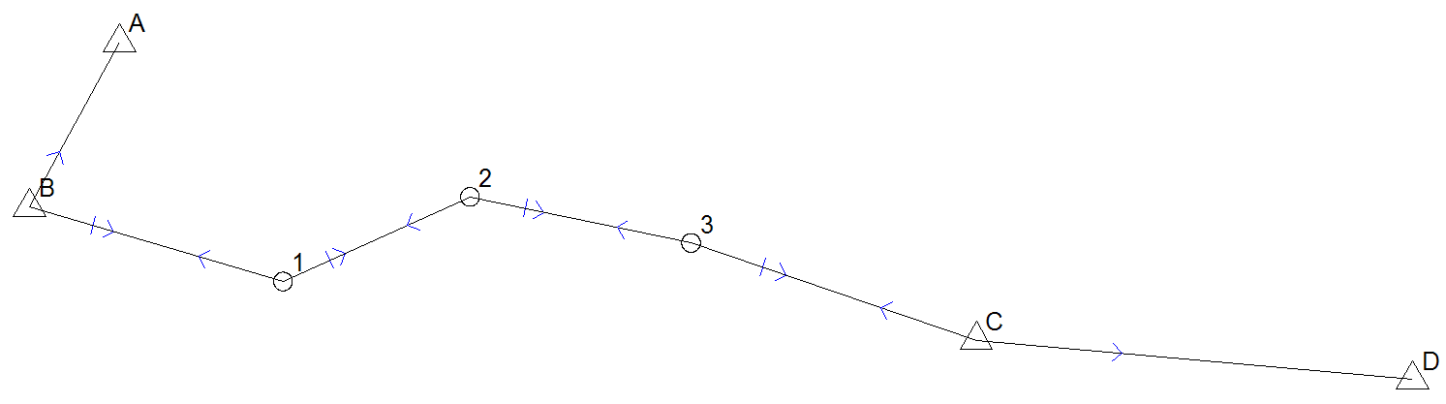
Figure 2.2 Traversing
Acceptance or rejection of a set of readings is generally determined by the predetermined degree of standard deviation of a measurement in a set. The Bowditch method of adjustment is used for traverse adjustment.

Accuracy Specifications for Linear Measurement
Accuracy specifications for traverses are quoted in terms of total error over the entire distance traversed, and these are commonly referred to as linear misclosures. In some countries, the minimum acceptable linear misclosures of traverses for boundary definitions are:
One part in six thousand (116000) for urban surveys:
One part in live thousand (1/5000) hr rural surveys; and
One part in one thousand (1/1000) for detail surveys

According to these specifications, all individual traverse lines should be measured to the appropriate (or higher) accuracy. Thus, in the case of a survey executed in the rural areas, only a relative error of 1 mm will be tolerated for a measured distance of 5 meters while 20 mm would be the corresponding error for a distance of 100 meters. It is thus clear that surveyors need to be more careful when measuring short distances. Similarly, greater control and care ought to be exercised in the execution of short traverses whose individual legs are bound to be quite short and thus susceptible to linear and angular errors.

In cases where two datum points are to be proved for correct positioning, the measured and reduced distance between the points is compared with the known (as computed from coordinates) distance. The between the two is expressed as a fraction of the known length in terms of say one part in x. If the value of is less than 6000, then the points would not be acceptable as a basis on which to connect an urban survey. A different set of datum points will need to be found. The obvious advantage of following these accuracy specifications s that consistency in the quality of the work from different field parties in the country will be maintained. However, given that the establishment of control frameworks in the urban centers is no longer given due attention, this conception of consistency and quality will soon be a creature of the past. This will hay serious implications on the whole question of the provision of survey plots.

Computation
Because the pre-computations for datum checks and verifications have already been made, we are at this stage concerned with those computations which are related to the coordination of the new survey. Hence, computation work starts with the reduction and abstraction of the observed field data, followed by traverse computation (adjustment is by the Bowditch method); then bearing and distance fixes on-line fixes and finally computations for road widths and road parallelism. At every stage, attention should be paid to the accuracy requirements as stated in the regulations. Any fixes which are considered below the expected standard of accuracy should be checked for computational errors before a decision to return to the field for verifications and adjustments is taken.
All computational work must be neatly done and, as far as possible, using self checking methods and applying independent checks. Any data which is used for a particular computation must be cross referenced to its source which may be a field sheet, or a previous computation: in which case the referencing must be made to the held sheet or computational page number. From this, it is evident that a carefully planned and systematically executed job with good, neat, complete field notes and diagrams speeds up Computation work: leaving no room for boredom, mistakes or omissions. A neat, well presented job earns the surveyor extra credit from his/her employer, which in turn will generate interest in his profession and create job satisfaction.

Area Computation
In plot layouts, the individual plots will usually be rectangular with the dimension ratio of 1:1.3 in width and length respectively. All plots are categorized as high density, medium density or low density in accordance with the plot size. A high density plot covers an area of up to 400 square meters a medium density covers an area more than 400 up to 800; and I. density plot covers an area greater than 800 square meters to 1600 square meters,

Sizes of open spaces range from 1200 m² to 25.0 Ha depending on the use. For instance, an area for children’s play is 1200 m², a community open space is 2.5 Ha and a National Stadium 25.0 Ha.

For high density plots, the area for individual plots need not be computed since they can easily be determined from their rectangularity when they are required. But for all other plots and farms, the area for individual land parcels must be computed and rounded off.

Rounding Off of Areas
All urban plots of an area equal to one hectare or less should have their areas rounded of to the nearest square meter.

Coordinate List
At the end of a computation task, a list known as data sheet, is usually drawn showing all points which have been fixed and those (only beacons which have not been fixed). The beaconed points are arranged serially. The list showing beacon numbers of all the beacons which were erected together with their respective coordinates. For beacons which were not coordinated, short explanatory notes such as line beacon, not coordinated”, should be given indicating also why such points were not coordinated.

Block Subdivision for Plots
Once demarcation work is complete and proved to be in order, the task of providing for the individual plots may start. In setting out the individual plots, particularly the high density plots, it is important that rectangular plots are made rectangular as far as it is practicable. All plot sides must be measured and the measurement recorded in a field diagram as soon as they are made. The field diagram we have been working with hitherto will be full of information. Any addition of more information on it would only succeed in making it illegible. Hence a new field diagram for plot subdivision should preferably be prepared. This diagram is more or less a duplicate of the layout plan.

High Density Plot Layouts
The following particulars should be observed when carrying out block subdivision for high density plots:
- All plot corners must be marked, plot sides measured and recorded on the field diagram to two decimal places of a meter.
- Temperature and sea level corrections to individual plot sides may be ignored;
- Slope corrections may be ignored if it is less than 5 cm. To minimize the effect of slope errors, the tape should be kept as horizontal as is possible. Again, here is another situation where step chaining is called for.
- To check against gross errors, the plot sides fronting onto a common lime should be summed up and this sum compared with the measured/computed distance between the terminals of the line. Usually this should give a relative error of 1/300 or better.

Medium and Low Density Plot Layout
In this case, plot sides are to be measured and recorded to the accuracy specifications stipulated in linear measurements of traverses. Hence temperature, sea level, slope and (where applicable), sag corrections ought to be applied.

Detail Surveys
Detail traverses may be used for the purpose of surveying irregular boundaries or natural features provided that such traverses are closed between rigorously fixed points which need not be more than 300 meters apart. When tacheomctric methods are employed, no distance (determined by staff reading), should exceed 180 meters in length. As for the use of offsets, it is required that when an offset exceeds 30 meters, right angles must be set off with a theodolite or an optical square. Because these details give a reflection of the value of the land surveyed, they ought to be shown on the cadastral plan thus adding to the worthiness of the plan as a basis for future planning and development.

Chapter 3 Data Capturing Techniques

3.1 Traditional Methods
Traditional methods vary both between and within countries. They typically consist of a relatively simple method for measuring parcel boundaries and another for area estimation. Common examples would be to use ‘kada’, ‘tilm’, and the rope method which utilizes a rope of known length (e.g., 50 m, 100 m) to measure boundaries of parcels. Areas are determined using simple mathematical methods (areas of rectangles and triangles) with assumptions on parcel shape.

3.2 Compass and tape
The standard surveyor’s compass is a hand-held device which shows the bearing of a line relative to magnetic north. A graduated circular card incorporating a bar magnet rests on a low-friction pivot; prisms or mirrors and sights are arranged so that the graduations on the card may be read whilst making a sighting on the distant point. Damping is incorporated, and there is usually a locking device for the card whilst the instrument is not in use. Bearings may be read to 0.5° (or 1 part in 120, when the angle is converted to radians).

Tapes come in a variety of lengths and materials. For engineering work the lengths are generally 10 m, 30 m, 50 m and 100 m. They are usually encased in plastic boxes with recessed handles. These tapes are graduated in 5-mm intervals only. Tapes are now mainly used only for the quick measurements of short distances (horizontal or vertical). However, they used to be the most accurate method of measuring all distances, so their use was developed to a fine art by surveyors in the first part of the twentieth century. Tape measurements are subject to the following sources of error:
- inaccuracy in the length of the tape;
- variations in the length of the tape due to changes in temperature;
- variations in the length of the tape due to changes in tension;
- slope (since it is usually the horizontal component of the length that is required);
- sag on any unsupported spans;
- errors at the junction of tape lengths
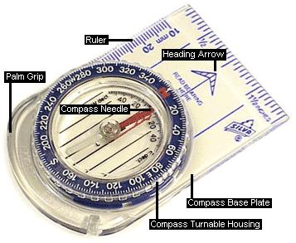
Figure 3-1 Compass

Fabric tapes made of linen or preferably of fibreglass are used for low accuracy or detail work. Steel bands or tapes are more accurate but are easily damaged if kinked or trodden on. On smooth ground, an accuracy of about 1/2,000 is attainable. For the highest accuracy:
- calibrate the tape against a known distance, at the same temperature and tension as will be used on the job;
- avoid large changes of temperature by working early, late or on a cloudy day;
- use a steady pull, ideally by means of a spring balance;
- correct for slope; if there are marked changes of gradient, measure the slope and note the length of each section;
- use the longest tape possible, if the distance is greater than one tape length;
- take the mean of two measurements in opposite directions
Tape and compass is a survey method for determining position and area based on the concept of measurement using distances and angles. In this case a principle of traversing is applied by measuring the sides of the parcel by tape and its bearing by compass.
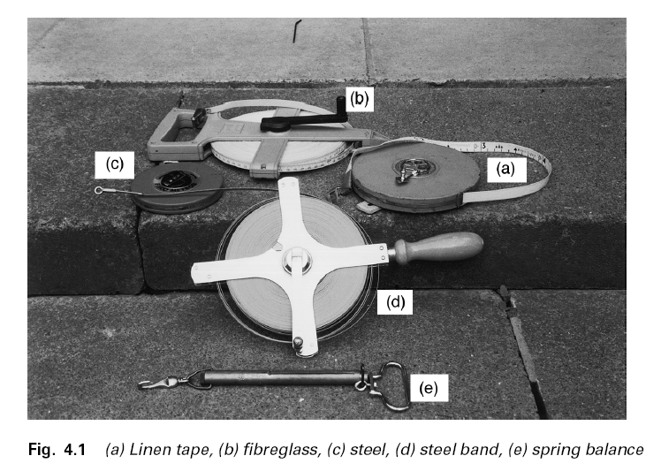
Figure 3-2 a) Linen tape, b) Fibre Glass, c) Steel, d) Steel Band, e) Spring Balance

3.3 Total station
A total station (see Fig 3.3) is a combination of theodolite and electronic distance measuring device (EDM). With this device, as with a transit and tape, one may determine angles and distances from the instrument to points to be surveyed. With the aid of trigonometry, the angles and distances may be used to calculate the actual positions (x, y, and z or northing, easting and elevation) of surveyed points in absolute terms.

The electronic transit provides a digital read-out of those angles instead of a scale; it is both more accurate and less prone to errors arising from interpolating between marks on the scale or from mis-recording. The readout is also continuous; so angles can be checked at any time.

The other part of a total station, the electronic distance measuring device or EDM, measures the distance from the instrument to its target. The EDM sends out an infrared beam which is reflected back to the unit, and the unit uses timing measurements to calculate the distance traveled by the beam. With few exceptions, the EDM requires that the target be highly reflective, and a reflecting prism is normally used as the target. The reflecting prism is a cylindrical device about the diameter of a soft-drink can and about 10 cm in height; at one end is a glass covering plate and at the other is a truncated cone with a threaded extension. It is normally screwed into a target/bracket on the top of a pole; the pointed tip of the pole is placed on the points to be surveyed.

The total station also includes a simple calculator to figure the locations of points sighted. The calculator can perform the trigonometric functions needed, staring with the angles and distance, to calculate the location of any point sighted. Many total stations also include data recorders. The raw data (angles and distances) and/or the coordinates of points sighted are recorded, along with some additional information (usually codes to aid in relating the coordinates to the points surveyed). The data thus recorded can be directly downloaded to a computer at a later time. The use of a data recorder further reduces the potential for error and eliminates the need for a person to record the data in the field.
The determination of angles and distance are essentially separate actions. One should focus the telescope with great care first; this is the part of the process with real potential for human error. When the telescope has been focused, the angles are determined. Only then does one initiate the reading of the distance to the target by the EDM. That takes only a few seconds; the calculations are performed immediately.

Total station do not use any signal from satellite to fix a position on the ground. Hence it has high advantages in urban and forest area than satellite methods.

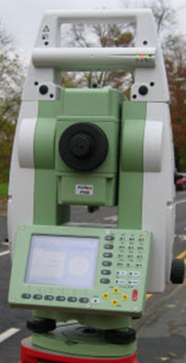
Figure 3-3 Leica 1200 total station

Total station is very accurate instrument. For example Leica TPS1200+ model has a superb accuracy of 1 mm + 1.5 ppm for a range of 3 km. And it has a choice of accuracy for angle from 1 to 5 seconds.

3.4 Satellite image
Setting out in orbit of the new generation of satellites, providing images with high resolution which are available for civil purposes, widen considerably the areas of application of the satellite images. In some respects they compete with the aerial pictures, especially for small-scale mapping.

A convenient way of collecting cadastral data is through satellite images. This is a comparatively new technique that makes it possible to use geo-referenced images and digitize features in the image directly on the screen. Nowadays, satellite images with a resolution of less than one meter are possible to obtain in Ethiopia. If reference points with known coordinates are obtained, they can be used to determine the position, scale and rotation of the image compared to the ground coordinate system. To calculate this, the reference points must be possible to identify with high accuracy and without doubt in the image.
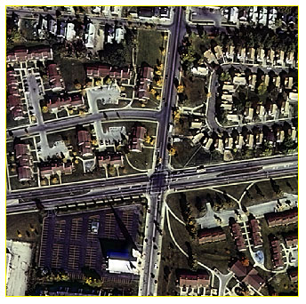
Figure 3-4 A 1 m image from IKONOS satellite

After selecting reference points that are visible on the image, geo-referencing will be done by software such as ArcGIS. Using the tools of software, it is then possible to draw the whole parcels from details that are marked in the image. It is important to bear in mind though, that a contrast between two details, e.g. parcels, might not be a border in reality. In the same way, borders might exist between features of equal color and brightness, so that the border is not visible in the image. Parcels drawn from images should therefore be regarded as a helpful tool to collect data, but should always be followed by a confirmation survey on the ground such as handheld GPS.

Another helpful use of imagery is for error detection in a map made from ground survey data. The map is then projected on the image, and the survey map details can be compared to the image background.

The main advantages of satellite images are the following:
- Generally the image gives a very good overview of the survey, making it easy to verify that all parcels and details in an area are measured.
- Making a parcel is easier in satellite image than with ground survey.
- It is easy to detect in the image if e.g. a parcel border line is slightly bent, and digitize this with some extra points along the line. This is often missed in ground surveys, where the bent border is often only represented by a single line.
It is important though to be aware of the following disadvantages:
- The image is describing the landscape as it looked like when the image was taken. If e.g. two years have passed since then, the landscape might have changed considerably by changed parcel shapes, new roads, cut down trees etc.
- Digitized parcel borders between two parcels might be wrong for two reasons. First, two farmers might use the same crops, making the border invisible in the image. Secondly, one farmer might grow two different crops on the same parcel, making one parcel look like two different parcels in the image.
- Clouds might obscure parts of the image.
- To order a new satellite image might mean high initial costs. An enquiry in June 2008 revealed prices between 30-50 US$ / square km for a detailed (<1m resolution) orthorectified image (the same scale in the whole image).
- The accuracy is often a subject of misunderstanding when it comes to satellite images. The resolution means the size of one pixel projected on the ground, and is often mistaken for the resulting accuracy. Height differences in the image will result in that the high parts of the landscape that are closer to the camera will have a larger scale than lower lying areas. To correct this, one needs to have a terrain model which makes it possible to adjust all parts of the image to get an even scale through the process of orthorectification. If this is not done at all, the image will have severe displacements of the digitized coordinates, even if the image has a high resolution. If an inaccurate terrain model is used (e.g. the one provided by the satellite image manufacturers), the image will not give better results than the handheld GPS. Therefore, an accurate satellite image often demands that an extensive terrain model is surveyed in the area before the image is orthorectified. Then, sub meter accuracy might be possible. A possible way to increase the accuracy in a poorly orthorectified image is to use local georeferencing.
- To georeference the image, it is needed to find details in the image that can be clearly identified in the field. This can sometimes be difficult, and there is a risk of mixing e.g. parcel borders in the image if they serve as ground control points. Therefore, it is important to select several points for the georeferencing, surrounding the area of interest for the digitizing. Some manufacturers offer images that are already georeferenced. In most cases, they use the satellite position and approximate ground points, resulting in severe errors (e.g. 50 m) in the absolute positions. If is possible, however, to supply the manufacturer with surveyed ground points (identified in the image) to obtain an accurately georeferenced image when it is delivered. Mostly, it is more cost and time effective to do the precise georeference yourself, though.

The coordinate differences between image and reality are dependent on several factors, e. g. errors in the geo-referencing, optical errors in the camera used, errors in surveyed reference points etc. It is very important to remember that the accuracy of a geo-referenced image will never be better than the weakest link of the chain, i.e. a high definition image will loose its accuracy if inaccurate survey points are used on the ground. Therefore, high precision GPS or total stations are recommended for the survey of the ground points. Handheld GPS points can only be used if a very rough overview map is to be created. If a CAD map is used for geo-referencing the image, it is therefore very important to check the sources of the image to avoid using data with low accuracy.

The conclusion regarding satellite images is that it is an excellent tool to acquire a general planning map, but confirmation in the field of each parcel is necessary. It is also important to check the image accuracy regarding both the resolution and the orthorectification.

3.5 GPS for Cadastral Surveying
Cadastral surveys establish property corners, boundaries, and areas of land parcels. Conventional surveying methods have been used, and are still being used, for that purpose. Conventional methods, however, have the drawback that extensive traversing is required. Moreover, extensive clear-cutting and intervening private properties might be required as well. GPS overcomes these conventional-method drawbacks.

Any of the GPS surveying methods, such as kinematic GPS or RTK GPS, can be used depending on the project requirements, location, and other factors. The RTK surveying, however, seems to be the most suitable method, especially in unobstructed areas. This is mainly because of its ease of use and the availability of the results while in the field. Inaccessible locations or obstructed areas can be surveyed with integrated systems such as GPS/total station.

There are several advantages of using GPS for cadastral surveying. The most important one is that intervisibility between the points is not required with GPS. This means that extensive traversing is eliminated, clear-cutting is not required, and intervening private properties is avoided. Other advantages include the fact that GPS provides user-defined coordinates in a digital format, which can be easily exported to any GIS system for further analysis. The accuracy obtained with GPS is consistent over the entire network; such accuracy is lacked by conventional surveying methods. Also, with GPS, one reference station can support an unlimited number of rover receivers. A number of governmental and private organizations have reported that the use of GPS in cadastral surveying is cost-effective.

RTK surveying is a carrier phase-based relative positioning technique employs two (or more) receivers simultaneously tracking the same satellites. In this method, the base receiver (see Fig 3.5) remains stationary over the known point and is attached to a radio transmitter. The rover receiver is attached to a radio receiver. Similar to the conventional kinematic GPS method, a data rate as high as 1 Hz (one sample per second) is required. The base receiver measurements and coordinates are transmitted to the rover receiver through the communication (radio) link. The built-in software in a rover receiver combines and processes the GPS measurements collected at both the base and the rover receivers to obtain the rover coordinates. The initial ambiguity parameters are determined almost instantaneously using a technique called on-the-fly ambiguity resolution. The expected positioning accuracy is of the order of 2 to 5 cm (rms). This can be improved by staying over the point for a short period of time, for example, about 30 seconds, to allow for averaging the position.

In the specifications for carrier phase GPS equipments, the terms L1 and L2 are often mentioned. These are two separate frequencies that the GPS satellites use to send the signals. Simple carrier phase receivers can only receive the L1 frequency, whereas more advanced (and expensive) receivers (e.g. Leica 1200) also receive L2, which makes it less sensitive to disturbances of the signal and increases the precision. This is important for e.g. static precision measurements but is less important for cadastral detail surveying.

Another technique is to activate a reference receiver on a known point. The rover, which has no radio contact with the reference, then survey each detail point for a few minutes (two is normally enough). This long time on each point is due to the lack of radio contact, which makes it impossible to determine when enough measurements are obtained directly in the field. Therefore, a sufficient amount of data has to be measured. The main advantage is that there is no need of a radio link between the reference and the rover. This means longer lasting batteries, large distance possibilities between reference and rover, lightweight and small equipment, which is normally cheaper than the radio link system. The disadvantages are mainly longer surveying time, lack of direct confirmation of the survey and no accurate real time coordinates in the field. To calculate the positions of the surveyed points, the measurements (from reference and rover) are downloaded to a GPS software where the positions are calculated. The name of this method is post processing.

The handheld GPS can be used for diffuse borders, e g between mountain and common land. Especially common land boundaries or other large areas where the accuracy demand is lower are suitable for handheld GPS measurements, since this equipment is much more lightweight and easy to use. To minimize the relative error, surrounding borders and details should be measured within a short period of time. This is to ensure that the configurations of the received satellites are as similar as possible for the measured points.

The lower accuracy demand also applies to details in most cases. If a house is displaced with 5 meters, it will not affect any important data such as area, land use or parcel position. It can also be very time consuming to measure the exact centre of most details, e g houses. Therefore, most details (especially in remote or difficult terrain areas) can be measured with a handheld GPS (Fig 3.6). Since the main purpose of the details is recognition of the parcels, the accuracy demand is normally not so high. If the details are needed for accurate planning though, high accuracy is demanded and the handheld GPS should be avoided. It is of very high importance that the method used for each area and survey is documented.

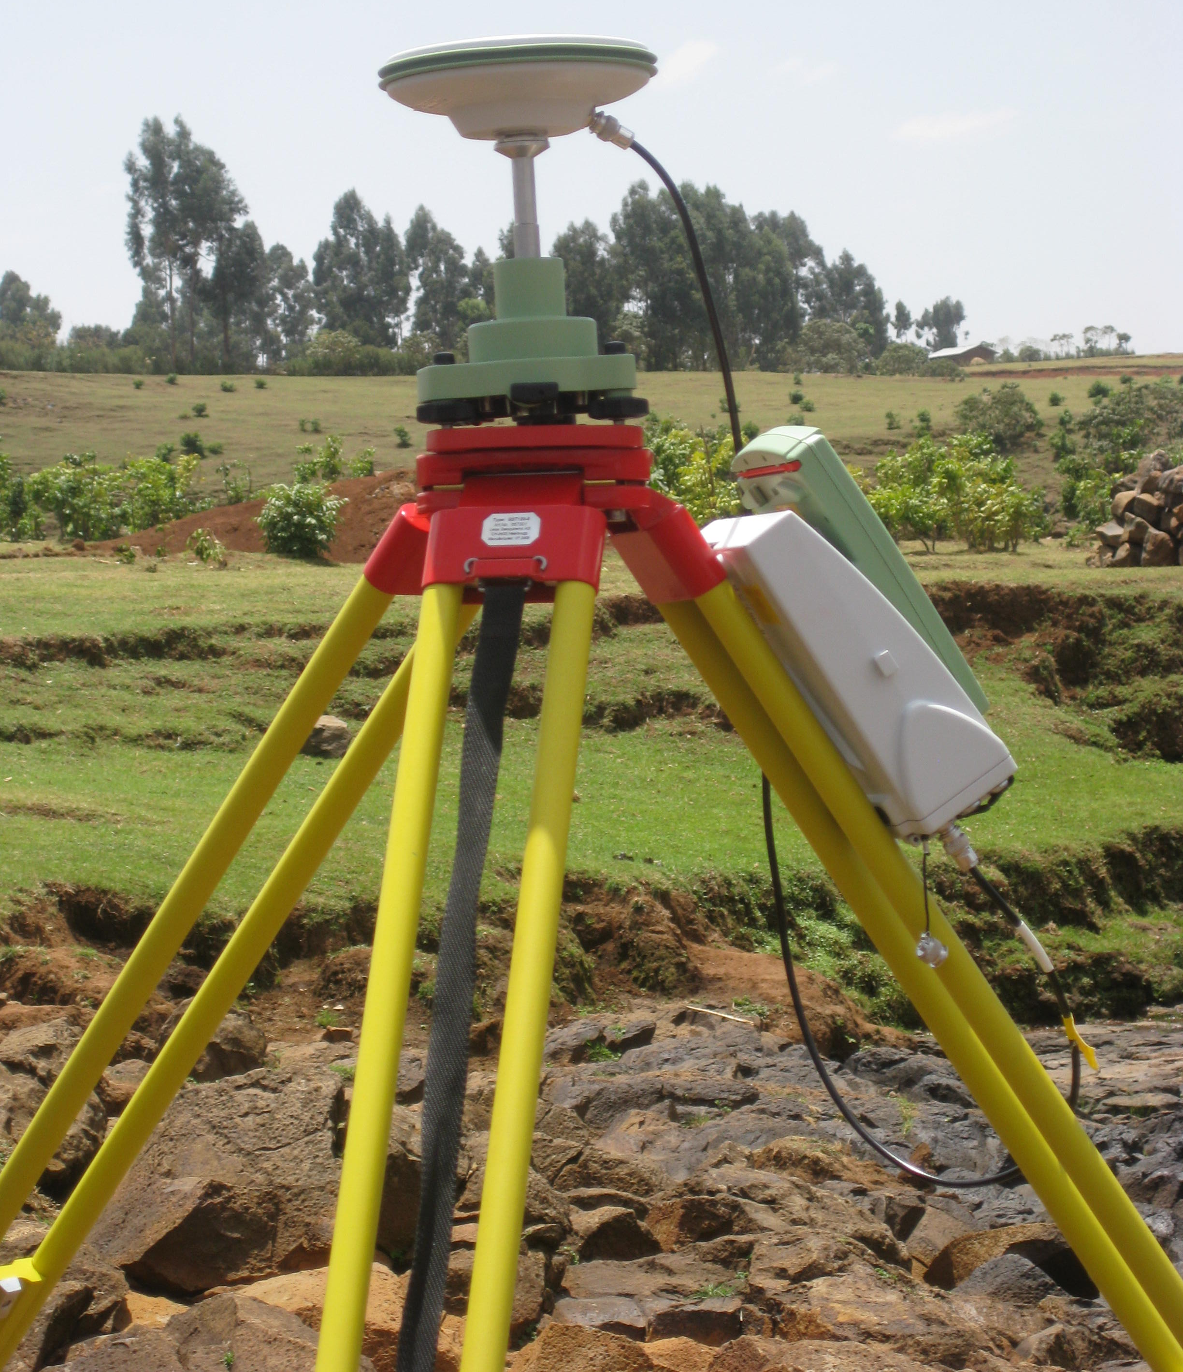
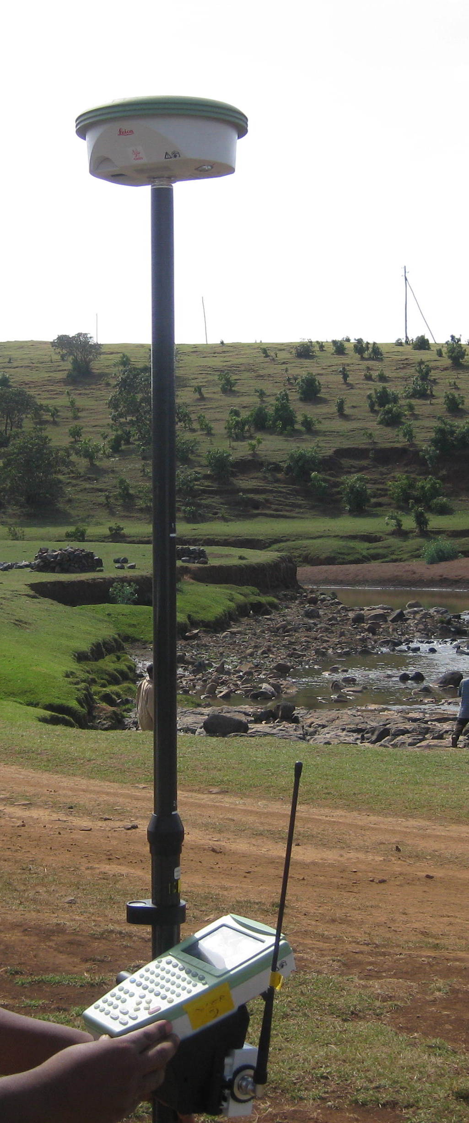

Figure 3-5 Leica 1200 reference and rover receivers

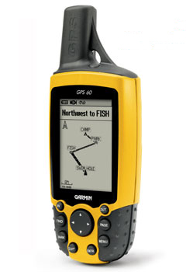
Figure 3-6 Garmin 60 GPS receiver
3.6 Aerial Images
Aerial photogrammetry involves the use of photographs taken in a systematic manner from the air. They are then controlled by land survey and measured by photogrammetric techniques. Accuracies achieved are comparable with those obtained by land survey and in many cases the work is carried out more economically.
Conventional aerial photogrammetry has several advantages over satellite images when it comes to accuracy:
- The considerably lower height of the exposures gives a high resolution, often on decimeter level in the ground coordinate system.
- From a stereo pair of images, a 3D model can be created from the stereo perspective of the details in the images. This will automatically give an accurate terrain model for the rectification. The amount of needed ground control points is much lower than the terrain model needed for satellite image rectification.
- The use of ground control points for the photogrammetric calculations will give an accurate georeference of the images.

Therefore, an orthorectified aerial image is generally an accurate tool for cadastral digitizing. Especially the georeferencing, resolution and rectification is much more accurate than for satellite images. The other mentioned disadvantages for the satellite image remain though, e.g. the need to confirm each parcel in the field. Aerial images often mean high costs if recent images are not available and new ones have to be taken. This might delay the project if permissions to fly the selected route have to be applied for.

3.7 “GIS-GPS” Equipment
Some modern GPS equipments have, except for receiving GPS signals, full Windows Mobile capacity. This makes it possible to use customized GIS software’s such as ArcPad in the field. In this software, which is similar to the basics of ArcMap, georeferenced images as well as ArcGIS shapefiles (layers showing points, lines and areas, the latter also called shapes or polygons) can be displayed, with many editing possibilities using a touch-screen. The current GPS position can be displayed in the image or the shapefile.

By using this technique, it is possible to digitize a georeferenced satellite image on e.g. a laptop in the office and then transfer the image and the shapefile to the GPS. In the field, the position will be shown approximately (the usual 6m error) in the display, pointing out which parcel that is going to be checked. If the digitized borders are confirmed compared to the image, a symbol or attribute showing this can be attached to the parcel shape. If there is an error, the GPS position is not recommended to use for creation of new border points in the parcel shape, but the shapefile or the image can be used in the field to digitize the correct position.

The main advantage of this method is that the accuracy of the image (or shapefile) is used instead of the accuracy of the GPS. It is also a very useful tool to check digitized or ground surveyed parcels in the field. Also, attributes and photos (through the built-in camera) can be connected to a certain object or location in the field.
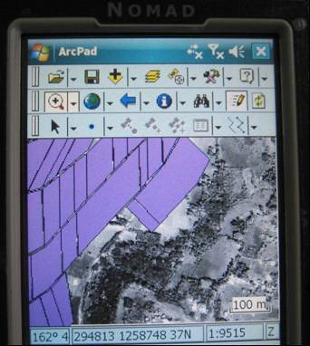
Figure 3-7 Nomad TDS ”GIS-GPS” display

http://www.sli.unimelb.edu.au/fig7/cadastre/statement_on_cadastre.html (visited on August 2009)

