1. Determine the appropriate two-dimensional coordinate transformation for the following data at a 0.01 level of significance when transforming the *XY* coordinates into the *EN* coordinate system.

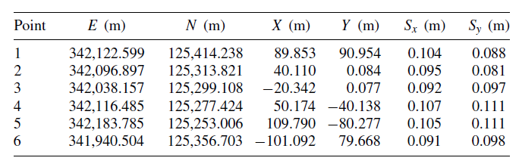

1. Using a weighted three-dimensional coordinate transformation and the follow set of data:

(a) Determine the transformation parameters and their standard deviations.

(b) Compute the XYZ coordinates and their standard deviations for points 7 to 10.

