10. Statistical Inference for two populations
10.1. Estimation about Two Populations
10.1.1. Estimation about Difference between Means for Independent Samples
In the previous chapter we have learned how to estimate the parameter μ from a single population. We now proceed to a technique for using the information in two samples to estimate the difference between two population means (μ₁ – μ₂), where the samples are collected independently. Consider two different populations. The first population has meanμ₁ and standard deviation σ₁, the second has mean μ₂ andstandard deviation σ₂. From the first population take a sample of size n₁and compute its mean ; from the second population takeindependently a sample of size n₂ and compute ; intuitively, we want to use the difference between the sample means, (, to estimate (μ₁ – μ₂).
The characteristics of the sampling distribution of differences of means are:
1) The mean of the sampling distribution of differences of means equals the difference of the population means (Mean = μ₁ – μ₂).
2) The standard deviation of the sampling distribution of differences of means, also called the standard error of differences of means is denoted by = 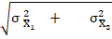 where is the standard error of the mean of the first population and is the standard error of the mean of the second population. (= ; = ).
3) The two random samples are selected in an independent manner from the target populations. That is, the choice of elements in one sample does not affect, and is not affected by, the choice of elements in the other sample.
4) The sampling distribution is normal if both populations are normal, and is approximately normal if the samples are large enough (even if the populations aren’t normal). In practice, it is assumed that the sampling distribution of differences of means is normal if both n₁ and n₂ are ≥30.
Confidence interval for the difference of means:
A formula for large sample (1 - )100% confidence interval for the difference population means, (μ₁ – μ₂), independent sample is:
± *± *(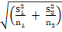 , where the sample variance and as approximations to the corresponding population parameters in case if they are unknown.
Example: If a random sample of 50 non-smokers have a mean life of 76 years with a standard deviation of 8 years and a random sample of 65 smokers live 68 years with a standard deviation of 9 years, then
a) What is the point estimate for the difference of the population means?
b) Find a 95% C.I. for the difference of mean lifetime of non-smokers and smokers.
Solution: let that Population 1 is non-smokers and Population 2 is smokers. Therefore,
n₁=50, = 76, S₁ = 8, = 64/50 =1.28 years.
S₂ = 9, == 92/65 =1.25 years.
a) A point estimate for the difference of population means (μ₁- μ₂) is ( = 76-68 = 8 years.
b) The 95% confidence for (μ₁- μ₂) =±* = 8 ±1.96* (1.28 +1.25) ^{½}
= 8 ±1.96* 1.59 years = (4.88 to 11.12 years).
Hence, the 95% C.I. for the difference of mean lifetime of non-smokers and smokers is between 4.88 years and 11.12 years.
Estimation for Small Sample Mean Differences:
The (1 - )100% C.I for the difference population means, (μ₁ – μ₂), for independent sample and = is given by:± *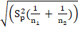 , where the value is based on (n₁ + n₂ - 2) degree of freedom (df).
This procedure requires that the samples be selected from two normal populations that have equal variances (i. e., = = ²). Since we are assuming the variances are equal, we construct an estimate of ² based on the information contained in both samples as pooled estimate. This pooled estimate is denoted by and computed as 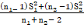 in which a weighted average of the two sample variances with the weights of proportional to the respective sample sizes.

Example: Mr. A is the owner of a small bakery in a large town. He believes that the smell of fresh baking will encourage customers to purchase goods from his bakery. To investigate this belief, he records the daily sales for 10 days and obtains mean sales of 202.18 birr with a SD of 115.7284 birr when all the bakery’s windows are open and the daily sales for another 10 days has mean of 188.47 birr with a variance of 156.6534 birr when all the windows are closed. Assuming that, these data may be deemed to be random samples from normal populations with the same variance.
- Give the difference mean of sales for the two conditions.
- Construct the 95% CI of the mean difference sales for the two conditions.
Solution: let 1= windows open and 2 = windows closed. Therefore,
n₁=10, = 202.18, S²₁ = 115.7284
S²₂ = 156.6534
a) A point estimate for the difference of mean sales of goods (μ₁- μ₂) is (
= 202.18 – 188.47= 13.71 birr.
b) df = n₁ + n₂ – 2 = 18, S²_{p} = (115.7284 *(10 - 1) + 156.6534 *(10 - 1))/ (10 + 10 - 2) = 11.67.
The 95% CI for (μ₁- μ₂) =±* = 13.71 ±2.101* {11.67*(0.1 + 0.1)} ^{½}
= 13.71 ±3.21 = (10.5 to 16.92 birr).
Hence, with the 95% confidence we can conclude that the difference of mean sales of goods when windows open and closed is between 10.5 birr and 16.92 birr.

10.1.2. Estimation about Difference between Proportions
This section extends the method of estimate one population proportion to the case in which we want to estimate the difference between two binomial proportions.
Conditions: the proportions are taken from two simple random samples which are independent. Here, independent means that observations from the first population are not related to, or not paired with, observations from the second population.
Let X₁ and X₂ represent the numbers of successes in two independent binomial experiments with samples of size n₁ and n₂, respectively. To estimate the difference (p₁ – p₂), where p₁ and p₂ are binomial parameters- i.e., the probabilities of success in the two independent binomial experiments- consider the proportion of successes in each of the samples.
Intuitively, we would expect () to provide a reasonable estimate of (p₁ – p₂), where and =.
Confidence interval for the difference of two proportions:
By the same analogy of one sample case, the C.I. for the difference of population proportions (P₁ – P₂)is given by the following formula. The (1 - )100% C.I. for (P₁ – P₂) is given by (₁ – ₂) ± (₁ – ₂) ± * 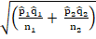, where and are the sample proportions of observations with the characteristics of interest. Also we have followed the usual procedure of substituting the sample values for the corresponding population values required for .
Example: Each of two groups consists of 100 patients who have leukaemia. A new drug is given to the first group but not to the second (the control group). It is found that in the first group 75 people have remission for 2 years; but only 60 in the second group.
- What is the point estimate for the difference in the proportion of all patients with leukaemia who have remission for 2 years?
- Find the 95% confidence limits for the difference in the proportion of all patients with leukaemia who have remission for 2 years.
Solution:
₁ = 0.75, ₁ = 0.25, n₁ = 100, = ₁₁ / n₁ =0.75 x 0.25 / 100 = 0.001875.
₂ = 0.60, ₂ = 0.40, n₂ = 100, = ₂₂ / n₂ =0.60 x 0.40 / 100 = 0.0024.
Hence, = (+ ) ^{½} = (0.001875 + 0.0024) ^{½} = 0.065.
- The point estimate for the difference in the proportion of all patients with leukaemia who have remission for 2 years is (0.75 – 0.60) = 0.15.
- The 95 % C.I. for (p₁ – p₂) = (₁ – ₂) ± = (0.15 ± 1.96 * 0.065)
= (0.15 ± 0.13) = (0.02 to 0.28). Therefore, the difference in the proportion with 2-year remission is between 0.02 and 0.28 with 5% significant level.

10.2.Hypothesis Testing about Two Population means
The purpose of this section is to extend the arguments of the single mean to the comparison of two sample means. Since medical and biological science are, by nature, comparative, this is a rather widespread situation, more common than that of the single mean of the preceding section. In the comparison of two means, there are two samples of observations from two underlying independent populations whose means are denoted by μ₁ and μ₂ and whose standard deviations are denoted by σ₁ and σ₂.
Recalling that a test of significance involves a null hypothesis that specifies values for population quantities, the relevant null hypothesis is that the means are identical, i.e., H_{O}: μ₁ = μ₂ or H_{O}: μ₁ – μ₂= 0.
The rationale for the test of significance is as before. Assuming the null hypothesis is true (i.e., that there is no difference in the population means), one determines the chance of obtaining differences in sample means as discrepant as or more discrepant than that observed. If this chance is sufficiently small, there is reasonable evidence to doubt the validity of the null hypothesis; hence, one concludes there is a statistically significant difference between the means of the two populations (i.e., one rejects the null hypothesis).
To perform a test of hypothesis about the difference between means of two independent populations held the following steps.
For both samples sizes are large (n₁ and n₂30)
One-Tailed Test: Two-Tailed Test:
H_{o}: μ₁ – μ₂= 0 H_{o}: μ₁ – μ₂ = 0
H₁: μ₁ – μ₂> 0 or μ₁ – μ₂< 0 H₁: μ₁ – μ₂ 0
Test statistic: Z = 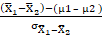
Rejection region: Rejection region:
Z > or Z < - │Z│ >
Where, = if and are known and = if and are unknown; p(Z >) = and p(Z >) = .

Example: An instructor in statistics class believes that students will not do well in his class if they skip his lectures, even if they look at his notes and read the text book. To test his claim, the instructor divides students into high-attendance group and low-attendance group according to their attendances and compares their mean scores of final exam. Here are the data
Group | n |  | S
High-attendance | 65 | 84 | 12
Low-attendance | 55 | 71 | 14
Treat the above data as two random samples from the population of normally distributed.
- What is the point estimate for the difference of mean final exam score between the high- and low- attendance group?
- Give the 95% confidence interval for the difference of mean final exam score between the high- and low- attendance group.
- Is there significant evidence at the 0.05 level that the mean final exam score of high- attendance group is higher than the final exam score of low- attendance group?
Solution for c: let that 1= high- attendance group and 2 = low- attendance group. Therefore,
n₁=65, = 84, S₁ = 12
S₂ = 14 and .
( =84 – 71 = 13,, = 1.64
H_{o}: μ₁ – μ₂= 0 V_{s}H₁: μ₁ – μ₂> 0
Test statistic: Z = 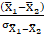 = 13/2.404 = 5.408.
Decision: if Z >we reject H_{o} at 5% SL. Since 5.408 is greater than 1.64 we reject H_{o} at 5% significant level.
Conclusion: with 95% confidence, we can conclude that there is significant evidence that the mean final exam score of high- attendance group is higher than that of the final exam score of low- attendance group.

Hypothesis testing for small sample mean differences:
We have seen in the preceding sections how the Standard normal distribution can be used to calculate confidence intervals and to carry out tests of significance for the means and proportions of large samples. In this section we shall see how similar methods may be used when we have small samples, using the t-distribution. It should be noted that the Z-test is applied when the distribution is normal and the population standard deviation σ is known or when the sample size n is large (n ≥ 30) and with unknown σ (by taking S as estimator of σ).
But, what happens when n<30 and σ is unknown? We will use a t-distribution which depends on the number of degrees of freedom (df). The sample standard deviation is used as an estimate of σ (the standard deviation of the population which is unknown) and appears to be a logical substitute. In general, if the two independent populations from the two samples are drawn are normal (approximately) and both n₁ and n₂ are less than 30, we use the t-distribution to infer about the differences of the two population means.
For σ₁ and σ₂ are unknown and equal σ₁ = σ₂ = σ:
Since σ is unknown, we estimate it by S_{p} (the pooled estimate of variance ) by assuming the null hypothesis is true. The pooled estimate variance S²_{p} combines information from both of the sample to produce a more reliable estimate of σ². It can be
S _{p} = 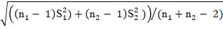.
Therefore, the value of = S_{p}
To perform a test of hypothesis about the difference between means of two independent populations held the following steps.
For both samples sizes are small (n₁ and n₂< 30)
One-Tailed Test: Two-Tailed Test:
H_{o}: μ₁ – μ₂= 0 H_{o}: μ₁ – μ₂ = 0
H₁: μ₁ – μ₂> 0 or μ₁ – μ₂< 0 H₁: μ₁ – μ₂ 0
Test statistic: t = 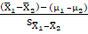 = 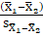 as =0 from H_{o}
Rejection region: Rejection region:
t > or t < - │t│ >
Where, = S_{p} , the distribution of t is based on (n₁ + n₂ - 2) degree of freedom;
p(t >) = and p(t >) = .
Example: We are interested in determining whether a reduction in the intake of Lactose-a sugar found in milk- increases or decreases energy absorption. In this study, a random sample n₁ =8 infants who were fed their mothers breast milk has mean energy absorption of 87.38% with a SD of 4.56%; another random sample of n₂ = 10 new born who were given the formula-that contained only half as much Lactose-has mean energy absorption of 90.14% with a SD of 4.58%. Assume the samples are independent and the populations are normally distributed with equal variance.
- What is the point estimate of the differences of the two population means?
- Construct the 99% CI for the difference between the two population means.
- Test at 1% significant level for the claim that the mean carbohydrate energy absorption for the two populations is identical.
Solution for c: let that 1= infants fed their mothers breast and 2 = infants given the formula. Therefore,
n₁=8, = 87.38%, S₁ = 4.56%
S₂ = 4.58% and .
( =87.38 –90.14 =-2.76, df =n₁ + n₂ – 2=16, , = 2.921
H_{o}: μ₁ – μ₂= 0 V_{s}H₁: μ₁ – μ₂ 0
Test statistic: t = 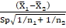 = -2.76/2.17 = -1.272.
Decision: if │t│ >we reject H_{o} at 1% significance level. Since 1.272 is less than 2.921 we do not reject H_{o} at 1% significant level.
Conclusion: with 99% confidence statistically we can conclude that the mean of carbohydrate energy absorption of the population mean are not different.
10.3. Paired Hypothesis testing for difference of means
The distinguishing characteristic of paired samples is that for each observation in the first group, there is a corresponding observation in the second group. In the technique known as self-paired (paired-sample), measurements are taken on a single subject at two distinct points in time.
The characteristic feature of paired samples is that each observation in one sample has one and only one match or matching observation in the other sample. One common example for paired samples is before and after experiment. That means individual is examined before a certain treatment has been applied and then again after the treatment has been computed.
The comparison of means for paired observations is simple and reduces to the methods already discussed. The key to the analysis is that concern is only with the difference for each pair. Ruther than consider the two sets of observations to be distinct samples, we focus on the difference in measurements are as follows:
Sample1: X₁₁ X₂₁ X₃₁ … X_{n1}
Sample2: X₁₂ X₂₂ X₃₂ …. X_{n2}
Differences: d₁ d₂ d₃ ... d_{n}
Where d_{i} = X_{jk} – X _{jk} ,i, j = 1, 2, 3, … n and k = 1,2.
We first note that the mean and standard deviation of the set of differences as follows:
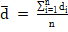andS_{d} = 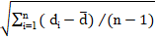.
After these we can estimate and infer about the mean of the paired differences for the population.
The (1 - )100% C.I. for μ_{d} = ± t_{n -1},_{α/2} * = ± t_{n -1},_{α/2} * 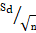.
The null hypothesis states that the population mean difference (μ_{d} = 0).
Hypothesis testing aboutμ_{d}:
H_{o}: μ_{d} = 0 V_{s} H₁: μ_{d} 0 or μ_{d}> 0 or μ_{d}< 0
Test statistic: t =.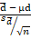
Decision: for H_{o}μ_{d} 0, reject H_{o} if │t│ >t_{n -1},_{α/2} .
For H_{o}μ_{d}>0 , reject H_{o} if t >t_{n -1},_{α} .
For H_{o}μ_{d}< 0, reject H_{o} if t < -t_{n -1},_{α}.
Example:A random sample of 10 young men was taken and the heart rate (HR) of each young man was measured before and after taking a cup of caffeinated coffee. The results were (beats / min):
Subject | HR before | HR after | Difference
1 | 68 | 74 | +6
2 | 64 | 68 | +4
3 | 52 | 60 | +8
4 | 76 | 72 | -4
5 | 78 | 76 | -2
6 | 62 | 68 | +6
7 | 66 | 72 | +6
8 | 76 | 76 | 0
9 | 78 | 80 | +2
10 | 60 | 64 | +4
Mean | 68 | 71 | +3

- What is the point estimate for the difference heart beat of young men before and after taking cup of caffeinated coffee?
- Find the 95% C.I. for the mean of the population differences.
- Does caffeinated coffee have any effect on the heart rate of young men? (useα = 0.05).
Solutions:Given;= 3, S_{d}= =
== 3.92, t_{n -1},_{α/2} = t_{9,0.025} = 2.26, =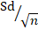 ₌ 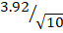= 1.24.
- The point estimate for the difference heart beat of young men before and after taking cup of caffeinated coffee is 3.
- The 95% C.I. for the mean of the population differences, μ_{d} = ± t_{9, 0.025} * = 3± 2.26*1.24 = 3 ± 2.8024 = (0.1976, 5.8024). Therefore, with 95% confidence we can conclude that the mean of the population differences is between 0.1976 and 5.8024.
- H_{O}: μ_{d} = 0 V_{s} H₁: μ_{d}≠ 0
Test statistic: t =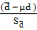 = ( 3- 0) /1.24 = 3 / 1.24 = 2.4.
Decision: since t >t_{9, 0.025} (2.4 > 2.26), we reject H_{O} at 5% significant level.
Conclusion: with 95% confidence we can conclude that the mean of the population difference is different from zero.
Example: A random sample of seven adults elected and put them on a special dietary plan for three months. The following table gives the systolic blood pressure of these seven adults before and after the computation of this plan.
Before: | 210 | 180 | 195 | 220 | 231 | 199 | 224
After: | 193 | 186 | 186 | 223 | 220 | 183 | 233
d_{i}: | 17 | -6 | 9 | -3 | 11 | 16 | -9
- Construct the 95% CI for .
- Test whether the mean systolic blood pressure for ALL adults decrease as a result of this special dietary. Use 5% SL!
Solution: be the differences mean systolic blood pressure of ALL adults.
= 5, S_{d}= 10.75, t_{n -1},_{α/2} = t_{6,0.025} = 2.447, = 4.08, t_{n -1},_{α} = t₆,_{α} = 2.943.
- 95% CI for μd = ± t_{6,0.025}* = 5± 2.447*4.08 =(-4.98, 14.98). Therefore, with 95% confidence we can conclude the mean of all adult blood pressure differences is between -4.98 and 14.98.
- H_{O}: μ_{d} = 0 V_{s} H₁: μ_{d}>0
t = = = 1.235.
Since t < t₆,_{0.05} that is 1.235 < 1.943 we do not reject H_{O}. Therefore, we can conclude that the mean systolic blood pressure for all adults is not decrease as a result of this special dietary plan based on 5% significant level.
10.4. Comparison of two Proportions
A similar approach is adopted when hypothesis test to compare two proportions. In testing the null hypothesis that the proportions from two independent populations are identical i.e., H_{o}: p₁ = p₂ against the alternative hypothesis i.e., H₁: p₁≠ p₂ or p₁> p₂ or p₁< p₂. But because we are evaluating the probability of the data on the assumption that the null hypothesis is true we calculate a slightly different standard error.
If the null hypothesis is true, the two samples come from populations having the same true proportion of individuals with the characteristic of interest, say, P. We do not know P, but both p₁ and p₂ are estimates of P. Our best estimate of P is given by calculating: p =(X₁ + X₂)/(n₁ + n₂).
The standard error of () under the null hypothesis is thus calculated on the assumption that the proportion in each group is p, so that we have
= .
Thus, the approximate test statistic is:
Z = 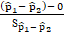 = 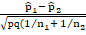 and decision rule is the same as comparisons of means.
Example: A health officer is trying to study the malaria situation of Ethiopia. From the records of seasonal blood survey (SBS) results he came to understand that the proportion of people having malaria in Ethiopia was 3.8% in 1978 (Ethiopian Calendar). The size of the sample considered was 15000. He also realized that during the year that followed (1979), blood samples were taken from 10,000 randomly selected persons. The result of the 1979 seasonal blood survey showed that 2% persons were positive for malaria. Help the health officer in testing the hypothesis that the malaria situation of 1979 did not show any significant difference from that of 1978 (take the level of significance, α =.01).
Solution: let 1 =1978 and 2= 1979
H_{O}: P₁ = P₂ (or P₁ – P₂ = 0) V_{s}H₁ : P₁≠ P₂ (or P₁ – P₂≠ 0 )
= 0.038, n₁ = 15,000, = 0.02, n₂ = 10,000, Z_{α/2} =Z _{0.005}) = 2.58
Common (pooled) proportion, p =(570 + 200)/(15000 + 10000) = 0.0308 and the standard error = 0.0308×0.9692(1/15000 +1/10000) = (0 .0022) ^{½} = 0.047
Hence, Z = (0.0308 - 0.020) / 0.047 = 0.018 / 0.047 = 0.383
Decision: since Z <Z_{α/2} ) do not reject Ho α = 0.01
Therefore, it is concluded that statistically there is no significant difference in the proportion of malaria patients between 1978 and 1979 at a .01 level of significance.
- Analysis of Variance
  - Test of hypothesis about the equality of more than two population means
We are interested in testing the statistical hypothesis of the equality of a set of population means.
Introduction
The F test used to compare three or more means. This technique is called analysis of variance, or ANOVA.It is used to test claims involving three or more means. (Note: The F test can also be used to test the equality of two means. But since it is equivalent to the t test in this case, the t test is usually used instead of the F test when there are only two means.) For example, suppose a researcher wishes to see whether the means of the time it takes three groups of students to solve a computer problem using Fortran, Basic, and Pascal are different. The researcher will use the ANOVA technique for this test. The z and t tests should not be used when three or more means are compared.
The analysis of variance that is used to compare three or more means is called a one way analysis of variance since it contains only one variable. In the previous example, the variable is the type of computer language used. The analysis of variance can be extended to studies involving two variables, such as type of computer language used and mathematical background of the students. These studies involve a two-way analysis of variance.
11.1.2. One-Way Analysis of Variance
When an F test is used to test a hypothesis concerning the means of three or more populations, the technique is called analysis of variance (commonly abbreviated as ANOVA).
At first glance, you might think that to compare the means of three or more samples, you can use the t test, comparing two means at a time. But there are several reasons why the t test should not be done.
First, when you are comparing two means at a time, the rest of the means under study are ignored. With the F test, all the means are compared simultaneously. Second, when you are comparing two means at a time and making all pair wise comparisons, the probability of rejecting the null hypothesis when it is true is increased, since the more t tests that are conducted, the greater is the likelihood of getting significant differences by chance alone. Third, the more means there are to compare, the more t tests are needed.
For example, for the comparison of 3 means two at a time, 3 t tests are required. For the comparison of 5 means two at a time, 10 tests are required. And for the comparison of 10 means two at a time, 45 tests are required.
Assumptions for the F Test for comparing three or more means
- The populations from which the samples were obtained must be normally or approximately normally distributed.
- The samples must be independent of one another.
- The variances of the populations must be equal.
Even though you are comparing three or more means in this use of the F test, variances are used in the test instead of means. With the F test, two different estimates of the population variance are made. The first estimate is called the between-group variance, and it involves finding the variance of the means. The second estimate, the within-group variance, is made by computing the variance using all the data and is not affected by differences in the means. If there is no difference in the means, the between-group variance estimate will be approximately equal to the within-group variance estimate, and the F test value will be approximately equal to 1. The null hypothesis will not be rejected. However, when the means differ significantly, the between-group variance will be much larger than the within-group variance; the F test value will be significantly greater than 1; and the null hypothesis will be rejected. Since variances are compared, this procedure is called analysis of variance (ANOVA). For a test of the difference among three or more means, the following hypotheses should be used:
H_{0:}==…=
H₁: At least one mean is different from the others.
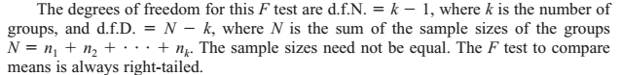
Example1 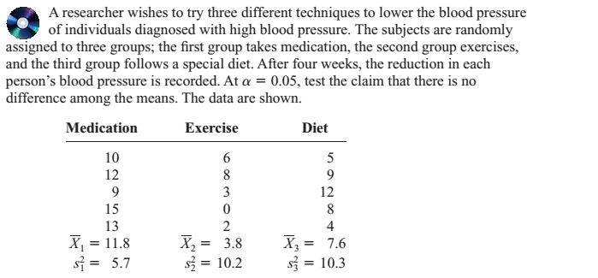
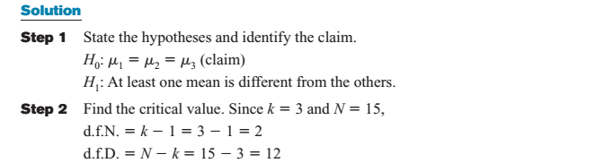
The critical value () =3.89 which is a table value.
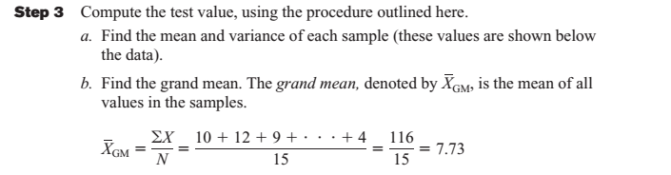
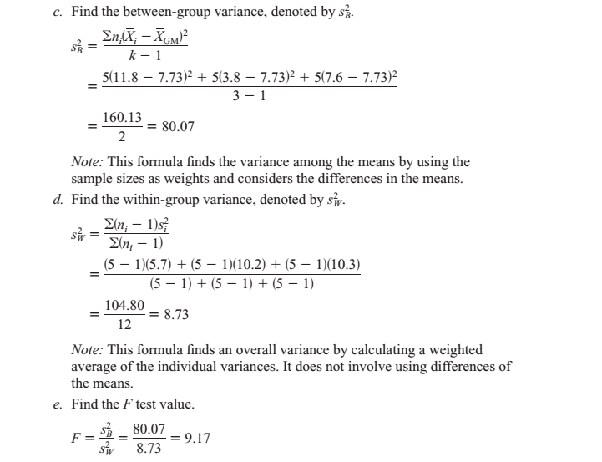
The numerator of the fraction obtained in step 3, part c, of the computational procedure is called the sum of squares between groups, denoted by SS_{B}. The numerator of the fraction obtained in step 3, part d, of the computational procedure is called the sum of squares within groups, denoted by SS_{W}. This statistic is also called the sum of squares for the error. SS_{B} is divided by d.f.N. to obtain the between-group variance. SS_{W} is divided by N-k to obtain the within-group or error variance. These two variances are sometimes called mean squares, denoted by MS_{B} and MS_{W}. These terms are used to summarize the analysis of variance and are placed in a summary table, as shown in the following Table.
Table 1:ANOVA TABLE
Source | Sum of squares | Df | Mean Square | F
Between |  | k-1 |  | 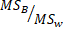
With in error |  | N-k
Total

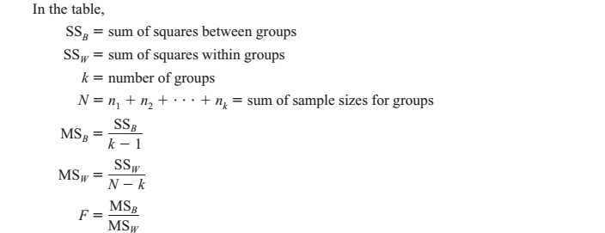The totals are obtained by adding the corresponding columns. For Example 1, the ANOVA summary table is shown in Table 2.
Table 2:ANOVA SUMMARY TABLE for Example 1
Source | Sum of squares | Df | Mean Square | F
Between | 160.13 | 3-1=2 | 80.07
With in error | 104.80 | 14-2=12 | 8.73
Total | 264.93 | 14

Exercise
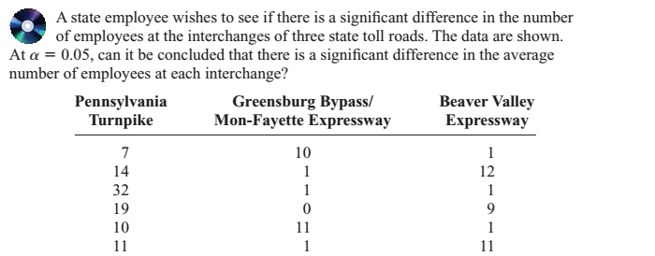
  - Multiple Means Comparison Method
When the null hypothesis is rejected using the F test, the researcher may want to know
where the difference among the means is. Several procedures have been developed to
determine where the significant differences in the means lie after the ANOVA procedure
has been performed. Among the most commonly used tests are the Scheffé test and the
Tukey.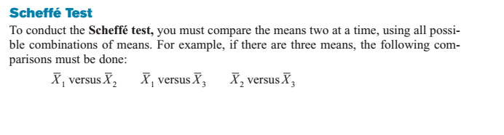Example A
Example 1: Using the Scheffé test, test whether aspecific difference exists between each pair of means, at 0.05.
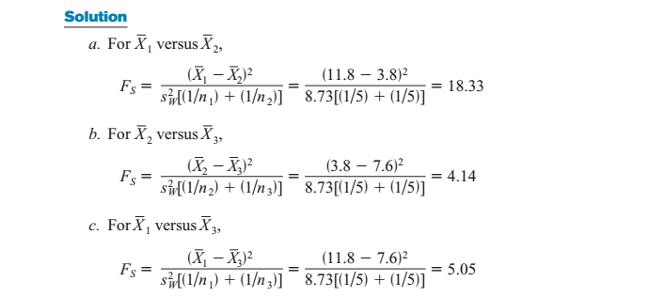
The critical value for the analysis of variance for Example 1 is 3.89, found by using Table with 0.05, degree of freedom Numerator k -1 =2, and degree of freedom Denominator N -k =12. In this case, it is multiplied by k-1.
The critical value for at =0.05, with d.f.N. 2 and d.f.D.12, is (k -1)(C.V.) = (3-1)(3.89) =7.78. Since only the F test value for part a ( ) is greater than the critical value, 7.78, the only significant difference is between, that is, between medication and exercise.
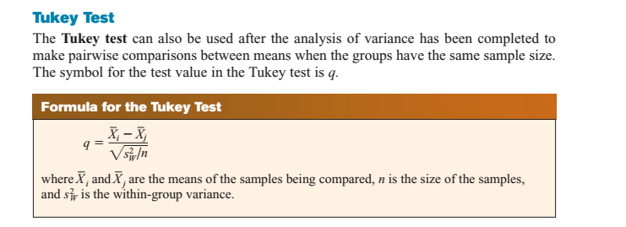
When the absolute value of q is greater than the critical value for the Tukey test, there is a significant difference between the two means being compared.
Example 2: Using the Tukey test, test each pair of means in Example 1 to see whether a specific
difference exists, at = 0.05.
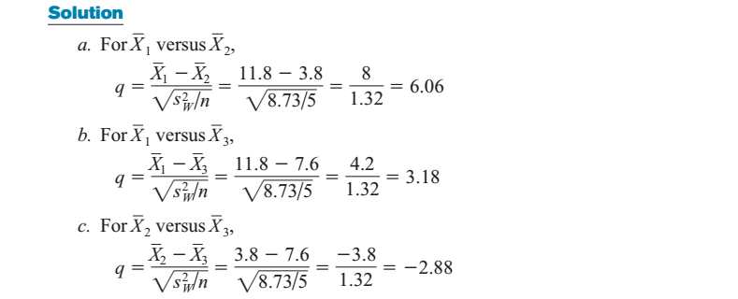To find the critical value for the Tukey test, use Table 1 below. The number of means k is found in the row at the top, and the degrees of freedom for are found in the left column (denoted by v). Since k =3,d.f.=12, and 0.05, the critical value is 3.77. Hence, the only q value that is greater in absolute value than the critical value is the one for the difference between . The conclusion, then, is that there is a significant difference in means for medication and exercise. These results agree with the Scheffé analysis.
You might wonder why there are two different tests that can be used after the ANOVA.
Actually, there are several other tests that can be used in addition to the Scheffé and
Tukey tests. It is up to the researcher to select the most appropriate test. The Scheffé
test is the most general, and it can be used when the samples are of different sizes.
Furthermore, the Scheffé test can be used to make comparisons such as the average of
, compared with. However, the Tukey test is more powerful than the Scheffé
test for making pair wise comparisons for the means. A rule of thumb for pair wise comparisons is to use the Tukey test when the samples are equal in size and the Scheffé test
when the samples differ in size.
Table 1: Critical Values for the Tukey Test
