Chapter– 9
Hypothesis testing of two population means, population proportion and Analysis of variance (ANOVA)
9.1Testing the difference b/n two population means by using Z-tests
Does the mean age ofnursing students who enroll at a community college differ from the mean age of nursingstudents who enroll at a university? Here, the hypotheses are:

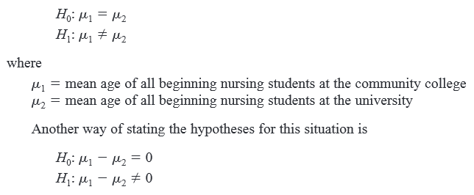
Assumptions of testing the difference b/n two means
- The samples must be independent of each other. That is, there can be no
relationshipbetween the subjects in each sample.
- The standard deviations of both populations must be known, and if the sample sizes
are less than 30, the populations must be normally or approximately normally distributed.

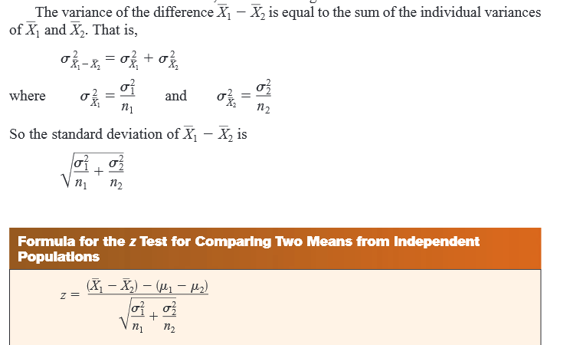
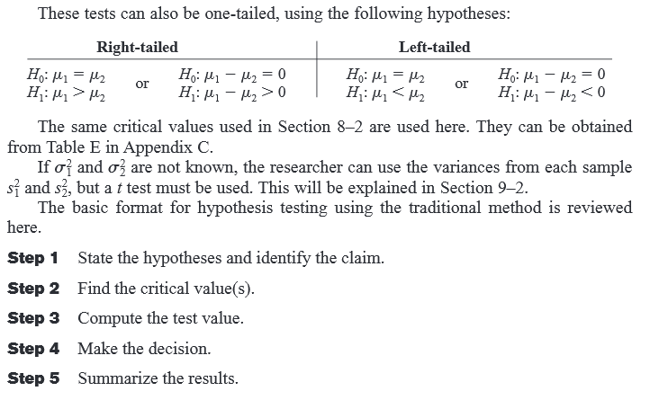
Example
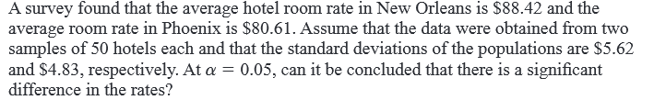
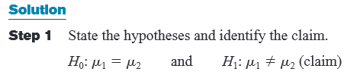
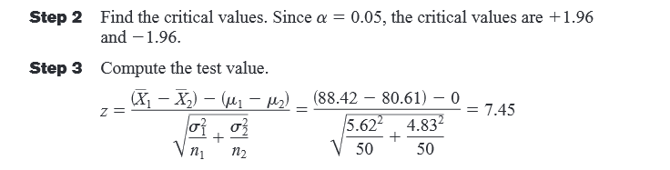

- 9.2 Hypothesis testing one population Proportion
You are testing p, you are not testing pˆ. If you knew the value of p, then there would be nothing to test. The population proportion has an approximately normal distribution if np and nq are both at least 5. Remember that we are approximating the binomial using the normal, and that the p we're talking about is the probability of success on a single trial. The test statistic is
$$z_{\text{cal}}=\frac{\overset{}{p}−p}{\sqrt{\text{pq}n}}$$
The critical value is found from the normal table.
The steps involved in the hypothesis testing remain the same. The only thing that changes is the formula for calculating the test statistic and perhaps the distribution which is used.

General Pattern
Notice the general pattern of these test statistics is
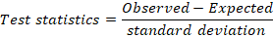
Example 1:
A random sample of 262 disciplinary problem cases in a certain organization shows that 150 are male and 112 are female. Therefore, the observed proportion of cases that are male = 150 / (150 + 112) = .5725. If there were no gender difference for this case, we would expect 50% of cases to be male. Is the observed proportion significantly different from expected at α= .05 level?
Solution
Let p represent the population proportion that is male.
Observed proportion: pˆ =0.5725 based on n = 262
H0: p =0.50 vs. H1: p 0.50
Check to see if normal approximation can be used: np = (262)(0.5) =132. And n(1-p)=262(1-0.5)=132 which is sufficiently large therefore, the normal approximation is OK.
α=0.05=>Z tab=1.96
$$z_{\text{cal}}=\frac{\overset{}{p}−p}{\sqrt{\text{pq}n}}=\frac{0\text{.}\text{5725}−0\text{.}5}{\sqrt{(0\text{.}5)(\text{.}\text{05})\text{262}}}=2\text{.}\text{34}$$
Reject H0.since |_{Z cal ≥} Z _{tab}|
Interpretation: More than 50% of cases in the population are male.
Example1. For the entire nation, the mortality rate for patients over age 65 during a certain type of surgery is 0.014 (i.e., 14 deaths per 1,000 surgeries). At certain Hospital last year, 473 such surgeries were performed, resulting in 9 deaths (p = 9/473 = 0.019).
9.3 Analysis of variance (ANOVA)
When aF-test is used to test a hypothesis concerning the means of three or more populations, the technique is calledanalysis of variance(commonly abbreviated asANOVA).

Assumptions for the F-Test (ANOVA)

1. The populations from which the samples were obtained must be normally or approximately normally distributed.
2. The samples must be independent of one another.
3. The variances of the populations must be equal

With the F test, two different estimates of the population variance are made. The first
estimate is called the between-group variance, and it involves finding the variance of
the means. The second estimate, the within-group variance, is made by computing the
variance using all the data and is not affected by differences in the means. If there is no
difference in the means, the between-group variance estimate will be approximately
equal to the within-group variance estimate, and the F test value will be approximately
equal to 1.

For a test of the difference among three or more means, the following hypotheses
should be used.
H_{O}: µ₁ = µ₂ = ,----------, = µ_{K}
H1: At least one mean is different from the others.

