24-02-2015
Hawassa University, Department of Biology
Principles of Taxonomy (Biol 3063)
Introduction
- Questions to be answered during discussion3063
- What is taxonomy?
- What is its scope?
- What do you think that a taxonomist does?
- What are your criteria to say that two or more organisms are similar or different?
- What is/are the importance of taxonomy?
- Taxonomy is derived from the Greek words- taxis="arrangement/to classify;" nomos =“law” or “science”
Definitions of taxonomy:
- Taxonomy: the science of classification of organisms (from its origin = narrow definition)
- Taxonomy: the study of variation + sources of variation + consequences of variation + classification/the principles underlying classification + discovering & naming of organisms/groups of organisms.(Broad definition)
Contemporary definition of taxonomy (based on its practices):
- Taxonomy: the science that involves description, identification, classification and nomenclature of organisms/ taxonomic groups (the most accepted), and deals with both living and extinct organisms.
- Naming, describing & classifying living organisms are natural & integral activity of humans.
Without such knowledge, it would be difficult to communicate.
Practices of Taxonomy
- Description: assignment of features to an organism
- Identification: assignment of one single organism or specimen to an existing classification (taxa produced)
- Classification: ordering of organisms into groups on the basis of their r/ship.
- Nomenclature: naming of taxonomic groups/taxa according to some standardized system (i.e. allocation of name of the taxa produced)
N.B: Classification precedes nomenclature.
- Accordingly, there are about five different Codes of Nomenclature.
- ICBN,
- ICZN,
- International Code of Nomenclature for Cultivated Plants (ICNCP)
- International Code of Nomenclature of Bacteria (ICNB).
- International Code of Virus Classification (Draft)
- Names that are given to organisms/taxa by obeying nomenclatural code are called scientific names.
Taxonomy and Systematics
- Taxonomy: the science that deals with description, identification, classification & nomenclature of taxa.
- Systematics: taxonomy + study of evolutionary relatedness among various groups of organisms/phylogenetic analysis
In general, systematic includes an aspect of evolutionary relatedness among various groups of organisms (phylogenetic relationships). That is, it deals not only with identifying, describing, naming, and classifying organisms (taxa), but also with investigating the evolutionary relationship between them. Thus, according to this perspective, systematic includes both the traditional activities of taxonomy and investigations of evolutionary relationships, variations and speciation (formation of new species).
However, the two terms, taxonomy and systematic, are often used interchangeably in different textbooks and research papers. In this Course, taxonomy is dealt with as the sub-part of systematic.
Importance of Taxonomy
- Taxonomy is an important science, and is basic to all biological disciplines since each requires the correct names and descriptions of the organisms being studied. It is also dependent on the information provided by other disciplines, such as genetics, physiology, ecology and anatomy.
- Classification systems serve four important roles:
- They do aid to memory.
- Classification systems greatly improve our predictive powers.
- Improve our ability to explain relationships among organisms.
- Provide relatively stable, unique, and unequivocal names for organisms/taxa.
Unit 2: History and Development of Taxonomy
- Taxonomy has passed different stages of developments similar to other sciences. Different scholar variously divided the developmental stages of taxonomy mainly based on some important occasions and events (such as well-known discoveries, publications, theories forwarded, etc) which contributed to the science of taxonomy. Generally, we can divide the phases of developmental stages of taxonomy into Pre-Linnaean taxonomy, Taxonomy during the Linnaean Era & Post-Linnaean taxonomy.
- Phases Of Developmental Stages of Taxonomy:
- Pre-Linnaean Taxonomy
- Ancient taxonomy
- Ancient people have grouped/ categorized living things into groups & gave common/vernacular names. e.g. Identifying edible plants & animals and non-edible ones, useful and harmful organisms, and aggressive and non-aggressive wild animals in their environment, and giving names are as old as human races.
- This system is called folk taxonomy.
- It is important for communication of the people.
- In such system of classification, organisms that were obvious (common) or more important (useful or harmful) to the people got names while the others might not.
- The system is characterized by existence & non-existence of vernacular names for organisms/groups of them.
- Folk taxonomy is characterized by existent & no-existent of common names.
- One can say that taxonomy is as old as the language skill of mankind.
- Taxonomy during the Greek and Roman Philosophers-Essentialists
a. Aristotle (384–322 BC)
- the first to classify living things into plants & animals
- Animals: into “animals with blood” & “animals without blood”
- animals with blood: live-bearing & egg-bearing,
- Without blood: insects, crustacea and testacea (molluscs)
b. Theophrastus (370–285 BC)
- Classified of all known plants during the time, De Historia Plantarum, which contained 480 species.
- His plant classification was based on growth form: tree, shrub/herb
- Many of his plant genera like Narcissus, Crocus & Cornus still in use.
c. Dioscorides (40–90 AD)- Greek physician
- De Materia Medica ≈ 600 plant species.
- used in medicine until the 16th C
- classification based on medicinal properties
d. Plinius (23–79 AD)
- Wrote many books, the only survived is Naturalis Historia
- Described several plants & gave them Latin names.
- Many of these names are stil in use (e.g. Populus alba & Populus nigra)
- Some call him the Father of Botanical Latin.
- Middle Age /Medieval Period (5th to 15th C)
- Little/no progress in botanical & zoological investigation
- Europe & Asia = famine, endemics (=Dark Age) during this period.
- Mostly copying & recopying of earlier manuscripts + errors
- Albertus Magnus (1200-1280) -famous plant taxonomist
- “Doctor of Universalis” / “Aristotle of the Middle Age”
- Recognized monocots+dicots; vascular + no-vascular
- Herbalists’ time (16 C): publications of several books on medicinal uses of plants.
- After the Middle Age, taxonomy was influenced by two occasions:
- Innovation of printing machine & development of science of navigation.
- 15th century was the onset of Renaissance in Europe.

- Innovation of printing machine:
- eased printing efforts
- promoted the publication of many medicinal oriented books, particularly in the next century.
- lowered prices of books
- Medicinal oriented book are said to be Herbals & the authors of such books are Herbalists.
- 16th century is called the time of great herbalists.
e. g. Otto Brunfels, Jerome Bock & Leonart Fuchs whom named the German fathers of botany
- Herbals exhibit excellent illustrations + detailed descriptions of plants.
- However, didn’t emphasize on any system of classification
- Plants simply arranged in alphabetical/medicinal uses in herbals.
- Innovation of Navigation
- Enabled sailors/investigators to go on long voyages.
- Exploration of several new areas of the world by crossing large water bodies and collection of new plants and animals.
- Increased man’s practical knowledge taxonomy.
- Early taxonomists- study of living things for basic knowledge
- Until end of 16th C, existing studies couldn’t replace the ideas of ancient Greek philosophers.
- Discovery of optic lenses & growth of science in 17th C
- Emphasis was turned from medical aspects to taxonomic aspects; this means, scientists started to study living things for intrinsic purposes instead of only for food and medicinal uses.
- Caesalpino (1519–1603) – in Italy
- Some call him “the first taxonomist". He wrote De Plantis (1583,) which contained 1500 spp.
- His classification based on growth habit + fruit and seed.
- o Some of the names given by him are still in use . e.g The names for plant families, Brassicaceae and Asteraceae, have been given by Caesalpino.
- Caspar Bauhin -Swiss botanist
- Travelled extensively to collect plant specimens and formed a herbarium of 4000 specimens. Published Pinax Theatri Botanici (1623) which contained a list of 6000 plants spp.
- He also introduced binomial nomenclature (writing species name in two words) for several species. He sought to clarify in a single publication the confusion regarding the multiplicity of names for all species known at that time. Although he did not describe genera, he recognized the differences between species and genera, and several species were included under the same generic names.
- Jean Bauhin (1541-1613)-elder brother of C. Bauhin
- compiled a description of 5000 plant spp. with more >3500 figures
- The work of J. Bauhin was published under the name Historia Plantarum Universalis in 1650-1651, several years after his death.
- It is tragic that the two brothers never collaborated and rather worked on identical lines independently.
- John Ray (1627–1705)- English naturalist
- wrote several important works
- His most important contribution was the establishment of species as the ultimate unit of taxonomy.
- Methodus Plantarum Nova (1682)≈18 000 plant species
- His classification was based on many combined characters - more natural than the work of earliest taxonomists.
- Ray aimed at publishing a complete system of nature, which included works on mammals, reptiles, birds, fishes and insects.
- de Tournefort (1656–1708)- Franch
- Botanical classification –ruled until time of Carl Linnaeus.
- Institutiones Rei Herbariae ( 1700 ) = 9000 spp in 698 genera.
- primary emphasis on the classification genera
- Classification based on floral characters.
B. Linnaean Era (1707-1778) -Sexual sysytem
- starting points of modern & taxonomy
- binary form of species names ("trivial names“) for both plants & animals.
i. Species Plantarum(1753)
- Starting point for botanical names
- used "trivial names" (binomial name) for all plant spp.
ii. Systema Naturae (1758, 10th ed.)
- Used "trivial names" (binomial name) for all animal spp.
- He used both trivial and phrasal names (up to 12 words) in his publications
- Soon, binomial names replaced the phrasal names
- But his classification was based on sexual parts of a flower
- Recognized 24 classes of plants based on number of stamens.
- Classes subdivided into orders on bases of carpel. e.g. Monogynia, Digynia, etc.
- Such classification is sexual system =Artificial system
- Plant & animal name published before 1753 & 1758, respectively, are called "prelinnaean" = not valid.
- Early names published by Linnaeus himself before these periods are "prelinnaean"!
- Pre-Linnaean + Linnaeus =Essentialists& Artificial system
- binomial name-still in use, but Linaeus classification system is artificial
C. Post-Linnaean Taxonomy
- Foundation Natural System of Classification
- Different taxonomists criticized classification of Linnaeus= for being artificial, particularly French scientists.
- Georges de Buffon (1707–1788) - strong critic to Linnaeus work
- Considered classification by Linnaeus as artificial order on the disorderly world.
- Buffon’s aim was to describe the world rather than to classify it.
- His theories touched with the development of species, infraspecific variety & acquired inherited characters in species
- Opened pathway for an evolutionary theory.
- Michel Adanson (1727–1806)
- Familles des Plantes already in 1763.
- launched the idea that in classification one should :
- Use as many characters as possible
- Characters should be given equal weight/no priority and
- Classification depends on overall similarity
- Such classification is said to be called Natural classification.
- Antoine L. de Jussieu (1748–1836)
Estabilished family rank b/n genus andclass
Acotyledons, Monocotyledons and Dicotyledons
- B.P. de Lamarck (1744–1829)
Theory of inheritance of acquired characters ="Lamarckism".
Opened path for evolution theory (Charles Darwin & Wallace, 1858)
ii. Formation of nomenclatural code (ICBN & ICZN)
- First attempt to create botanical nomenclatural code = by de Candole in 1813.
Published names should have priority starting Linnaeus
- On a congress in Paris, 100 botanists adopted the rules in a book by the son of Alphons de Candolle (1806–1873), Lois de Nomenclature Adoptee from 1867.
- On congress in Vienna (1905) starting date was set to 1753 (Species Plantrum)
- In 1907, Americans created their own code
- In 1935, both codes merged together by agreement & formed ICBN.
- Initiation of a zoological code started somewhat later. In 1842 a British ornithologist Hugh E. Strickland (1811–1853) elaborated the first nomenclatural laws for zoology, the "Strickland Code".
- He was assisted by a committee where Charles Darwin was a member, among others. The Strickland Code (which was first published in 1842) was accepted among British & American zoologists within three years.
- The code was accepted as International Code of Zoological Nomenclature firstly on an International Congress in Moscow in 1892. In 1905, a further modified international code was published in French, English and German languages.
iii. Natural system developed to Numerical Taxonomy/ Phenetics- phenogram
- Michel Adanson was published Familles des in 1763 and forwarded the idea that classification should depend on many characters with equal weight=overall similarity.
- With the development of computer softwares (1960s)/cluster analysis by computer software → numerical taxonomy/ phenetics became popular
- Principles of Numerical Taxonomy by Senath & Sokal (1963 & 1973) & it is the new method of organizing data of N/S & obtaining a classification.
- Phylogenetics/cladistics
- Charles Darwin (1809–1882) launched the evolutionary theory in 1858. However, this did not affect systematics in the beginning.
- Ernst Haeckel (1834–1919) and August W. Eichler (1839–18878) were two German biologists who started the construction of evolutionary trees.
- Haeckel established the term "phylogeny". However, the main part of the 20th century was dominated by extended phenetics (i.e., looking for overall similarities and differences to create classification).
- The German biologist Willi Hennig (1913–1976) founded the cladistic era in 1966, by stating that only similarities in derived characters (synapomorphies) should be used in classification of species, and that taxa should include all descendants from one single ancestor (the rule of monophyly).
UNIT 3: CLASSIFICATION SYSTEMS
Introduction
- Different systems of classification have been used.
- Major ones are: artificial, natural & phylogenetic systems. They all vary in their objectives, types & number of characters used, and approaches of selecting characters.
I. Artificial Classification
- Use single or at most only a few characters
- Superficial & easily observable features often used
- Characters are selected first →organisms compared & grouped based on selected criteria = called prioritized classification
eg. Plant classification based only on: flower color, No of stamen & pistil or growth forms
- For animals’ classification: animals that can fly/not, live in water /on land, etc
- Classification by Aristotle, Theophrastus, & Herbalists = were artificial systems
- Caesalpino, Ray & Magnol (17th–18thC) = tried to produce more natural classification system
- However, culminated in Linnaeus Sexual System (18th C) = Artificial System
Strength and Weakness
Strength : easy to use and classify organisms.
Weakness:
- Classify unrelated organisms together & separate more reacted ones
- Only superficial features don’t reflect natural relationships.
- Does not reflect the evolutionary r/ship
II. Natural Classification and Phenetic System
- a great number of chrs ; equal weight, based on overall similarities.
- Linnaeus =popular & efficient classification, but artificial
- Taxonomists started reconsidering natural idea
- Number & diversity of tropical plants enabled M. Adanson → Natural system (Familles des Plantes in 1763)
- In natural classification:
- great numbers of characters with equal weight are used.
- organisms classified based on overall similarity
- highly predictive & organisms are classified objectively.
- Objective: one can predict natural group, regardless of whether or not & by whom they are classified
Numerical Taxonomy (Phenetics)
- Computers (1960s) → numerical taxonomy/ phenetics became popular
- Principles of Numerical Taxonomy by Senath & Sokal (1963 & 1973).
- New method of organizing data of N/S & obtaining a classification
- No characters, ≥ 60 per organism (taxon) & often ≥ 100
- Data are analyzed usually by computer
- Similarity (resemblance) based on a set of phenotypic characters
- Phenetic r/ship is represented by phenogram, (for cladstic = cladogram)
Principles of Numerical Taxonomy
- Modern numerical taxonomy is based on the idea of Michel Adamson
- Neo-Adansonian principles
principles of numerical taxonomy
- The greater the numbers →the better the classification will be;
- All characters have of equal weight;
- Overall similarity is the function of their individual similarities
- Phylogenetic inference can be made??? (not widely accepted currently)??
- Taxonomy is viewed & practiced as an empirical science; and
- Classification is based on character similarity.
Operational Taxonomic Units (OTU) & Characters
- Selection of OTUs and characters
- OTUs are the objects of taxonomy (eg. populations, species, genera, etc.)
- Similarity/ dissimilarity of OTUs is determined by using various statistical formulae (eg. Simple similarity coefficient = Ssm).
- Character state (attributes): alternate state of a character = feature varies from one organism to another
e.g. Character → Character states/ attributes
- Hair colors a Cow → Black and red hair colors
- No of leaves per node → Two, three and four leaves
- important to select a unit character
- Unit character: a taxonomic character of two or more state; but not subdivided at character level
3. Coding of characters
- Most suitable if two-state characters are used.
- Can be coded as presence / absence of a character state: eg. woody/ herbaceous for plant habit, red/ black for hair color, etc.
- may not be in two-states; may be qualitative multistate
(e.g. Petal may be white, red, blue, etc.) or quantitative multistate (leaves 1, 2, 3 or 4/node).
- Multistate chrs can be converted into two-state (e.g. flower white vs colored; leaves 4 vs leaves < 4).
- two-state (binary chrs) are best coded as 0 or 1 for two alternate states
- matrix with t number of rows (OTUs) and n number of columns (characters) = with the dimension of the matrix (and the number of attributes) being t x n

- If character state is not available/ irrelevant=NC (not comparable)= by passes during comparison
Measuring Resemblance
- To calculate similarity/ dissimilarity:
- 1(presence of a character) & 0 (absence of a character); possible combinations are:
A. Match (m) refers to:
- Presence (1) x Presence (1) = a,
- Absence (0) x Absence (0) = d;
OTU k →
OTU j↓ |  | 1 | 0
OTU j↓ | 1 | a | b
OTU j↓ | 0 | c | d
B. Mismatches (u) refer to:
- Presence of (1) x Absence (0) = b, and
- Absence (0) x Presence (1) = c
Therefore:
- Match (m) = a + d
- Mismatch (u) = b +c; sample size n = a +b +c + d = number of combinations.
- k and j are two OTUs under comparison
- In phenetic analysis, more than about 100 or more characters should be used. But in the Table below, only 8 characters are used, as an example, to classify (compare) 14 OTUs (in this case14 plant taxa). This table shows how to code character states.
- Table below: A Portion of the data matrix with hypothetical “t” (14) OTUs and “n” (8) characters to show character coding. Simple matching coefficient (Ssm) is represented as:
Characters  (n) →  OTUs (t)↓ | Habit:  0-Wood, 1-herbaceous | Fruit:  0-fillicle, 1-achene | Ovary:  0-superior, 1-inferior | Leaves:  0-simple, 1-compound | Habitat:  0-terrestrial, 1-aquatic | Pollen:  1-triporate,0-monosulcate | Ovule:  1-unitegmic, 0-bitegmic | Carpel:  0-free,1-united
1 | 1 | 0 | 1 | 1 | 0 | 1 | 1 | 1
2 | 1 | 0 | 1 | 1 | 1 | 1 | 0 | 0
3 | 0 | NC | 0 | 1 | 0 | 0 | 1 | 1
4 | 1 | 1 | 1 | 0 | 1 | 0 | 0 | 0
5 | 1 | 0 | 1 | 1 | 0 | 1 | 1 | 0
6 | 1 | 1 | 0 | 1 | 1 | NC | 0 | 1
7 | 0 | 1 | 1 | 0 | 1 | 1 | 0 | 0
8 | 0 | 0 | 0 | 1 | 0 | 0 | 1 | 1
9 | 1 | 1 | 1 | 0 | 0 | 1 | 1 | 0
10 | 0 | 0 | 0 | 1 | 1 | 1 | 1 | 0
11 | 1 | 0 | 1 | 1 | 0 | 1 | 0 | 0
12 | 1 | 1 | 0 | 0 | 1 | 1 | 0 | 0
13 | 0 | 0 | 1 | 0 | 1 | 0 | 1 | 0
14 | 1 | 0 | 1 | 0 | 1 | 0 | 1 | 0
- Ssm = Matches
Matches + Mismatches OR
- Ssm = m x 100
m +u
- For example, from in table above:
- Ssm for OTUs 1 and 2 = m x 100 = 5/8 x 100= 63%
m+u
- Ssm for 1 and 3 = 4/7x100= 57 (NC = not comparable).
- Ssm for 1 and 4 = 2/8 x100 = 25%
- Ssm for 1 and 5 = 7/8x100 = 88%
- Ssm for 1 and 6 = 3/7x100 = 43%, etc
OTUs | 1 | 2 | 3 | 4 | 5 | 6 | 7 | 8 | 9 | 10 | 11 | 12 | 13 | 14
1 | 100
2 | 63 | 100
3 | 57 | 14 | 100
4 | 25 | 63 | 14 | 100
5 | 88 | 63 | 43 | 25 | 100
6 | 43 | 57 | 50 | 57 | 29 | 100
7 | 25 | 63 | 14 | 75 | 38 | 43 | 100
8 | 50 | 25 | 100 | 14 | 50 | 43 | 13 | 100
9 | 63 | 50 | 29 | 50 | 63 | 29 | 63 | 25 | 100
10 | 50 | 63 | 57 | 25 | 63 | 43 | 50 | 63 | 25 | 100
11 | 75 | 86 | 29 | 50 | 86 | 43 | 50 | 38 | 50 | 50 | 100
12 | 25 | 63 | 14 | 63 | 38 | 71 | 86 | 13 | 63 | 75 | 50 | 100
13 | 38 | 50 | 43 | 50 | 38 | 14 | 63 | 38 | 50 | 50 | 38 | 38 | 100
14 | 50 | 63 | 29 | 75 | 50 | 29 | 50 | 38 | 63 | 50 | 50 | 50 | 86 | 100
Table below: Similarity matrix of the representative hypothetical taxa above.
- Notice: Dissimilarity coefficient (percentage) can be found by subtracting Ssm from 100.
OTUs | 1 | 2 | 3 | 4 | 5 | 6 | 7 | 8 | 9 | 10 | 11 | 12 | 13 | 14
1 | 0
2 | 37 | 0
3 | 43 | 86 | 0
4 | 75 | 37 | 86 | 0
5 | 12 | 37 | 57 | 75 | 0
6 | 57 | 43 | 50 | 43 | 71 | 0
7 | 75 | 37 | 86 | 25 | 62 | 57 | 0
8 | 50 | 75 | 0 | 86 | 50 | 57 | 87 | 0
9 | 37 | 50 | 71 | 50 | 37 | 71 | 37 | 75 | 0
10 | 50 | 37 | 43 | 75 | 37 | 57 | 50 | 37 | 75 | 0
11 | 25 | 14 | 71 | 50 | 86 | 57 | 50 | 62 | 50 | 50 | 0
12 | 75 | 37 | 86 | 27 | 62 | 29 | 14 | 87 | 37 | 25 | 50 | 0
13 | 62 | 50 | 57 | 50 | 62 | 86 | 37 | 62 | 50 | 50 | 62 | 62 | 0
14 | 50 | 37 | 71 | 25 | 50 | 71 | 50 | 62 | 37 | 50 | 50 | 50 | 14 | 0
Table: Dissimilarity matrix of the representative hypothetical taxa above.

- The effective number of similarity/dissimilarity value (for t number of OTUs) = t(t-1)/2.
- If 14 OTUs are compared, the number of values calculated would be = 14 x (14-1)/2 = 91

Cluster Analysis and Phenograms
In this part, you will practice common numerical taxonomic method (cluster analysis) by using selected hypothetical organisms called Caminalcules (Figure below). In so doing, you will come to understand the important assumptions of this methodological approach, its strengths and its weaknesses.

- In the first step, let the paired similarities (simple matching coefficients) between all pair-wise combinations of the eight OTUs, using a scale of 1.0 (maximum similarity) to 0 (complete dissimilarity) are given. These similarity rankings are then cast into a similarity matrix. An example of such a matrix (for the eight OTUs in Figure above) is shown in Table-a below.
a) The given paired similarity matrix.
OTUs | 1 | 2 | 3 | 4 | 5 | 6 | 7 | 8
1 | 1
2 | 0.2 | 1
3 | 0.2 | 0.1 | 1
4 | 0.7 | 0.3 | 0.4 | 1
5 | 0.5 | 0.2 | 0.8 | 0.3 | 1
6 | 0.8 | 0.2 | 0.4 | 0.7 | 0.4 | 1
7 | 0.1 | 0.9* | 0.2 | 0.3 | 0.2 | 0.3 | 1
8 | 0.5 | 0.3 | 0.6 | 0.4 | 0.6 | 0.4 | 0.4 | 1

- N.B: The rankings have been subjectively assigned, but can be calculated from given character states as we have already discussed.
- Our aim is to calculate over all similarities of all the 8 OTUs, using it as the base and draw a clustered graph/a branching diagram called a phenogram which shows the scaled similarity of all OTUs.

- Step 1: Find the pair of OTUs; having the highest similarity ranking.
- OTUs 2 & 7, Ssm = 0.9* shown in bold with an asterisk*) is the largest.
- Step 2: Combine OTUs 2 and 7, and treat them as a single composite unit from this point on.
- Construct a new matrix (this time it will be 7 x 7), as shown in Table-b.
- Step 3: Recalculate the similarity values for each OTU with the new composite 2/7 OTU.
- Compute average Ssm for each OTU with 2 &7. For instance:
- Ssm For 1 &2/7= Avrage of 1 with 2 & 1 & 1 with 7 =(0.2+0.2)/2 =0.15
- Ssm for 4 &2/7=0.3+0.3/2=0.3
- Ssm for 8 &2/7= 0.3+0.4/2 = 0.35; continue in this way until all OTUs will combine.
Table b: Reduced matrix with similarity values recomputed for all with composite OTU 2/7.
OTUs | 2/7 | 1 | 3 | 4 | 5 | 6 | 8
2/7 | 1
1 | 0.15 | 1
3 | 0.15 | 0.2 | 1
4 | 0.3 | 0.7 | 0.4 | 1
5 | 0.2 | 0.5 | 0.8* | 0.3 | 1
6 | 0.25 | 0.8* | 0.4 | 0.7 | 0.4 | 1
8 | 0.35 | 0.5 | 0.6 | 0.4 | 0.6 | 0.4 | 1

Step 4. In the new, reduced matrix with recomputed similarity values, find the next pair of OTUs with the highest similarity value. In this case, OTUs 1 & 6 and OTUs 3 & 5 have the highest similarity values (0.8). For simplicity, choose one pairing at random and recalculate the similarity indices, and then do the next pairing, as shown in Table c below.
Table c.
OTUs | 1/6 | 2/7 | 3 | 4 | 5 | 8
1/6 | 100
2/7 | 0.18 | 100
3 | 0.3 | 0.15 | 100
4 | 0.7 | 0.3 | 0.4 | 100
5 | 0.45 | 0.2 | 0.8* | 0.3 | 100
8 | 0.45 | 0.35 | 0.6 | 0.4 | 0.6 | 100

Step 5: Continue to construct reduced matrices, each time recalculating the similarity indices between your new combined OTU with all remaining OTUs, as shown in Tables d-g below. The last step will result in a 2 x 2 matrix with a single, final similarity value. (In this example, composite OTU 4/1/6/8/3/5 has a 0.3 similarity with composite OTU 2/7).
Table d
OTUs | 3/5 | 1/6 | 2/7 | 4 | 8
3/5 | 100
1/6 | 0.38 | 100
2/7 | 0.35 | 0.18 | 100
4 | 0.35 | 0.7* | 0.3 | 100
8 | 0.6 | 0.45 | 0.35 | 0.4 | 100

Table e) Table f)
OTUs | 4/1/6 | 3/5 | 2/7 | 8
4/1/6 | 100
3/5 | 0.37 | 100
2/7 | 0.24 | 0.35 | 100
8 | 0.43 | 0.6* | 0.35 | 100

OTUs | 8/3/5 | 4/1/6 | 2/7
8/3/5 | 100
4/1/6 | 0.4* | 100
2/7 | 0.35 | 0.24 | 100
Table g)
OTUs | 4/1/6/8/3/5 | 2/7
4/1/6/8/3/5 | 100
2/7 | 0.3* | 100

N.B: i) Your OTUs can now be clustered into a phenogram. The result of our sample cluster analysis is shown in Figure below. Note that the most similar OTUs from Table a (OTUs 2 and 7) have been paired at a branch point reflecting their similarity index (0.9). The next most similar OTU pairings (1/6 and 3/5) have been clustered at their respective levels (0.8) in the same fashion, and each successive reduced matrix yields the appropriate branch level, shown on the similarity scale at the left side of the diagram.
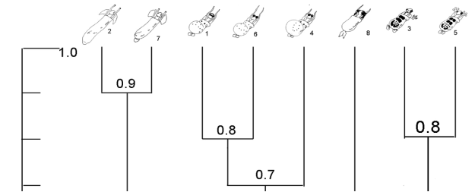
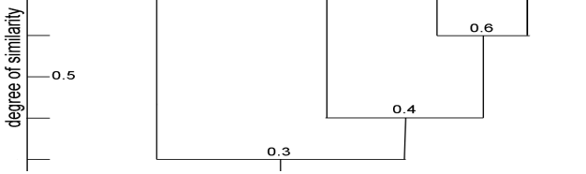
Fig1: Phenogram of the caminalcules clustered in the sample exercise
- This phenogram is designed to not only indicate which of the Caminalcules are the most physically similar, but also to what degree they are phenotypically similar.

Exercise1: By using the hypothetical OTUs and characters in the following table, answer questions from i-iii. (OTUs represent four hypothetical taxa (e.g. species) for which their five characters are selected for this exercise. Presence of a character is represented by 1 while 0 represents the absence of a character).

OTUs  (Species) | Characters
OTUs  (Species) | 1 | 2 | 3 | 4 | 5
A | 0 | 0 | 1 | 1 | 0
B | 1 | 1 | 1 | 1 | 0
C | 1 | 1 | 0 | 1 | 0
D | 1 | 1 | 1 | 0 | 1

- Calculate the simple similarity coefficient (Ssm) and construct a similarity table (a similarity matrix).
- Which two different OTU’s are the most similar?
- Which two different OTU’s are the most different?
- Try to draw a phenogram for the given hypothetical OTUs.

III. Phylogenetic System of Classification/Cladistics
- classification based on phylogenetic data,
- developing a cladogram/phylogenetic tree.
- Cladogram = best estimate of phylogeny (evolutionary relationship) of organisms
- Characters are identified into:
- primitive (plesiomorphic) and advanced/ derived (apomorphic)
- Shared primitive character synplesiomorphy & shared advanced character synapomorphy are considered
- Synapomorphy is more important than synplesiomorphy in cladistics.
- Having similar characteristics due to a common ancestor = homologous features /homology is more important in cladistics. This means organisms that have recently evolved common characters are considered as evolutionarily more related.
- Having similar characteristics due to convergent evolution= analogous feature or homoplasy is not show presence of recent common ancestor.
eg. Having streamlined body shapes (in aquatic animals) is analogous= due to living in similar environment/ due to convergent evolution.
- Only shared derived homologous characters could possibly give us information about evolutionary r/ships or phylogeny ( Willi Hennig, 1966)
- The working units (taxa to be classified) in cladistics are called Operational Evolutionary Units (OEUs)
Fig2. Example of a Cladogram or Phylogenetic Tree for Taxa A–F
- Method that groups organisms that share derived characters = cladistics or phylogenetic systematics.
  - Constructing Cladogram
  - By considering symplesiomorphies & synapomorphies, and by identifying homologous & analogous characters
- a single branching pattern is selected from many possibilities.
- number of possible branching cladograms increases with increase in number of taxa.
- eg. For 2 taxa, only 1 cladogram; for 3 taxa, 3 different cladograms; and for 4 taxa, 15 cladograms can be constructed, etc (Figure
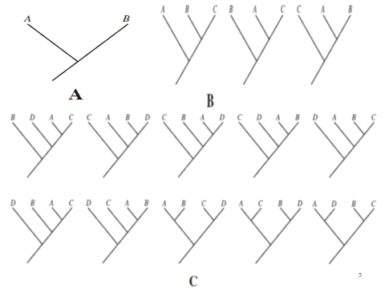
Fig 3: Possible cladograms with the different numbers of ETUs.
- From these many cladograms the one that is based on the fewest assumption is selected = principle of parsimony
- i.e. the one exhibiting the fewest number of evolutionary steps (the simplest one is accepted. )=the best estimate of phylogeny.
- A cladogram - infer collective evolutionary changes occurred.
may be used.to - classify life in a way that directly reflects evolutionary history.
- N.B: Phylogenetic tree shows only decency of common descent.
- does not indicate s "primitive" or "derived” taxa.
- Look at to the following example.
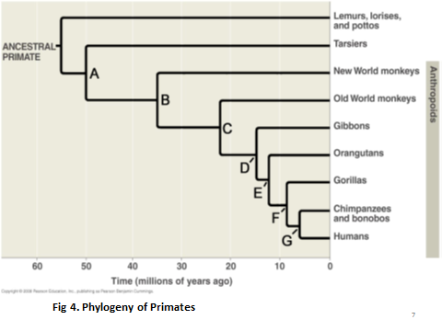
Some Principles to Construct Evolutionary Trees
Rule 1: The branches coming from every node can be rotated
- do not imply any sort of order; indicate only recency of common descent
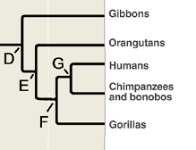
Fig. 5:
Rule 2: Two lineages (clades) branching from a single ancestral node = sister taxa.
- specialization after a branch point is irrelevant to the systematist
Rule 3: There is no such thing as a “most highly evolved species”.
Rule 4: No extant taxon is ancestral to any other extant taxon.
When an ancestral lineage diverges to become two separate taxa, the ancestral lineage is considered extinct.
eg. “Humans evolved from monkeys”.( incorrect)
Humans and monkeys share a common ancestor. (correct)

Monophyletic, Paraphyletic and Polyphyletic Taxa
- A monophyletic taxon -consists of a common ancestor + all descendants of that ancestor.
eg. Reptilia can be made monophyletic by including Aves (birds).
- A paraphyletic group -includes a common ancestor & some, but not all known descendants of that ancestor.
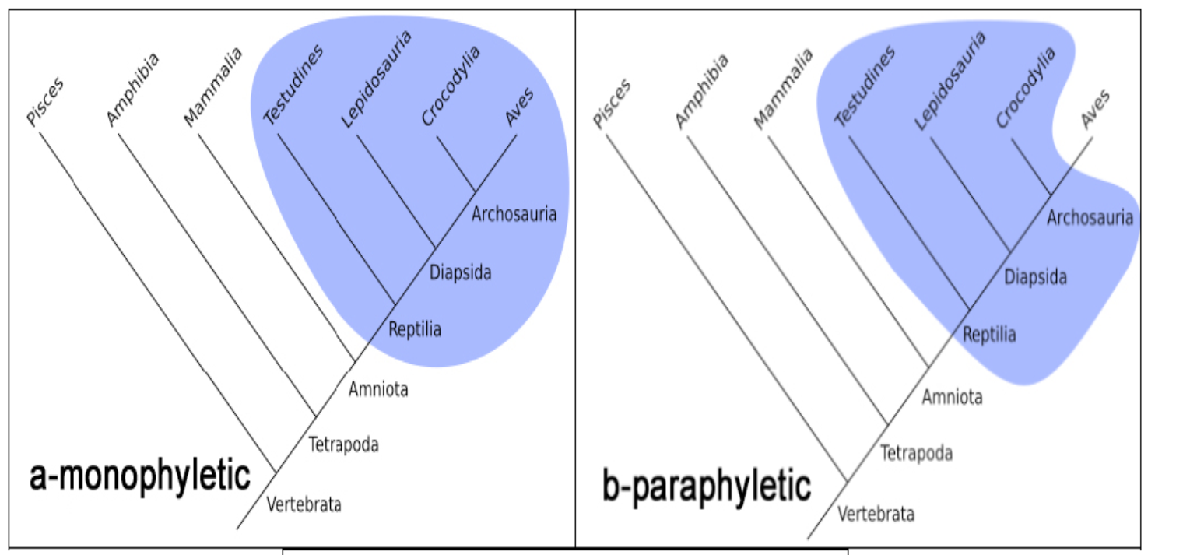
Fig 6. Vertebrate taxa are grouped in Monophletic (a), Paraphyletic (b)
- A polyphyletic taxon- includes members that have descended from two or more different ancestors, but the common ancestor of those has not been included.
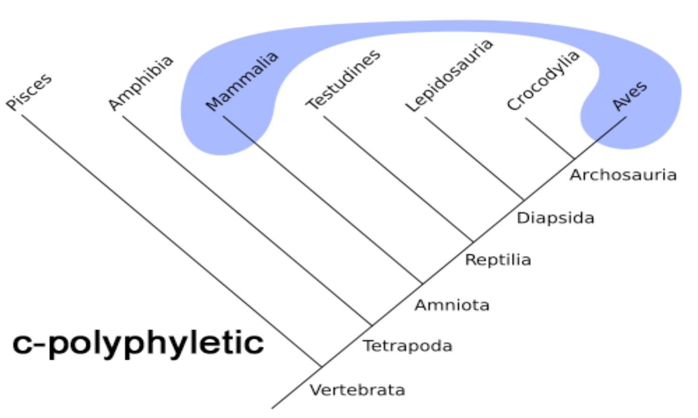
Fig: 7
- The polyphyletic tree/classification based on superficial similarity, such as “warm bloodedness” or “four-chambered heart”.
- These characters most likely evolved independently in mammals and in birds.
Determining Primitive and Derived Characters
- The 1st step in cladistic analysis is determining Plesiomorphic & Apomorphic character states.
- Designation of relative ancestry to character states (morphocline)-determination of polarity.
e.g. If a superior ovary is hypothesized as ancestral to inferior ovary , the polarized morphocline = superior ovary → inferior ovary.
- For determination of polarity, outgroup comparison method is the primary one.
- If a taxon that is not a member of group of organisms being classified has a plesiomorphic character that is shared with some of the organisms in the group, the taxon will be an outgroup .
- The outside taxon = outgroup and the organisms being classified = ingroup.
Fig7. Branching of Ingroup and Outgroup from a common Ancestor
e.g. Let a character has states ‘a’ and ‘b’. There are only two possibilities:
- ‘ b’ is plesiomorphic and ‘a’ is apomorphic, b →a (b has evolved to a), or
- ‘a’ is plesiomorphic and ‘b’ is apomorphic, a →b (a has evolved to b).
- If state ‘a’ is also found in the outgroup, the 1st hypothesis will force you to make more assumptions than the 2nd (it is less parsimonious),
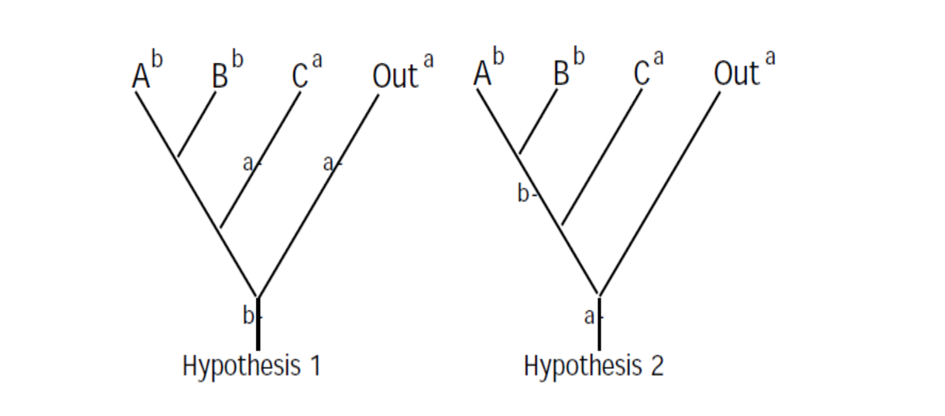
- In hypothesis 2, state a is the plesiomorphic state & both character states a & b each evolve only once.
- Thus, hypothesis 2 is more parsimonious and is a more defensible hypothesis.
- The state which is in the outgroup is primitive & the one found only in the ingroup is derived.
- Commonly, primitive states are designate by 0 (zero) and the derived states by 1 (one).
OEUs | Characters
OEUs | 1 | 2 | 3 | 4 | 5
Outgroup | a | a | a | a | a
A | a | a | b | a | b
B | b | a | a | b | a
C | a | a | a | b | b

Notice: In the tables above, the pleiomorphic (a) and apomorphic (b) character states.
OEUs | Characters
OEUs | 1 | 2 | 3 | 4 | 5
Outgroup | 0 | 0 | 0 | 0 | 0
A | 0 | 0 | 1 | 0 | 1
B | 1 | 0 | 0 | 1 | 0
C | 0 | 0 | 0 | 1 | 1
Constructing a Cladogram
- By Hennig Argumentation and Wagner Method.
Hennig Argumentation method:
- Considers the information provided by each character one at a time.
- Easiest to understand with a small data set as shown in example below.
OEUs | Characters
OEUs | 1 | 2 | 3 | 4 | 5
Outgroup | 0 | 0 | 0 | 0 | 0
A | 1 | 0 | 0 | 0 | 1
B | 1 | 1 | 0 | 1 | 0
C | 1 | 0 | 1 | 1 | 0
- Character 1 unites taxa A, B, and C because they share apomorphic state
- For character 2, derived state is found only in taxon B. It is an autapomorphy for taxon B, and provides no more information.
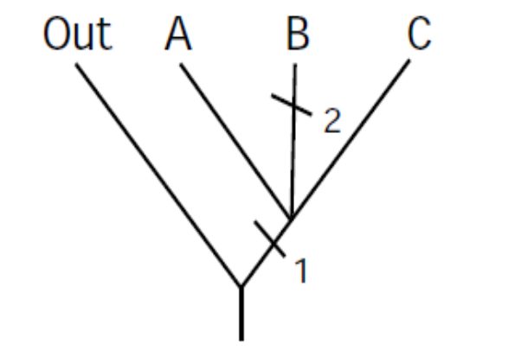

- For character 3, the derived state is an autapomorphy for taxon C:
d. For character 4, the derived state is a synapomorphy that unites taxa B and C:

e. For character 5, the derived state is an autapomorphy for taxon A.
- The cladogram is finished: all characters have been considered & the relationships of the taxa are resolved.
- The cladogram is finished: all characters have been considered & the relationships of the taxa are resolved.

Unit 4 : Taxonomic Structure
Taxonomic Hierarchy & Ranks of Taxa
- Taxon (Taxa pl ):) taxonomic groups eg. species, genera, families, etc.
- Taxonomic Hierarchy: being inclusive of taxa as one proceeds from lower taxa to higher taxa.
- Ranks of taxa: levels in the hierarchy of classification
- can be illustrated by a nested box system, a box within box arrangement.
The outermost box = highest category and includes smaller inner boxes.
The innermost box = smallest category.
- Spermacoce articularis belongs to the category ‘species’ at the rank of ‘species’
- Rubiaceae is another taxonomic group, family, of the category ‘family’, at the rank of ‘family’.
- The use of the same term to denote different things might seem confusing.

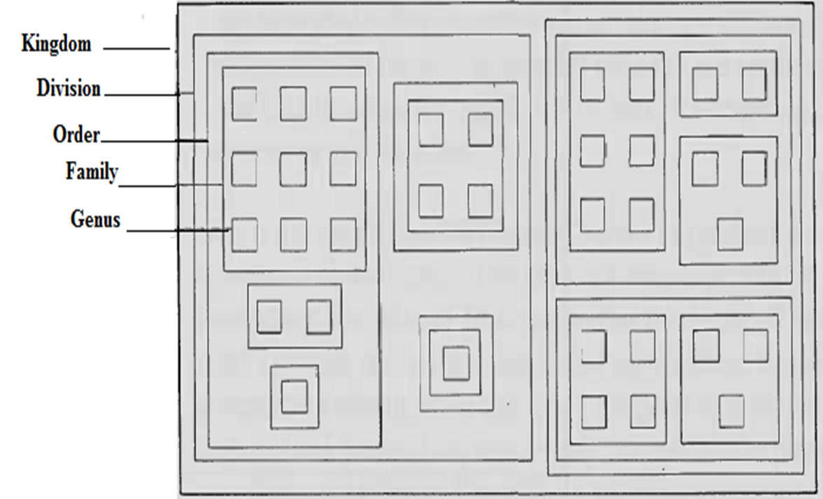

Fig. 8: A Nested box system
- Thus, taxonomic structure is clarified by the example of filling of cabinet that consist of a series of vertical boxes:
I. Level of each box represents taxonomic ‘rank’ in the hierarchy,
II. The empty box at a particular level/rank = taxonomic ‘category’, and
III. Finally, contents of the box =‘taxonomic group’ or ‘taxon’.
Major Recognized Taxonomic Ranks in Biology
- Theoretically, there is no limit to the number of levels contained in hierarchy.
e.g. ICBN recognizes twelve main ranks in the hierarchy (kingdom, division, order, family, tribe, genus, section, series, species, variety and form).
- Main taxonomic ranks and standard ending of for plants, animals, bacteria and fungi are shown in the Table below.

Table: Main taxonomic ranks & standard ending of for plants, animals, bacteria.
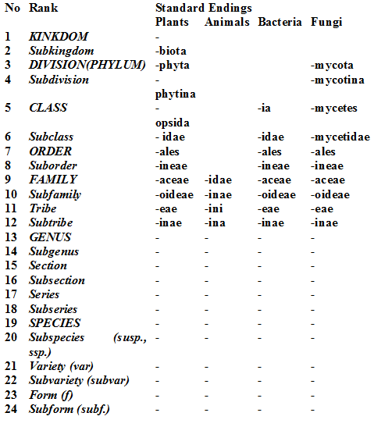
Concepts of the Kingdom
Different Kingdom Systems
- No of kingdom has increased from 2 to 5 or 6/7.
- Two kingdom approach:
The classification of living things into animals and plants is an ancient one. Aristotle (384 BC–322 BC) classified animal species in his work entitled History of Animals, and his pupil Theophrastus (371-287 BC) also wrote a parallel work on plants (the History of Plants).
Carolus Linnaeus distinguished two kingdoms of living things: Animalia for animals and Vegetabilia for plants (Linnaeus also treated minerals, placing them in a third kingdom, Mineralia). He also divided each kingdom into classes, later grouped into phyla for animals and divisions for plants.
According to the two kingdom approach, kingdom animalia included every living thing that moved, ate, and grew to a certain size and stopped growing. Kingdom plantea included every living thing that did not move or eat and that continued to grow throughout life. Later on, it became very difficult to group some living things into one or the other, so the number of kingdoms was increased.
- kingdom animalia -living thing that moved, ate, and grew to a certain size
- Kingdom plantea - living thing that did not move or eat and that continued to grow
ii) Three Kingdoms
- A third kingdom, protista (unicellular) was proposed by Ernst Haeckel in 1866.
- Whether organisms are unicellular (Protista) or multicellular (Animals and Plants).
- Three kingdom systems: Kingdom Protista, Kingdom Plantae and Kingdom Animalia.
III. Four kingdoms
- The result of thee discovery of the electron microscope
- A four-kingdom was proposed by Copeland in 1938
- Prokaryotes (bacteria and blue green algae =kingdom Monnera) and eukaryotics (plantae, Animalia & Protista) were distinguished
- Initiated the rank above kingdom, a super-kingdom/ empire/ domain = Prokaryot vs Eukaryta
IV. Five kingdoms
- proposed by Whittaker in 1969
- based mainly on differences in nutrition; multicellular saprotrophs formed kingdom Fungi
- Kingdom Monera (prokaryotic) and Eukaryotics (Kingdoms Protista, Plantae, Fungi & Animalia )
VI. Six Kingdoms
- Based on such RNA studies, Carl Woese divided prokaryotes (Kingdom Monera) = Eubacteria & Archaebacteria.
- Kingdom Bacteria, Archae, Protista, Plantae, Fungi & Animalia

Life | Domain Bacteria | Kingdom Bacteria
Life | Domain Archaea | Kingdom Archaea
Life | Domain Eukarya | Kingdom Protista
Life | Domain Eukarya | Kingdom Plantae
Life | Domain Eukarya | Kingdom Fungi
Life | Domain Eukarya | Kingdom Animalia

The Concept of the Species
- How best to define "species" is one that has debated biologists/naturalists for centuries
- the debate itself is called the species problem
- Species can be delimited broadly & inclusively, or narrowly → created conflicts b/n groups of taxonomists (b/n “lumpers” & “splitters).
- No one definition of species has yet satisfied all naturalists/taxonomists.
Different Species Concepts ( > 26 different concepts)
- “Biological” or reproductive isolation concept:
  - Taxa possessing reproductive isolation with respect to other species.
- Cladistic concept: unbranched segments/ lineages in an organismal phylogeny.
- Darwin’s morphological concept: “Varieties” b/n w/h there are no or few morphological intermediate.
- Recognition species: a group of organisms that recognize each other for mating & fertilization
- Ecological concept: “A lineage w/h occupies an adaptive zone different from that of any other lineage.
- Evolutionary concept: a lineage evolving separately & “with its own unitary evolutionary role and tendencies.”
- Population concept: Populations are the real units of evolution, not species.

5. Taxonomic Characters
- Features used as evidence for classification/ tax discovery =taxonomic characters.
Continuous and discontinuous characters/ variations
- Characters show slight/ significant differences among individuals/taxa= variations
- Discontinuous Variation: two or more distinct phenotypes are observed.
  - e.g. Blood group: O, A, AB/B ; ability to roll tongue: either tongue roller / not
- Continuous variation: phenotypes with a wide range of quantitative/qualitative values exist.
e.g. Body weight, height, hand span & shoe size in human& milk yield in cows
- Continuous variation is more common than discontinuous ones
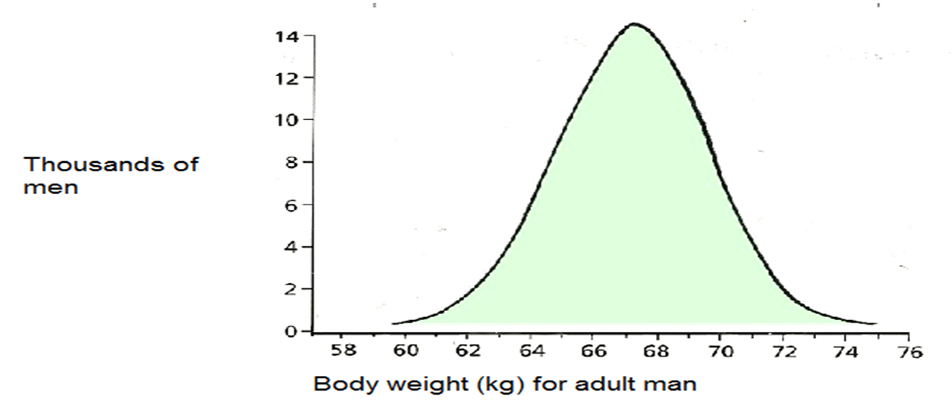
Fig 9: Body weight of adult men (examples of continuous variation)
- Discontinuous characters are commonly used in classification as they are easier to analyze.
- Diagnostic characters: identify a taxon from other related taxa.
- Diagnostic characters are distinct and sometimes unique to a particular taxon.

Sources of Taxonomic Characters
- Includes morphological & anatomical structures, molecular structures (genetic materials and proteins), embryology, palynology, and behavioral features.
- Morphological characters
- Morphological character refers to characters of external form/appearance of an organism.
- e.g. Vegetative characters (roots, stems, and leaves) & reproductive structures (flowers, fruits, & seeds) in plants
- Skull bones, limb bones, scales, hair & feathers can be used for the same purpose in animals
- Can be from living specimens and fossils
- Extensively used for centuries & for practical identification; e.g. In practical identification keys
- Anatomical characters
- Anatomical characters refers to the characters of internal structures of an organism
eg. Xylem & phloem, nodal anatomy, leaf anatomy, & floral anatomy, etc. in plants, and the bone structure, and the structures of different organs and tissues of animals.
- Homologous structure is more important than analogous ones in classification, particularly in cladistics.
- Comparative Embryology
- Study of embryological development of an organism.
- Homologous structures sometimes can be evident only in embryological stage, not exist in adults.
eg. Post-anal tail & paired pharyngeal pouches on sides of throats in all embryos of vertebrates.
- Develop to gills (fish), cavity of middle ear & auditory tube, tonsils, thymus and parathyroid glands (man)
- Embryologists of late 19th C proposed extreme view = "ontogeny recapitulates phylogeny" = theory of recapitulation.
- Ontogeny is a replay of phylogeny, but it is overstatement (exaggeration).
- not supported by scientific evidence
- In plants, embryology = study of development of sporangia, gametophytes & embryos.
- Differ from Bryophytes to seed plants.
- Palynology
- the study of pollen & spores
- Taxonomic characters: pollen nucleus number, storage product, polarity, aperture (pore), symmetry, pollen size, shape and pollen sculpturing (lobes).
- Behavioral or Ecological Features
- conform the biological peculiarities of particular taxa.
- genetically fixed without ontogenetic learning, such as call patterns of insects, bats and frogs.
- Genetic (Chromosomal and Molecular) Evidence
- Evidences from Chromosomes
- **Chromosome number= chromosome number is generally constant within a species
- May vary for varieties, subspecies, etc

- Chromosome Structure
- Chromosome size, location of the centromere and banding patterns varies and may used in classification.
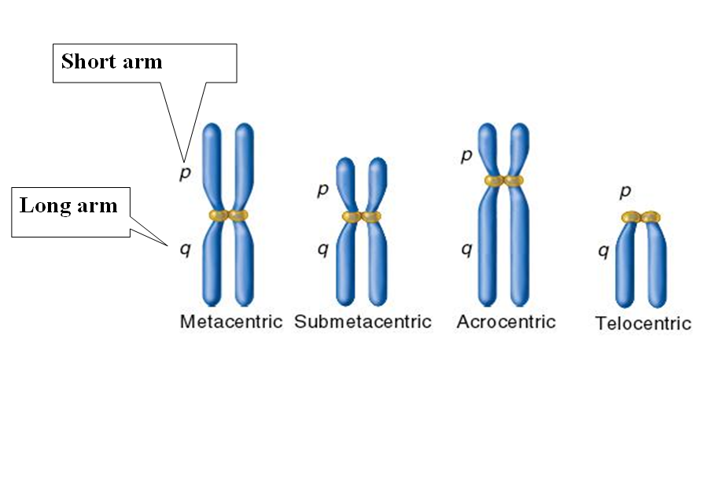

- Molecular systematics: using data on the molecular constitution of biological organisms: DNA, RNA, or both (and sometimes proteins), in order to resolve questions in systematics.
- Sequences of nucleotides in DNA and RNA, and the sequences of amino acids in polypeptides (proteins) are good sources of molecular data for classification.

