Combined IR Spectroscopy and Mass Spectrometry Problems

Determine the molecular formula and possible structures for each unknown based on the given
spectra. Use the IR Correlation Table. Note: DOU = #Cs+1-0.5(#Hs-#Ns+#halogens).

SHOW YOUR WORK!
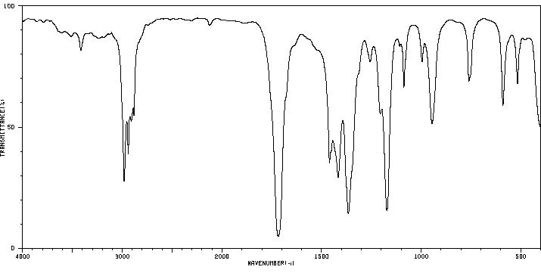
1.

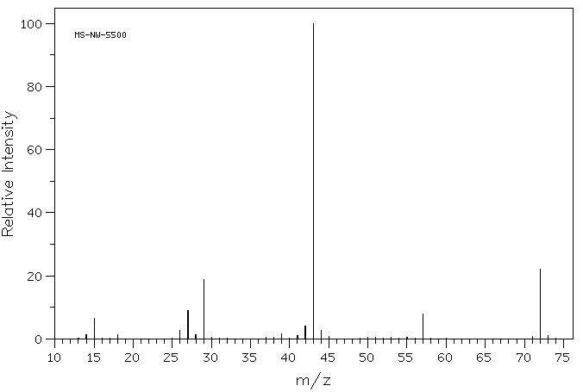
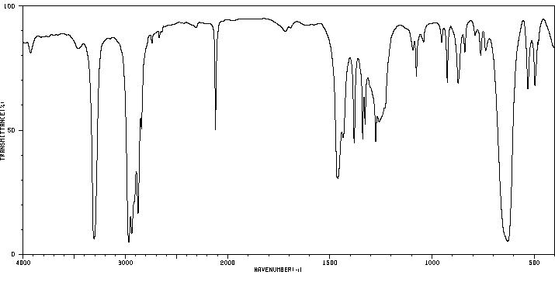
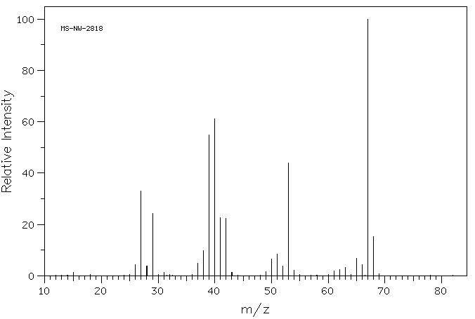

2.

M+• = 68

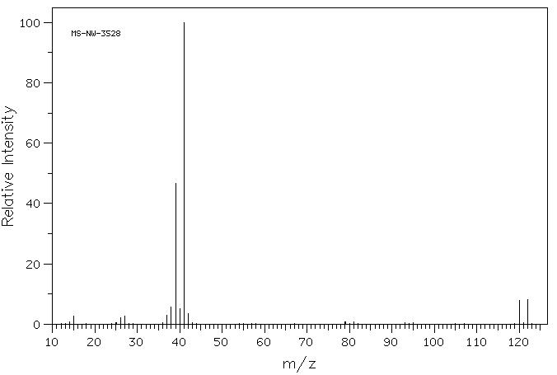
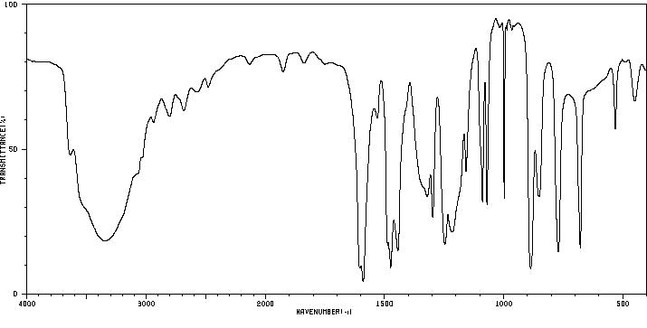
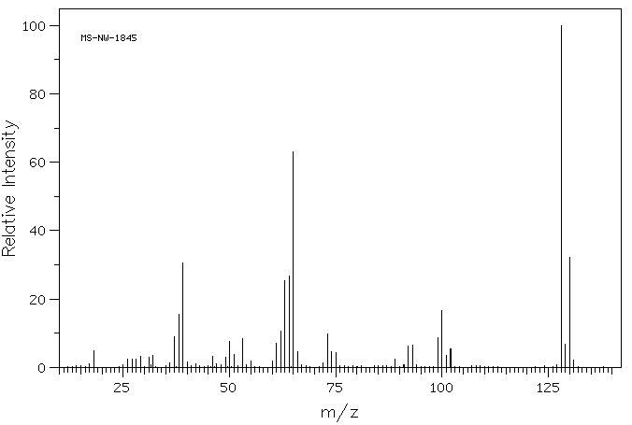

3.


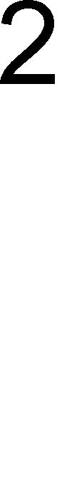


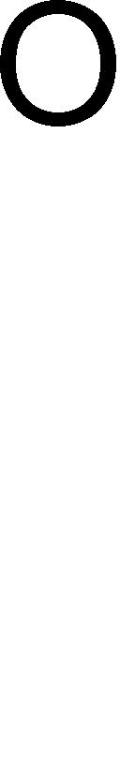


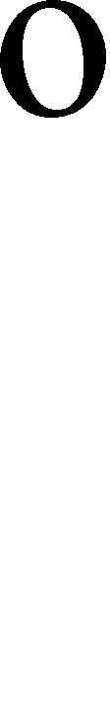


Answers
1. m/z = 59, odd mass means odd # of Ns. IR (2 peaks at 3300-3500 cm-1 and 1 peak at 1600
cm-1): NH₂. 59 – 16 (NH₂) = 43. 43/12 = 3Cs + 7Hs. Total of 9Hs (two from NH₂): C₃H₉N.

DOU = 0.

Structures:

1. m/z = 72. IR (~1700 cm-1): C=O. 72 – 28 (C=O) = 44. 44/12 = 3Cs + 8 Hs. Total of 4Cs:

C₄H₈O. DOU = 1.

Structures:

2. m/z = 68. IR (2100-2200 cm-1): C≡C or C≡N. IR (3300 cm-1, sharp): C≡C-H.

Thus, it’s C≡C NOT C≡N. 68 – 25 (C≡C-H) = 43. 43/12 – 3Cs + 7Hs.

Total of 5Cs and 8Hs: C₅H₈. DOU = 2.

Structures:

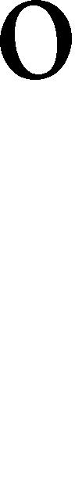




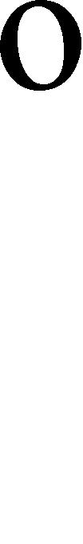


4. M = 120, M+2 = 122 (1:1, 1 Br present). 120 – 79 (Br) = 41. 41/12 = 3Cs + 5Hs.

C₃H₅Br. DOU = 1.

Structures:

3. M = 128, M+2 = 130 (3:1, 1 Cl present). IR (3200-2600 cm-1, broad): OH.
IR (1450-1600 cm-1): benzene C=C. 128 – 35 (Cl) – 17 (OH) = 76. 76/12 = 6Cs + 4 Hs (from
benzene). Total of 5Hs: C6H5ClO. DOU = 4.

Structures:

