Combined Structural Problems Procedure

There are 3 main tools that you will use/see/encounter as budding young chemists that will help you determine the structures of organic molecules. These tools are Infrared Spectroscopy (IR), Mass Spectrometry (MS) and Nuclear Magnetic Resonance Spectroscopy (NMR).

There are three basic things you would like to know in order to begin to answer the question. They would be, in no particular order,…

a. What functional groups are present?
b. The molecular weight
c. How the functional groups are assembled
d. Molecular formula

Mass Spectrum:-MS allows one to determine the molecular weight of an unknown compound if the M+· peak can be identified. Use Rule Thirteen to find molecular formula. An odd molecular weight suggests that an odd number of N atoms are present. The presence and size of an M+2 peak tells you whether Cl or Br atoms are present. The size of the M+1 peak tells you how many C atoms are present. The fragmentation pattern observed in MS provides clues to the structure of a compound.
Table of Common Fragments

Note: this table is not exhaustive but instead represents fragments you are likely to encounter in the simpler kinds of compounds we study in this course. In this table, as in all of the tables in this section,
the benzene ring is represented by φ.

Table of Common Fragments Lost
Sometimes fragment peaks are more easily interpreted if considered as "fragments lost" rather than specific fragment ions (for example, P-17 in an alcohol represents loss of -OH). The table below gives some of these values and their usual assignments. Most species are radicals.
Infrared Spectrum:- The motions of all but the simplest molecules are extremely complex, so we divide the IR spectrum up into the interpretable region (4000-1500 cm-1) and the fingerprint region (1500-800 or so cm-1). IR spectra allow one to determine the presence or absence of certain functional groups in a compound. It is especially useful for identifying
OH, NH, CX, C=C, and C=O groups.

When you analyze the spectra, it is easier if you follow simple series of steps.

- Look first for the carbonyl C=O band. Look for a strong band at 1820-1660 cm-1. This band is usually the most intense absorption band in a spectrum. It will have a medium width. If you see the carbonyl band, look for other bands associated with functional groups that contain the carbonyl by going to step 2. If no C=O band is present, check for alcohols and go to step 3.
- If a C=O is present you want to determine if it is part of an acid, an ester, or an aldehyde or ketone. At this time you may not be able to distinguish aldehyde from ketone and you will not be asked to do so.

ACID
Look for indications that an O-H is also present. It has abroad absorption near 3300-2500 cm⁻¹. This actually will overlap the C-H stretch. There will also be a C-O single bond band near 1100-1300 cm⁻¹. Look for the carbonyl band near 1725-1700 cm⁻¹.

ESTER

ALDEHYDE

KETONE

Look for C-O absorption of medium intensity near 1300-
1000 cm⁻¹. There will be no O-H band.

Look for aldehyde type C-H absorption bands. These are
two weak absorptions to the right of the C-H stretch near
2850 cm⁻¹ and 2750 cm⁻¹ and are caused by the C-H bond
that is part of the CHO aldehyde functional group. Look
for the carbonyl band around 1740-1720 cm⁻¹.

The weak aldehyde CH absorption bands will be absent.
Look for the carbonyl C=O band around 1725-1705 cm⁻¹.

3. If no carbonyl band appears in the spectrum, look for an alcohol O-H band.

ALCOHOL

Look for the broad OH band near 3600-3300 cm⁻¹ and a C-
O absorption band near 1300-1000 cm⁻¹.

4. If no carbonyl bands and no O-H bands are in the spectrum, check for double bonds, C=C, from an aromatic or an
alkene.

ALKENE

AROMATIC

Look for weak absorption near 1650 cm⁻¹ for a double bond.
There will be a CH stretch band near 3000 cm⁻¹.

Look for the benzene, C=C, double bonds which appear as
medium to strong absorptions in the region 1650-1450 cm⁻¹.
The CH stretch band is much weaker than in alkenes.

5. If none of the previous groups can be identified, you may have an alkane.

ALKANE

The main absorption will be the C-H stretch near 3000 cm⁻¹.
The spectrum will be simple with another band near 1450 cm⁻¹.

6. If the spectrum still cannot be assigned you may have an alkyl bromide.

ALKYL BROMIDE Look for the C-H stretch and a relatively simple spectrum
with an absorption to the right of 667 cm⁻¹.

The ¹H NMR spectrum detects a single resonance for every non-equivalent 1H in the compound. The chemical shift of the resonance, which is independent of spectrometer frequency when it is expressed in ppm, gives information about the chemical environment of the ¹H’s. The resonances can be integrated to obtain the number of H atoms contributing to each resonance. The multiplicity of a resonance tells us how many neighbours the ¹H’s contributing to that resonance have.

¹³C NMR spectrum :-The number of different signals indicates the number of different kinds of carbon. The location (chemical shift) indicates the type of functional group. The peak area indicates the numbers of carbons (if integrated). The splitting pattern of off-resonance decoupled spectrum indicates the number of protons attached to the carbon
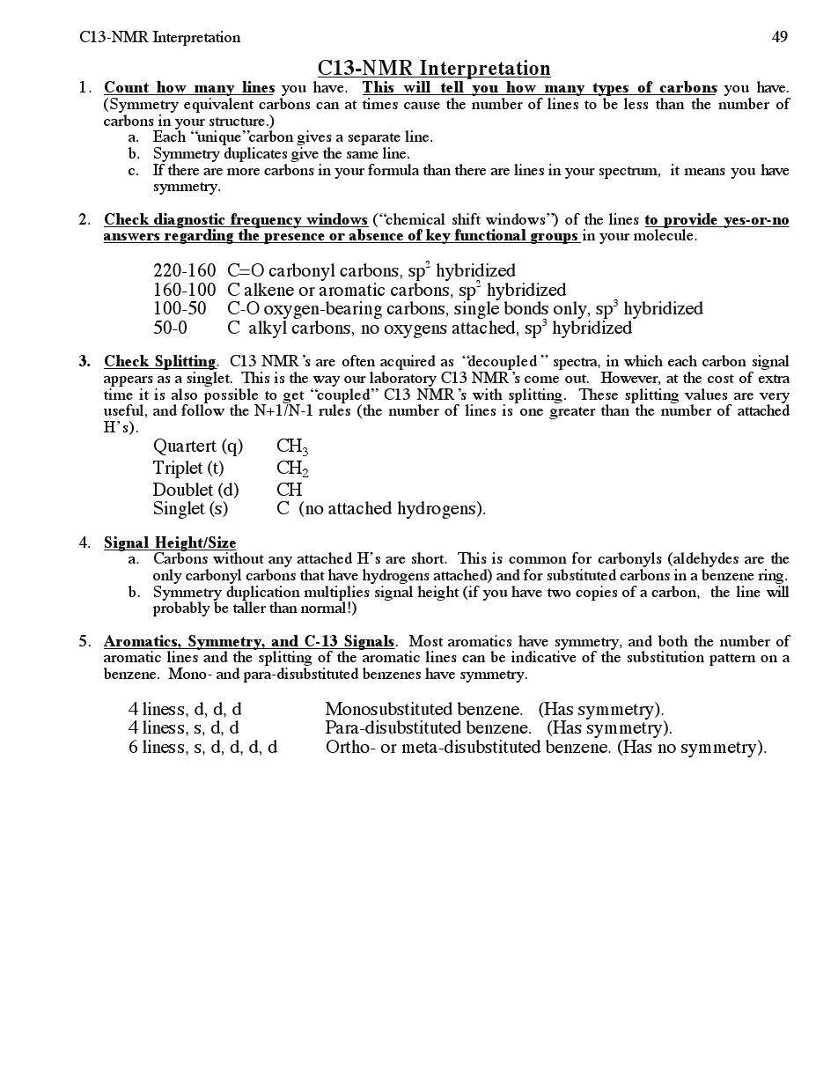
Ultraviolet-Visible (UV-vis) spectroscopy measures the absorption of visible and ultraviolet light by π bonds in an organic compound. Bonds of different types (C=C, C=O) and with different extents of conjugation (C=C vs. C=C–C=C vs. aromatic) absorb energy of different wavelengths.
- A single band of low to medium intensity (ԑ=100-10000) at <220 nm indicate Amines, alcohols, ethers and thiol. no conjugation
- A single band of low intensity(=10 to 100) in region 250-360 nm with no majer absorption at shorter wavelength (200-250nm), unconjugated may contain O,N, or S atom ex. C=O,C=N, N=N
- Two bands of medium intensity (= 1000-10000) both >200 nm indicate the presence of aromatic system (conjugation)
- Bands of high intensity (=10000-20000) that appear above 210nm represent –unsaturated ketone
Exercise 1
.
Exercise 2

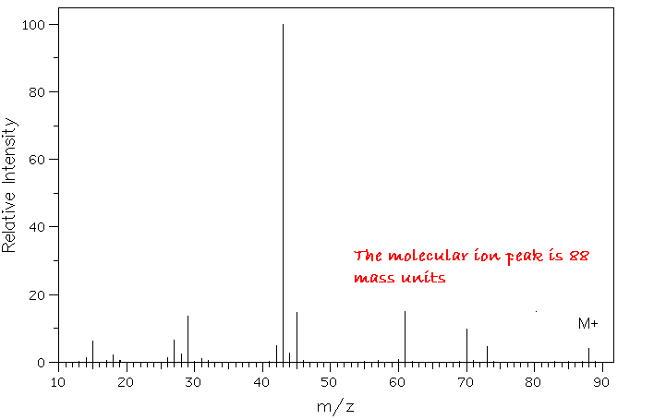
3

