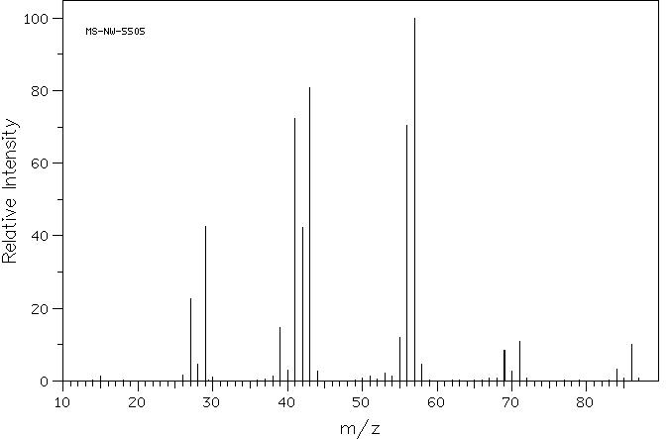
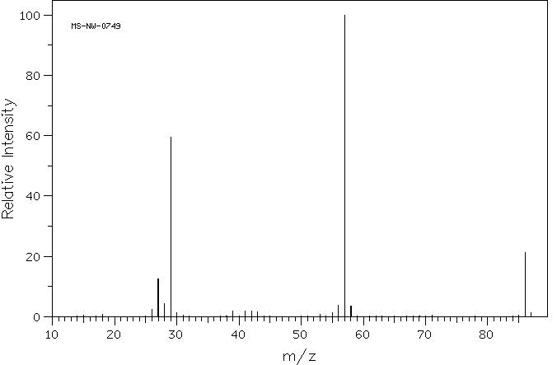
Mass Spectrometry Problems

1) Calculate the exact mass and average mass for these structures.

O
Br
NH

C₇H₁₆C₁₃H₁₁NO C₆H₅Br

C₆H₈

2) Match each structure to one of the following mass spectra.

a

C₅H₁₃N

NH₂

b

O
C₅H₁₀O

c

C₆H₁₄

d
Exact Mass: 87.1

e
O
Exact Mass: 86.1

f
Exact Mass: 86.1

g

C₆H₁₄
Exact Mass: 86.1

N
H
C₄H₉NO
Exact Mass: 87.1

N

C₅H₁₃N
Exact Mass: 87.1

O

C₅H₁₀O
Exact Mass: 86.1

mass = 86, unbranched, M-15 (CH₃)
mass = 86, unsaturated, M-29 (CH₂CH₃)

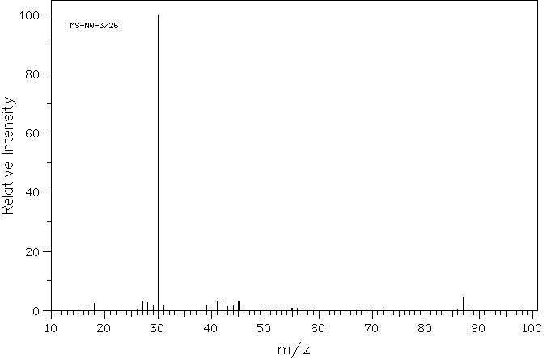
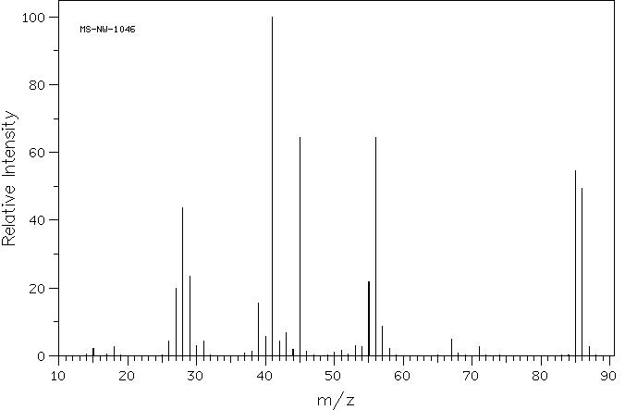
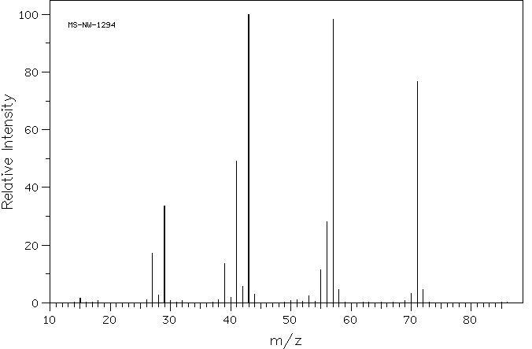
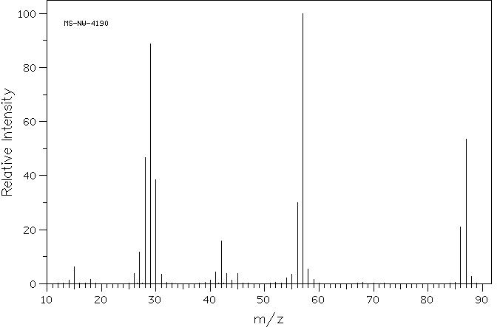
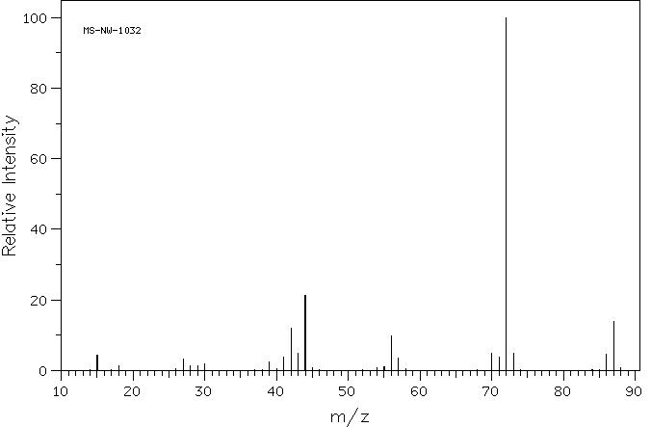

mass = 87, unbranched

mass = 86, branched, large M-15 (CH₃)

mass = 87, branched, large M-15 (CH₃)

mass = 86, ring, M-30 (CH₃CH₃)

mass = 87, ring, M-30 (CH₃CH₃)

