

BA IN Logistic and Supply chain Management
COURSE MATERIAL FOR
E-COMMERCE AND SUPPLY CHAIN INFORMATION SYSTEM (LSCM2052)
CREDIT HOUR: 3 (5 ECTS)
TARGET GROUP: 3RD YEAR, 2ND SEMESTER

Compiled by:
Gebrekiros Hagos Belay (MA. Business Administration)
Assistant Professor , Department of Management , CBE, MU
Email:gebrekiros.hagos2@mu.edu.et
Mobile No. +251938132091
LinkedIn: Gebrekiros Hagos
Website: http://www.mu.edu.et
Facebook: https://www.facebook.com/MekelleUniversity
Twitter: https://twitter.com/MekUniETH
Department of Management
College of Business and Economics
Mekelle University

April 2020
CHAPTER ONE
FUNDAMENTALS/ FOUNDATION OF SUPPLY CHAIN INFORMATION SYSTEMS
1.1 SYSTEMS CONCEPT
What is a system?
A system is a set of components (sub systems or component parts) that operate together to achieve a common objective (or multiple objectives) by accepting inputs and producing outputs in an organized transformation process.
Such a system (sometimes called a "dynamic system) has three basic interacting components or functions: input, process and output. Moreover, the systems concept can be made even more useful by including two additional components: feedback and control. A system with feedback and control components is sometimes called a "cybernetic" system, that is, self- monitoring, self-regulating system.
The hallmark (distinctive feature) of a system, as opposed to an unrelated collection of components, is synergy, an effect best defined by Aristotle: The whole is more than the sum of the parts. The objectives of a system are realized in its outputs.
Environment

Other Systems

Feedback Feedback
Signals Signals
Feedback signal
Control Signal Control Signal
Control signal

System Boundary
Control
Output
Processing
Input

Figure 1: cybernetic system
Input involves capturing and assembling elements that enter the system to be processed. Example: data
Processing involves transformation processes that convert inputs into output.
Output involves transferring elements that have been produced by a transformation process to their ultimate destination.
Feedback is data about the performance of a system. For example, data about sales performance is feedback to a sales manager.
Control involves monitoring and evaluation feedback to determine whether a system is moving toward the achievement of its goal.
A system performing properly generates positive feedback, which signals the control function to maintain the system's current course toward its goal. A system whose performance is deteriorating - deviating from the attainment of its goal- generates negative feedback. In real world, the performance of most systems tends to deteriorate overtime. This characteristic is called entropy - the tendency of a system to lose its homeostasis, that is, a relatively stable state of equilibrium. Thus, the function of control is to reverse the entropy and maintain the equilibrium of a system through a variety of corrective actions.
Characteristics of systems
A system exists and functions in an environment containing other systems (it doesn’t exist in a vacuum) If a system is one of the components of a larger system, it is called a subsystem, and the larger system is its environment. Also, a system is separated from its environment and other systems by its system boundary. Several systems may share the same environment. Some of these systems may be connected to one another by means of a shared boundary, or interface. Normally, a system that interacts with other systems in its environment is called an Open System. (The above figure represents an open system) If a system has the ability to change itself or its environment in order to survive, it is known as an Adaptive System.
1.2 INFORMATION SYSTEMS CONCEPT
1.2.1. Data, Information and Information Systems
So how can we distinguish between data and information? The distinction can easily be grasped from the following figure.
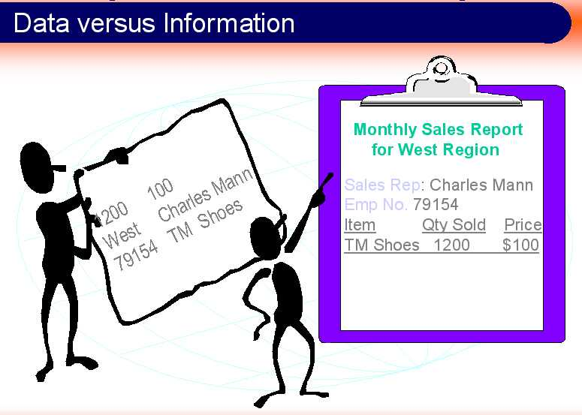
Figure 2: Data Vs Information
Data:
Data are only raw facts, the material for obtaining information. Information systems use data stored in computer databases to provide needed information. A database is an organized collection if inter related data reflecting a major aspect of a firm’s activities.

Information
Information is an increment in knowledge. It contributes to the general framework of concepts and facts that we know. Information relies on the context (your question) and the recipient’s general knowledge for its significance.
Example:
If I suddenly throw the word “five” into our discourse at this point, it obviously means nothing to you. It is a data item, but it becomes meaningful information only if it is placed within a context familiar to you. Now, if you had just asked me, “what were the sales of the packaged goods division last month?” then I have provided you with information rather than data. I provided information, that is, if you already know that the sales are measured in millions of dollars.
1.2.2. What is an Information System?
An information system is an organized set of components for collecting, transmitting, sorting, and processing data in order to deliver information for action. In business firms and other organizations, this information is necessary for both operations and management. Most technologies these days are built around the information technologies of computers and telecommunications- they are computer-based information systems.
Too often you hear someone say, "Oh yeah, I know how to use a computer. I can surf the Web with the best of them and I can play Solitaire for hours. I'm really good at computers." Okay. So that person can pound a keyboard, use a mouse at lightning speed, and has a list of favorite Web sites a mile long. But the real question is "Is that person information literate?" Just because you can pound the keyboard doesn't necessarily mean you can leverage the technology to your advantage or the advantage of your organization. An organization can gather and keep all the data on its customers that a hard drive can hold. You can get all the output reports that one desk can physically hold. You can have the fastest Internet connection created to date. But if the organization doesn't take advantage of customer data to create new opportunities, then all it has is useless information. If the output report doesn't tell the management that it has a serious problem on the factory floor, then all that's been accomplished is to kill a few more trees. If you don't know how to analyze the information from a Web site to take advantage of new sales leads, then what has you really done for yourself today?
As you may conclude, information literacy (and not just computer literacy!) is necessary to perform your job as a manager or a professional, to conduct a firm’s activities, and to seek opportunities in the market place for the products of a firm or of a nation.
In particular, the objective of information system is to provide the appropriate information output to the members of the organization.
Information systems transform data into information. To obtain information we need data.
If we expand our view of what an information system does, we can obtain the following figure.
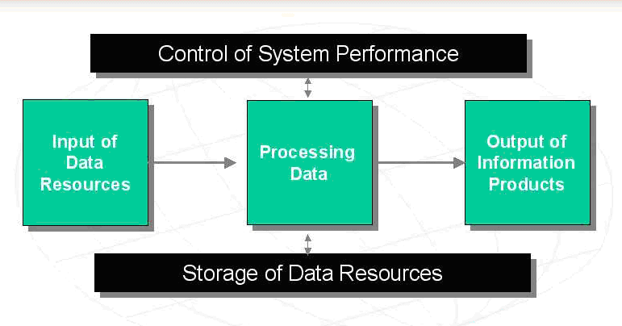
Figure 3: Transforming Data into Information
As you can see, information systems capture data from the organization (internal data) and its environment (external data). They store the data items over an extensive period of time when specific information needed, the appropriate data items are manipulated as necessary and the user receives the resulting information. Depending on the type of information system, the information output may take the form of a response to a database query, an outcome of a decision suggested by a decision support system, advice given by an expert system, a transaction document(say and invoice), or a report (which may appear on paper or on-screen). As the above figure tells you, the value of information is much higher than that of data.
In this course we discuss formal information systems that rely on procedures for collecting, storing, manipulating, and accessing data in order to obtain information. Formal systems don’t have to computerized, but today they usually are. Note that much of the information flowing in an organization, and very important information at that, is informal. Indeed, a lot of informal information is gained through interpersonal networking, water cooler gossip, or conversations with the supplier’s truckers at the loading dock.
1.2.3. Attributes of Quality Information
What characteristics would make information products valuable and useful to you? One way to answer this important question is to examine the characteristics or attributes of information quality. Information that is outdated, inaccurate, or hard to understand would not be very meaningful, useful, or valuable to you or other end users. People want information of high quality, that is, information products whose characteristics, attributes, or qualities help to make information more valuable to them. It is useful to think of information as having the three dimensions of time, content, and form. These dimensions are summarized as follows

Figure 4: Attributes of Quality Information
Time Dimension: deals with the when aspect of information
Timeliness: Information should be provided when it is needed
Currency: Information should be up-to-date when it is provided
Frequency: Information should be provided as often as needed
Time period: Information can be provided about past, present, and future time periods
Content Dimension: deals with the what aspect of information
Accuracy: Information should be free from errors
Relevance: Information should be related to the information needs of a specific recipient for a specific situation
Completeness: All the information that is needed should be provided
Conciseness: Only the information that is needed should be provided
Scope: Information can have a broad or narrow scope or an internal or external focus
Performance: Information can reveal performance by measuring activities accomplished, progress made, or resources accumulated
Form Dimension: deals with how aspect of information
Clarity: Information should be provided in a form that is easy to understand
Detail: Information can be provided in detail or summary form
Order: Information can be arranged in a predetermined sequence
Presentation: Information can be presented in narrative, numeric, graphic or other form
Media: Information can be provided in the form of printed paper documents, video displays, or other media.
1.2.4. COMPONENTS OF INFORMATION SYSTEMS
We are now ready to apply the system concepts we have learned to help us better understand how an information system works. We have said that an information system is a system that accepts data resources as input and processes them into information products as output. How does an information system accomplish this? What system components and activities are involved?
The following figure illustrates an information system model
An information system depends on the resources of
- People (end users and IS specialists)
- Hardware (machines and media)
- Software (programs and procedures)
- Data (data and knowledge bases)
- Networks (communications media and network support)
to perform input, processing, output, storage and control activities that convert data resources into information products.
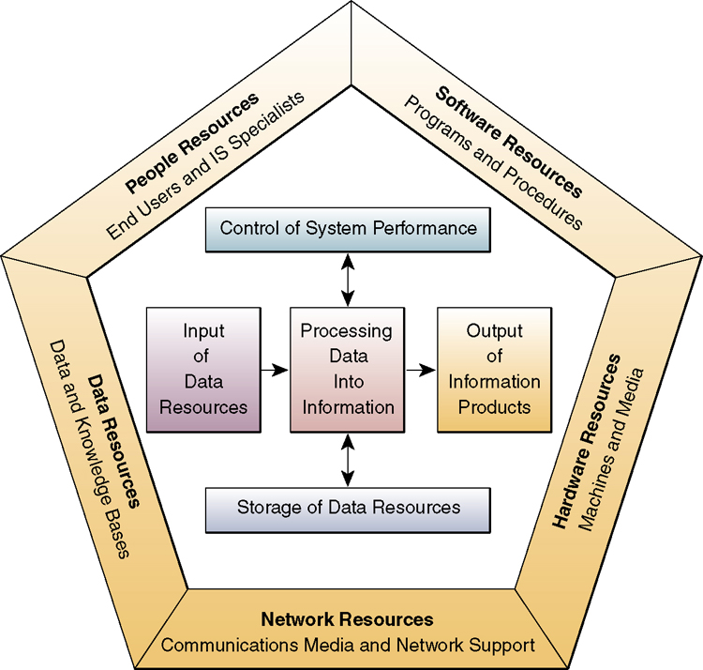
Figure5: The Information Systems Model
This information system model highlights the relationships among the components and activities of information systems. It provides a framework that emphasizes four major concepts that can be applied to all types or information systems:
- People, hardware, software, data, and networks are the five basic resources of information systems
- People resource include end users and IS specialists, hardware consists if machine and media, software resources include both programs and procedures, data resources can include data and knowledge bases, and network resources include communication media and networks.
- Data resources are transformed by information processing activities into a variety of information products for end users
- Information processing consists of input, processing, output, storage and control activities.
So, no matter what kind of information system you use, these four basic concepts are at work. And there are many kinds of information systems in the real world. Some are simple manual information systems, where people use tools such as pencils and paper, or even machines such as calculators and typewriters, to convert data into information. Others are computer based information systems that use one or more types of computers and a variety of computer devices to process data automatically.
1.2.4.1. Information System Resources
An information system consists of four major resources:
- Hardware Resources
The concept of hardware resources includes all physical devices and materials used in information processing.
It includes: machines and media
Examples
- Large mainframe computers, minicomputers and microcomputers
- Telecommunication networks
- Computer peripherals
2. Software Resources
Includes all sets of information processing instructions. It includes not only the set of operating instructions called programs, which direct and control computer hardware, but also set of information processing instructions needed by people, called procedures. So even information system that don’t use computers have a software resource component.
3. People Resources
People are required for the operation of all information systems. These people resources include end users and IS specialists.
End Users (users or clients) are people who use an information system or the information it produces.
IS Specialists are people who develop and operate information systems.
4. Data Resources
The data resources of information systems are typically organized into:
Databases – which hold processed and organized data
Model bases – which hold conceptual, mathematical, and logical models that express business relationships, computational routines, or analytical techniques
Knowledge bases – which hold knowledge in a variety of forms such as facts and rules of inference about various subjects
5. Network Resources
These resources include the communication media and network support
1.2.4.2. Information Systems Activities
The basic information processing activities that occur in information systems include:
Input of data resources
Data about business transactions and other events must be captured and prepared for processing by the basic data entry activities of recording and editing. End users typically record data about transactions on some type of physical medium such as paper form or enter it directly into a computer system. This usually includes a variety of editing activities to assure they have recorded data correctly. Once entered, data may be transferred onto a machine readable medium such as magnetic disk or tape, until needed for processing.
For example, data about sales transactions can be recorded on source documents such as paper sales order forms. Or sales data could be captured by salespersons using computer keyboards or optical scanning devices who are visually prompted to enter data correctly by video displays.
Processing of data into information
Data is manipulated by such activities as calculating, comparing, sorting, classifying, and summarizing. These activities organize, analyze, and manipulate data, thus converting it into information for end-users. The quality of any data stored in an information system must also be maintained by a continual process of correcting and updating activities.
For example, data received about a purchase can be 1) added to a running total sales results, 2) compared to a standard to determine eligibility for a sales discount, 3) sorted in numerical order based on product identification numbers, 4) classified into product categories (such as food and non food items), 5) summarized to provide a sales manager with information about various product categories, and finaly, 6) used to update sales records.
Output of information products
Information in various forms is transmitted to end users and made available to them in the output activity. The goal of information systems is the production of appropriate information products for end users. Common information products are video displays, paper documents, audio responses that provide us with messages, forms, reports, listings, etc.
For example, a sales manager may view a video display to check on the performance of a salesperson, accept a computer- produced voice by telephone, and receive a printout of monthly sales results.
Storage of Data Resources
Storage is a basic system component of information systems. Storage is an IS activity in which data and information are retained in an organized manner for later use.
For example, just as written material is organized into words, sentences, paragraphs and documents; stored data is commonly organized into field, records, files, and databases.
Control of System Performance
An information system should produce feedback about its input, processing, output, and storage activities. This feedback must be monitored and evaluated to determine if the system is meeting established performance standards. Then appropriate system activities must be adjusted so that proper information products are produced for end users.
For example, a manager may discover that subtotals of sales amount in a sales report do not add up to total sales. This might mean that data entry or processing procedures need to be corrected. Then changes would be made to ensure that all sales transactions would be properly captured and processed by a sales information system.
1.2.5. LEVELS AND TYPES OF INFORMATION SYSTEMS
Kinds (Levels) of Information System
• Strategic-Level Systems: support the long-range planning activities of senior management - match external and internal environments.
• Management-Level systems: support the monitoring, controlling, decision-making, and administrative activities of middle managers - periodic reports.
• Knowledge-Level Systems: support knowledge and data workers in an organization - control flow of knowledge.
• Operational-Level systems: monitor the elementary activities and transactions of the organization - real time data.
Types of Information System
• Executive Support Systems (ESS) - address non-routine decision making through advanced graphics and communications
• Management Information Systems (MIS) - serve the functions of planning, controlling, and decision making by providing routine summary and exception reports.
• Decision-Support Systems (DSS) - combine data and sophisticated analytical models or data analysis tools to support non routine decision making.
• Knowledge Work Systems (KWS) - aid the creation and integration of new knowledge in the organization.
• Office Systems - designed to increase the productivity of data workers in the office.
• Transaction Processing Systems (TPS) - perform and record the daily routine transactions necessary to conduct the business

1.3. Technology of information systems
1.3.1 INTRODUCTION TO INFORMATION TECHNOLOGY
Information Technology (IT) is a broad subject concerned with technology and other aspects of managing and processing information. It can also be defined as any computer-based tool that people use to work with information and support the information and information-processing needs of an organization. In particular,
- IT deals with the use of electronic computers and computer software to convert, store, protect process, transmit, and retrieve information.
- IT is mainly a synthesis of developments in the field of computer science and the developments in telecommunication technology.
- IT is a logical development arising out of confluence of telecommunication technology and compute technology which have unused the differences between collecting, storing and processing information and transporting the information elsewhere thereby driving the geographical distance to irrelevance.

THE COMPUTER SYSTEM CONCEPT
A computer is more than a processing "box" or a collection of electronic devices performing a variety of information processing chores. A computer is a system - an interrelated combination of components that perform the basic system functions of input, processing, output, storage and control, thus providing end users with a powerful information-processing tool. Understanding the computer as a computer system is vital to the effective use and management of computers.
MAJOR TECHNOLOGIES IN COMPUTER SYSTEMS
1. Computer Hardware 2. Computer Software
3. Telecommunications 4. Data Resource Management
      - COMPUTER HARDWARE
Computer hardware is the physical devices that make up a computer (often referred to as the computer system). Computer hardware refers to the physical facility or device used in inputting, processing, output, storing and communicating information.
They are of the following types.
- Input hardware
- Processing hardware
- Output hardware
- Storage hardware
- Communications hardware

INPUT DEVICES

Enter Data and
Instructions i
nto the
CPU

OUTPUT DEVICES

Communicate and
Record Information

SECONDARY
STORAGE
DEVICES

Store Data and
Programs for
processing

CENTRAL PROCESSING UNIT

CONTROL UNIT

Interprets
Instructions &
Directs Processing

ARITHMETIC
-

LOGIC UNIT

P
erforms Arithmetic
operations and
makes comparisons

PRIMARY STORAGE UNIT

Stores data and program instructions
during processing

o

Keyboard

o

Mouse

o

Touch screen

o

Optical
scanner

o

Light pen

o

Voice input

o

Etc

o

Visual display
unit

o

Printer

o

Audio
response unit

o

Physic
al
control device

Magnetic Disk
and Tape Units,
Optical Disk, etc

COMMUNICATION
DEVICES

A. INPUT HARDWARE
The function of input hardware is to collect data and convert data into machine-readable form for direct entry or through telecommunications links into the computer system.
The most common input devices are keyboard, mouse, touch screen, scanner etc
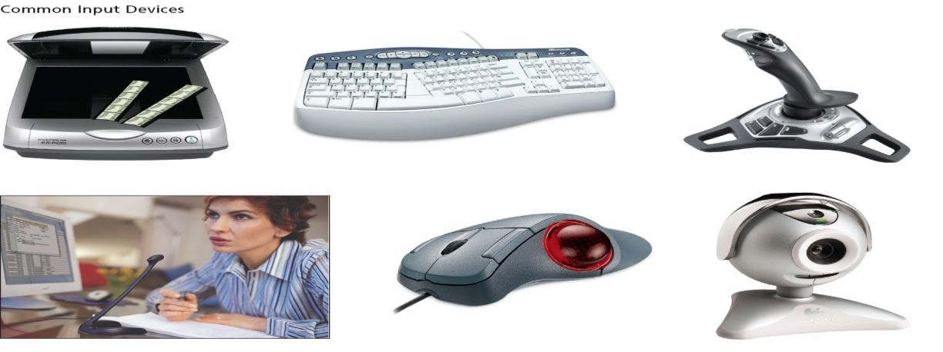

B. PROCESSING HARDWARE:
The function of processing hardware is to retrieve and execute (interpret) instructions (software) provided to the computer.
Processing may consist of performing calculations and similar logical activities, such as comparing sales figures, etc.
The essential components of processing hardware are
- The Central Processing Unit (CPU) and
- Main memory
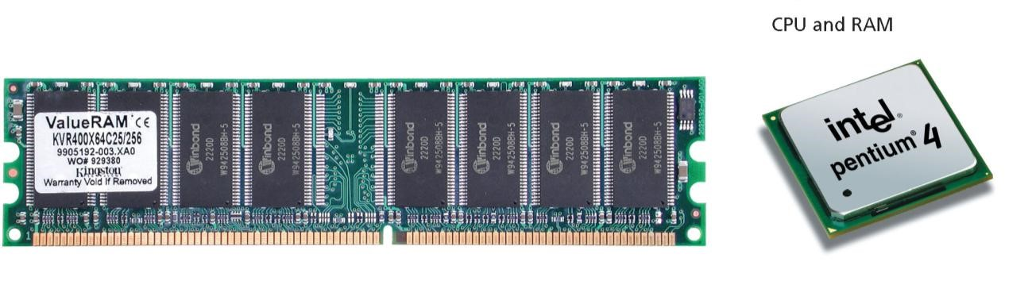

The CPU
The CPU, for central processing unit, follows the instructions of the software to manipulate data into information. The CPU consists of two parts:
- The Control Unit: That tells the rest of the computer system how to carry out a program's instructions. It directs the movement of electronic signals between main memory and the input and output devices.
The control unit obtains instructions from those stored in the primary storage unit and interprets them. Then it transmits direction to other components of the computer systems ordering them to perform required operations.
- Arithmetic/logic unit (ALU) performs arithmetic operations and logical operations and controls the speed of those operations.

Main Memory
Also known as, memory, primary storage, internal memory, or RAM (for random access memory) is working storage. It has three tasks:
- It holds data for processing
- It holds instruction (the program) for processing the data.
- It holds data after it is processed (that is, information) waiting to be sent to an output or storage device.

C. OUTPUT HARDWARE:
Consists of devices that translate information processed by the computer into a form that human can understand. The computer–processed information consists 0s and 1s, which need to be translated into words, numbers or pictures that people can comprehend.
The two principal kinds of output are hardcopy and softcopy.
Softcopy: refers to data that is shown on display screen or is in audio or voice form.
Hardcopy: refers to printed output–the principal examples are printouts, whether text or graphics.
Output devices communicate the results of the computer processing the input. Typical output devices are monitors and printers.
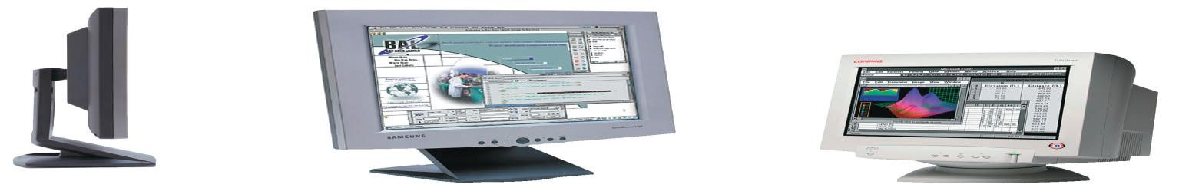
Monitor
Monitors allow the user to see the results of the computer processing their information.
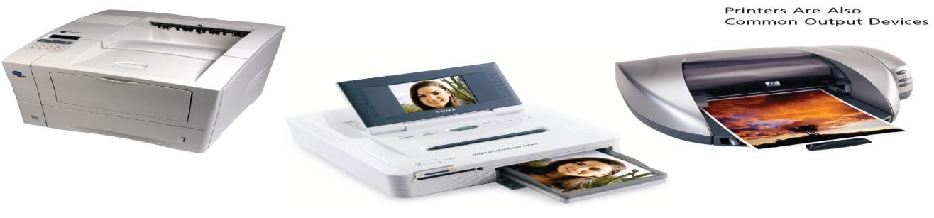
Printer
Printers give the computer user a "hard copy" of the results of the computer processing the input. This hard copy is usually paper but it can be in overhead transparencies or wax thermal paper.

D. STORAGE HARDWARE
This refers to hardware devices that are used for storage.

Primary and Secondary Storage
The term primary storage (main memory) refers to RAM, where both data and instructions are temporarily held for immediate access and use by the computer's microprobes.
Secondary storage (or auxiliary storage) is any storage device designed to regain data and instructions (programs) in a relatively permanent form. Secondary storage is non–volatile, meaning saved data and instructions remain intact when the computer is turned off.
Secondary storage devices include:
- Diskettes/floppy disk
- Hard disks
- Magnetic tape
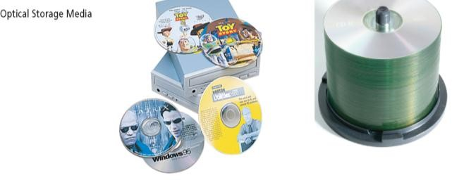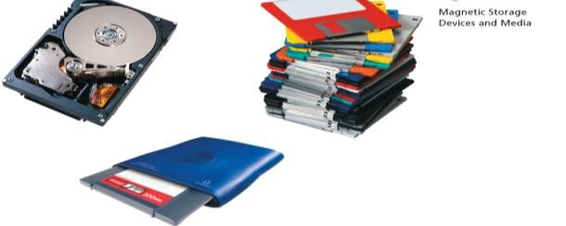
–

Optical disks

Magnetic storage devices and media

Optical storage media

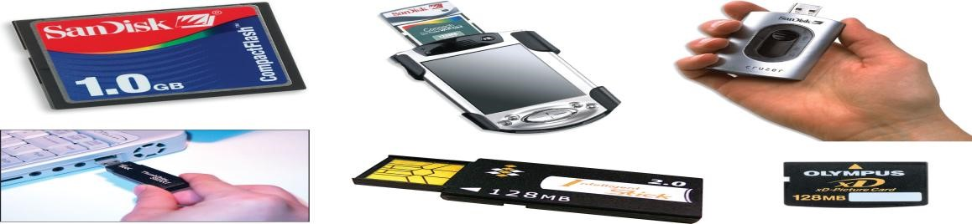
Common types of flash memory

E. COMMUNICATION HARDWARE

For communication to take place between two people from widely different countries or cultures, an electronic or human translator is required to act as an interface between them. Similarly for a computer to communicate with another completely different system, this will also require an interface of some kind.
An interface is usually provided by a card which contains ports for input and output devices, plus processing and memory microchips. In effect it translates one form of communication from an external input device into that which can be understood by the computer and then, if necessary, into another that can be sent to any special output device, or another computer. An interface card may be inserted in one of the slots provided inside the computer or it may be external with its own power supply and plugged into the computer's serial communication port. Here are some common examples:
MODEM (Modulator - Demodulator) - needed for Internet, email, fax and video-conferencing communications using telephone cables. It converts outgoing digital signals from the computer into analogue audio tones which can travel along the telephone wires, and the reverse for incoming signals.
Sound Card - for music or speech from programs, CD-ROMs, and microphone. It usually includes a MIDI (Musical Instrument Digital Interface) for input from musical instruments. MIDI is needed to connect musical instruments to a computer so that the music played can be stored as a file, displayed on screen, edited, printed or played back.
Network Card - enables the computer to communicate with other computers linked together by cable through the interface.
Used for shared storage of programs and work files, and for sharing printers.

COMPUTER SOFTWARE
What is software?
Software is the set of instruction that your hardware executes to carry out a specific task for you. It is a program instruction that creates interaction between a computer hardware and user.

The system and application software interface between end users and computer hardware.
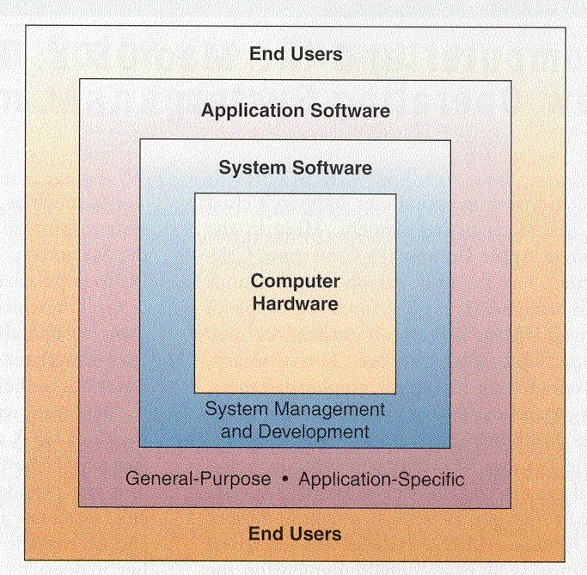
Computer software is typically classified into two major types of programs: Application Software and System software.
SYSTEM SOFTWARE
Programs that manage and support the resources and operations of a computer system as it performs various information processing tasks. System software handles tasks specific to technology management and coordinates the interaction of all
Technology devices

Computer
Software

System
Software

Application
Software

System
management
Programs

Systems

Support

Programs

Systems

Development

Programs

General Purpose
Application
Programs

Applicat
ion
Specific
Programs

Systems Software consists of programs that manage and support a computer system and its information processing activities. These programs serve as a vital software interface between computer system hardware and the application programs of end users. Systems software tells the computer how to interpret data and instructions; how to run peripheral equipment like printers, keyboards, and disk drives; and how to use hardware in general. Without systems software, we will not be able to use any applications software. It also allows the user interact with the computer. Note that such programs can be grouped into three major functional categories:
a. Systems Management Programs
Programs that manage the hardware, software and data resources of the computer system during its execution of the various information processing jobs of users. The most important system management programs are operating systems and operating environment, followed by telecommunications monitors and database management systems.
Operating system (OS) consists of the master system or programs that manage the basic operations of the computer. These programs provide resource management services of many kinds, handling such matters as running and storing programs and storing and processing data. It interprets the commands you give to run programs and allows you to interact with the programs while they are running. Its primary purpose is to maximize the productivity of a computer system by operating it in the most efficient manner. It minimizes the amount of human intervention required during processing. It helps your application programs perform common operations such us entering data, saving and retrieving files, and printing or displaying output. The operating system is automatically leaded into main memory as soon as you turn on, or "boot" the computer. Thus, operating system is the most indispensable component of the software interface between users and the hardware of their computer system.
In general, OS performs five basic tasks of a computer system: the following tasks:
- Providing User Interface: End User-system Communication
- Resource Management: Managing the use of hardware resources
- Task Management: Managing the accomplishment of tasks
- File Management: Managing data and program files
- Utilities and Support Services: Providing a variety of support services

The user interface of operating systems is typically enhanced by the use of operating environment. Operating environment enhances the user interface by adding a graphical user interface between end users, the operating system and their application Programs.
Database Management Systems (DBMS) is viewed as a system software package in mainframe and midrange computer systems. It controls the development, use and maintenance of the databases of computer-using organizations. It allows different user application programs to easily access the same database. It also simplifies the process of retrieving information from databases in the form of displays and reports.
Telecommunications Monitors helps provide electronic communication links between end users workstations, other
Computer systems, and an organization’s database. These programs are used by the host computers in the network or network servers (telecom control computers). They perform such functions as connecting or disconnecting communication links between computers and terminals, automatically checking terminals for input/output activity, assigning priorities to data communications requests from terminals, and detecting and correcting transmission errors. They also control and support the data communication activities occurring in a telecommunications network.

b. System Support Programs
Programs that support the operations and management of a computer system by providing a variety of support services. Major support programs are Utility programs (utilities), performance monitors, and security monitors.
Utility programs are generally used to support, enhance, or expand existing programs in a computer system. These programs miscellaneous housekeeping and file conversion functions. Some common examples of utility programs include: Sort Programs, Data recovery, back–up, Virus protection, Data compression etc.
Performance Monitors are programs that monitor the performance and usage of computer systems to help its efficient use.
Security Monitors are packages that monitor and control the use of computer systems and provide warning messages and record evidence of unauthorized use of computer resources.
c. System Development Programs
Programs that allow programmer or end users to develop information system programs and procedures and prepare user programs for computer processing. Major development programs are language translators (translates a program written by a programmer in a high level language such as BASIC into machine language); programming tools and CASE (Computer Aided Software Engineering) packages.

ii. APPLICATION SOFTWARE
Application Software consists of computer programs that direct computers to perform specific information processing activities for end users. These programs are called application packages because they direct the processing required for a particular use, or application, that end users want accomplished. The task or problem may require, for example, computations for payroll processing; the maintenance of different types of data in different types of files, or the preparation of forms and documents. These programs can be classified as General-purpose programs and Application Specific Programs.
- General-purpose programs: are programs that perform common information processing jobs of end users. For example Word processing programs, Spreadsheet programs, database management programs, graphics programs are some of the popular programs with microcomputer users for home, education, business, scientific and many other purposes. Because they significantly increase the productivity of end users, they are also known as productivity packages.
- Application Specific Programs: Software developed internally or externally to meet specific needs of an organization. Major categories of such application-specific programs are:
  - Business application programs – programs that accomplish the information processing tasks important business functions or industry requirements. Examples of such business functions and their corresponding applications are accounting (general ledger), marketing (sales analysis), manufacturing (material requirement planning), operations management (inventory control) and human resource management (employee benefit analysis).
  - Scientific application programs - programs that perform information processing tasks for the natural, physical, social and behavioral sciences; and for mathematics, engineering and other areas involved in scientific research, experimentation, and development. Some broad application categories include scientific analysis, engineering design, and monitoring of experiments.
  - Other application programs -there are so many other application areas of computers that we lump them all into this category. Thus, we can talk of computer applications in education, entertainment, music, art, law enforcement, medicine and so on. Some specific examples are computer assisted instruction programs in education, video game programs in entertainment, and computer - generated music and art programs.

TELECOMMUNICATIONS
Telecommunications is the transmission of any form of information from on location to another over some type of network. Think about it - telecommunications can enable anyone in the world to communicate with anyone else in the world, almost at the speed of light. "Anyone else" could be you customer. "Anyone else" could be you or your competitor. Or vice versa. Think about it again.
End users need to communicate electronically to succeed in today's global information society. Managers, end users, and their organizations need to electronically exchange data and information with end users, customers, suppliers and other organizations.
Today, telecommunications are used to organize more or less remote computer systems in to telecommunications networks. These networks themselves are run by computers. A telecommunication network is an arrangement of computing and telecommunications resources for communication of information between distant locations. The telecommunications networks include the following components, shown in the following figure.
Terminals or any input/output devices
Telecommunications processors
Telecommunications channels/media
Computers
Telecommunications network software

Telecommunications

Software

1

2

3

4

5

2

User

Terminal
Computers

Telecommunications

Channels and Media

Telecommunications

Processors

1. Terminals
Terminals are any input/output devices that use telecommunications networks to transmit or receive data. They include devices like Telephones, Personal computers, Network computers, Office equipment, Video terminals.

2. Telecommunications Processors
These support data transmission and reception between terminals and computers. The common devices in serving as mediators in this case include modems and switches. A modem provides an interface between a computer (or network) and the phone line, cable line (or cellular connection). It converts digital into analog and analog into digital signals. The following figure represents how the Modem works.
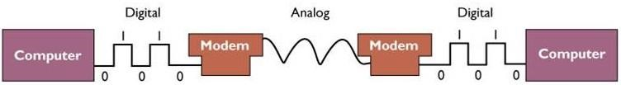

3. Telecommunications channels/media
Message is communicated via a signal and Transmission medium (communication channel) “carries” the signal. Telecommunications channels connect the message source with the message receiver. A channel can use different kinds of telecommunications transmission media.
Telecommunications media physically link the devices in a network. They include twisted wire, coaxial cable, fiber optics, terrestrial microwave, satellite and other wireless transmission
Telecommunication Media | Characteristics
Twisted pair | - Consists of copper wire twisted in pairs.  - It connects a telephone to its telephone jack in most homes.  - It is an older transmission medium.  - Used to transmit analog phone conversations but can be used for digital communication as well.  - Relatively slow for transmitting data.  - Inexpensive.  - Widely available.
Coaxial cable | - Consists of thickly insulated copper wire.  - Used by cable TV companies, brings television signals into the home.  - Can transmit large volumes of data quickly.  - Hard to wire in many buildings.  - Cannot support analog phone conversations.  - More expensive.  - Less common in buildings than twisted-pair wire.
Fiber optics cable | - Extremely thin strands of glass bound together  - Has the greatest capacity of the telecommunications media.  - A fast, light and durable transmission medium.  - Can transfer large volume of data.  - More expensive, harder to install.  - Many long-distance companies use it.  - Can carry digital signals as well as analog signals
Microwave | - Used for long-distance transmission.  - Uses the atmosphere as the medium through which to transmit signals.  - Can carry high-volume data.  - Expensive.  - Requires no cabling.
Communication satellites | - The transmission of data using orbiting satellites.  - Cost effective for transmitting large quantities of data over very long distances.  - Typically used for communications in large, geographically dispersed organizations that would be difficult to tie together through cabling media.  - Very expensive.  - Signals weaken over long distances.  - It is useful for only 7-10 years.

4. Computers
Telecommunications networks interconnect computers of all sizes and types. They include mainframe computers, minicomputers and microcomputers.

5. Telecommunications Network Software
This consists of programs that control telecommunications activities and manage the functions of telecommunications networks. It allows network managers to add or delete users and to specify their permission to access to files, devices and services. They include network operating systems, Web browsers, and programs. For example, many operating systems such as Windows 2000/Server provide a number of key network services.

Topologies (Configurations) and Types of Telecommunications Networks

Network Topologies
There are different configurations/topologies of Telecommunication Networks. These include star, bus, ring, hierarchical and hybrid network topologies. These are depicted in the following figure.
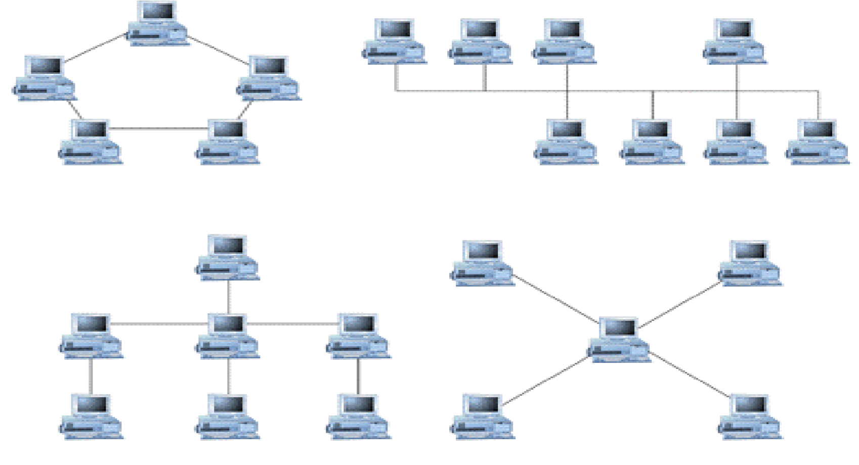

RING

HIERARCHICAL

BUS

STAR

Local Area Networks (LANs) and Wide Area Networks (WANs)

Local Area Networks (LAN): A LAN connects two or more communicating devices within a short distance (One building or several buildings in close proximity). It allows all computer users to connect with each other to share information and devices. In an office a LAN can give users fast and efficient access to a common collection of information while also allowing the office to pool resources, such as printers.

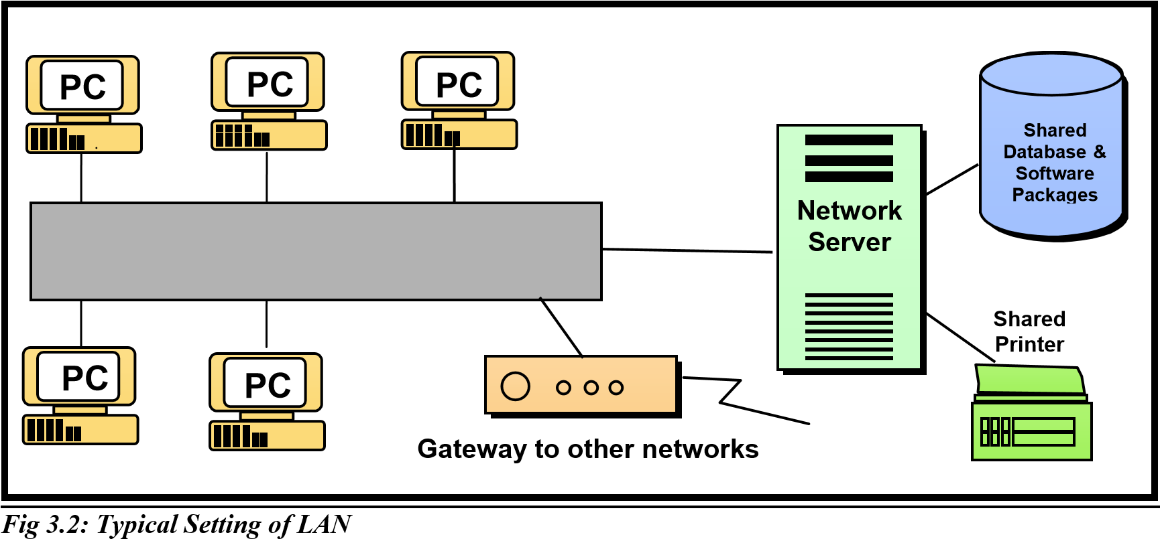

Wide Area Networks (WAN): WAN is a computer network that spans a large geographical area (they serve greater distance). They transmit and receive information across cities and countries. Some WANs are commercial, regulated networks while others are privately owned. Some others are public in terms of their management, resources and access. One such public WAN is the Internet.
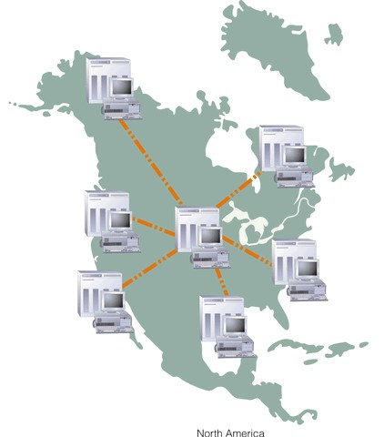

Intranet, Extranet and Internet

Intranet: An Intranet is a private and internal network using Web technologies inside an organization. It can be considered a private internal Web, which limits viewing access to authorized users within the organization. It enables employees to communicate, share information and work together on common projects regardless of their physical location. Employees access information on the Intranet through a Web browser. This information cannot be viewed by users outside the organization. Thus it is separated from the visible, publicly accessible Web. It is protected by security measures such as passwords, firewalls.
Extranet: Extranets are private intranets extended to authorized users outside the company. It is accessible to authorized outsiders. Firms use such networks to coordinate their activities with business partners, suppliers, customers for making purchases, collaborating on design and other inter-organizational work. An extranet connects the intranets of two or more business partners. Extranets are useful for linking organizations with suppliers, customers or business partners. Extranets make customer and supplier access of intranet resources a lot easier and faster than previous business methods.
Internet: Internet is a collection of networks that pass data around in packets, each of which carries the addresses of its sender & receiver.
FOCUS | TYPE OF  INFORMATION | USERS | ACCESS
Internet | External communications | General public | Any user with an Internet  connection/public and not restricted
Intranet | Internal | Employees | Authorized employees/private and restriction
Extranet | External | Business partners,  customers, suppliers | Authorized business  partners/private and restriction

A Logistics and Supply chain Management Perspective on Telecommunications

Telecommunications should be viewed not only as a method of electronic communications, but as a competitive weapon. Having this managerial perspective on the importance of telecommunications, you should develop an appreciation for 1) the potential benefits and problems of telecommunications and 2) how to plan and implement a proper role for telecommunications in organizations.
Telecommunications can add value to business. It has three basic effects on the operation of a business:
- Compress the time taken to accomplish business activities
- Reduce the limits placed on a firm’s business activities by geographic distances.
- Restructure traditional business relationships with a firm’s customs and suppliers and with other organizations. These impacts of telecommunication can add value to a business in three major dimensions:
- improve the efficiency of business operations
- improve the effectiveness of business functions
- business innovation
The following table outlines a framework for understanding how telecommunications can add value to a business.

IMPACT |  | VALUE
IMPACT | Operational Efficiency | Business Effectiveness | Organizational innovation
Compress time  Examples | Accelerate business operations & processes  Online transaction processing | Reduce information floating  Electronic mail | Create superior service  Instant credit checks
Reduce Geographic limits  Examples | Generate economies of scale  Online, centralized purchasing | Ensure control of dispersed operations  Teleconferencing | Penetrate new markets  Remote ATM banking
Restructure  Relationships  Examples | Bypass intermediaries in the distribution chain  Direct sales by phone | Provide expertise to remote sites  Remote diagnostics and  maintenance | Lock in customers and  suppliers  Electronic in-home shopping
4. Data Resource Management
Data is a vital organizational resource, which needs to be managed like other important business resources. Most organizations could not service or succeed without quality data about their internal and external operations. That is why organizations and managers need to practice data resource management - a managerial activity that applies information system technology and management tools to the task of managing an organization's data resources to meet the information needs of business users.

Data Hierarchy
Data can be grouped according to a hierarchy of categories. The data storage hierarchy consists of the leads of stored data: bits bytes (character), fields, records, files and databases.
Bit: in the binary system, each 0 or 1 is called a bit, which is sort for binary digit.
Byte (character): is a group of 8 bits. A character may be–but is not necessarily–the same as a byte. A character is a single letter, number of special character such as, $, or %
Field: is a unit of data consisting of one or more characters. A particular field that is chosen to uniquely identify a record so that it can be easily reviewed known as a key field
Record: is a collection of related fields. It can be the name, address and ID number of a student
File: is a collection of related records. An example of a file is collected data of employees in the same department of a company. That is all names, addresses and security numbers of employees in a department represents a file.
Database: a data base is a collection of related files company database might include files on all past and current employees in all departments.
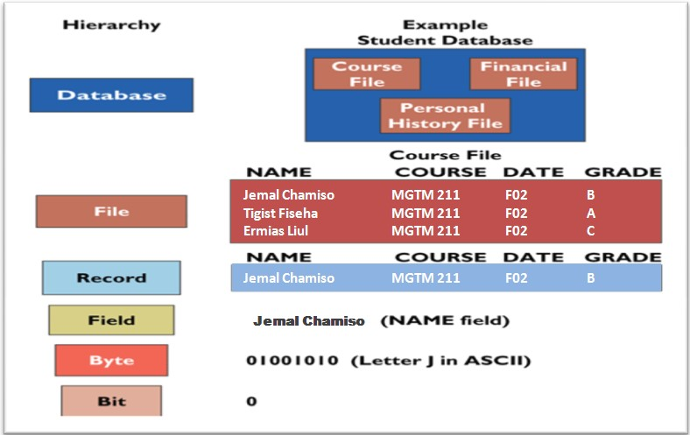

Major Developments in Data Management System

A. Manual Files Processing System
Before computerization, data was stored using manual filing system. In a manual system, data is usually stored in an organized way in a filing cabinet i.e. files are stored in alphabetical or numerical order inside a file cabinet. This way of storing data has a number of disadvantages like:
Files are prone to errors
Difficult to share the file at the same time
Files are easily damaged, lost or misplaced
Time consuming to access and maintain the files
There is also duplication of files in different sections.
To alleviate the problems in manual filing system, currently we are using two different systems.
Computer File-processing system
Database processing system

B. Computer File- Processing System
Computer file -processing system is supported by a conventional operating system (0S). Operating system is software that performs basic tasks, such as recognizing input from the keyboard, sending output to the displaying screen, keeping track of files and directories on the disk, and controlling the peripheral devices such as disk devices and printers.
Advantages of computer file-processing system a change over manual-file processing system:
Reduction in storage space
Increased security of data
Easier accessibility of data
Less time consuming to search and amend the files
Although file-processing systems are a great improvement over manual record keeping system, they have the following drawbacks in comparison with database systems:
Data redundancy and inconsistency
Difficulty in accessing data
Application program dependency
Integrity Problems
Concurrent- access anomalies
Data redundancy and inconsistency: Since different programmers create the files and application programs over a long period, the various files are likely to have different formats and the programs may be written in several programming languages. Moreover, the same information may be duplicated in several places (files). For example the address and telephone number of a particular customer may appear in a file that consists of saving account record and in a file that consists of checking- account records. This redundancy leads to higher storage and access cost. In addition, it may lead to data inconsistency; that is, the various copies of the same data may no longer agree. For example a changed customer address may be reflected in saving-account records but not elsewhere in the system.
Difficulty in accessing data: Suppose that one of the bank officers needs to find out the names of all customers who live within a particular postal-code area. The officer asks the data processing department to generate such a list. Since the designers of the original system did not anticipate this request, there is no application program on hand to meet it. There is, however, an application program to generate the list of all customers. The bank officer has now two choices: either obtain the list of all customers and extract the needed information manually or ask a system programmer to write the necessary application program. Both alternatives are obviously unsatisfactory.
Application program dependency: With file processing, application programs depend on the file formats. Usually in file-processing systems the physical formats of files and records are part of the application code.
The problem with this arrangement is that when changes are made in the file formats, the application programs also must be changed.
The point here is that conventional file-processing environments (computer file- processing system) do not allow needed data to be retrieved in a convenient and different manner. More responsive data-retrieval systems are required for general use.
Integrity Problems: A collection of data has integrity if the data are logically consistent. Poor data integrity can often be seen in file-processing systems. For example, if a customer changes his/her or address, then all those files containing that data must be updated, but the danger is that all of the files might not be updated, causing discrepancies among them.
Data integrity problem are serious. If data items differ, they will produce inconsistent results. For example, if a report from one application disagrees with a report from another application, who will be able to tell which one is correct? When results are inconsistent, the credibility of the stored data, and even the MIS function itself, comes in to question.
Concurrent- Access Anomalies: For the sake of overall performance of the system and faster response, many systems allow multiple users to update the data simultaneously. In such an environment, interaction of concurrent updates may result in inconsistent data. Considered Bank accounts A containing $500. If two customers withdraw funds (say $50 and $100 respectively) from account A at about the same time, the result of the concurrent executions may leave the account in an incorrect (or inconsistent state). Suppose that the programs executing on behalf of each withdrawal read the old balance, reduce that value by the amount being withdrawn, and write the result back. If the two programs run concurrently, they may both read the value $500, and write back $450 and $400, respectively. Depending on which one writes the value last, the account may contain $450 or $400, rather than the correct value of $ 350.

C. Database Management Systems
A database is an integrated collection of logically related records or files. A database consolidates records previously stored in separate files into a common pool of data records that provides data for many applications. It is a collection of data stored in a standardized format, designed to be shared by multiple users. The development of databases and database management software is the foundation of modern methods of managing organizational data. In the database management approach, data records are consolidated into databases that can be accessed by many different application programs.
In addition, an important software package called a database management system (DBMS) serves as a software interface between users and databases. This helps users easily access the records in a database. Database management solves some of the problems found in file management systems.
Reduced data redundancy: because the same fields need not be recorded in different records.
Minimal file–updating and file integrity problems: with a DBMS, one program is able to gain access to all data in all files. Data is independent: If you decide one data element to records, you can do so and still use the application program you were using, because the data's organization is independent of the program being used.

CHAPTER TWO
SOLVING BUSINESS PROBLEMS WITH INFORMATION SYSTEMS
- The scientific Method
The systems approach is based on a widely accepted problem - solving methodology known as the scientific method.
The scientific method consists the following steps:
Step 1: Recognize phenomena in the real world
Step 2: Formulate a hypothesis about the causes or effects of the phenomena.
Step 3: Test the hypothesis through experimentation
Step 4: Evaluate the results of the experiments
Step 5: Draw conclusions about the hypothesis

- A Systems Approach to Problem Solving
A systems approach is an approach to solve organizational problems by using a systems orientation to define problems and/or opportunities and develop solutions. Using systems thinking to understand a problem or opportunity is one of the most important aspects of the systems approach. The essence of the systems thinking is "seeing the forest and the trees" in any situation by seeing interrelationships among systems and the process of change among systems.
One way of practicing systems thinking is to try to find systems, subsystems, components of systems in any situation you are studying. This is also known as using a systems context, or having a systemic view of a situation. For example, the business organization or business processing which a problem or opportunity arises could be viewed as a system of inputs, processing, output, feedback and control components. Then to understand a problem and solve it, you would determine if these basic system functions are being properly performed.

Analyzing a problem and formulating a solution using the systems approach involves the following interrelated activities:
- Understanding a problem or opportunity
1.1. Defining problems and opportunities using systems thinking (in systems context)
1.1.1. Separating problems or opportunities from symptoms
1.1.2. Identifying systems in the organization and environment
1.1.3. Determining objectives, standards and constraints
1.2. Gathering Data and Information describing the problem/opportunity
- Developing an information system solution
2.1. Designing alternative solutions
2.2. Evaluating Alternative Solutions
2.2.1. Evaluation Criteria
2.2.2 Cost/benefit analysis
2.3. Selecting the Best Solution
- Implementing the information system Solution
3.1. Implement the selected solution
3.2. Evaluate the Success of the Implemented Solution
Each of these interrelated steps is discussed as follows
- Understanding a problem or opportunity
Understanding a problem is considered solving part of the problem because without having good deal of understanding of the problem, we can't solve a problem or pursue an opportunity. That is why the first stage of the systems approach is necessary. To better understand the problem, we need to separate problems from symptoms, determine objectives and constraints, view the problem or opportunity in a systems context.
- Defining Problems and Opportunities
- Separating problems or opportunities from symptoms
Symptoms must be separated from problems. Symptoms are merely signals of an underlying cause or problem. A problem is a basic condition that is causing undesirable results. An opportunity is a basic condition that presents the potential for desirable results. For example the fact that "sales are declining" is a symptom, not a properly defined problem.
- Identifying systems in the organization and environment
One of the most important aspects of the systems approach is viewing a problem or opportunity in a systems context. When you use a systems context, you try to find systems, subsystems, and components of systems in the situation you are studying. This ensures that important factors and their interrelationships are considered. Thus, to understand a problem or opportunity, you must understand both the organizational systems and environmental systems in which the problem or opportunity arises.
- A business as an organizational system
A business faced with a problem or opportunity should be viewed as an organizational system operating in a business environment. The concept of a business as a system helps us isolate and better understand how a problem or opportunity may be related to the basic system components of a business. It also emphasizes the vital feedback role played by information systems in helping managers control the performance of their organizations.
As shown on figure 2.1, you can see that a business is an organizational system where economic resources (inputs) are transformed by various organizational processes (processing) into goods and services (output). Information system provides information (feedback) on the operations of the system to management for the direction and maintenance of the system (control), as it exchanges inputs and outputs with its environment.
- Environmental systems
A business is a subsystem of society surrounded by the other systems of the business environment. It is open and adaptive system which exchanges inputs and outputs with its environment and adjusting to the demands of various environmental systems. A business tries to maintain proper interrelationships with the economic, political and social stakeholders in its environment. Remember that strategic information systems can help a business shape strategic relationships that build closer ties with the many stakeholders in its environment. Therefore, the stakeholders that interact with a business should be identified. This helps determine their effect on a problem or its solution.
- Organizational subsystems
A business is typically subdivided into various organizational subsystems. For example, most businesses are organized into departments, divisions, and other types of business units. Firms may also be subdivided into subsystems such as project teams, product groups, task forces, etc. Whatever the case, you must try to identify these subsystems, the boundaries of each subsystem, and their relationships to each other. The process is called decomposition. Then, you should try to isolate those subsystems most affected by the problem or opportunity you are studying.
- Relationships between systems
Once you have identified the subsystems in an organizational system, you can analyze the relationships and connections between them. Such analysis is frequently aided by a black box approach, where you concentrate on defining the boundaries, interfaces, inputs, and outputs of a system but do not attempt to study the technical details of transformation processes. In other words, a system's processing component remains in an undefined black box while you study the components that define that systems' interactions with other systems.
- Evaluating selected systems
The specific systems (or subsystems) in which a problem or opportunity arises should be viewed as systems of input, processing, output, feedback, and control components. To really understand a problem and solve it you should try to determine if basic system functions are being properly performed. That is how you can really use a systems context in your evaluation.
For example, you could view the sales department of a business as a system and then you could then ask: Is poor sales performance (output) caused by inadequate selling effort (input), out–of–date sales procedures (processing), incorrect sales information (feedback), or poor sales management (control)?
Poor sales Management?
Out-of-date sales
Procedures?

Poor Sales Performance?
Inadequate Selling Effort?
Feedback
Control
Incorrect Sales information?

Input Processing Output

- Determining objectives, standards and constraints
- Objectives
When using the systems approach, you should determine the objectives of the organizational systems and subsystems you wish to study. We should determine how these objectives fit into the overall strategic plan of the business. Objectives should not be stated in vague terms. They should be specific.
- Standards
It is also important to identify the standards used to measure progress toward the objectives of a system. Standards are vital component of the effective control of any system. Feedback about actual performance is compared by managers to standards of performance to measure the degree of attainment of business unit's objectives. Budgets and forecasts are typically used as standards. Knowing the standards should help determine the extent of perceived problems or opportunities in the system we are studying. Standards are usually more specific and quantitative than objectives.
- Constraints
Constraints are restrictions on the form and content of a solution. Constraints can be internal or external to the business organization. External constraints are typically required by law or industry agreement. Internal constraints may arise due to a scarcity of organizational resources or to conflicting information needs of departments and personnel within an organization.
- Gathering Data and Information
In order to properly understand a problem or opportunity you must gather data and information about it. In business situations, this may involve one or more of the following:
- Interviewing with employees, customers, and managers.
- Questionnaires to appropriate individuals in the organization.
- Personal observation of business operations and systems.
- Examination of documents, reports, procedures manuals, and other documentation.
- Inspecting accounting and management reports to collect operating statistics, cost data, and performance results. Development, manipulation, and observation of a model of the business operations or systems affected by the problem or opportunity.
- Developing a solution
This is the second stage of the systems approach to problem solving. It consists of three steps:
i) Designing alternative solutions
There are usually several different ways to solve any problem or pursue any opportunity. Jumping immediately from problem definition to a single solution is not a good idea. It limits your options and robs you of the chance to consider the advantages and disadvantages of several alternatives. You also lose the chance to combine the best points of several alternatives. Having too many alternatives can obscure the best solution. However, a screening process in the next step of the systems approach should help reduce the number of alternatives.
- Where do alternative solutions come from?
- Experience
- The advice of others–including consultants and expert systems.
- Your intuition, ingenuity and creativity.
- Simulation–through decision support software packages used to develop and manipulate models of a business operation.
Alternative solutions should include what you think is an ideal solution. Then, more realistic alternatives that recognize the limited financial, personnel and other resources should be developed. Also, don't forget that "doing nothing" about a problem or opportunity is a legitimate solution with its own advantages and disadvantages.
ii) Evaluating Alternative Solutions
Once alternative solutions have been developed, they must be evaluated so that the best solution can be identified. The goal of evaluation is to determine how well each alternative solution helps the firm and its selected subsystems meet their objectives.
Evaluation Criteria
First, we should develop evaluation criteria, and then determine how well each alternative solution meets these criteria. The criteria we develop should reflect the objectives and the constraints defined in the first stage of the solution process.
Cost/benefit analysis
Every legitimate solution will have some advantages or benefits and some disadvantages or costs. Thee advantages and disadvantages are identified when each alternative solution is evaluated. This process is called cost/benefit analysis. If costs and benefits can be quantified, they are called tangible; if not, they are called intangible. Tangible costs–e.g. costs of hardware and software, employee salaries, etc. Intangible costs–are difficult to quantify, such as the loss of customer goodwill or employee moral caused by errors and disruptions arising from the installation of a new system. Tangible benefits–are favorable results, such as the decrease in payroll costs caused by a reduction in personnel or a decrease in inventory carrying costs caused by a reduction in inventory.
- Increase in sales or profits.
- Decrease in information processing costs.
- Decrease in operating work.
Intangible benefits are harder to estimate. Better customer service or faster and more accurate information for management, improved management decision making, and improved image can be cases in point.
iii. Selecting the Best Solution
Once all alternative solutions have been evaluated, the process of selecting the best solution can begin. Alternative solutions can be compared to each other because they have been evaluated using the same criteria. For example, alternatives can be screened and ranked, based on individual criteria or overall scores.
Note that it is possible that we will decide not to select the top–ranked alternative. A low–ranked solution could be chosen for a variety of other reasons. Or, all proposed alternatives could be rejected. In this case, new alternative solutions must be identified and evaluated. However, don't forget that the legitimate alternative of "doing nothing" could be selected as the best option.
- Implementing a Solution and Evaluating the Results
- Implement the selected solution
Once a solution has been selected, it must be implemented. An implementation plan specifies the activities, resources, and timing needed for proper implementation.
- For example, the following items might be specified:
– Types and sources of hardware and software
– Construction of physical facilities
– Hiring and training of personnel
– Start–up and operating procedures
– Implementation timetables.
- Evaluate the Success of the Implemented Solution
The results of implementing a solution should be monitored and evaluated. This is called a post implementation review process. The focus of this step is to determine if the implemented solution has indeed helped the firm and selected business units meet their system objectives. If not, the systems approach assumes you will cycle back to previous step and make another attempt to find a workable solution.

2.1. Overview of the Development of Information System Solutions
2.1.1. Applying Systems Approach to Information Systems
The systems approach seems like a simple, commonsense approach to good problem solving. Real–life situations can be quite complex, unclear, and changeable. Putting the systems approach into practice may be difficult to accomplish in the face of emotional conflicts or fast–breaking developments. This is especially true in the field of information systems. Some organizational problems are amenable to information system solutions. The systems approach described earlier can be applied to the solution of many types of problems. When this involves the development of information system solutions to business problems, it is called information systems development. Developing information system solution to business problems is a major responsibility of managerial end users. They are responsible for proposing or developing new or improved information systems for their organizations. They must also frequently manage the development efforts of information systems specialists and other end users
However, such solutions typically
- Involve changing the way people do things, which is always a potential source of conflict and resistance.
- Involve the introduction of new technology, which is also fraught with potential implementation problems.
The information system industry has responded to these obstacles with a variety of traditional and computer–aided information systems development methodologies, which tailor the systems approach to the process of developing information system solutions to business problems. One of then commonly used methodologies is what we call the systems development life cycle.
- The Systems Development Life Cycle (SDLC)
Developing information system solutions to business problems is typically a multi step process or cycle. This is frequently called the systems development cycle or systems development life cycle (SDLC). The traditional information systems development cycle includes five steps, which is shown figure 2.2 below.

Figure 2.2: The Systems Development Life Cycle
As shown on the above figure, the steps within SDLC methodology include investigation, analysis, design, implementation and maintenance, respectively. The steps and the products of each step in the SDLC are also shown on the figure 2.3.
Maintenance Cycle
Feasibility Study
System Requirement
System Specification
Operational System
Improved System
System Investigation
System Analysis
System Design
System Implementation
System Maintenance
Products
SDLC Steps

Figure 2.3: The Steps and Products of SDLC Methodology
- System Investigation:
This stage includes the following three steps.
i) Information Systems Planning
Survey the organization to screen and select potential systems development projects, including those generated by formal information systems planning. (Determine whether a business problem or opportunity exists). There are typically many opportunities to use information systems to support organization end users and its business operations, management decision making, and strategic objectives.
ii) Feasibility studies
Conduct a feasibility study to determine whether a new or improved information system is needed. A feasibility study is a preliminary study to investigate the information needs of prospective end users and the objectives, constraints, basic resource requirements, costs, benefits, and feasibility of a proposed project.
The findings of this study are usually formalized in a written report. It includes preliminary specification and a developmental plan for the proposed system. The feasibility of a proposed system can be evaluated in terms of four major categories:
- Organizational feasibility–how well the proposed system supports the strategic plan of the organization.
- Economic feasibility–whether expected cost savings, increased revenue, increased profits, reductions in required investment, and other benefits exceed the costs of developing and operating a proposed system.
- Technical feasibility–whether reliable hardware and software capable of meeting the needs of a proposed system can be acquired or developed by the required time.
- Operational feasibility–the willingness and ability of the management, employees, customers, suppliers, and so on to operate, use, and support a proposed system.
iii) Feasibility report
This report is submitted to the management of the firm for its approval before development work can begin. If management approves the recommendations of the feasibility study, the systems analysis stage can begin. The goal of feasibility studies is to evaluate alternative systems and to propose the most feasible and desirable systems for development.
- Systems Analysis
Many of the system analysis activities are an extension of those used in conducting a feasibility study. However, systems analysis is not a preliminary study. It is an in–depth study of end user information requirements that is needed before the design of a new information system can be completed. Systems analysis traditionally involves a detailed study of:
- The information needs of the organization and its end users. /Organizational analysis /
- Analyze in detail the information needs of end users, the organization and its subsystem, and environmental systems.
- We have to know something about the organization: its management structure, its people, its business activities, the environmental systems it must deal with, etc.
- The activities, resources, and products of any present information systems. (Analysis of the present system)
- Before we design a new system, it is important to study the system that will be improved or replaced.
- We should analyses how the system resources (data, hardware, software, and people) are used to accomplish the information system activities of input, processing, output, storage, and control.
- The information system capabilities required meeting the information needs of users. /functional requirements analysis/: This step is considered the most difficult and in this step, we are supposed to do the following:
- First determine our (end user's) specific information needs–called needs analysis or user-requirements analysis.
- Second, we must try to determine the information processing capabilities required for each system activity (input, processing, output, storage, and control) to meet these information needs–called functional requirements analysis.
- Finally, we should try to develop functional requirements. These are end user information requirements that are not tied to the physical resources of hardware, software, and people that end users presently use of might use. The final product of systems analyses is a set of system requirements for a proposed information system.
- Systems Design

Systems analysis describes what a system should do to meet the information needs of users. Systems design specifies how the system will accomplish this objective. Systems design consists of design activities, which produce system specifications satisfying the system requirements developed in the systems analysis stage. These specifications are used as the basis for software development, hardware acquisition, system testing, and other activities of the implementation stage.
User Interface, Data, and Process Design
A useful way to look at systems design is illustrated in the following figure:
Screen, Form, Report, and dialog design

Data element structure design
Program and procedure design
User Interface Design
Data Design
Process Design
System Design

Figure 2.4: System Design Activities
This concept focuses on three major products or deliverables that should result from the design stage. In this framework, systems design consists of three activities: user interface, data, and process design. This results in specifications for user interface methods and products, database structures, and processing and control procedures.

User Interface Design
This focuses on designing the interaction between end users and computer systems. It concentrates on input/output methods and the conversation of data and information between human–readable and machine-readable forms.
Therefore, the UID produces detailed specifications for information products such as display screens, interactive user/ computer dialogues, audio responses, forms, documents, and reports.
Data Design
Focuses on the design of the logical structure of databases and files to be used by the proposed information system. Data design produces detailed descriptions of:
- The entities–people, places, things, events about which the proposed information system needs to maintain information.
- The relationships between these entities.
- The specific data elements (databases, files, records, etc.) that need to be maintained for each entity tracked by the information system.
- The integrity rules that govern how each data element is specified and used in the information system.
Process Design
Process design focuses on the design of the software resources, i.e., the programs and procedures needed by the proposed information system. It concentrates on developing detailed specifications for the program modules that will have to be:
- Purchased as software packages, or
- Developed by custom programming.
Thus, process design produces detailed program specifications and procedures needed to meet user interface and data design specifications.
- Systems Implementation
Once a proposed information system has been designed, it must be implemented. The systems implementation stage involves:
- Acquisition of hardware and software
- Developing any computer programs that will not be acquired externally as software packages.
- Educating and Training management, end users, and operating personnel.
- Testing and making necessary corrections to the programs, procedures, and hardware used by a new system.
Documentation:–record and communicate the detailed system specifications including procedures for end users and operating personnel, and examples of input/output displays and reports.
Conversion:–convert from the use of a present system to the operation of a new or improved system. This involves:
- Operating both new and old systems in parallel for a trail period
- Operation of a pilot system on a trial basis at one location
- Phasing in the new system one location at a time, or
- An immediate cut over to the new system.
- Systems Maintenance
It involves a post implementation review process to monitor, evaluate, and modify the system as needed. Errors in the development or use of a system are corrected by the maintenance activity. Systems maintenance also includes making modifications to a system due to changes within the business or the business environment. For example change in tax laws–requires change to tax computations in payroll.
It contains four ongoing activities.
  - Systems maintenance: it is concerned with making error correction.
  - System recovery: it involves elimination of systems crash.
  - End user assistance: providing additional training for the end user to better utilize the implemented system.
  - System reengineering and enhancement: it involves adapting the implemented system to new requirements.

CHAPTER THREE: INFORMATION SYSTEMS AND SUPPLY CHAIN MANAGEMENT
3.1. ELECTRONIC SUPPLY CHAIN MANAGEMENT
Inefficiencies in the supply chain, such as parts shortages, underutilized plant capacity, excessive finished goods inventory, or high transportation costs, are caused by inaccurate or untimely information. For example, manufacturers may keep too many parts in inventory because they do not know exactly when they will receive their next shipments from their suppliers. Suppliers may order too few raw materials because they do not have precise information on demand. These supply chain inefficiencies waste as much as 25 percent of a company’s operating costs.
If a manufacturer had perfect information about exactly how many units of product customers wanted, when they wanted them, and when they could be produced, it would be possible to implement a highly efficient just-in-time strategy. Components would arrive exactly at the moment they were needed and finished goods would be shipped as they left the assembly line.
In a supply chain, however, uncertainties arise because many events cannot be foreseen uncertain product demand, late shipments from suppliers, defective parts or raw materials, or production process breakdowns. To satisfy customers, manufacturers often deal with such uncertainties and unforeseen events by keeping more material or products in inventory than what they think they may actually need. The safety stock acts as a buffer for the lack of flexibility in the supply chain. Although excess inventory is expensive, low fill rates are also costly because business may be lost from canceled orders.
One recurring problem in supply chain management is the bullwhip effect, in which information about the demand for a product gets distorted as it passes from one entity to the next across the supply chain. A slight rise in demand for an item might cause different members in the supply chain—distributors, manufacturers, suppliers, secondary suppliers (suppliers’ suppliers), and tertiary suppliers (suppliers’ suppliers’ suppliers) to stockpile inventory so each.
Supply chain Management;

- A cross-functional enter enterprise system
- To help support and manage the links between a company’s key business processes
- And those of its suppliers, customers and business partners
The main goal of having E-SCM are Fast, efficient, low-cost network of business relationships or supply chain to get a company’s products from concept to market.
A supply chain refers to Interrelationships with suppliers, customers, distributors, and other businesses that are needed to design, build and sell a product.
E-supply chain management Architecture
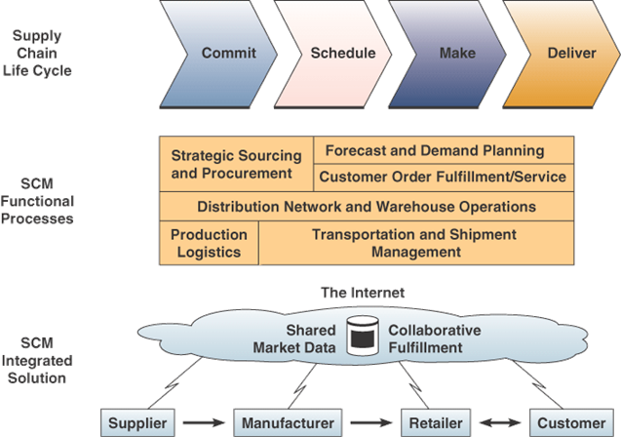
Figure 3.1. E-SCM structure
Electronic Data Interchange (ED) is one pillar of supply chain management and facilitate business activities;.
  - The electronic exchange of business transactions
  - Over the Internet and other networks
  - Between supply chain trading partners
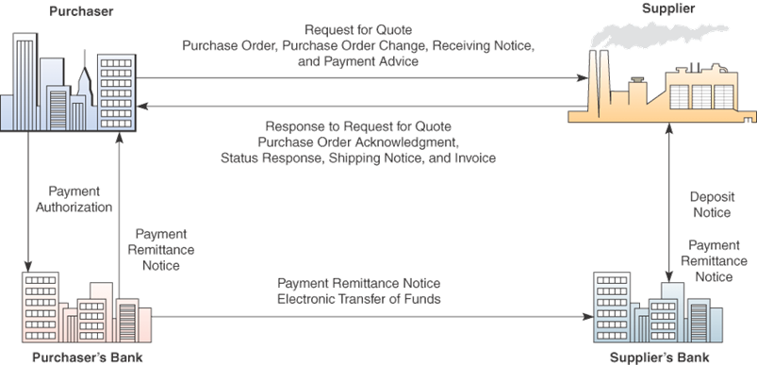
Figure 3.2: Example of EDI structure
The Role and objectives of supply chain Management
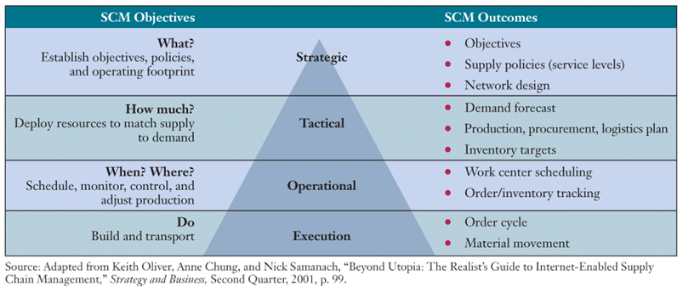

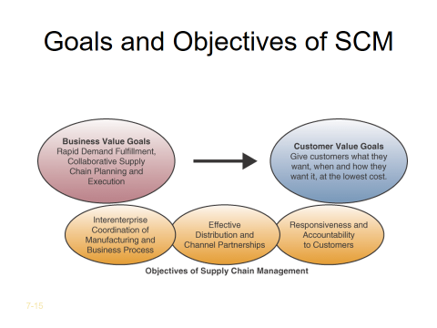
Causes of problems in SCM
- Lack of proper demand-planning knowledge, tools and guidelines
- Inaccurate or overoptimistic demand forecasts
- Inaccurate production, inventory, and other data
- Lack of adequate collaboration within the company and between partners
- SCM software considered immature, incomplete and hard to implement
3.2. Introduction to E-Commerce:
E-Commerce is the use of the Internet and the Web to transact business; more formally digitally enabled commercial transactions between and among organizations and individuals.
It is the process of buying and selling goods and products over internet. E-commerce is the sharing of business information, maintaining business relationships, and the conducting business transactions by means of telecommunications networks.
The use of the global Internet for purchase and sale of goods and services, including service and support after the sale. The Internet may be an efficient mechanism for advertising and distributing product information, but our focus is on enabling complete business transactions.
Electronic commerce includes the use of computing and communication technologies in financial business, online airline reservation, order processing, inventory management. Historically speaking, the best known idea in electronic commerce has been Electronic Data Interchange (EDI).
Internet-based commerce, in general, and Web-based commerce, in particular, is important sub-disciplines of electronic commerce.
“Electronic commerce is the symbiotic integration of communications, data management, and security capabilities to allow business applications within different organizations to automatically exchange information related to the sale of goods and services.”
    - Features of E-Commerce:
- Ubiquity:
In traditional commerce, a marketplace is a physical place you visit in order to transact. For example, television and radio typically motivate the consumer to go someplace to make a purchase. E-commerce, in contrast, is characterized by its ubiquity: it is available just about everywhere, at all times. It liberates the market from being restricted to a physical space and makes it possible to shop from your desktop, at home, at work, or even from your car, using mobile commerce. Market place extended beyond traditional boundaries and removed from a temporal and geographic location.
From a consumer point of view, ubiquity reduces transaction costs, the costs of participating in a market. To transact, it is no longer necessary that you spend time and money travelling to a market. At a broader level, the ubiquity of e-commerce lowers the cognitive energy required to transact in a market space. Cognitive energy refers to the mental effort required to complete a task.

- Global Reach:
E-commerce technology permits commercial transactions to cross cultural and national boundaries far more conveniently and cost-effectively than is true in traditional commerce. As a result, the potential market size for e-commerce merchants is roughly equal to the size of the world’s online population. The number of internet users has increased tenfold from 1999 to 2013.The first billion was reached in 2005. The second billion in 2010. The third billion in 2014.growing rapidly, according to the Computer Industry Almanac).
In contrast, most traditional commerce is local or regional it involves local merchants or national merchants with local outlets. Television and radio stations, and newspapers, for instance, are primarily local and regional institutions with limited but powerful national networks that can attract a national audience. In contrast to e-commerce technology, these older commerce technologies do not easily cross national boundaries to a global audience.
- Universal Standards:
One strikingly unusual feature of e-commerce technologies is that the technical standards of the internet, and therefore the technical standards for conducting e-commerce, are universal standards they are shared by all nations around the world. In contrast, most traditional commerce technologies differ from one nation to the next. For instance, television and radio standards differ around the world, as does cell phone technology.
The universal technical standards of the internet and e-commerce greatly lower market entry costs the cost merchants must pay just to bring their goods to market. At the same time, for consumers, universal standards reduce search costs the effort required to find suitable products. And by creating a single, one-world market space, where prices and product descriptions can be inexpensively displayed for all to see, price discovery becomes simpler, faster, and more accurate.
And users of the internet, both businesses and individuals, experience network externalities benefits that arise because everyone uses the same technology. With e-commerce technologies, it is possible for the first time in history to easily find many of the suppliers, prices, and delivery terms of a specific product anywhere in the world, and to view them in a coherent, comparative environment. Although this is not necessarily realistic today for all or many products, it is a potential that will be exploited in the future.
- Richness:
Information richness refers to the complexity and content of a message. Traditional markets, national sales forces, and small retail stores have great richness: they are able to provide personal, face-to-face service using aural and visual cues when making a sale. The richness of traditional markets makes them a powerful selling or commercial environment. Prior to the development of the Web, there was a trade-off between richness and reach: the larger the audience reached the less rich the message.
- Interactivity:
Unlike any of the commercial technologies of the twentieth century, with the possible exception of the telephone, e-commerce technologies allow for interactivity, meaning they enable two-way communication between merchant and consumer. Television, for instance, cannot ask viewers any questions or enter into conversations with them, and it cannot request that customer information be entered into a form. In contrast, all of these activities are possible on an e-commerce Web site. Interactivity allows an online merchant to engage a consumer in ways similar to a face-to-face experience, but on a much more massive, global scale.
- Information Density:
The Internet and the Web vastly increase information density—the total amount and quality of information available to all market participants, consumers, and merchants alike. E-commerce technologies reduce information collection, storage, processing, and communication costs. At the same time, these technologies increase greatly the currency, accuracy, and timeliness of information making information more useful and important than ever. As a result, information becomes more plentiful, less expensive, and of higher quality.
A number of business consequences result from the growth in information density. In e-commerce markets, prices and costs become more transparent. Price transparency refers to the ease with which consumers can find out the variety of prices in a market; cost transparency refers to the ability of consumers to discover the actual costs merchants pay for products.
But there are advantages for merchants as well. Online merchants can discover much more about consumers; this allows merchants to segment the market into groups willing to pay different prices and permits them to engage in price discrimination selling the same goods, or nearly the same goods, to different targeted groups at different prices. For instance, an online merchant can discover a consumer’s avid interest in expensive exotic vacations, and then pitch expensive exotic vacation plans to that consumer at a premium price, knowing this person is willing to pay extra for such a vacation. At the same time, the online merchant can pitch the same vacation plan at a lower price to more price-sensitive consumers-. Merchants also have enhanced abilities to differentiate their products in terms of cost, brand, and quality.
- Personalization/Customization:
E-commerce technologies permit personalization: merchants can target their marketing messages to specific individuals by adjusting the message to a person’s name, interests, and past purchases. The technology also permits customization changing the delivered product or service based on a user’s preferences or prior behaviour. Given the interactive nature of e-commerce technology, much information about the consumer can be gathered in the marketplace at the moment of purchase.
With the increase in information density, a great deal of information about the consumer’s past purchases and behaviour can be stored and used by online merchants. The result is a level of personalization and customization unthinkable with existing commerce technologies. For instance, you may be able to shape what you see on television by selecting a channel, but you cannot change the contents of the channel you have chosen. In contrast, the online version of the Wall Street Journal allows you to select the type of news stories you want to see first, and gives you the opportunity to be alerted when certain events happen.
Now, let’s return to the question that motivated this section: Why study e-commerce? The answer is simply that e-commerce technologies—and the digital markets that result—promise to bring about some fundamental, unprecedented shifts in commerce. One of these shifts, for instance, appears to be a large reduction in information asymmetry among all market participants (consumers and merchants).
In the past, merchants and manufacturers were able to prevent consumers from learning about their costs, price discrimination strategies, and profits from sales. This becomes more difficult with e-commerce, and the entire marketplace potentially becomes highly price competitive.
In addition, the unique dimensions of e-commerce technologies also suggest many new possibilities for marketing and selling a powerful set of interactive, personalized, and rich messages are available for delivery to segmented, targeted audiences. E-commerce technologies make it possible for merchants to know much more about consumers and to be able to use this information more effectively than was ever true in the past.
Potentially, online merchants could use this new information to develop new information asymmetries, enhance their ability to brand products, charge premium prices for high-quality service, and segment the market into an endless number of subgroups, each receiving a different price. To complicate matters further, these same technologies make it possible for merchants to know more about other merchants than was ever true in the past. This presents the possibility that merchants might collude on prices rather than compete and drive overall average prices up. This strategy works especially well when there are just a few suppliers (Varian, 2000b).

- Social Technology: User Content Generation and Social Networking
Social technology is technology promotes user content generation and social networking the effect is: New Internet social and business models enable user content creation and distribution, and support social networks.

    - E-Commerce vs. Traditional Commerce
The major difference is the way information is exchanged and processed:
      - Traditional commerce:
- face-to-face, telephone lines, or mail systems
- manual processing of traditional business transactions
- individual involved in all stages of business transactions
- Heavy dependency on information exchange from person to person.
- Communication/ transaction are done in synchronous way. Manual intervention is required for each communication or transaction.
- It is difficult to establish and maintain standard practices in traditional commerce.
- Communications of business depends upon individual skills.
- Unavailability of a uniform platform as traditional commerce depends heavily on personal communication.
- No uniform platform for information sharing as it depends heavily on personal communication.
      - E-Commerce:
- using Internet or other network communication technology
- automated processing of business transactions
- individual involved in all stages of transactions
- pulls together all activities of business transactions, marketing and advertising as well as service and customer support
- Information sharing is made easy via electronic communication channels making little dependency on person to person information exchange.
- Communication or transaction can be done in asynchronous way. Electronic system automatically handles when to pass communication to required person or do the transactions.
- In e-Commerce or Electronic Market, there is no human intervention.
- E-Commerce provides a universal platform to support commercial /business activities across the globe.
- E-Commerce website provides user a platform where all information is available at one place.
  - The scope of internet and web
    - What is internet?
The Internet, sometimes called simply "the Net," is a worldwide system of computer networks - a network of networks in which users at any one computer can, if they have permission, get information from any other computer (and sometimes talk directly to users at other computers). The U.S. Department of Defence laid the foundation of the Internet roughly 30 years ago with a network called ARPANET. But the general public didn't use the Internet much until after the development of the World Wide Web in the early 1990s.

What is the World Wide Web?
The World Wide Web came into being in 1991, thanks to developer Tim Berners-Lee and others at the European Laboratory for Particle Physics, also known as Conseil European pour la Recherche Nucleure (CERN). The CERN team created the protocol based on hypertext that makes it possible to connect content on the Web with hyperlinks. Berners-Lee now directs the World Wide Web Consortium (W3C), a group of industry and university representatives that oversees the standards of Web technology.
Early on, the Internet was limited to non-commercial uses because its backbone was provided largely by the National Science Foundation, the National Aeronautics and Space Administration, and the U.S. Department of Energy, and funding came from the government. But as independent networks began to spring up, users could access commercial Web sites without using the government-funded network. By the end of 1992, the first commercial online service provider, Delphi, offered full Internet access to its subscribers, and several other providers followed. In June 1993, the Web boasted just 130 sites. By a year later, the number had risen to nearly 3,000. By April 1998, there were more than 2.2 million sites on the Web.
Today, the Internet is a public, cooperative, and self-sustaining facility accessible to hundreds of millions of people worldwide. Physically, the Internet uses a portion of the total resources of the currently existing public telecommunication networks. Technically, what distinguishes the Internet is its use of a set of protocols called TCP/IP (for Transmission Control Protocol/Internet Protocol). Two recent adaptations of Internet technology, the intranet and the extranet, also make use of the TCP/IP protocol.
For many Internet users, electronic mail (e-mail) has practically replaced the Postal Service for short written transactions. Electronic mail is the most widely used application on the Net. You can also carry on live "conversations" with other computer users, using Internet Relay Chat (IRC). More recently, Internet telephony hardware and software allows real-time voice conversations.
The most widely used part of the Internet is the World Wide Web (often abbreviated "WWW" or called "the Web"). Its outstanding feature is hypertext, a method of instant cross-referencing. In most Web sites, certain words or phrases appear in text of a different colour than the rest; often this text is also underlined. When you select one of these words or phrases, you will be transferred to the site or page that is relevant to this word or phrase. Sometimes there are buttons, images, or portions of images that are "clickable." If you move the pointer over a spot on a Web site and the pointer changes into a hand, this indicates that you can click and be transferred to another site.
To view files on the Web, you need Web browsing software. You use this software to view different locations on the Web, which are known as Web pages. A group of Web pages is a Web site. The first page of a Web site is often called the home page. Just as each household in the world has a unique address, each Web page in the world has a unique Internet address, sometimes called a URL. For example, the Internet address of the Mekelle university home page is http://www.mu.edu.et.
What is World-Wide Web (WWW)?
The World-Wide Web (www) is a collection of documents and services, distributed across the internet and linked together by hypertext links. The web is therefore a subset of the Internet, not the same thing. It can be viewed as a huge distributed system consisting of millions of clients and servers for accessing linked documents. Servers maintain collections of documents, while clients provide users an easy to use interface for presenting and accessing those documents.
A technical definition of the World Wide Web is: all the resources and users on the Internet that are using the Hypertext Transfer Protocol (HTTP).
Hypertext - Generally any text that contains "links" to other text.
HTML (Hypertext Mark up Language) - The coding language used to create documents for use on the World Wide Web. There are three-letter suffixes used in coding that help to identify the type location one is viewing
HTTP (Hypertext Transport Protocol) - the set of rules for exchanging files (text, graphic images, sound, video, and other multimedia files) on the World Wide Web. Relative to the TCP/IP suite of protocols (which are the basis for information exchange on the Internet), HTTP is an application protocol.
TCP/IP -- TCP/IP (Transmission Control Protocol/Internet Protocol) is the basic communication language or protocol of the Internet. It can also be used as a communications protocol in a private network (either an intranet or an extranet). When you are set up with direct access to the Internet, your computer is provided with a copy of the TCP/IP program just as every other computer that you may send messages to or get information from also has a copy of TCP/IP.
The WWW is essentially a huge client-server system with millions of servers distributed worldwide. Each server maintains a collection of documents; each document is stored as a file (although documents can also be generated on request). A server accepts requests for fetching a document and transfers it to the client. In addition, it can also accept requests for storing new documents.
The simplest way to refer to a document is by means of a reference called a Uniform Resource Locator (URL).It specifies where a document is located, often by embedding the name of its associated server along with a file name by which the server can look up the document in its local file system. Furthermore, a URL specifies the application-level protocol for transferring the document across the network.
A client interacts with Web servers through a special application known as a browser. A browser is responsible for properly displaying a document. Also, a browser accepts input from a user mostly by letting the user select a reference to another document,

What is Uniform Resource Locators (URL)?
Uniform Resource Locators or URLs are the addresses used to locate the files or it is the Internet address. Every URL is unique and identifies one specific file. Usually, a URL leads to a file, but that is not always the case. A URL can point you to a single record in a database, the front-end of an internet program, or a result of a query. The prefix of a URL indicates which area of the Internet will be accessed. URLs look differently depending on the Internet resource you are seeking.
The standard way to give the address of any resource on the Internet that is part of the World Wide Web (WWW). A URL looks like this:
Example:
http://www.mu.edu.et (The home page of Mekelle University)
http://www.matisse.net/seminars.html
telnet://well.sf.ca.us
gopher://gopher.ed.gov/
What are Domains?
Domains divide World Wide Web sites into categories based on the nature of their owner, and they form part of a site's address, or uniform resource locator (URL). Common top-level domains are provided in the following Table.
Table 1.1. Common top-level domains
Common top-level domains
.com. | For businesses and commercial enterprises; most companies use this extension
.edu | For educational institutions and universities
.gov | Reserved for United States government agencies
.info | For informational sites
.int | For organizations established by international treaties
.jobs | For employment-related sites
.mil | For military
.net | For networks; usually reserved for organizations such as Internet service providers
.org | For non-commercial organizations

Additional three-letter, four-letter, and longer top-level domains are frequently added. Each country linked to the Web has a two-letter top-level domain, for example .et is for Ethiopia .fr is for France, .ie is Ireland.
    - The World Wide Web: Tools
Web Browsers and Web Servers:
Hyper Text Transfer Protocol (HTTP) is the original Web Communication protocol which supports the connectionless communications between a Web server and its clients above TCP layer. To support the client-server communications on the Web, web browsers and web servers are important.
- What is web browser?
A web browser is the software program you use to access the World Wide Web, the graphical portion of the Internet. The first browser, called NCSA Mosaic, was developed at the National Centre for Supercomputing Applications in the early 1990s. The easy-to-use point-and-click interface helped popularize the Web.
A Web browser contains the basic software you need in order to find, retrieve, view, and send information over the Internet. It enables to connect your computer to the Web server. This includes software that lets you:
      - Send and receive electronic-mail (or e-mail) messages worldwide nearly instantaneously.
      - Read messages from newsgroups (or forums) about thousands of topics in which users share information and opinions.
      - Browse the World Wide Web (or Web) where you can find a rich variety of text, graphics, and interactive information.
      - To process users requests
      - To connect to a web server using URL information
      - To send the request to the sever
      - To format the responding information (from the server)
      - To display the formatted information as a document
The most popular or common web browsers are:
- Microsoft Internet Explorer
- Netscape Navigator.
- Firefox Mozilla,
- Google Chrome,
- Google Saffery and Opera etc.
The appearance of a particular Web site may vary slightly depending on the browser you use. Although each computer connected to the Internet has a unique IP address, most Web browsers use domain name addressing to locate Web sites and pages.
- What is Web Server?
- A web server plays as a server on the web
- To listen for incoming requests from the browser
- To find the requested document, and transmit to the browser or
- To find the corresponding program and execute it
- To send the responding information back to the browser
Web Search Tools and Search Directories:
To search the Internet you use what are called Internet search engines. These are easily accessed via your Internet browser (i.e. Microsoft Internet Explorer, Fire fox Mozilla or Netscape Navigator/Communicator). Within the search engine you enter a word or phrase and it will retrieve documents from the Internet based on the information you typed in. They provide on-line subject guides for users to find the useful information over the Web.
Their major functions are:
    - Process users search requests
    - Conduct an information search according to a classified and well-structure index library (database).
    - Generate the search results
    - Display them to the users
Using the Web to Reach Customers
The internet has changed everything. Music, books, shopping, banking, news, networking, sharing, everything. The web as it is worldwide; it can help companies to address their potential customers all over the world. The web used companies to reach their customers and to develop sustainable relationship with customers. It is simple and cost effective way to reach customers. We may use the web to promote our products to our customers, to announce some information to the customers, to receive feedback from the customers. Moreover, the modern technology helps companies to undertake transaction via internet by creating virtual market place on the web. With no need of physical contact between sellers and buyers, it is possible to transact via internet. (This will be discussed in detail in chapter two).
    - Benefits of the E-commerce
      - Benefits of E-Commerce to Business Organizations
- Enables companies to procure material and services from other companies, rapidly and at less cost.
- Shortens or even eliminates marketing distribution channels, making products cheaper and vendors’ profits higher.
- Allows lower inventories by facilitating pull-type supply chain management. This allows product customization and reduces inventory costs.
- Lowers telecommunications costs because the Internet is much cheaper than value-added networks (VANs).
- Helps small businesses compete against large companies.
- Enables a very specialized niche market.
- Improved market analysis, product analysis and customer analysis.
- Low-cost advertising.
- Easy to create and maintain customer o client database
- Using E-Commerce, organization can expand their market to national and international markets with minimum capital investment. An organization can easily locate more customers, best suppliers and suitable business partners across the globe.
- E-Commerce helps organization to reduce the cost to create process, distribute, retrieve and manage the paper based information by digitizing the information.
- E-commerce improves the brand image of the company.
- E-commerce helps organization to provide better customer services.
- E-Commerce helps to simplify the business processes and make them faster and efficient.
- E-Commerce reduces paper work a lot.
- E-Commerce increased the productivity of the organization. It supports "pull" type supply management. In "pull" type supply management, a business process starts when a request comes from a customer and it uses just-in-time manufacturing way.
      - Benefits of E-Commerce to Customers

- Frequently provides less expensive products and services by allowing consumers to conduct quick online comparisons.
- Gives consumers more choices than they could easily locate otherwise.
- Customer can do transactions for the product or enquiry about any product/services provided by a company anytime, anywhere from any location. Here 24x7 refers to 24 hours of each seven days of a week. Delivers relevant and detailed information in seconds.
- Enables consumers to get customized products, from PCs to cars, at competitive prices.
- Makes it possible for people to work and study at home.
- Allows consumers to interact in electronic communities and to exchange ideas and compare experiences.
- Rapid inter-personal communications and information accesses
- Wider access to assistance and to advice from experts and peers.
- Save shopping time and money.
- Fast services and delivery.
      - Benefits of E-Commerce to Society

- Enables individuals to work at home and to do less travelling, resulting in less road traffic and lower air pollution.
- Allows some merchandise to be sold at lower prices, thereby increasing people’s standard of living.
- Enables people in developing countries and rural areas to enjoy products and services that are otherwise are not available. This includes opportunities to learn professions and earn college degrees, or to receive better medical care.
- Facilitates delivery of public services, such as government entitlements, reducing the cost of distribution and chance of fraud, and increasing the quality of social services, police work, health care, and education.
- Customers need not to travel to shop a product thus less traffic on road and low air pollution.
    - Limitations of electronic commerce:
Although e-commerce has the above mentioned advantages, it has also some limitations. The limitations of e-commerce can be categorized in to two broad divisions. These are technical limitations and non technical limitations.
      - Technical Limitations:
- There can be lack of system security, reliability or standards owing to poor implementation of e-Commerce.
- Software development industry is still evolving and keeps changing rapidly.
- In many countries, network bandwidth might cause an issue as there is insufficient telecommunication bandwidth available.
- Special types of web server or other software might be required by the vendor setting the e-commerce environment apart from network servers.
- Sometimes, it becomes difficult to integrate E-Commerce software or website with the existing application or databases.
- There could be software/hardware compatibility issue as some E-Commerce software may be incompatible with some operating system or any other component.
      - Non-Technical Limitations
- Initial cost: The cost of creating / building E-Commerce application in-house may be very high.
- There could be delay in launching the E-Commerce application due to mistakes, lack of experience.
- User resistance: User may not trust the site being unknown faceless seller. Such mistrust makes it difficult to make user switch from physical stores to online/virtual stores.
- Security / Privacy: Difficult to ensure security or privacy on online transactions.
- Lack of touch or feel of products during online shopping.
- E-Commerce applications are still evolving and changing rapidly.
- Internet access is still not cheaper and is inconvenient to use for many potential customers like one living in remote villages.

SUMMARY
In a remarkably short time, the Internet has grown from a quirky playground into a vital , sophisticated medium for business, and, as the Web evolves further, the threshold for conducting successful business online will move increasingly higher. Online consumers are flooding to the Internet, and they come with very high expectations and a degree of control that they did not have with traditional brick-and-mortar companies. Businesses, too, are rushing to join the Internet revolution, and new, viable competitors are emerging in all industries.
This chapter deals with introductory part of electronic commerce, the features of electronic commerce. It also compares electronic commerce with traditional commerce; it describes the scope of internet and web familiar with the benefits of electronic commerce. How portal, and partners are critical to solving business problems in the four most common areas of electronic commerce: direct marketing, selling, and service; value chain integration; corporate purchasing; and financial and information services.
The enticement of doing business online must be tempered by the understanding that when the dust settles, a significant percentage of e-businesses will have failed. The ones that succeed will be those that are able to deliver a satisfying and consistent customer experience online, building brand loyalty and guaranteeing high rates of customer retention.
Although customer experience includes intangible, no quantifiable aspects, it also includes a wide range of entirely measurable Web site elements. It is necessary for any organization wanting to succeed in e-business to define a broad spectrum of performance parameters, establishing benchmarks for speed, reliability, availability, and accuracy, and to monitor all of those parameters. Nothing works perfectly all the time, and the spoils will go to those e-businesses that constantly and efficiently monitor their Web sites, immediately identifying any glitches that do occur and fixing them promptly.
Moving forward, all businesses will be affected by the global move to electronic commerce. Business operations will change, and new processes will be created. Companies that start learning in this new environment today will be leaders in the future.
REVIEWED QUESTIONS
True false Question
        - Supply management is also known as procurement at many firms and government agencies
        - Strategic sourcing starts with the analysis of the supply market.
        - Supply management plays a major role in improving the “bottom line” by driving sales up and costs down.
        - Generally speaking, firms with the fasted time to market with new products by using cross functional teams including suppliers, enjoy higher profits.
        - When a group or network of firms collaborates in a partnership (alliance) fashion; the collaboration is sometimes referred to as a strategic network, virtual corporation, or extended enterprise.
        - Strategic sourcing is about understanding the markets you're purchasing from inside and out and learning from your own organization and your suppliers' organizational processes, working as a mediator between suppliers and your organization, and capturing information and using it to improve relationships

Eassay Part
        - What is supply chain management? Discuss various characteristics of SCM.
        - What is a supply chain?
        - Define the role of Internet in Supply Chain Management.
        - Explain various advantages and disadvantages of internet based SCM.
        - How intranet is different from internet?
        - What is an Intranet? Explain its various features.
        - What do you mean by Bullwhip Effect? How it can minimized by using SCM?
        - Could you define the meaning of electronic commerce in your own words?
        - What electronic commerce activities do you observe in your local area?
        - Take a local organization that uses electronic commerce and explain how the features of ecommerce apply to your in the organization.
        - How does electronic commerce facilitate customization of products and services?
        - What’s so different about e-commerce when compared to other technologically driven forms of commerce?
        - Why study e-commerce? When we generally did not have courses on radio commerce or TV commerce?
SUGGESTED READINGS
- Kalakota, Ravi and Whinston, Andrew B. “Electronic Commerce – A Manager’s Guide”, Pearson Education, Inc.
- Kalakota, Ravi and Whinston, Andrew B. “Frontiers of Electronic Commerce”, Pearson Education, Inc.
- Rich, Jason R. “Starting an E-Commerce Business”. IDG Books, Delhi, 2000.
- Samantha Shurety. “E-business with Net Commerce”, Addison Wesley, Singapore, 2001.
- Turban et al. “Electronic Commerce: A Managerial Perspective”, Pearson Education, Inc.

CHAPTER FOUR E-PRECURMENT

Introduction
In its broadest sense, e-procurement involves electronic data transfers to support operational, tactical and strategic procurement. E-procurement has therefore been around for much longer than the term itself which first came into usage after the establishment of the internet in the 1990s. From the 1960s until the mid-1990s, e-procurement primarily took the form of electronic data interchange (EDI). Nowadays, e-procurement is often supported by internet technologies and is becoming more prevalent. The historic context is demonstrated in the chart below:
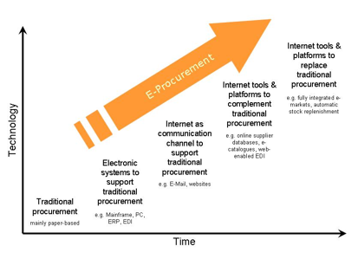
Figure 4.1: Trends of E-procurement
Those involved in the procurement function need to understand the e-procurement concepts and tools to provide input into their development, use, evaluation and refinement as a means of improving procurement efficiency and effectiveness.
Procurement officers and managers can make a contribution to decisions about investments in, and configuration and use of e-procurement tools by:
- having a general understanding of the various e-procurement applications
- identifying the procurement processes that are effectively supported by e-procurement
- understanding the sources of benefit of e-procurement
- identifying the risks associated with the adoption of e-procurement
- Contributing to the development of e-procurement tools through identifying scope for e-commerce supported process improvement.

E-procurement tools and applications
Some e-procurement tools and applications include:
- electronic systems to support traditional procurement
- EDI (electronic data interchange)
- ERP systems
- internet as a support or complement to traditional procurement
- electronic mail (e-mail)
- web enabled EDI
- extensible markup language (XML)
- world wide web (www)
- internet tools and platforms that replace traditional procurement

Electronic systems to support traditional procurement
These include mainframes and personal computers (PC), Electronic Data Interchange (EDI) and Enterprise Resource Planning (ERP).

EDI (Electronic Data Interchange)
EDI is an application whereby electronic messages can be exchanged between computer programs of two separate organizations. Some features of EDI include:
- Messages are exchanged in groups, known as batches.
- Messages can automatically be sent, transmitted and stored between computers without retyping or keying data.
- EDI has to be implemented by each pair of organizations (sender and receiver) who wish to use it. This means that the implementation costs of EDI are relatively high.
- EDI is mostly used where the messages exchanged concern such matters as orders, confirmations, transport information and invoicing.
- EDI traditionally runs on so-called, “Value Added Networks”, which are closed networks (unlike open networks like the Internet).

ERP systems
ERP systems are management information systems that integrate and automate many of the business practices associated with the operations of a company or organization. ERP systems typically handle the manufacturing, logistics, and distribution, inventory, shipping, invoicing, and accounting for a company or organization. ERPs aid in the control of many business activities, like sales, delivery, billing, production, procurement, inventory management, and human resources management.

Internet as a support or complement to traditional procurement
There are various types of internet based applications that serve different purposes. Some well-known applications that use the internet are described below:

Electronic mail (e-mail)
Email is an Internet based application through which electronic messages are exchanged between people.

Web enabled EDI
web enabled Edi is like traditional EDI (see above), but run on the Internet; also known as EDI-INT.

Extensible Markup Language (XML)
XML is used to allow for the easy interchange of documents on the World Wide Web.

World Wide Web (WWW)
The WWW is a major service on the Internet. The World Wide Web is made up of "Web servers" that store and disseminate "Web pages," which are "rich" documents that contain text, graphics, animations and videos to anyone with an Internet connection.
The figure below illustrates the categories of electronic communication exchange between people and computers.
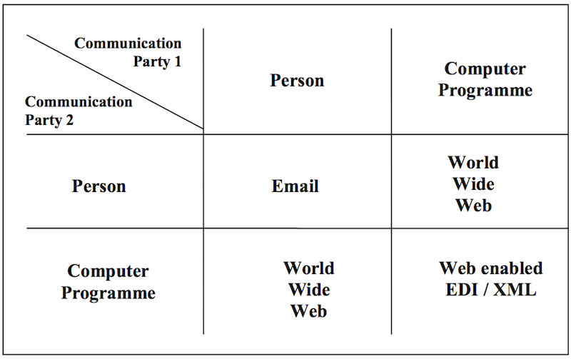

Internet tools and platforms that replace traditional procurement
Some internet tools and platforms that replace traditional procurement include:
- E-sourcing
- E-tendering
- E- auctioning
- E-ordering and web-based ERP
- E-information

E-sourcing: E-sourcing supports the specification phase; it can be used to pre-qualify suppliers and also identifies suppliers that can be used in the selection phase. For suppliers the benefit is: “marketing” and for the buying organizations the benefit is facilitating the sourcing of suppliers. The UN Global Market Place (UNGM www.ungm.org) is an example of an E-sourcing tool.

E-tendering: E-tendering supports the selection stage and acts as a communication platform between the procuring organization and suppliers. It covers the complete tendering process from REOI via ITB/RFP to contracting, usually including support for the analysis and assessment activities; it does not include closing the deal with a supplier but facilitates a large part of the tactical procurement process. It results in equal treatment of suppliers; transparent selection process; reduction in (legal) errors; clear audit trial; more efficiency in the tactical procurement process and improved time management of tendering procedures. Some UN organizations such as UNDP-IAPSO and UNHCR have used E-tendering in the formulation of long-term agreements for vehicles, tents, motorcycles and pharmaceuticals through an in-house developed tendering portal.

E-auctioning: E-auctioning supports the contract stage. It enables the closing of a deal with a supplier if parties agree on price. They operate with an upward or downward price mechanism e.g. e-auctioning with upward price mechanism for the selling organization and e-reverse auctioning with a downward price mechanism for the buying organization. They can be made in accordance with traditional ITB/RFP. They are internet based using open or closed systems.

E-ordering and web-based ERP: E-ordering and web-based ERP is the process of creating and approving procurement requisitions, placing purchase orders, as well as receiving goods and services ordered, by using software systems based on the Internet.
System | Usually used…
E-ordering | - For indirect (facility) goods and services.  - By all employees of an organization.  - For ad-hoc ordering.
Web-based ERP | - For direct (product related) goods and services.  - By a procurement department.  - For planned ordering.

E-informing: E-informing is not directly associated with a stage in the procurement process; it is the process of gathering and distributing procurement information both from and to internal and external parties using Internet technology.

4.3. E-procurement in the procurement cycle
The figure below shows the six forms of e-procurement plotted in the procurement process
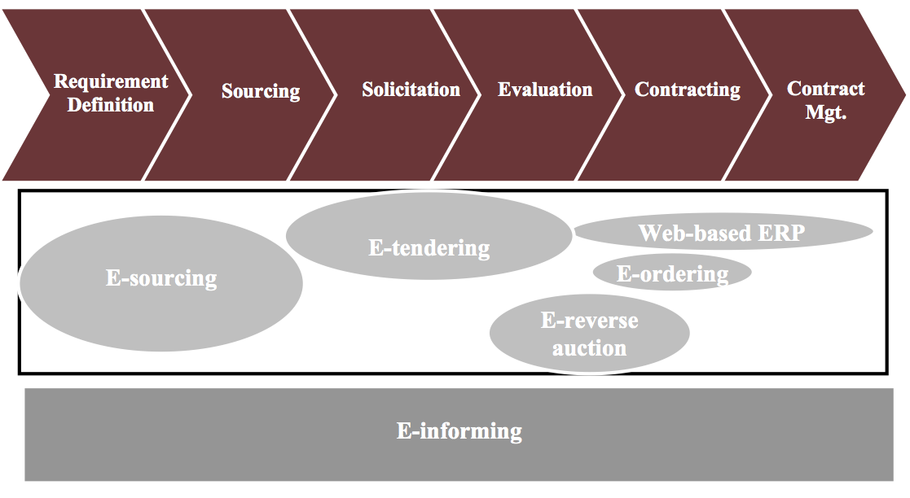
Each of these forms can be explained as follows:
- E-sourcing supports the specification phase; it identifies suppliers that can be used in the selection phase.
- E-tendering supports the selection phase; it facilitates the REOI and ITB/RFP activities, usually including support for the analysis and assessment activities.
- E-reverse auctioning supports the contract phase; it enables closing a deal with a supplier;
- E-ordering and web-based ERP is the process of creating and approving procurement requisitions, placing purchase orders, as well as receiving goods and services ordered, by using a software system based on the Internet.
- E-informing is not directly associated with a phase in the procurement process; it is the process of gathering and distributing procurement information both from and to internal and external parties using Internet technology.

4.4. E-procurement strategy – costs, benefits and risks
Business cases aimed at adopting or enhancing e-procurement tools are often prepared by information technology and/or finance specialists. However, some of the most successful e-procurement implementations have been driven by those who best understand the procurement processes and outcomes to be achieved. Because of their understanding and proximity to procurement processes, those involved in the procurement function have a key role to play in identifying and assessing the costs and benefits of e-procurement tools and in providing input into how existing tools may be enhanced.
The following costs and benefits as identified by de Boer, Harink et al. (2002), can be influenced by e-procurement:
- The cost of expenditure on goods/services related directly to the production/service delivery.
- The cost of non-production of goods and services.
- The cost of operational procurement activities – e.g., requisitioning, ordering, expediting and administrative support.
- The cost of tactical procurement activities – e.g., formulating specifications, selecting suppliers, negotiating with suppliers, contracting, disposals etc.
- The costs of strategic procurement activities – e.g., spend analysis, transaction analysis, market analysis, planning, developing procurement policies etc.
- Internal benefits arising from investments in particular inter-organizational relationships.
- The contribution of investments in particular inter-organizational relationships to revenues.
These costs and benefits should be assessed in relation to each e-procurement tool. While it is usually assumed that e-procurement will automatically deliver benefits, the actual benefits will depend on many factors including: cost of required investment, ability to convert associated savings to cash, nature of the procurement process being automated, particular supply market and the extent to which the organization supports its implementation.

Benefits
Particular benefits of e-procurement in the public sector are thought to include greater transparency in procurement through electronic publishing of tender notices and contract awards. This in turn is likely to enhance accountability and reduce the instances of corruption.
When developing a business case for adopting or enhancing an e-procurement tool, it is important to assess the baseline benefits and costs associated with the process or processes to be automated in order to understand the probable outcomes of e-procurement adoption or enhancement. In essence, it is important to understand what will change and how it will change when an e-procurement tool is implemented.

Risks
The implementation of e-procurement tools carries certain risks. One of the primary risks is missing opportunities to implement strategies that improve procurement management without the need for investment in e-procurement. This is because many of the benefits ascribed to e-procurement may be achieved simply by improving procurement practice. For example, it is often said that e-procurement reduces “maverick buying”. However, other measures, including the implementation of corporate buying strategies that offer value for money, do not need electronic tools.
Another risk is over-investment in e-procurement tools that do not deliver the expected benefits. This risk arises when there has been inadequate evaluation of the implications of the adoption or enhancement of e-procurement tools. The risk that users will not accept an e-procurement tool is another common risk. This risk often arises where users have not been adequately consulted about the adoption or enhancement of particular tools.
On the supply side, there is a risk that suppliers will not cooperate with the use of e-procurement tools. For example, some suppliers are sufficiently powerful to insist on the use of paper-based systems. Others may not have access to affordable internet based technology that would give them access to the e-procurement tools of purchasers. In markets that are already competitive with low profit margins, suppliers may choose not to participate in e-reverse auctions.
Normal methods of risk assessment and management (see Unit 4.1 Risk Management) should be applied during the development of business cases for e-procurement development or enhancement.

4.5. Legal aspects of e-procurement
The accepted legal framework guiding e-procurement is the UNCITRAL Model Law on Electronic Commerce which states:
“In the context of contract formation, unless otherwise agreed by the parties, an offer and the acceptance of an offer may be expressed by means of data messages.”
“Where a data message is used in the formation of a contract, that contract should not be denied validity or enforceability on the sole ground that a data message was used for that purpose.”
Good practice in the UN system adopts this approach, for example, the UN revised FRR take into account the feasibility of electronic contracting. As per UN Financial Rule 105.18 (b) which states:
“The requirement for written procurement contracts shall not be interpreted to restrict the use of any electronic means of data interchange. Before any electronic means of data interchange is used, the Under-Secretary General for Management shall ensure that the electronic data interchange system is capable of ensuring authentication and confidentiality of the information”.
In the UN Secretariat, this authority has been delegated to the UN controller, who determines whether in a particular case, electronic contracting may be possible, for example by an electronic exchange of information without the need to issue a traditional purchase order. Electronic contracting may only be agreed with a supplier in specific cases where prior written authorization has been obtained. In adopting or adapting any e-procurement systems, the practical issues around these legal aspects need to be taken into consideration during the planning and implementation stages.
  - . DEFINITION OF INTERNET
The Internet is a global network of computers that allows people to send email, view web sites, download files such as mp3 and images, chat, post messages on newsgroups and forums and much more. The Internet was created by the Advanced Research Projects Agency (ARPA) of the U.S. government in 1960's and was first known as the ARPANet. At this stage the Internet's first computers were at academic and government institutions and were mainly used for accessing files and to send emails. From 1983 onwards the Internet as we know it today started to form with the introduction of the communication protocol TCP/IP to ARPANet. Since 1983 the Internet has accommodated a lot of changes and continues to keep developing. The last two decades has seen the Internet accommodate such things as network LANs and ATM and frame switched services. The Internet continues to evolve with it becoming available on mobile phones and pagers and possibly on televisions in the future.
The actual term “Internet” was finally defined in 1995 by FNC (The Federal Networking Council). According to Federal Networking Council (FNC) Internet refers to the global information system that,
- Is logically linked together by a globally unique address space based on the Internet Protocol (IP) or its subsequent extensions/follow-ons.
- Is able to support communications using the Transmission Control Protocol/Internet Protocol (TCP/IP) suite or its subsequent extensions/follow-ons, and/or other IP-compatible protocols.
- Provides, uses or makes accessible, either publicly or privately, high level services layered on the communications and related infrastructure described herein.
    - BASIC CONCEPT OF INTERNET
Who Runs The Internet?
Who controls this web, this cloud, this network of networks? Well, no one, really. The Internet seems to be both institutional and anti-institutional at the same time, massive and intimate, organized and chaotic. In a sense the Internet is an international cooperative endeavour, with its member networks kicking in money, hardware, maintenance, and technical expertise.
The U.S. government has had a big influence on the federally funded parts of the Internet. The National Science Foundation (NSF) initiated the NSFNET in the mid 1980s, a nationwide backbone in the United States that connected many mid-level networks, which in turn connected universities and other organizations. At the time of this writing, the NSFNET production backbone is being phased out and connectivity will be offered by other providers, including commercial networks, in the near future. But you may still hear people refer to the NSF and its influence on the Internet. The NSF funds an experimental high-speed network and will continue to provide funding for a short time to assist universities and schools in getting Internet connections.

Names and Addresses
If you've ever travelled in a country where you couldn't read the street signs or figure out how they numbered the houses, you'll understand the wisdom of learning the Internet's name and address system. Most computers on the Internet can be identified in two ways. Each computer, or host, has a name and a numerical address (both unique), just as most of us can be located by our names or numerically by our phone numbers. It's easier to remember a name than a phone number, and it's the same on the Internet. An Internet computer name is usually several words separated by periods, such as yahoo.com. An Internet address—technically an IP address—is four numbers also separated by periods, for example, 161.44.128.70.
When you're saying these names and addresses out loud, you should substitute "dot" for "period" to sound as though you belong.
The idea is for people to use the computers' names when accessing resources, and to let the computers and routers work with the IP addresses. Each Internet-connected organization keeps a database of the names and addresses of all the computers connected to its own networks. Because there are so many computers on the Internet and there is no real central authority, name assignment is best left to the local networks.
Domain Name System. There's actually a method to these names and addresses—a naming system known as the Domain Name System, or DNS. The DNS is also the worldwide system of distributed databases of names and addresses. These databases provide the "translation" from names to numbers and vice versa, a sort of international Who's Who of computers. DNS names are constructed in a hierarchical naming fashion, which you can think of as a worldwide organization chart. At the top of this chart are top-level specifications, such as EDU (educational), COM (commercial), GOV (government), MIL (military), ORG (organizations), and NET (networks), and also two-letter country codes, such as US for the United States and CH for Switzerland.

An organization can register for a domain name, selecting one of the top-level specifications mentioned above that describes it best, and then preceding it with a recognizable version of its name. For example, the ABC Software Systems company will have a domain name like abc.com. From there, it can divide itself into subdomains, extending the organization chart to department levels, or it can just give all of its computers names in the abc.com domain.
Once you understand how this naming system works, you can remember names more easily, and you can also tell things about a computer, such as to what organization it belongs. The names do not, however, always indicate geographical location.
Many U.S. organizations and companies use the three-letter designations mentioned above (for example, EDU, COM, and ORG). However, most countries have stipulated that organizations use their two-letter country codes for top-level domains. For example, an actual computer name, quake.think.com, refers to a commercial (COM) enterprise: the computer's name is quake and it belongs to Thinking Machines Corporation (think), a supercomputer manufacturer in the United States. Another example is fujitsu.co.jp, a computer at the Fujitsu Company in Japan (jp is the two-letter country code for Japan).
Advantages of internet
There many advantages to using the internet such as:
E-mail : Email is now an essential communication tool in business. It is also excellent for keeping in touch with family and friends. The advantage to email is that it is free ( no charge per use) when compared to telephone, fax and postal services.
Information: There is a huge amount of information available on the internet for just about every subject known to man, ranging from government law and services, trade fairs and conferences, market information, new ideas and technical support.
Services: many services are now provided on the internet such as online banking, job seeking and applications, and hotel reservations. Often these services are not available off-line or cost more.
Buy or sell products. : The internet is a very effective way to buy and sell products all over the world.
Communities: Communities of all types have sprung up on the internet. It’s a great way to meet up with people of similar interest and discuss common issues.
A Leading-Edge Image: Presenting your company or organization as leading-edge shows your customers and prospective customers that you are financially strong, technologically savvy, and ready for the 21st century. And that you care enough about your customers to take advantage of new technologies for their benefit. And finally that you have the resources to support your clients in the most beneficial manner possible.
More and more advertisers on television, radio, magazines, and newspapers are including a Web address. Now is the time to avoid playing catch-up later.
Improved Customer Service: The companies are available to their customers 24 hours a day, 7 days a week. The Internet never sleeps. Whenever customer needs information about any company, products or services, they can access the company’s Web Page.
Market Expansion: The Internet is a global system. Latest estimates are that there are about 40 million people with access to the Internet, and this number is growing every day. By simply posting a Web Page you are also addressing International markets.
Low Cost Marketing: Imagine developing a full color brochure without having to incur the costs of proofs, printers, wasted paper, long lead times between revisions, and more. Then imagine a full color product or services brochure that is interactive and which incorporates text, graphics, audio, and/or video. One that can be immediately updated without incurring the usual costs of product material updates.
For a minimal initial investment your company or organization is presented to millions of Internet users worldwide. It's like a virtual brochure in everyone's hand without the associated costs.
Low Cost Selling: Without the cost of direct selling potential customers can get detailed information about your products or services at any time. And they can easily order your products over the Internet, or request additional information be sent to them via a request form on your Web page.
Lower Communication Costs: Your time, and your employee’s time, is valuable. Most businesses and organizations spend time answering the same questions over and over again. With a Web page you can make the answers available to everyone immediately. You can also update your Wed page with new information quickly and easily.
Value Added Marketing: You can use your Web page to provide useful information about your particular industry, product or uses. Any type of information that you believe will be valuable to your customer base can be included in your web page to encourage visitors to your site. You can also provide easy links to other sites with information that would be of value to your customers.
    - REQUIREMENTS FOR INTERNET
The basic requirements for connecting the computer system to the internet can be classified into two categories:
- Hardware Requirement
- Software Requirement
Hardware Requirements
Users can use any of the PC models coming today e.g. Intel Celeron, Intel P-I, Intel P-II , Intel P-III, Intel P-IV, AMD K6, CYRIX MII, etc. The CPU of 350 MHz and above gives a good performance.
Your computer should have at least of 16 MB RAM to have good navigation on the net. The AGP card should have at least 4 MB RAM. This helps in watching the graphics/movies on the Internet effectively.
One should have a telephone line or ISDN (Integrated Services Digital Network) connection. ISDN connection has more bandwidth as compared to a single telephone line. A modem is also required. Modem stands for modulator / demodulator. The computer operates on digital signals, whereas the telephone lines operate on analogy signals. So an additional piece of hardware, i.e., modem is connected between the computer and the telephone line. Modem converts the digital signals to analogy and vice versa. Modems are inbuilt or they can be connected externally. The good modems available in the market are from the companies US ROBOTICS, D-Link etc. A modem can be an ordinary modem or a fax/voice modem. The fax/voice modem in addition to data, can also carry, voice on the net.
Software Requirements
We should have connecting software and web browser software. Internet can be called upon from any operating system e.g. Windows 98, Windows NT, Linux, Unix, etc. The two most widely used web browsers are Internet explorer and Netscape communicator.
After having the basic requirements the additional requirements that are required for smooth and quality service of internet, the following software are required:
- Anti-Virus
- Anti-Worm
- Firewall
- System Utilities
- Download Accelerator or Get right like software
- Compression and Uncompressing utilities
- Adobe Acrobat Reader
- Macromedia Flash
- E-mail configuring software like MS Outlook
- Web Messenger etc.
    - INTERNET SERVICE PROVIDER
An ISP (Internet Service Provider) is a company which provides internet access to other companies or individuals. An ISP maintains connections to other networks and ISPs, acting as a router for internet traffic between a customer's computer and any other machine also connected to the internet anywhere else in the world.
TYPES OF INTERNET SERVICE PROVIDER
Internet Service Provider is a company that you dial up to get on the Internet. There are basically four different kinds:
- National Companies That Offer Services throughout the country.
- Providers:
  - BSNL
- Pros:
  - If you travel or move, most likely you will be able to access the Internet at your new location.
  - The extra services like chat rooms can be an added bonus.
- Cons:
  - Technical support may be hard to reach or long distance.
  - Sometimes you get busy signals when trying to access them.
  - If you don't use the services, if there is an additional charge, it is a waste of money.
  - Although you buy an unlimited account, some will send you notices if you have been online too much.
- Specialized Companies That Offer A Service Like Filtering
- Providers:
  - Reliance
  - Airtel
  - Dishnet DSL
  - Satyam Infoways
  - HCL Infinet
- Pros:
  - You don't have to install additional software to get pornography out of your computer.
  - You will not have to update your filtering software.
- Cons:
  - In some cases roaming facility of account is not available.
  - Technical support may be limited.
- Local ISPs (Small companies that offer Internet service to a small area)
    - Providers:
  - Check in your telephone directory or yellow pages under Internet Services.
    - Pros:
  - Less error prone
  - Less disconnections
  - Offers a local dial up number if you are in a rural area that doesn't have local dial up numbers for the major providers.
    - Cons:
  - They may be limited in their equipment to offer a good, fast internet speed.
  - They may be limited in offering any web guidance.

  - Free ISPs
  - Providers:
  - Call Tiger
  - Pros:
  - Free and no commitment
  - Cons:
  - Technical support may be limited, long distance, or not available.
  - May not offer reliable service.
  - Advertising banner can take up a lot of space on your screen.
  - Some charge very high set up fees (stay away from these)

TYPES OF INTERNET SERVICE PROVIDER ACCOUNTS
There are many types of connections USER can get on the internet depending on the type of use and the amount of resources (money) available. The different types of connections, their advantages and limitations have been discussed below:
No matter what type of connection you go in for, it should be reliable, fast, easily available, and economical. There is no such things as a free connection to the Internet. Someone, somewhere has to pay for the equipment, software, telephone lines, and electricity.
Basically there are four types of connections to the Internet:
- Dial-up Connection
- ISDN Connection
- Leased Line Connection
- Cable Modem
- DSL
- Broadband
- V-SAT
The most popular type of connection for an individual is the broadband connection as it is easily available and economical.
1. Dial-Up Connection
As the name suggests, dial-up link means you have to dial into a modem over a telephone line before you can get connected to the internet. A modem (modulator demodulator) is a device which converts digital signals emitting from the computer into analog signals so that the data is easily transmitted over analog telephone lines. At the receiving end, there is another modem which converts these transmitted analog signals back to the digital form which are received by the target computer.
For this type of connection you require:
A computer whose configuration could be 80486 but the best is Pentium-IV or above. Communication software, like dialer which the Internet connection provider will give and a telephone line.
A modem (optimal speed is 36.6 Kbps). These days we use modems of speeds up to 56 Kbps. Software like a browser, e-mail programme, FTP software, Newsgroup reader, Eudora, Outlook Express, etc. Outlook Express is one of the software which helps to read news and mail offline once they have been collected online.
There are 3 major ways by which you can get linked to the Internet using a dial-up connection, namely;
  - Host terminal connection
  - Individual computer
  - Dial-Up or on demand through the LAN.

A. Host Terminal Connection (Terminal Emulation)
In case of host terminal connection, a PC is connected to some Internet host via modem and a terminal emulation programme is run. Your terminal now acts like a vt-100 terminal . In other words, you are connected to a large computer which is connected to the Internet. Thus if want to download a file, the file is downloaded to the host and not your computer. To download a file from their host to your computer you need to have some specific software. In this type of connection you can download only text but not graphics. Hence, a host terminal connection is also referred to as a shell account. This account is best suitable for:
- Students whose budget is low and their requirement is limited to text.
- Users who connect via Telnet programmes.
- Users whose frequency to use the Internet is low.
- Users who want to use the Internet to access the network of their workplace from their home place (personal account). Such users could connect via Telnet.
- Jobs where multi-tasking is not required. This connection permits only one task at a time, e.g., the user cannot read the news as well as download a file.
This type of a connection offers three different types of accounts depending on your distance from the ISP and the nature of work for which you want the connection.
- Local dial.
- Use of public data networks.
- Restricted access.
- Local Dial: Local dial is the cheapest type and is only possible if the host is at a local telephone call distance away.
- Public Data Network: If the host is not in the vicinity, then long distance calls have to be made over public data networks. If the speed of such networks is slow then data transmission speed will also be slow and so the connection will prove to be more expensive.
- Restricted Access Account: Suppose you want to access only E-mail or newsgroups. In such situations, restricted access account is best for you. There are certain sites which provide inexpensive E-mail accounts, local bulletin board services, etc. you just have to registered pay only for the services you want to use.

B. Individual Computer
Here your computer can work as an Internet Host, i.e., direct downloading of files and mails can be done when connected to the internet. This kind of link is a little more costly than the host terminal connection as you have to pay a monthly fees to the service provider or sometimes even a flat charge for a fixed period of time. Here you can have one or both the following account ;
- Serial Line Internet Protocol (SLIP)
- Point to Point Protocol (PPP)
- Serial Line Internet Protocol (SLIP) . In case of SLIP data is sent in packets under speeds of 9600 bps on telephone lines using data compression protocols.
- Point-to-Point Protocol (PPP). In case of PPP data is sent over telephone lines via modem. Double checking is done at the destination to see if data packets have arrived intact. This is better than SLIP as it allows authentication of users. These days PPP connections are more common. Again, speed of data transfer in PPP is faster than in SLIP.
This type of connection is good for people who:
- Use Graphics.
- Download files often.
- Use direct e-mail or any other online service.
- Use Internet regularly though for limited hours.
The limitations are few, such as, people may not be able to access the Internet easily if the disk space is limited or if the line is slow (i.e., speeds below 28.8 Kbps will not be accessible by other people)
C. Dial-Up or On-Demand through the LAN
In this case there is a dial up link from the LAN to which you are connected to. This type of connection is favourable for small business houses and educational institutes. Here the server, on demand, dials up for a connection and once the connection is established everybody logged on to the LAN can access the Internet. In such a situation if there is any file downloaded from the Internet then like any other file, this file will be accessible to all LAN clients. The only problem here is that the more the number of users logged onto the LAN and working on the Internet, the slower will be the Internet connect6ion. However, this is successful if you have a very fast server software along with a very fast line. Again extra software like proxy servers are also required to serve the needs of various individual LAN users with one Internet connection
2. Integrated Services Digital Network Connection (ISDN)
This is a very high speed connection to the Internet over normal telephone line. It combines both voice and digital information in a single medium, making it possible to provide the customers with digital as well as voice connections. In ISDN connection, the information which is sent from your computer to the Internet is digital. Here we do not use a normal modem. As no conversion from analog to digital or vice versa is required, so we use an ISDN modem which is merely a terminal adapter. Another differences lies in the fact that the ISDN lines, in order to work, require power from outside. When there is a power shutdown, ISDN lines will not work. ISDN service has many variations but we follow Basic Rate Interface (BRI) Service. Here the ISDN line is divided into three logical channels, namely:
- Two 64 Kbps B (bearer) channels.
- One 16 Kbps D (Data) channel.
Thus ISDN is commonly referred to as 2B+D.
Over bearer channels you can send data. If only data is sent then it could be sent at a speed of 64+64=128 Kbps but if both data and voice is to travel then one B channel is dedicated to voice and the other to data. The data or D channel is used to send signalling information for routing data which is being sent over B channels. Those telephone companies which do not have the ability to use D channels remove 8 Kbps from each B channel. Therefore, only 56 Kbps of data can go over each of these B channels.
Apart from voice, many value added services are also being offered like:
- Telephones will soon have the facility to display name, address, and telephone number of the caller while the telephone rings.
- When the telephone gets connected to the computer, the caller’s database record is displayed on the computer.
- Call forwarding facility
- Remote electricity meter reading services.
- Smoke alarms that automatically call up the hospital, fire station or police station.

Advantages of using ISDN:
- Allows high speed access, i.e., 128 Kbps.
- No special laying down of wires. The existing copper telephone cables work fine.
- Can be used for voice, data, graphics, full motion video as data transfer speed is high.
The only disadvantage of using ISDN is that it proves to be an expensive affair as special equipment is required for it and the tariff is also high.
3. Leased Line Connection (Dedicated Connection)
As the name suggests, a leased line connection is a permanent connection laid down between you and a modem. As it is permanently lined, you have a 24 hour access to the Internet, seven days in a week. A leased line connection is very useful especially when frequent information has to be accessed from the Internet and also when the volume of data transfer is high. It is also useful if the Internet is to be used for more than 12 hours a day.
This type of connection is the most reliable and has high speed. The only issue behind this connection is its cost.
The cost includes :
- One time installation (laying down of physical line upto your site).
- Yearly/periodically maintenance charge.
- Annual tariff.
- The necessary one time hardware, software and set up charges.
4. Cable Modem
In case of cable modem the Internet can be accessed through the normal coaxial television cables with the help of cable modems. Speed of cable modems is 10 to 100 times faster than normal dial-up connection modems. The only catch is that the local cable operator should have the capability to access the Internet over cable TV wires and that cable modems are slightly more expensive than normal modems. One advantage of cable modem connection is that you need not have a telephone line if you want this type of connection to the Internet.

Before giving approximate tariff rates for the different types of connections, let us discuss the role of Videsh Sanchar Nigam Limited (VSNL). VSNL is the gateway to Internet in India. It is also an Internet Service Provider (ISP) so that the user can acquire a connection from it. Until recently, VSNL was the only gateway of the Internet in India but now we have another private gateway, namely, Now Convergence. This organization also has some very good offers like faster downloads. Let us now discuss the role of an ISP.
5. DSL
DSL or Digital Subscriber Line service is provided through the existing telephone line, but it works differently than regular analog modem dial-up access. DSL operates over normal telephone lines and it can be used simultaneously with the telephone. DSL can increase the connection speed by as much as ten-fold from a standard dial-up modem.
6. Broadband
This type of access is good for remote locations, where ISDN, cable or DSL are not available. It gives a decent download speed, but to upload the data, the user still needs a regular analog modem to dial in, via a telephone line. Satellite connection can be either a two way service or a one way service. In case of two-way satellite service, the data is transmitted via satellite to a dish antenna at the user’s house. In one-way system, the user needs a conventional modem and a telephone link to an ISP. Satellite connection is expensive but sometimes is the only fast option for the people who are beyond the service area of cable and DSL providers.
7. Very Small Aperture Terminals (VSATs)
The two ground stations that communicate with one another via the satellite need not be the same size or transmit data with the same amount of power. Many satellite networks use a large number of small dishes, called VSATs (very small aperture terminals), for the outlying nodes and one central hub with a big dish that can transmit very powerful signals and is very sensitive to incoming ones. This system minimizes the cost of the majority of the ground stations at the expense of maintaining one big one, which can be shared by several users, However, this approach can cause additional delays, because the VSATs aren’t powerful enough to talk to one another directly through the satellite; messages must pass through the hub and make two trips into space before reaching their final destination, incurring a double delay.

VSATs are typically used by organizations, such as oil companies, that require data or voice communications between sites distributed over a wide geographical area. Terrestrial links are economical over short distances; their cost climbs quickly as the distance between locations increases. In addition, terrestrial data and voice links, while readily available in cities, are often difficult, if not impossible, to obtain in smaller urban 'and remote local areas using these links.
SUMMARY
As with any purchase, familiarity with a product will help you make a better decision. Find out which ISPs other people are using and ask them why. It should be noted that reluctance, on behalf of a potential ISP, to answer your questions is a negative indicator; the company may be hiding product/service deficiencies.

Make sure that you read the ISP's service contract before you commit to it. That way you'll know what to expect in event of a closure, merger or if the quality of Service does not meet your expectations
SELF ASSESSMENT QUESTIONS
1. What is internet? Discuss major applications of internet.
2. Why internet is so famous?
3. What are the various hardware and software requirements to have internet on computer system?
4. Define ISP. Discuss the various criterion for selecting an ISP.
5. Discuss various types of internet account with their characteristics and limitations.
6. Define the following terms:
  - WWW
  - Internet
  - Modem
  - DNS
SUGGESTED READINGS
- Kalakota, Ravi and Whinston, Andrew B. “Electronic Commerce – A Manager’s Guide”, Pearson Education, Inc.
- Kalakota, Ravi and Whinston, Andrew B. “Frontiers of Electronic Commerce”, Pearson Education, Inc.
- Rich, Jason R. “Starting an E-Commerce Business”. IDG Books, Delhi, 2000.
- Samantha Shurety. “E-business with Net Commerce”, Addison Wesley, Singapore, 2001.
- Turban et al. “Electronic Commerce: A Managerial Perspective”, Pearson Education, Inc.

CHAPTER FIVE: ELECTRONIC PAYMENT SYSTEMS
Chapter Objectives
For electronic commerce to have a chance to meet the soaring expectations set in the press with regards to the Internet, efficient and effective payment services need to be established and accepted by businesses and consumers alike.
After going through this Chapter, you will be able to:
- Describe the concept of Electronic Payment System
- Define various types of Electronic Payment System
- Explore various dimensions of Electronic Payment System
- Identify security issues in Electronic Payment System
- Explore the managerial issues in Electronic Payment System
- Explore the future of Electronic Payment System in Ethiopia
  - INTRODUCTION
Electronic payment systems are central to on-line business process as companies look for ways to serve customers faster and at lower cost. Emerging innovations in the payment for goods and services in electronic commerce promise to offer a wide range of new business opportunities.
Electronic payment systems and e-commerce are highly linked given that on-line consumers must pay for products and services. Clearly, payment is an integral part of the mercantile process and prompt payment is crucial. If the claims and debits of the various participants (consumers, companies and banks) are not balanced because of payment delay, then the entire business chain is disrupted. Hence an important aspect of e-commerce is prompt and secure payment, clearing, and settlement of credit or debit claims.
The current state of on-line electronic payments is in many ways reminiscent of the medieval ages. The merchants of Asia and Europe faced a similar problem while trying to unlock the commercial potential of the expanding marketplace. Those ancient traders faced a number of obstacles (e.g., conflicting local laws and customs regarding commercial practices and incompatible and nonconvertible currencies) that restricted trade. To circumvent some of these problems, traders invented various forms of payment instruments. The merchants also developed commercial law surrounding the use of these instruments that proved to be one of the turning points in the history of trade and commerce. We are on the verge of a similar sort of development today, but one that is unlikely to take anywhere near the centuries it took for the traditional payment system to evolve.

Everyone agrees that the payment and settlement process is a potential bottleneck in the fast-moving electronic commerce environment if we rely on conventional payment methods such as cash, checks, bank drafts, or bills of exchange. Electronic replicas of these conventional instruments are not well suited for the speed required in e-commerce purchase processing. For instance, payments of small denominations (micropayments) must be made and accepted by vendors in real time for snippets of information. Conventional instruments are too slow for micropayments and the high transaction costs involved in processing them add greatly to the overhead. Therefore new methods of payment are needed to meet the emerging demands of e-commerce. These neo-payment instruments must be secure, have a low processing cost, and be accepted widely as global currency tender.

Electronic Payment Systems
Electronic payment systems are becoming central to on-line business transactions nowadays as companies look for various methods to serve customers faster and more cost effectively. Electronic commerce brings a wide range of new worldwide business opportunities. There is no doubt that electronic payment systems are becoming more and more common and will play an important role in the business world. Electronic payment always involves a payer and a payee who exchange money for goods or services. At least one financial institution like a bank will act as the issuer (used by the payer) and the acquirer (used by the payee).

Awareness of risks Electronic Payment Systems
Security, legal certainty and trust are important elements, influencing the acceptance of commerce by both individuals and businesses. Furthermore, sociological and cost factors play a significant role.
Several reports on awareness of risks are related to the non-transparent legal background for both companies and consumers. In this context, e-commerce reluctance appears to be more pronounced in firms than in customers. The main reason for firms to be reluctant may be insecurity caused by the lack of legal rules determining when a transaction is legally binding. For customers, in addition to this, the security of on-line payment methods may be decisive. An important issue is credit card acceptance by retailers in Europe. The credit cards were offered to merchants originally on the grounds, that authorized transactions would be honored. Now the system is established, banks in some countries charge traders for fraudulent transactions, which causes tensions. Some large retailers still refuse to take credit cards because of the terms of business. The result has been a move towards debit cards - which use the same infrastructure but have different contractual terms.
In general, there seems to be no consensus on whether companies and customers clearly distinguish between secured and unsecured methods of payment and whether they would not accept the latter because of the risks involved. Some parties believe that companies and customers clearly distinguish between secured and unsecured methods. However, others maintain that only companies clearly distinguish between secured and unsecured methods. Customers’ awareness of risks on the other hand is most probably based on perception rather than on facts, and is therefore less analytical. If both partners in ecommerce (banks and merchants) are reliable and offer convenient payment schemes, customers will make use of them.
The general public remains unaware of the risk issue. The main concern of the average consumer seems to be confidentiality about credit card numbers exchanged on the Internet. Some experts share the view that the perceived lack of security in on-line electronic payments is largely exaggerated and not justified at all by the actual threat. The average consumer does not yet realize that the risk of compromising his card number is far greater in conventional face-to-face transactions than on the Internet. This is partly the result of ignorance and unfamiliarity, as well as a mistaken belief in the security of traditional payment systems. In this respect, the difficulty of generalizing about the security aspects of all systems should be stressed. There is a wide variety of payment systems with different security features and thus with varying security level.
Many other issues affect the security of electronic payments perhaps even more importantly: e.g. the physical, procedural and personnel security procedures operated at the ends of any telecommunications link (whether via a PC, smart card or mobile phone). It is also fairly well known that most security failures are caused by “insider” threats rather than by external hackers (or crackers). Confidence in the reliable operation of the terminal equipment(s) is essential.
  - TYPES OF ELECTRONIC PAYMENT SYSTEMS
Conventional Payment Process
A conventional process of payment and settlement involves a buyer-to-seller transfer of cash or payment information (e.g. credit card or check). The actual settlement of payment takes place in the financial processing network. A cash payment requires a buyer's withdrawal from his bank account, a transfer of cash to the seller, and the seller's deposit of the payment to his/her account. Non-cash payment mechanisms are settled by adjusting, i.e. crediting and debiting, the appropriate accounts between the banks based on payment information conveyed via check or credit card. Figure 5.1 is a simplified diagram for both cash and non-cash transactions. Cash moves from the buyer's bank to the seller's bank through face-to-face exchanges in the market. If a buyer uses a non-cash method of payment, payment information instead of cash flows from the buyer to the seller, and ultimately payments are settled between affected banks who notation ally adjust accounts based on the payment information. In real markets, this clearing process involves some type of intermediaries such as credit card services or check clearing companies. Schematically then most payment systems are based on similar processes. The 'information' conveyed to settle payments can be one of the following: information about the identities of the seller and the buyer and some instruction to settle payments without revealing financial information [payment clearing systems financial information such as credit card or bank accounts numbers (including checks and debit cards) actual values represented by digital currency

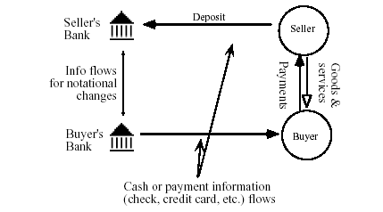
Figure 5.1: A Cheque simplified model of transaction
Type 1: Payment through an Intermediary - Payment Clearing Services
When face-to-face purchase is replaced with on-line commerce, many aspects of a transaction occur instantly, under which various processes of a normal business interaction are subsumed. For example, a typical purchase involves stages of locating a seller, selecting a product, asking a price quote, making an offer, agreeing over payment means, checking the identity and validity of the payment mechanism, transferring of goods and receipts. In order to be used as a substitute for face-to-face payments, online payment systems must incorporate all or some of these stages within their payment functions. The lack of face-to-face interaction also leads to more secure methods of payment being developed for electronic commerce, to deal with the security problems for sensitive information and uncertainty about identity. Consequently, electronic commerce transactions require intermediaries to provide security, identification, and authentication as well as payment support.
Figure 5.2 shows a stylized transaction for online commerce using an intermediary. In this model, the intermediary not only settles payments, it also takes care of such needs as confirming seller and buyer identities, authenticating and verifying ordering and payment information and other transactional requirements lacking in virtual interactions. In the figure, two boxes delineate online purchasing and secure or off-line payment clearing processes. Payment settlement in this figure follows the example of the traditional electronic funds transfer model which uses secured private value networks. The intermediary contributes to market efficiency by resolving uncertainties about security and identity and relieving vendors of the need to set up duplicative hardware and software to handle the online payment clearing process. The payment information transmitted by the buyer may be one of three types. First, it may contain only customer order information such as the identity of the buyer and seller, name of the product, amount of payment, and other sale conditions but no payment information such as credit card numbers or checking account numbers. In this case, the intermediary acts as a centralized commerce enabler maintaining membership and payment information for both sellers and buyers. A buyer need only send the seller his identification number assigned by the intermediary. Upon receiving the purchase order, the intermediary verifies it with both the buyer and seller and handles all sensitive payment information on behalf of both.

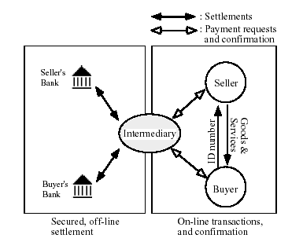
Figure 5.2: Transactions with an intermediary

The key benefit of this payment clearing system is that it separates sensitive and non-sensitive information and only non-sensitive information is exchanged online. This alleviates the concern with security that is often seen as a serious barrier to online commerce. In fact, First Virtual does not even rely on encryption for messages between buyers and sellers. A critical requisite for this system to work is the users' trust in the intermediaries.
Type 2: Payment Based on EFT - Notational Funds Transfer
The second type of payment systems does not depend on a central processing intermediary. Instead, sensitive payment information (such as credit card or bank account number) is transmitted along with orders, which is in effect an open Internet implementation of financial electronic data interchange (EDI) (see Figure 5.3). An electronic funds transfer (EFT) is a financial application of EDI, which sends credit card numbers or electronic checks via secured private networks between banks and major corporations. To use EFTs to clear payments and settle accounts, an online payment service will need to add capabilities to process orders, accounts and receipts. In its simplest form, payment systems may use digital checks simply an image of a check and rely on existing payment clearing networks. The Secure Electronic Transaction (SET) protocol - a credit card based system supported by Visa and MasterCard - uses digital certificates, which are digital credit cards. We call this type of payment system as notational funds transfer system since it resembles traditional electronic fund transfers and wire transfers which settle notational accounts of buyers and sellers.

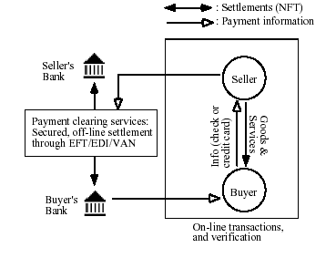
Figure 5.3: Notational funds transfer system
Notational funds transfer systems differ from payment clearing services in that the 'payment information' transferred online contains sensitive financial information. Thus, if it is intercepted by a third party, it may be abused like stolen credit cards or debit cards. A majority of proposed electronic payment systems fall into this second type of payment systems. The objective of these systems is to extend the benefit and convenience of EFT to consumers and small businesses. However, unlike EFTs, the Internet is open and not as secure as private value added networks (VANs). The challenge to these systems is how to secure the integrity of the payment messages being transmitted and to ensure the interoperability between different sets of payment protocols.
Type 3: Payment Based on Electronic Currency
The third type of payment systems transmit not payment information but a digital product representing values: electronic currency. The nature of digital currency mirrors that of paper money as a means of payment. As such, digital currency payment systems have the same advantages as paper currency payment, namely anonymity and convenience. As in other electronic payment systems, here too security during transmission and storage is a concern, although from a different perspective, for digital currency systems doubles pending, counterfeiting, and storage become critical issues whereas eavesdropping and the issue of liability (when charges are made without authorization) are important for notational funds transfers. Figure 5.4 shows a digital currency payment scheme.
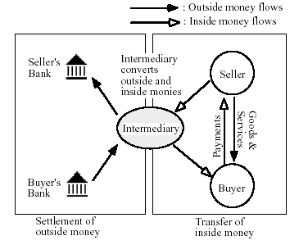
Figure 5.4: Digital Currency Payment Scheme

The only difference from Figure is that the intermediary in Figure 5.4 acts as an electronic bank which converts outside money, into inside money (e.g. tokens or e-cash) which is circulated within online markets. However, as a private monetary system, digital currency will have wide ranging impact on money and monetary system with implications extending far beyond mere transactional efficiency. Already digital currency has spawned many types of new businesses: software vendors for currency server systems; hardware vendors for smart card readers and other interface devices; technology firms for security, encryption and authentication; and new banking services interfacing accounts in digital currency and conventional currency.
  - DIMENSIONS OF ELECTRONIC PAYMENT SYSTEM
Electronic payment systems can be considered to be merely the next - albeit significant - step in a long line of changes in payment clearing systems. The electronic settling of accounts, for example, has long been an integral part of payment systems using credit cards, debit cards, automatic teller machines, and prepaid cards. What enables any payment mechanism to be processed electronically is the fact that unlike currency, bills, or coins which carry monetary values, non-cash mechanisms are promises or contracts of payments. Based on the information transmitted or characteristics following a transaction, the appropriate accounts representing notational money are adjusted between banks and financial institutions.
Table 5.1: DIMENSIONS OF ELECTRONIC PAYMENT SYSTEM
Dimension | Cash | Personal Check | Credit Card | Stored Value (Debit Card) | Accumulat-ing Balance
Instantly convertible without intermediation | Yes | No | No | No | No
Low transaction cost for small transactions | Yes | No | No | No | Yes
Low transaction cost for large  transactions | No | Yes | Yes | Yes | Yes
Low fixed costs for merchant | Yes | Yes | No | No | No
Refutable (able to be repudiated) | No | Yes | Yes | No (usually) | Yes
Financial risk for consumer | Yes | No | Yes | Limited | No
Financial risk for merchant | No | Yes | Yes | No | Yes
Anonymous for consumer | Yes | No | No | No | No
Anonymous for merchant | Yes | No | No | No | No
Immediately respendable | Yes | No | No | No | No
Security against unauthorized use | No | Some | Some | Some | Some
Tamper-resistant | Yes | No | Yes | Yes | Yes
Requires authentication | No | Yes | Yes | Yes | Yes
Special hardware required | No | No | Yes – by merchant | Yes – by merchant | Yes – by merchant
Buyers keeps float | No | Yes | Yes | No | Yes
Account required | No | Yes | Yes | Yes | Yes
Has immediate monetary value | Yes | No | No | Yes | No
Source: Adapted from Mackie-Mason and White,1996
  - TRADITIONAL PAYMENT SYSTEMS VS ELECTRONIC PAYMENT SYSTEMS
- Offline versus Online Offline payments involve no contact with a third party during payment: The transaction involves only the payer and payee. The obvious problem with offline payments is that it is difficult to prevent payers from spending more money than they actually possess. In a purely digital world, a dishonest payer can easily reset the local state of his system to a prior state after each payment. Online payments involve an authorization server (usually as part of the issuer or acquirer) in each payment. Online systems obviously require more communication. In general, they are considered more secure than offline systems. Most proposed Internet payment systems are online. All proposed payment systems based on electronic hardware, including Mondex and CAFE (Conditional Access for Europe), are offline systems. Mondex is the only system that enables offline transferability: The payee can use the amount received to make a new payment himself/herself, without having to go to the bank in between. However, this seems to be a politically unpopular feature. CAFE is the only system that provides strong payer anonymity and un-traceability. Both systems offer payers an electronic wallet, preventing fake-terminal attacks on the payer’s PIN. CAFE also provides loss tolerance, which allows the payer to recover from coin losses (but at the expense of some anonymity in case of loss). Mondex and CAFE are multicurrency purses capable of handling different currencies simultaneously. All these systems can be used for Internet payments, and there are several plans for so doing, but none is actually being used at the time of this writing. The main technical obstacle is that they require a smart card reader attached to the payer’s computer. Inexpensive PCMCIA smart card readers and standardized infrared interfaces on notebook computers will solve this connectivity problem. Another system being developed along these lines is the FSTC (Financial Services Technology Consortium) Electronic Check Project, which uses a tamper-resistant PCMCIA card and implements a check-like payment model. Instead of tamper-resistant hardware, offline authorization could be given via preauthorization: The payee is known to the payer in advance, and the payment is already authorized during withdrawal, in a way similar to a certified bank check.
- Trusted hardware Offline payment systems that seek to prevent (not merely detect) double spending require tamper-resistant hardware at the payer end. The smart card is an example. Tamper-resistant hardware may also be used at the payee end. An example is the security modules of point-of-sale (POS) terminals. This is mandatory in the case of shared-key systems and in cases where the payee does not forward individual transactions but the total volume of transactions. In a certain sense, tamper-resistant hardware is a “pocket branch” of a bank and must be trusted by the issuer. Independent of the issuer’s security considerations, it is in the payer’s interest to have a secure device that can be trusted to protect his secret keys and to perform the necessary operations. Initially, this could be simply a smart card. But in the long run, it should become a smart device of a different form factor with secure access to a minimal keyboard and display. This is often called an electronic wallet. Without such a secure device, the payers’ secrets and hence their money are vulnerable to anybody who can access his computer. This is obviously a problem in multiuser environments. It is also a problem even on single-user computers that may be accessed directly or indirectly by others. A virus, for example, installed on a computer could steal PINs and passwords as they are entered. Even when a smart card is available to store keys, a virus program may directly ask the smart card to make a payment to an attacker’s account. Thus for true security, trusted input/output channels between the user and the smart card must exist.
- Cryptography A wide variety of cryptographic techniques have been developed for user authentication, secret communication, and nonrepudiation. They are essential tools in building secure payment systems over open networks that have little or no physical security. There are also excellent reference works on cryptography.
- “Cryptofree” systems Using no cryptography at all means relying on out-band security: Goods ordered electronically are not delivered until a fax arrives from the payer confirming the order. First Virtual is a cryptofree system. A user has an account and receives a password in exchange for a credit card number, but the password is not protected as it traverses the Internet. Such a system is vulnerable to eavesdropping. First Virtual achieves some protection by asking the payer for an acknowledgment of each payment via email, but the actual security of the system is based on the payer’s ability to revoke each payment within a certain period. In other words, there is no definite authorization during payment. Until the end of this period, the payee assumes the entire risk.
- Generic payment switch A payment switch is an online payment system that implements both the prepaid and pay-later models, as exemplified by the Open Market payment switch. Open Market’s architecture supports several authentication methods, depending on the payment method chosen. The methods range from simple, unprotected PIN-based authentication to challenge-response-based systems, in which the response is computed, typically by a smart card. Actually, Open Market uses passwords and optionally two types of devices for response generation: Secure Net Key and Secure ID. User authentication therefore is based on shared-key cryptography. However, authorization is based on public-key cryptography: the Open Market payment switch digitally signs an authorization message, which is forwarded to the payee. The payment switch is completely trusted by users who use shared-key cryptography.

- Shared-key cryptography Authentication based on shared-key cryptography requires that the prover (the payer) and a verifier (the issuer) both have a shared secret. A DES key is one example of a shared secret; a password and PIN are other examples. Because both sides have exactly the same secret information, shared-key cryptography does not provide nonrepudiation. If payer and issuer disagree about a payment, there is no way to decide if the payment was initiated by the payer or by an employee of the issuer. Authenticating a transfer order on the basis of shared keys is therefore not appropriate if the payer bears the risk of forged payments.4 If authentication is to be done offline, each payer payee pair needs a shared secret. In practice this means that some sort of master key is present at each payee end, to enable the payee to derive the payer’s key. Tamper-resistant security modules in point-of-sale terminals protect the master key. Most offline systems Danmont / Visa and the trial version of Mondex) and online systems (NetBill, and the 2KP variant of iKP) use a shared secret between payer and issuer for authentication.
- Public-key digital signatures Authentication based on public-key cryptography requires that the prover have a secret signing key and a certificate for its corresponding public signature verification key. The certificate is issued by a well-known authority. Most systems now use RSA encryption, but there are several alternatives. Digital signatures can provide nonrepudiation— disputes between sender and receiver can be resolved. Digital signatures should be mandatory if the payer bears the risk of forged payments. A rather general security scheme that uses publickey signatures is Secure Socket Layer. SSL is a socketlayer communication interface that allows two parties to communicate securely over the Internet. It is not a payment technology per se, but has been proposed as a means to secure payment messages. SSL does not support nonrepudiation. Complete payment systems using public-key cryptography include e-cash, NetCash, CyberCash, the 3KP variant of iKP, and Secure Electronic Transactions (SET). The protocol ideas themselves are much older. The use of digital signatures for both online and offline payments, anonymous accounts with digitally signed transfer orders, and anonymous electronic cash were all introduced during the 1980s.
- Payer anonymity Payers prefer to keep their everyday payment activities private. Certainly they do not want unrelated third parties to observe and track their payments. Often, they prefer the payees (shops, publishers, and the like) and in some cases even banks to be incapable of observing and tracking their payments. Some payment systems provide payer anonymity and un-traceability. Both are considered useful for cash-like payments since cash is also anonymous and untraceable. Whereas anonymity simply means that the payer’s identity is not used in payments, un-traceability means that, in addition, two different payments by the same payer cannot be linked. By encrypting all flows between payer and payee, all payment systems could be made untraceable by outsiders. Payer anonymity with respect to the payee can be achieved by using pseudonyms instead of real identities. Some electronic payment systems are designed to provide anonymity or even un-traceability with respect to the payee (iKP, for example, offers this as an option). Currently, the only payment systems mentioned here that provide anonymity and un-traceability against payee and issuer are e-cash (online) and CAFE (offline). Both are based on public-key cryptography, a special form of signatures called blind signatures. A blind signature on some message is made in such a way that the signer does not know the exact content of the message. DigiCash’s e-cash, which is also based on the concept of blind signatures, is a cash-like payment system providing high levels of anonymity and un-traceability. In an e-cash system, users can withdraw e-cash coins from a bank and use them to pay other users. Each e-cash coin has a serial number. To withdraw e-cash coins, a user prepares a “blank coin” that has a randomly generated serial number, blinds it, and sends it to the bank. If the user is authorized to withdraw the specified amount of e-cash, the bank signs the blind coin and returns it to the user. The user then unblinds it to extract the signed coin. The signed coin can now be used to pay any other e-cash user. When a payee deposits an e-cash coin, the bank records its serial number to prevent double-spending. However, because the bank cannot see the serial number when it signs the coin, it cannot relate the deposited coin to the earlier withdrawal by the payer. NetCash and anonymous credit cards also provide anonymity and un-traceability. But they are based on the use of trusted “mixes” that change electronic money of one representation into another representation, without revealing the relation. Neither e-cash nor CAFÉ assume the existence of such trusted third parties.
  - ELECTRONIC PAYMENTS AND PROTOCOLS
There are many protocols that are currently employed to allow money to change hands in cyberspace. But the most important open protocols used for payments on the Web are SSL/TLS, SET, and IOTP.
SSL and TLS
The Secure Sockets Layer (SSL) protocol was designed by Netscape as a method for secure client-server communications over the Internet. Using public key cryptography and certificates, SSL offers a mechanism so that clients and servers can authenticate each other and then engage in secure communication. During an initial handshaking phase, the client and server select a secret key crypto scheme to use and then the client sends the secret key to the server using the server’s public key from the server’s certificate. From that point on, the information exchanged between the client and server is encrypted.

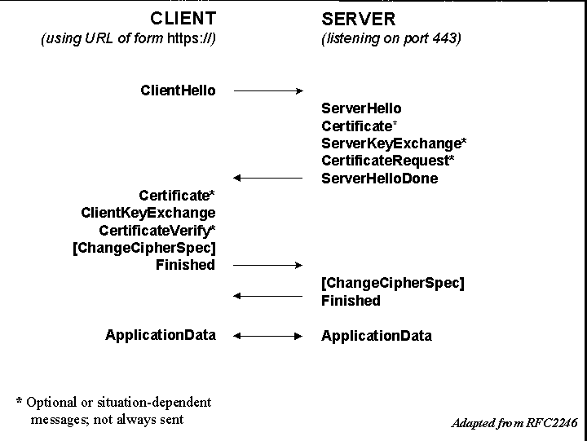
FIGURE 5.5: SSL/TLS messages exchanged between client and server.

SSL/TLS is an intermediate protocol layer that sits between TCP and a higher-layer application. SSL/TLS can be employed by any application layer protocol running over the Transmission Control Protocol (TCP), including Hypertext Transfer Protocol (HTTP), File Transfer Protocol (FTP), Telnet, and the e-mail protocols (Simple Mail Transfer Protocol — SMTP, Post Office Protocol — POP3, and Internet Message Access Protocol — IMAP4). Indeed, the most widely known and widely used application of SSL/TLS is for securing HTTP communication, denoted by the https:// in URLs and use of TCP port 443.

At its heart, SSL/TLS is not a payment protocol at all. SSL’s goal is to provide a secure connection between two parties and its application for electronic commerce is to provide a secure communications channel over which a customer and business can exchange private information. In fact, the processing of payments - such as the seller obtaining credit card approval - continues to use the same mechanisms that are employed today by businesses, such as the use of a private business-to-bank network or use of card swipe machines at the business.
Secure communications in SSL/TLS relies on secret key cryptography (SKC) to ensure privacy and public key cryptography (PKC) for key exchange and authentication. The exact SKC and PKC algorithms, as well as key sizes, are negotiated on a per-session basis between the client and server. In general, the client tells the server what crypto algorithms it can support and lists them in preference order; the server selects the crypto scheme that it supports that is highest on the client’s list. The client then creates an SKC session key and sends it to the server.
One of the criticisms and concerns about SSL/TLS is that only the server provides a certificate for authentication prior to securing the communication channel. The buyer is authenticated when the seller checks the buyer’s credit card and determines that it is valid, but this takes place after the communication channel is secured. The risk, of course, is that the credit card could be stolen and then used by the thief to make on-line purchases. Use of a client-side certificate would make this much more difficult.
As the SSL/TLS protocol handshaking in Figure 5.1 shows, however, the protocol provides the messages and procedures so that a certificate could be provided by both client and server. This feature is not widely used today largely because the market hasn’t demanded it. Recall that prior to the introduction of SSL in the mid-1990s, many people were actually conducting business by sending credit card information in unencrypted e-mails. To require users to obtain certificates for secure transactions would have been a serious impediment to e-commerce due to the relative lack of sophistication of most users and the lack of a user-oriented certificate mechanism. In any case, users today either appear to be willing to accept the risks associated with not having a client certificate in exchange for the convenience, or they are unaware of the risks and have not demanded something different.
TLS continues the evolution started by SSL. Market acceptance and user confidence in the protocol is extremely high and its use will clearly continue. It is worth noting that SSL/TLS is sufficiently secure for the vast majority of consumers who use it today to guard everything from credit card transactions and electronic banking to voting their proxy shares and applying to college. Furthermore, we don’t hear about attackers stealing users’ credit card numbers by grabbing packets off of the Internet and breaking the encryption; the attackers instead break into the server and grab tens of thousands of unencrypted credit card numbers!

TLS is also the basis for the Wireless Application Protocol (WAP) Forum‘s Wireless TLS (WTLS) specification. WTLS is functionally similar to TLS 1.0 and provides authentication, privacy, and data integrity between two applications communicating over a wireless network. WTLS is optimized for the relatively low bandwidth and high latency characteristics of this environment by incorporating such additional features as datagram support, streamlined protocol handshaking, and dynamic key refreshing.
SET
Despite SSL’s popularity, MasterCard, Visa, and several other companies developed the Secure Electronic Transaction (SET) protocol specifically to handle electronic payments. SET version 1.0 was released in May 1997. Today, interoperability testing is in full swing-many products, such as Cybercash’s popular merchant software, are already SET compliant.
Fraud prevention is a primary motivator behind SET. Visa and Mastercard claim that online credit card frauds closely track offline rates, which they estimate to be less than one-tenth of one percent. That would seem to indicate that the current model of using SSL to protect transactions is adequate. However, some recent studies have suggested that merchants are experiencing fraud rates as high as 40% in certain segments of the electronic marketplace-items such as airline tickets, computers, and downloadable software carry the greatest risk. SET has the potential to reduce the chance of fraud by providing rigorous authentication measures in addition to encrypting transactions.
The SET approach to cryptography is similar to SSL’s, employing a combination of of the DES secret key and RSA public key schemes. A unique facet of SET’s RSA implementation is that participants use two public/private key pairs: one for key exchange and another for digital signatures. Digital certificates form the basis of SET security. In addition to merchants possessing server-side certificates, customers are required to obtain certificates so that their identities as legitimate cardholders can be verified. Payment gateways interfacing between the Internet merchant and the traditional payment network are also required to have certificates.
One of the biggest differences between SET and SSL is in scope. SET has several components which communicate securely end-to-end across the Internet. Cardholders interact with merchants who process order information and pass payment information to payment gateways. In contrast, SSL is essentially point-to-point between buyer and seller, and makes no explicit provisions for involving financial institutions.

SET only appears on the scene at the end of a purchase. All cryptographic schemes add processing delay, so product selections are generally made without encryption to improve performance, while registration, ordering, and other interactions involving personal information take place using another secure protocol such as SSL.
After completing the order process, the customer clicks a button on the website’s payment page to activate a wallet application. A reference number is generated by the merchant software and sent to the customer software along with a summary of the order. The cardholder selects the appropriate credit card in the digital wallet and clicks on a payment button, invoking SET and beginning the payment process. An exchange of SET messages over the Internet-between the cardholder and the merchant, and between the merchant and the payment gateway-completes the transaction. Connections between the payment gateway and banks use the existing payment network, and are thus are not part of the SET specification.
SET provides a high degree of privacy for customers by encrypting payment information so that only the bank can see it. Customer software sends a purchase request to the merchant containing the following (Figure 5.6): unencrypted order information and a dual signature, intended for the merchant; payment instructions and a dual signature, both encrypted and intended for the payment gateway; and the cardholder’s digital certificate to be used by the merchant and the payment gateway for authentication. Lacking the payment gateway’s private key, the e-commerce site can only read the order information. The merchant passes payment instructions in an authorization request to the gateway. SET, then, eliminates the merchant as a vulnerability in the credit card chain; because the merchant does not require access to the credit card account information, it is neither processed nor stored it in their databases!

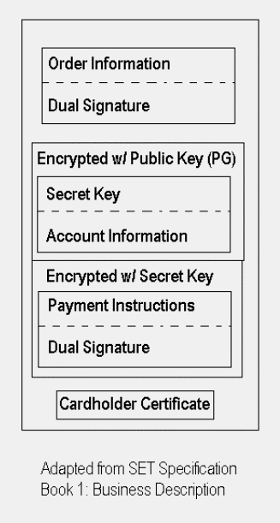
FIGURE 5. 6: SET Purchase Request.
The order details and the account information are unequivocally associated through a “dual signature” mechanism. The SET client software first combines a hash of the order information with a hash of the payment instructions. The result is then hashed, thus linking the order and payment together such that nobody can deny the bond. This second hash value is signed by encrypting it with the customer’s secret key, tying the customer to the purchase.
The greatest weakness is on the consumer side. For SET to be of any real security benefit, end user authentication has to be a part of the transaction. However, requiring the average surfer to obtain a certificate is a dicey proposition, partially proven by the continued use of SSL and server-only authentication. To promote migration, there are provisions to allow for optional customer certificates in the short-term. Generating certificates involves new user behavior, potentially complicating the customer’s shopping experience and thereby discouraging purchases. To promote adoption of SET, the specification allows for optional customer certificates-whether to require them is at the card issuer’s discretion.
IOTP
Whereas SSL is a secure communications protocol that can be used by a consumer to forward payment information and SET is a protocol specifically designed for credit card transactions, the Internet Open Trading Protocol (IOTP) provides an interoperable framework for consumer-to-business Internet-based electronic commerce. As a commerce framework specification, IOTP is designed to replicate the "real" world of transactions where consumers choose their product, choose their vendor, choose their form of payment (in conjunction with their vendor), arrange delivery, and, periodically, even return products. The designers of IOTP intend that this protocol will be the lingua franca of Internet commerce just as EDI has become the standard document language for "real" commerce; any two parties conducting Internet-based e-commerce in a way that conforms to the IOTP specifications will be able to complete their transactions securely.
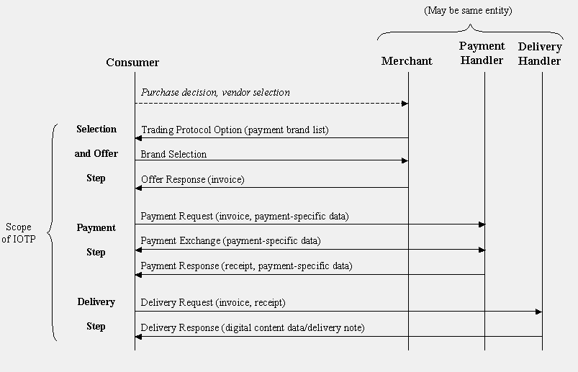
FIGURE 5.7: The flow of IOTP messages clearly indicates that the protocol can support the entire shopping process and all parties to buying, selling, paying, and delivering products and goods.
Figure 5.7 shows the general flow of an IOTP-based purchase. Note that it might be more proper to refer to IOTP as a shopping protocol rather than a payment protocol since it attempts to capture the entire online shopping cycle and shopping is more than merely paying for stuff. And just as you might wander through the stores of a new mall in the real world, IOTP is optimized for those cases where the buyer and merchant do not have an a priori relationship.
The Selection and Offer step is a particularly good example of mapping e-commerce to realspace. In this step, the user selects amongst payment mechanisms the way they might in a "real" store. I might select a credit card, for example, because of an award that I may get for using the card or perhaps because of a discount offer made by the store. Alternatively, I may use one currency over another for some other perceived benefits. IOTP maintains payment-system independence and can be used to encapsulate and support payment systems such as CyberCoin, e-cash, GeldKarte, MilliCent, Mondex, SET, and others. Note also that IOTP procedures can be employed by the customer for communication with the merchant, payment handler, and shipper which may be one, two, or three different entities.
But while IOTP will support the familiar models of business that we have today, it also has to support the new models that only the Internet has made viable. Individual very low-value transactions don’t even exist in the real world because they use currency that doesn’t "exist"! New product delivery models will also appear. Consider today’s Internet market where the value of a product might be is irretrievably transferred to the customer upon downloading a file; in this case, an item must be proved delivered before payment is rendered but payment must be forthcoming upon delivery and nonrefundable.
Clearly, cryptography is an important part of the security associated with IOTP. Although IOTP does not call out for specific algorithms, it does provide the flexibility that any given transaction may employ symmetric (secret key), asymmetric (public key), or both types of crypto schemes. Furthermore, depending upon transaction type, digital certificates may or may not be employed. Again, the overhead and cost of the security must be balanced with the needs of the buyer and the seller on a per-transaction basis. Use of XML (eXtensible Markup Language) as the data representation language provides flexibility and extensibility, and facilitates the development of a broad range of IOTP-aware applications.
  - SECURITY REQUIREMENTS IN ELECTRONIC PAYMENT SYSTEMS
The concrete security requirements of electronic payment systems vary, depending both on their features and the trust assumptions placed on their operation. In general, however, electronic payment systems must exhibit integrity, authorization, confidentiality, availability, and reliability.

Integrity and authorization
A payment system with integrity allows no money to be taken from a user without explicit authorization by that user. It may also disallow the receipt of payment without explicit consent, to prevent occurrences of things like unsolicited bribery. Authorization constitutes the most important relationship in a payment system. Payment can be authorized in three ways: via out-band authorization, passwords, and signature.
Out-band authorization
In this approach, the verifying party (typically a bank) notifies the authorizing party (the payer) of a transaction. The authorizing party is required to approve or deny the payment using a secure, out-band channel (such as via surface mail or the phone). This is the current approach for credit cards involving mail orders and telephone orders: Anyone who knows a user’s credit card data can initiate transactions, and the legitimate user must check the statement and actively complain about unauthorized transactions. If the user does not complain within a certain time (usually 90 days), the transaction is considered “approved” by default.
Password authorization
A transaction protected by a password requires that every message from the authorizing party include a cryptographic check value. The check value is computed using a secret known only to the authorizing and verifying parties. This secret can be a personal identification number, a password, or any form of shared secret. In addition, shared secrets that are short - like a six-digit PIN - are inherently susceptible to various kinds of attacks. They cannot by themselves provide a high degree of security. They should only be used to control access to a physical token like a smart card (or a wallet) that performs the actual authorization using secure cryptographic mechanisms, such as digital signatures.
Signature authorization
In this type of transaction, the verifying party requires a digital signature of the authorizing party. Digital signatures provide nonrepudiation of origin: Only the owner of the secret signing key can “sign” messages (whereas everybody who knows the corresponding public verification key can verify the authenticity of signatures.)

Confidentiality
Some parties involved may wish confidentiality of transactions. Confidentiality in this context means the restriction of the knowledge about various pieces of information related to a transaction: the identity of payer/payee, purchase content, amount, and so on. Typically, the confidentiality requirement dictates that this information be restricted only to the participants involved. Where anonymity or un-traceability are desired, the requirement may be to limit this knowledge to certain subsets of the participants only, as described later.
Availability and reliability
All parties require the ability to make or receive payments whenever necessary. Payment transactions must be atomic: They occur entirely or not at all, but they never hang in an unknown or inconsistent state. No payer would accept a loss of money (not a significant amount, in any case) due to a network or system crash. Availability and reliability presume that the underlying networking services and all software and hardware components are sufficiently dependable. Recovery from crash failures requires some sort of stable storage at all parties and specific resynchronization protocols. These fault tolerance issues are not discussed here, because most payment systems do not address them explicitly.
  - ELECTRONIC PAYMENTS AND CONSUMER EMPOWERMENT
Electronic payments empower the consumer in several fundamental ways that cash and cheques cannot. One of the clearest ways is the security that dispute resolution provides, offering consumers a form of insurance against purchases of faulty goods or services that are not delivered or lower in quality than expected. Insurance against lost, stolen or otherwise unauthorized use allows consumers to quickly shield themselves from liability, at zero cost in some markets, unlike lost cash or cheques. Electronic payments also provide the ability to control payment for goods and services over time by allowing buyers to pay now, pay later, or prepay. Credit cards provide liquidity through pre-approved credit availability, something that transaction-specific loans cannot do. This works favorably for consumers, merchants, and banks because the process facilitates current period sales while minimizing the cost of obtaining credit. Debit cards offer convenient and immediate access to funds on deposit. Globally branded electronic payments have the ubiquitous and interoperable features that lend themselves to immediate acceptability by consumers and businesses. Despite the value that consumers place on electronic payments, and the benefits that extend to economies from the underlying system, concerns are sometimes raised about abuse of credit and erosion of consumer wealth. Often these concerns are raised in the context of new regulations that would raise barriers to consumer access to credit and are based on an implicit assertion that expanded credit availability and use produces widespread harm to consumers. However, with the application of an objective analysis quite a different picture emerges. An in-depth study of consumer behavior in Australia provides some insights into the level and sophistication of payment usage and clearly shows that consumers have a high level of understanding of payments and responsibly manage revolving credit.
  - DESIRABLE PROPERTIES OF DIGITAL CURRENCY
Developers of digital currency have a wide range of options to implement strong safety requirements of transmitting values over the network. For example, a secure digital currency can be implemented by using strong encryption algorithms, by employing tamper-resistant hardware, or by securing the network communication. Although physical specifications of digital coins and tokens may vary, the following properties are fundamental to any digital currency payment system.
- Monetary Value To be used as a monetary unit, digital currency must have value that can be exchanged for other goods and services, be used to pay fiduciary obligations, or be transferred to another person. Since digital currency is essentially a file, it does not have an intrinsic value, but must be linked to other system of value. The most common implementation is to base the value of digital currency on bank deposits, credits, or prepayments using outside money. Once a digital currency is convertible to dollars, the next step is for it to be accepted in the market as a monetary token. Once accepted and trusted, a digital currency can establish related properties such as exchangeability and transferability.
- Convenience has been the biggest factor in the growth of notational currencies such as checks, which are scalable and easy to transport. Similarly, digital currencies must be convenient to use, store, access, and transport. As a digital file, it may allow remote access to money via telephone, modem, or Internet connection. Electronic storage and transfer devices or network capabilities will be needed. To gain wide acceptance, digital cash also must be convenient in terms of scalability and interoperability so that users need not carry multiple denominations or multiple versions for each operating system.
- Security To secure physical money and coins, one needs to store them in wallets, safes or other private places. If digital currencies are stored in hard drives connected to an open network, theoretically anybody can snoop and tamper with the money. Encryption is used to protect digital currency against tampering. Some proposals using smart cards, e.g. Mondex, store digital currency in tamper-resistant hardware that can be maintained offline. E-cash relies on the security of each client software residing on users' computers. At the same time, digital currencies must be resistant to accidents by owners. Rupee bills are printed on strong paper that withstands many adverse treatments, such as washing. To achieve similar security, adequate protection standards are needed both in physical specifications of digital coins and in policy matters for legal and commercial liabilities.
- Authentication of money is done by visually inspecting bills and coins. Although further tests could weighing, chemical analysis, and contacting the authorities, authentication is usually a simple matter for physical currency. Digital currency, however, cannot be visually inspected, and it is difficult to distinguish the original and a counterfeit. Because of this, inspection of digital currency depends on authenticating secondary information that accompanies the bills or coins such as the digital signatures of banks or payers attached to the currency (serial number). A more rigid system will require contacting a third party each time a transaction is made. Although this system is more secure, the transaction costs may be too high for small-value purchases. A hardware based system like Mondex relies on software and hardware and does not require authentication for each transfer of values. Other systems will have to strengthen their client software or introduce hardware protection to allow peer-to-peer transactions.
- Non-refutability Acknowledging payment and receipt is a basic property required of a payment system. In cash transactions, simple receipt is enough to establish non-refutability. A similar exchange of digital receipts can be used for digital transactions. An alternative is to append all transaction records into the digital currency itself. In this system, digital coins accumulate information about all parties involved in past transactions. These are called identified tokens compared to anonymous tokens, which do not reveal information about users.
- Accessibility and Reliability One advantage of digital currency over cash is its capability to be transported over the network. Therefore, users can store digital money at home but access it remotely via telephone or modem, the same network used to clear payments. Because of this crucial role, digital payment systems must provide continuous, fast, and reliable connections.
- Anonymity Unlike checks and cards, cash transactions are anonymous. An anonymous payment system is needed to protect against revealing purchase patterns and other consumer information, although untraceable transactions are opposed by the government in view of possible criminal uses. Nevertheless, the need will persist, and anonymity is perhaps the single most important property of cash transactions. Digital currency can be equipped with varying degree of anonymity masking the user identity to the bank, the payee, or both. Strong anonymity guarantees un-traceability while a weaker version allows the user's identity to be traced when the need arises. While the issue of anonymity invokes debates about tax evasion, money laundering and other criminal uses of digital currency, the economic rationale for simple, anonymous digital coins is that they reduce transaction costs by eliminating third parties and protect consumer information that could be used to price-discriminate among consumers.

  - PROSPECTS OF ELECTRONIC PAYMENT SYSTEMS
As the volume of Electronic Commerce becomes larger, the role of secure and economical online payments on the Internet will, accordingly, become more important. At the moment, the credit card payment for B2C trades with SSL protocol is the most widely adopted. However, SET protocol tailored to credit card payment may become one of the next generation standards. For micro payment, smart-card-based e-cash will become popular and will be recharged through the Internet from the cyber-banks, which will revitalize the benefit of cyber-banks.
As B2B occupies the major portion of Electronic Commerce, more economical payment methods like Internet-based funds transfer equipped with the benefit of check systems will become the major medium for large-amount payments. The credit card fee seems too high to transfer large amounts among credible corporations. This prospective trend should envision opportunities to payment businesses and corporate finance managers.
  - MANAGERIAL ISSUES IN ELECTRONIC PAYMENT SYSTEMS
Managerial issues for electronic payment systems vary depending upon the business position.
- Security solution providers can cultivate the opportunity of providing solutions for secure electronic payment systems. Typical ones include authentication, encryption, integrity, and nonrepudiation.
- Electronic payment systems solution providers can offer various types of electronic payment systems to e-stores and banks. The SET solution of having the certificate on the smart card is an emerging issue to be resolved.
- Electronic stores should select an appropriate set of electronic payment systems. Until electronic payment methods become popular among customers, it is necessary to offer traditional payment methods as well.
- Banks need to develop cyber-banks compatible with the various electronic payment systems (credit card, debit card, stored-value card, and e-check) that will be used by customers at e-stores. Watch for the development of consistent standards in certificates and stored-value-card protocols.
- Credit card brand companies need to develop standards like SET and watch 'the acceptance by customers. It is necessary to balance security with efficiency. Careful attention is needed to determine when the SSL-based solution will be replaced by the SET -based solution and whether to combine the credit card with the open or closed stored-value card.
- Smart card brands should develop a business model in cooperation with application sectors (like transportation and pay phones) and banks. Having standards is the key to expand interoperable applications. In designing business models, it is important to consider the adequate number of smart cards from the customer’s point of view.
- Certificate authorities need to identify all types of certificates to be provided. Banks and credit card companies need to consider whether they should become a clearing agent.
  - FUTURE OF ELECTRONIC PAYMENTS SYSTEMS
The critical reasons in acceptance of electronic payment instruments and their niche in the payments environment are:
- The cost savings are substantial, and businesses and consumers will not be able to ignore that fact once other issues are resolved.
- The exponential growth of electronic commerce, online financial services, electronic bill presentment and payment products, and new financial communication networks will demand greater velocity in the movement of value which are efficient and instantaneous.
- The proliferation of business-to-business ("B2B") electronic commerce will force payments systems to adapt to even greater speeds and standards of efficiency.
- The adults of the future will not be wed to bricks and mortar, checkbooks or passbooks or even ATM cards.
But we should not be fooled into thinking that 21st century electronic payments products will totally replace checks, credit and debit cards, or cash. They will simply find their niche in the financial products landscape like every other product did in the 20th century.
Legal Considerations
There are a variety of policy, operational and legal considerations confronting any entrepreneur who attempts to tackle the challenge of creating a new form of value or a new way to transmit it. Because most current banking and payments systems laws and regulations have been constructed to deal with more traditional payment mechanisms, they often do not provide a clear picture of whether and how they apply to new payment vehicles or systems. That creates a sense of uncertainty that is not helpful to developing markets. If the government does anything in the near future, it should foster legal predictability in this area.

Jurisdictional Considerations
Money and payments systems are by their vary nature, multi-jurisdictional products. If there is one thing that is meant to be in commerce, it is money. Thus the creation of new global electronic payment instruments and systems raises a threshold issue. Whose laws apply? While today, there is a well-worn path of understanding regarding the application of check clearing, ACH, credit card, FedWire and other traditional payments systems rules, the development of new forms of money and new payments systems that are based in Cyberspace necessarily raise jurisdictional questions. Which state or country will regulate the activities of the entity or the movement of the electronic value it creates?
State Banking Laws
The creation of a new electronic payment product raises the possibility that it may unknowingly conflict with banking laws in the states. To the extent that a non-bank creates a payment product that is linked to an “account,” that entity may be engaging in the business of banking without a license under state law. It may also have established an illegal deposit relationship with its customers that subjects it to criminal penalties under federal law. .
Who Should Facilitate Electronic Payments?
In a similar vein, there are intriguing legal, regulatory and policy questions that must be answered when it comes to the question of who may mint, distribute, circulate and transmit electronic payments? While most systems really aren't creating money in the technical legal sense, in the economic and practical sense, they may be. If the medium of exchange is trusted and the scale of acceptability is large, several critical questions arise:
- Do electronic payment products affect the money supply?
- Should non-regulated companies be permitted to mint, distribute, circulate and transmit electronic money?
- What protections should be constructed to deal with the failure of companies that create, distribute or clear electronic money and liquidity crises in the resulting electronic payments markets?
- How should new electronic payments systems be protected, regulated and made safe and secure?
- Who provides the ultimate liquidity and stability that makes these new money and payments systems work?
Most governments do not generally allow anyone but governmental entities to create money. While private entities are able to create and distribute substitute money products such as travelers checks, generally, they are viewed as special purpose instruments and are not used in the same frequency, volume or scale as traditional money. Indeed, if one form of electronic money offered by a private company or consortium of companies, became ubiquitous, there would be economic downsides to consider alongside the economic benefits it might confer. For example, if most Americans used electronic money on smart cards, any hint that the sponsor of the system was in financial difficulty or that the security of the system had been broken could result in a "run" on that form of money. Merchants might refuse to accept the card. Card holders would rapidly retreat to the bank whose name was co-branded on the smart card and demand "real money" in exchange for their electronic money. If on the way to their bank, they passed an off-line vending machine that accepted the card, they might use it to purchase a car load of sodas to wipe out the value on the card, thus shifting the risk of loss to the owner of the vending machine. While regulators are well equipped to handle bank failures, the collapse of a form of currency is another matter altogether.
Similarly, the emerging area of electronic bill payment and presentment raises new issues for payments systems. Today, a growing number of consumers pay their bills electronically (electronic bill payment) without writing a check, finding an envelope or licking a stamp. They may also receive their bills electronically (electronic bill presentment) without ever receiving a paper bill in the mail. This system potentially offers enormous cost savings to both consumers and billers. Yet, it also raises new issues as to who bears responsibility should payments not be made. As the system has evolved to date, the third party processors that facilitate electronic bill payment and presentment, and through which a consumer. s funds may travel, typically are not insured financial institutions. Once value leaves the insured banking system and becomes the property of such processor, even overnight, the failure of such entity raises significant financial issues for businesses and consumers, each of whom would assert a claim to the funds. In short, new products, players and systems implicate new rules of management and risk.
  - SUMMARY
Although there is a plethora of disparate payment systems offered for electronic commerce, many firms are reluctant to expand into online commerce because of the perceived lack of suitable payment mechanisms. Widely different technical specifications make it difficult to choose an appropriate payment method. In this chapter, instead of focusing on the technical specifications of proposed electronic payment systems, we have distinguished electronic payment methods based on what is being transmitted over the network. Since consumers are familiar with credit card payment methods, they may accept its electronic versions as the standard for electronic commerce. Nevertheless, Web-based information trading cannot be adequately supported by existing payment methods that have been developed for relatively high-value transactions. A cost effective micropayment system is essential for transactions of extremely small value just as cash is still the preferred payment method for these transactions. Anonymity is only one aspect of cash transaction but it has received a disproportionate, often sensational, attention in the press and by regulatory agencies while the economic need for a cash-like payment system in electronic commerce is largely ignored. Factors such as micropayments and peer-to-peer transfers in electronic commerce-especially for the information market-seem to indicate a healthy market for digital currency or small-value digital checks or credit cards. In terms of the regulatory and monetary impact, private digital monies clearly present both problems and opportunities. But, as with any digital product, the future of digital currency will be determined by the market demand and supply. Consequently, it is more than likely that each of the payment methods we reviewed will find a niche market and consumers will selectively use an appropriate payment method depending on whether one prefers convenience, costs, privacy, or the advantage of credit extension. The usefulness of digital currency, however, has to be emphasized in terms of what the Web-based information economy would mean for the future of electronic commerce and the Internet. With a suitable payment method, the age of information will manifest itself on the Internet, albeit in a commercial form.
SELF ASSESSMENT QUESTION
1. What are the different types of Electronic Payment Systems? Explain each of them.
2. Discuss various security issues involved in Electronic Payment Systems.
3. What is SET?
4. Explain various protocols used in making online payments.
5. If you are given the responsibility to design Electronic Payment systems, what actors will you consider the most important?
6. Differentiate between credit card and debit card.
7. “The banking industry is facing an increasing volume of cheque transaction, rowing competitive pressure and shrinking profit margins.” What is the solution or this? Has Ethiopia taken any lead to solve this problem and if yes, in what way?
Differentiate between traditional payment system and electronic payment system.
8. Who Should Facilitate Electronic Payments?
SUGGESTED READINGS
- Kalakota, Ravi and Whinston, Andrew B. “Electronic Commerce – A Manager’s Guide”, Pearson Education, Inc.
- Kalakota, Ravi and Whinston, Andrew B. “Frontiers of Electronic Commerce”, Pearson Education, Inc.
- Rich, Jason R. “Starting an E-Commerce Business”. IDG Books, Delhi, 2000.
- Samantha Shurety. “E-business with Net Commerce”, Addison Wesley, Singapore, 2001.
- Turban et al. “Electronic Commerce: A Managerial Perspective”, Pearson Education, Inc.

CHAPTER SIX: E-COMMERCE SECURITY AND CONTROL
Chapter Objective
At the successful conclusion of this chapter, you should be able to:
- Understand the concept of internet and public policy
- Explain why e-commerce raises ethical, social, and political issues.
- Identify the main ethical, social, and political issues raised by e-commerce.
- Explain basic concepts related to privacy.
- Understand legal and ethical issues related to E-Commerce
- Describe the different methods used to protect online privacy

Introduction
You are undoubtedly aware by now that the technology revolution is here to stay. In fact, many of the things you take for granted today (e-mail, cell phones, PDAs) were unimaginable just a few short years ago. This rapid growth of technology, where prices drop while consumer value increases, is historically unprecedented. A frequently asked question is, “How exactly did we get here?”
One of the fundamental enablers of this change, and of the increase in productivity, is the shift to rapid product development cycles—particularly in the case of software. Feature-rich applications that were impossible to develop and deploy in the recent past are now conceived of and deployed with lightning speed. The increased intensity of business competition has driven this demand for faster and better products made available in the marketplace.
In the future, the stakes will become even greater, as competition in every sector continues to escalate. Still, entrepreneurs and visionaries will press on in spite of the risks, and deliver new technologies in better ways.
Creating a high-security, high-performance, e-business infrastructure demands close coordination of both technical and management policies and procedures. Additionally, e-business security is evolving from an old notion of an information fortress that keeps others out, to a new notion of privacy and trust as you give customers, partners, and remote employees’ access to your business data. Although allowing access is the very basis of e-business, this also adds additional levels of complexity far beyond the traditional security model. The time, costs, and associated with monitoring external connections, internal activities, and vulnerabilities can be overwhelming.
  - The Internet and Public Policy
Buying groceries, paying bills, purchasing clothes, seeking medical advice cyberspace has become a vital part of everyone’s daily lives. According to the Information Technology Association of America (ITAA), total worldwide Internet users now exceed 600 million. In 2008, the number of users worldwide will pass the three-billion mark. In fact, the Internet is the most rapidly adopted technology ever—it has taken only eight years for it to reach 58 percent of households (versus 38 years for the telephone).
First came the dot-com explosion, with most “old economy” companies rushing to put up an electronic retail storefront. This business-to-consumer (B2C) marketplace quickly mushroomed into billions of dollars in value. Most recently, ferocious competition has made it tougher for “old economy” companies to maintain their advantage. Today, the strategic shift for most companies has been to the business-to-business (B2B) marketplace in which companies can partner in a “virtual village”—and thereby increase sales, lower costs, and increase productivity.
Instead of just being another sales or communications vehicle to the end consumer, the Internet has become integrated into the corporate infrastructure. Coinciding with this increased technological integration of the Internet, the value of the average transaction has also increased dramatically
Internet Security Education
To truly be successful in the digital economy, every company will have to rely on a combination of products, services, and training provided by partners. It is too risky and inefficient for any company to supply all of these from internal resources. Internet security education is critical to providing the proper deployment of security solutions. Technology makes it possible, and training makes it happen.
Products
Business buyers are now able to choose from a wide selection of competitively manufactured and priced goods. From PCs to routers to firewalls—the options are plentiful. E-commerce applications require a new, secure, technological approach to threat categories.
Services
Ongoing services are critical for companies because they allow them to be current with the latest technologies available in the marketplace. They enable companies to embrace best-of-breed products and to continually gain knowledge. This is particularly true in the area of information security where the tools and techniques change with exceptional frequency.
  - Privacy and Security Issues
What is privacy?
Internet technologies also have an effect on social issues, such as privacy. Physical and technological barriers to gathering personal information about consumers are rapidly disappearing. While companies have always gathered and resold information about their customers' purchasing habits, the Internet simplifies this process and allows new types of information to be collected. Double-click, a market research firm, compiles information not only about customer purchasing habits but also about their web browsing behavior across multiple stores and information sites.
Privacy issues exist concerning who owns and controls the use of this information and how it may be gathered. During 2001, the U.S. Congress reviewed at least fifty privacy-related bills, many of which had to do with whether consumers must opt in or opt out of such information gathering. In the private sector, major companies such as the IBM Corporation endorse using clearly posted privacy policies on web sites that detail where and how personal information can be used.
On the positive side, companies generally collect customer information to provide more personalized service and to speed up online transactions. Amazon.com's recommendation services combine information about a customer's past purchases with those of other customers with similar interests. Companies such as Soundscan and Bookstand gather previously unavailable music and book sales transaction data. Since these data detail not only how much merchandise was sold, but also where and to which demographic groups, marketing campaigns can use these data to target their focus and promote products to niche markets. Most Electronic Payment Systems knows the identity of the buyer. So it is necessary to protect the identity of a buyer who uses Electronic Payment System.
A privacy issue related to the employees of company is tracking. Monitoring systems are installed in many companies to monitor e-mail and other web activities in order to identify employees who extensively use business hours for non-business activities. The e-commerce activities performed by a buyer can be tracked by organizations. For example, reserving railway tickets for their personal journey purpose can be tracked. Many employees don’t want to be under the monitoring system even while at work.
As far as brokers and some of the company employees are concerned, E-Commerce puts them in danger zone and results in elimination from their jobs. The manner in which employees are treated may raise ethical issues, such as how to handle displacement and whether to offer retraining programs.
Privacy and Information Rights
Privacy is the right of the individual to be protected against intrusion into his personal life or affairs, or those of his family, by direct physical means or by publication of information. It can also define moral right of individuals to be left alone, free from Surveillance or interference from other individuals or Organizations.
Net Privacy: In the Eyes of the Consumer
Many consumers are responding to ubiquitous privacy breaches with intense levels of apprehension and strategies intended to reduce readily available information in their online profiles. In response, consumer-oriented privacy solutions are flooding the industry. These include protocols designed to shield instant messages (IM) from unauthorized eyes as well as software meant to ward off Web tags, or “cookies” and other Web bugs that create detailed profiles of customer preferences and purchases. Browser-enabled applications have also surfaced, intended to guard consumer privacy by means of capturing confidentiality preferences on the frontend.
Privacy: A Vital E-Business Enabler
Although Web-based consumer activity is often the focus of attention, respecting and protecting privacy goes further than securing data retrieved online. As a matter of fact, privacy management and control should extend to every customer touch point (from the call center to fulfillment to shipping), while at the same time supporting enterprise corporate directives. In order to realize and sustain e-business results, organizations need to appreciate the following considerations.
Trust
E-business depends on trust and a lot of it. All commerce involves some level of trust; however, e-business requires more of it because buyers are asked to provide greater amounts of personal information to online vendors they typically know little, if anything, about. Furthermore, increasing numbers of Web-based consumers understand that the frontend interface is connected to a backend infrastructure, making the confidentiality of their data even more tenuous.
Customers’ Trust
You can’t win customers’ trust if you don’t respect their privacy. Organizations that collect potentially sensitive information become custodians of personal data. Obviously, this trust must not be betrayed. IT systems and privacy policies need to protect personal data from theft and any unauthorized distribution or use. It is not just a matter of ethics it is sound business practice.
Companies that violate consumer privacy needs make the foolish and potentially fatal mistake of valuing the data more than the relationship. At the same time, customers who are not comfortable with a company’s privacy policy may likely conduct their business elsewhere.

Respecting Privacy
Respecting privacy takes more than mere adherence to laws and regulations. Given today’s e-business landscape, where information is now a heavily sought-after commodity, it is no surprise that government is stepping in to mandate consumer privacy. However, no regulation, despite how well-crafted, can match everybody’s needs and preferences. Furthermore, as privacy preferences change over the course of an individual’s life, the government cannot always be relied upon to operate in sync with such shifts.
Consequently, the onus of effective, real-time privacy protection rests on the enterprise. Not only do governments require it—consumers demand it.
Customer Privacy Needs
Companies benefit when they harness their understanding of customer privacy needs. Customer relationships and loyalty are fortified when strong privacy practices are employed. Treating people the way they want and ask to be treated (and communicating those efforts back to the marketplace) is a strong one-to-one customer relationship management approach and can offer companies a real competitive edge.
Security Issues and Concerns
What is Security?
While privacy addresses the customers' control over the confidentiality of their transaction information, security considers how such transactions can be protected from assault or corruption. Customers must be confident that credit card numbers will remain secure before providing them on the Internet. While credit card theft and other types of financial fraud have always been possible, the potential for thieves to use the Internet to steal credit card numbers on a wholesale basis has been a big concern.
To reduce this possibility, companies use digital certificates to authenticate that they are who they claim to be, and not some fraudulent site stealing customer credit card numbers. Certificate authorities, such as VeriSign, act as trusted third parties to issue digital certificates to companies. Using industry-standard Secure Sockets Layer (SSL) technology, digital certificates employ encryption-based protocols to protect the integrity of customer data exchanged online. Once the transaction data resides on the merchant site, firewalls can be used to restrict Internet access.
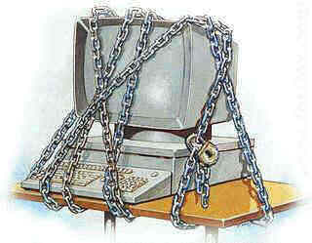

Fig 6.1.computer security

Computer security is the prevention and protection of computer assets from unauthorized access, use, alteration, degradation, destruction, and other threats. One issue that may keep customers from making purchases on your Web site is security. It is important to protect customers’ personal information and have proof that you are a legitimate business.
- Secure Sockets Layer (SSL) encrypts customers’ personal information, keeping it safe from hackers.
- Secure Sockets Layer (SSL) helps encrypt and protect the information that customers enter into Web pages when making a purchase; this protocol is built into most browsers and is supported by most Web servers.

Emergence of Cyber Crime
Unfortunately, not all of you are using the Internet in a positive way. The Internet has not only allowed you to communicate around the world, it has also opened up the doors for electronic crime. The Computer Security Institute’s (CSI’s) 2002 Computer Crime and Security Survey raised the level of awareness and aided in determining the scope of cyber-crime. This survey of large corporations revealed that 73 percent of the respondents detected the unauthorized use of their computer systems in the last year.
During the past few years, the most serious financial losses due to attacks have occurred through theft of proprietary information and financial fraud, according to CSI. Sixty-nine respondents in CSI’s 2002 Computer Crime and Security Survey reported a total loss of $99,019,000 in theft of proprietary information while 87 respondents reported a total loss of $88,229,000 in financial fraud. These 2002 totals were higher than the combined totals of the previous six years. The survey also confirmed that the following trends have evolved over the past few years:
- A broad spectrum of attacks has been spotted.
- Cyber-attacks are hitting organizations from the inside and outside.
- Huge financial losses are reported due to cyber-attacks.
- Information security technologies are not the sole solution to prevent these attacks.

Outside Attacks
Internet users are starting to realize the severity of these attacks. In the past eight years, the CSI has found that people are more aware of attacks happening, rather than being in denial. The following types of attacks have been recognized in the wide spectrum of cybercrime.
Unauthorized Intrusion
Networks that are not 100 percent protected are prime targets for external intrusion. Between 380 and 500 Web page hacks occur every week at small Web sites; whereas, on larger sites, the magnitude is greater. The New York Times Web site was recently brought down for 12 hours and then vandalized. Information that is tampered with leads to financial losses, service disruptions for a company’s site, and potentially irreparable damage to the corporate brand.

Service Denial
Similar to unauthorized intrusion, malicious denial of service also results in the loss of revenue and reputation. Big name Internet companies, such as Hotmail, Yahoo!, and Amazon.com, recently experienced denial-of-service (DoS) attacks. Hotmail’s site shut down for six consecutive days, not only preventing seven million users from accessing it, but also scarring the reputation of Hotmail.

Inside Attacks
Recently, more media attention has been placed on the “cyber-attacks” previously cited, rather than insider attacks. But, in reality, more of the widespread attacks are now coming from insiders. CSI confirmed this when it reported that the majority of the attacks in the past year have been from insider abuse and unauthorized access. And, insiders are not just trustworthy employees. Business partners, subsidiaries, and third-party suppliers have the same access as traditional employees of a company.

Cyber Security Need
As the Internet expands more and more rapidly, there is a greater and greater need for tighter security measures. A recent survey by ITAA found cyber security to be the next “top priority” issue facing the IT industry around the globe.
Likewise, according to the Carnegie Mellon Institute’s Computer Emergency Response Team Coordination Center (CERT/CC), the number of security- related incidents in the third and fourth quarters of 2002 has almost totaled the number in the entire year of 2001. It is obvious that instead of “reacting” to the problem, a strategic plan of attack is needed.
Lists of Mistakes
According to the SANS Institute, the answer to the preceding question is “Yes!” SANs have developed the following three lists of mistakes people make that enable attackers.
End Users: The Five Worst Security Mistakes
- Opening unsolicited e-mail attachments from unreliable sources
- Forgetting to install security patches, including ones for Microsoft Office, Microsoft Internet Explorer, and Netscape
- Downloading screen savers or games from unreliable sources
- Not creating or testing backups
- Using a modem while connected through a local area network

Profiling, Personalization, and Privacy
Thanks to the Web and its associated technologies, organizations now have the ability to construct complex customer profiles, which in turn can fuel the ability to market highly personalized offerings and ensure superior service. Although this can offer a competitive advantage and help win the hearts and minds of new and loyal customers alike, the related collection of personally identifiable information (PII) raises the bar on how organizations should manage and control privacy.
Accordingly, today’s e-business strategies must prioritize the implementation of a protocol-based, enterprise privacy program—one that is rooted in e-business best practices and executed on a continual and comprehensive basis to:
- Build and promote trust in the marketplace.
- Enhance and preserve the value of data assets.
- Operate a sound platform for ongoing privacy management.
- Operate consistently with multiple privacy rules and standards.
- Realize substantial privacy-management choices.
  - Legal, social and Political Issues in e-commerce
Yet another element that has helped some e-tailers remain strong is the issue of privacy. Many companies with Web channels have had some decisions to make recently: collect customer data and e-mail addresses and sell the information for a price to boost sagging profits, or prominently reassure customers that their information is private and will remain so in the future.
The former choice represents a short-term fix and the latter choice is the ticket to the long-term payoff. Many companies that sold customer data from the get-go or made a decision later to sell information seemed to think that their activities would not be noticed, or that the average consumer wouldn’t care if they received a few extra spams brought on by the sale of their personal information. This was a serious miscalculation. In crowded information age of little free time and space to breathe, most consumers are becoming rabidly protective of the little privacy they have.
More importantly, e-tailers and Web marketers that chose to collect information from children not only earned the ire of parents, they began to draw fire from federal and state regulators Finally, the vast majority of companies that made a go at succeeding in e-commerce only to fail a year or two later are like kids who begin playing with a complex toy and give up in a huff when they can’t operate the toy based on the fact that they didn’t read the instructions. All’s well and it ends well. The toy becomes available to the kid who values it and knows how to use it.

SUMMARY
Today, more than ever, organizations are challenged with improving security without incurring a corresponding increase in cost or burden to their existing staff. By comparing the benefits of a new product to the total cost of that product, organizations will make better choices that ultimately lead to greater security. Leveraging existing products is quite often the quickest way to improving both security and the bottom line. Finally, in many cases, organizations can address most of their e-commerce application concerns or problems with the products they already own.
Creating a high-security, high-performance, e-business infrastructure demands close coordination of both technical and management policies and procedures. Additionally, e-business security is evolving from an old notion of an information fortress that keeps others out, to a new notion of privacy and trust as you give customers, partners, and remote employee’s access to your business data. Although allowing access is the very basis of e-business, this also adds additional levels of complexity far beyond the traditional security model. The time, costs, and associated with monitoring external connections, internal activities, and vulnerabilities can be overwhelming.
Finally, International Data Corporation (IDC) research predicts that over time, the pressure to outsource security and privacy solutions will increase as the shortage of skilled IT professionals continues. But, whether you look to an external service provider or in-house to implement a new security infrastructure, you must take a series of specific steps to consider goals and basic capabilities. Without a blueprint based upon technical and business assessments, you cannot hope to create a system that is secure, up-to-date, and encompasses the divergent needs of greater information sharing and privacy
REVIEWED QUESTIONS
      - Define the meaning of privacy?
      - Explain the range of threats to e-commerce security
      - Discuss how Cyber-attacks are hitting organizations from the inside and outside?
      - Why might a Web site’s sales suffer if it only permits customers to pay using smart cards?
      - Describe the different methods used to protect online privacy?

Reference
- A copy of electronic materials will print and given to student because of unavailability of texts in the library as main reference.
- E. Lawrence. Corbitt, Fisher, Lawrence and Tidwell, (2000). Internet commerce, 2nd edition, John Wiley and sons Australia, Ltd
- Mahony, D., Peirce,M., Tewari,H.,( 2001) Electronic Payment Systems for E-Commerce, Second Edition, Artech House, inc.
- Schneider, G P., (2011), Electronic Commerce, 9th edition , Course Technology, Cengage Learning

