

COURSE MATERIAL FOR
OPERATIONS RESEARCH (MGMT3132)
CREDIT HOUR: 4 (6 ECTS)

Compiled by:
Gebreyohannes Gebreslassie (Assistant Professor)
Department of Management
College of Business and Economics
Mekelle University

April 2020
CHAPTER ONE
- Introduction to Operations Research
  - Historical Development of Operations Research
Operations Research originated in Great Britain during World War II to bring mathematical or quantitative approaches to bear on military operations. The main objective was to allocate the scarce resources in an effective manner to the various military operations and to the activities within each operation. The effectiveness of operations research in military area spread into other government department and industry. Due to the availability of faster and flexible computing facilities and the number of qualified OR professionals, it is now widely used in military, business, industry, transportation, public health etc. Since its birth in the 1940's, Operations Research has been widely recognized as an important approach to decision-making in the management of all aspects of any organization.
  - Definitions of Operations Research
- Operations Research is a scientific method of providing executive departments with a quantitative basis for decisions regarding the operations under their control (Morse & Kimball, 1948).
- Operations research is a scientific approach to problem solving for executive management (H.M. Wagner, unknown).
- Operations research is an aid for the executive in making these decisions by providing him with the needed quantitative information based on the scientific method of analysis (C. Kittel, unknown).
  - Management, Management Science and Operations Research
- Management may be equated with decision-making and control. Government Ministers manage the economy industrialists make decision within their companies and individual make personal decisions.
- Management science: Are the study of problems as abstractions and the application of the resulting theory to practical situations. Its two fundamental disciplines are behavioural science and quantitative methods.
- Operations Research: is the application of quantitative methods to decision making. It formulates problems incisively and assesses the possible consequence of alternative course of action, so that informed and effective decisions can be taken.
- Operations: The activities carried out in an organization related to attaining its goals and objectives.
- Research: The process of observation and testing characterized by the scientific method. The steps of the process include observing the situation and formulating a problem statement, constructing a mathematical model, hypothesizing that the model represents the important aspects of the situation, and validating the model through experimentation.
  - Operations Research Approach to Problem Solving
Operations Research encompasses a logical systematic approach to problem solving. This approach to problem solving as shown in fig. 1 follows a generally recognized ordered set or steps:
Operation Research Process/Techniques
Observation

Problem Definition

OR Techniques
Model Construction

Solution

Feedback
Information
Implementation

Figure 1: Operations Research Process

- Observations: The first step in a problem solving exercises in Operations Research is the identification of a problem that exists in the system.
- Definition of the problem: Once it has determined that a problem exists, it must be clearly and concisely defined. The problem definition includes the limits of the problems and the degree to which it pervades other organs of the system.
- Model Construction: An Operations Research model is an abstract representation of an existing problem situation. It can be in the form of a graph or chart, but mostly, an Operations Research model consists of a set of mathematical relationship. In Operations Research terminology, these are called objective function and constraints.
- Model Solution: Once models are constructed, they are solved using the OR techniques, presented in the next section. Actually it is difficult to separate model construction and solution in most cases, since OR technique usually applies to a specific type of model.
- Implementation of Results: The results of an Operations Research technique are information which helps in making a decision.
N.B: Operations Research is an On-going Process: Once the five steps described above are completed, it does not necessarily mean that Operations Research process is completed. The model results and the decisions based on the results provide feedback to the original model. In general, the Operations Research process is continuous rather than simply consisting of one solution to one problem
  - Use of Operations Research
Operations Research has entered successfully many different areas of research for military government and industry in many countries of the world. The basic problem in most of the developing countries in Asia and Africa is to remove poverty and improve the standard of living of a common man as quickly as possible. So there is a great scope for economists, statisticians, administrators, politicians and the technicians working in a team to solve this problem by an OR approach.
    - Potential area of application: As mentioned earlier OR can be applied in every field of life. Here are few of the many fields where Operations Research has potential application.
- Operations Research in the public sector such as federal, provincial and local government, health, defence.
- Operations Research in industry and commerce such as finance and investment, production, marketing.
- Operations Research in Transport such as rail, road, air and sea.
  - Nature of Operations Research:
Is an inter-disciplinary team approach, systems approach, helpful in improving the quality of solution, scientific method, goal oriented optimum solution, use of models, require willing executives, reduces complexity and so on.

Part I: Multiple Choice Questions
- Operations Research is the outcome of:
- National emergency C. Combined efforts of talents of all fields
- Political problems D. Economics and Engineering
- Operations Research came into existence during:
- World War I C. World War II
- India and Pakistan War D. None of the above
- The name of the subject Operations Research is due to the fact that:
- Problems can be solved by war approach
- The researchers do the operations
- The war problems are generally known as operations and inventing a new way of solving such problems
- Mathematical operations are used in solving the problems
- The first country to use Operations Research method to solve problems is:
- India C. United Kingdom
- China D. United State of America
- The name Operations Research is first coined in the year:
- 1945 B. 1950 C. 1935 D. 1940
- The person who coined the name Operations Research is:
- Bellman C. Newman,
- Mc Closky and Trefrhen D. None of the above
- The objective of Operations Research is:
- To find new methods of solving Problems C. Optimal utilization of existing resources
- To derive formulas D. To utilize the services of scientists
- Operations Research is the art of giving:
- Bad answers to problems where otherwise worse answers are given
- Good answers for war problems
- Bad answers to war problems
- Good answers to problems where otherwise bad answers are given
- Operations Research is:
- Independent thinking approach C. Inter-disciplinary team approach
- Group thinking approach D. None of the above
- The first step in solving Operations Research problem is:
- Model building C. Obtain alternate solutions
- Formulation of the problem D. Obtain basic feasible solutions
- One of the properties of Operations Research model is:
- Model should be complicated
- Model is structured to suit Operations Research techniques
- Model should be structured to suit all the problems we come across
- Model should be easy to derive
Part II: ESSAY QUESTIONS
- Give any four definitions of Operations Research.
- Comment the following statement:
I. Operations Research is the art of wining war without actually fighting it.
II. Operations Research is the art of finding bad answer where worse exists.
- What is an Operations Research Model? What are the characteristics of Operations Research Model?
- Give the main advantage and limitation of Operations Research model.
- What is the difference between Deterministic and Probabilistic model?
- What is the objective of Operation Research?
- What are the various phases of operation research problems?
- Explain the steps involved in the solution of Operations Research Problem.
- What is the importance of Operations Research in decision making?
- List the characteristics of operation Research.
Explain briefly the applications of operation research.

CHAPTER TWO

LINEAR PROGRAMMING
Linear Programming (LP) is a branch of mathematical programming which is designed to solve optimization problems where all the constraints as well as the objectives are expressed as linear function. LP is a technique for making decisions under certainty i.e.; when all the courses of options available to an organization are known & the objective of the firm along with its constraints are quantified. That course of action is chosen out of all possible alternatives, which yield the optimal results. LP can also be used as verification and checking mechanism to ascertain the accuracy and the reliability of the decisions, which are taken solely based on manager's experience- without the aid of a mathematical model.

Basic Assumptions of LP
- Decision or Activity Variables & Their Inter-Relationship: The decision or variables refer to any activities, which are in competition with other variables for limited resources. Examples of such activity variables are: services, projects, products etc. These variables are most often inter-related in terms of utilization of the scarce resources and need simultaneous solutions. It is important to ensure that the relationship between these variables be linear.
- Finite Objective Functions. A Linear Programming problem requires a clearly defined, unambiguous objective function which is to be optimized. It should be capable of being expressed as a liner function of the decision variables. The single-objective optimization is one of the most important prerequisites of linear programming. Examples of such objectives can be: cost-minimization/idle-time minimization or profits/revenue maximization etc.
- Limited Factors/Constraints. These are the different kinds of limitations on the available resources e.g. important resources like availability of machines, number of men, hours available, production capacity and number of available markets or consumers for finished goods are often limited even for a big organization. Hence, it is rightly said that each and every organization functions within overall constraints both internal and external. These limiting factors must be capable of being expressed as linear equations or in equations in terms of decision variables.
- Non-Negativity Restrictions. Since the negative values of (any) physical quantity has no meaning, therefore all the variables must assume non-negative values.
- Linearity Criterion. The relationship among the various decision variables must be directly proportional. Both the objective and the constraint, must be expressed in terms of linear equations or inequalities. For example. If one of the factor inputs (resources like material, labor, plant capacity etc.) increases, then it should result in a proportionate manner in the final output. These linear equations can graphically be presented as a straight line.
- Additively. It is assumed that the total profitability and the total amount of each resource utilized would be exactly equal to the sum of the respective individual amounts. Thus, the function or the activities must be additive.
- Divisibility. Variables may be assigned fractional values. i.e.; they need not necessarily always be in whole number. If a fraction of a product cannot be produced, an integer programming problem exists. Thus, the continuous values of the decision variables and resources must be permissible in obtaining an optimal solution.
- Certainty. It is assumed that conditions of certainty exist i.e.; all the relevant parameters or coefficients in the Linear Programming model are ful1y and completely known and that they don't change during the period. However, such an assumption may not hold good at all times.
- Finiteness. LP assumes the presence of a finite number of activities and constraints without which it is not possible to obtain the best or the optimal solution.

Linear Programming Problem Formation
Linear programming is one of the most useful techniques for effective decision making. It is an optimization approach with an emphasis on providing the optimal solution for resource allocation. How best to allocate the scarce organizational or national resources among different competing and conflicting needs (or uses) forms the core of its working.
Component of formulating a LP models are:
  - Decision variables: mathematical symbols representing levels of activity of an operation.
  - Objective function: a linear relationship reflecting the objective of an operation.
  - Constraint: a linear relationship representing a restriction on decision making.
  - Non-negativity: values of the decision variables are zero or non-zero positives.
Objective function Z = c₁x₁ + c₂x₂ +…………. +c_{n}x_{n}
Subject to restrictions (ST)
a₁₁x₁ + a₁₂x₂ + …..........+a₁nx_{n} (≤ or ≥) b₁
a₂₁x₁ + a₂₂x₂ + …………..+a₂nx_{n} (≤ or ≥) b₂
.
.
.
a_{m1}x₁ + a_{m2}x₂ + ………. +a_{mn}x_{n} (≤ or ≥) b_{m} &
x₁ ≥ 0, x₂ ≥ 0,…, x_{n} ≥ 0
Where
- Z = value of overall measures of performance
- x_{j} = level of activity (for j = 1, 2, ...,n)
- c_{j} = a unit profit/cost increase in Z that would result from each unit increase in the decision variables (j=1,2, . . .,n)
- b_{i} = amount of resource i that is available for allocation to each decision variables (for i = 1,2, …, m)
- a_{ij} = amount of resource i consumed by each unit of activity j
It can be summarized in a tabular form as below:
Resource |  | Resource usage per unit of activity |  | Amount of resource available
 |  |  | Activity
 |  |  | 1 2 …………………….. n
1  2  .  .  .  M |  | a₁₁ a₁₂ …………………….a_{1n}  a₂₁ a₂₂ …………………….a_{2n}  .  .  .  a_{m1} a_{m2} …………………a_{mn} |  | b₁  b₂  .  .  .  B_{m}
Contribution to Z per unit of activity |  | C₁, c₂ ……………………….c_{n}

- Profit Maximization Case
Example 1: Problem Definition
A company manufactures two products, tables and chairs by using three machines A, B, and C so as to maximize a profit. Machine A has 10 hrs of capacity available during the coming week. Similarly, the available capacity of machine B and C during the coming week is 36 hrs and 30 hrs, respectively. One unit of a table requires 2 hrs of machine A, 3 hrs of machine B and 3 hrs of machine C. Similarly, one unit of a chair requires 1 hr, 12 hrs and 6 hrs of machine A, B, and C respectively. When one unit of table is produced and sold, it yields a profit of Birr 5 and that of a chair is Birr 7.
Required:
Given the above information, formulate a linear programming model.
Exercise 1
Alpha Limited produces & sells 2 different products under the brand name black & white. The profit per unit on these products is Birr 50 & Birr 40 respectively. Both black & white employ the same manufacturing process which has a fixed total capacity of 50,000 man-hour. As per the estimates of the marketing research department of Alpha Limited, there is a market demand for maximum 8,000 units of Black & 10,000 units of white. Subject to the overall demand, the products can be sold in any possible combination. It takes 3 hours to produce one unit of black & 2 hours to produce one unit of white.
Required:
Formulate the about as a linear programming model?
- Cost Minimization Case
Example 2:
A company owns 2 oil mills A and B which have different production capacities for low, high and medium grade oil. The company enters into a contract to supply oil to a firm every week with 12, 8, 24 barrels of each grade respectively. It costs the company $1000 and $800 per day to run the mills A and B. On a day A produces 6, 2, 4 barrels of each grade and B produces 2, 2, 12 barrels of each grade.
Required: Develop the LP model.
  - Method for solving LPP
There are two approaches to solve linear programming problems:
- Graphic solution and
- Simplex solution

Graphical method of solving LPP

Steps in graphic solution method
Step I defining the problem. Formulate the problem mathematically. Express it in terms of several mathematical constraints & an objective function. The objective function relates to the optimization aspect, i.e. Maximization or minimization Criterion.

Step II Plot the constraints graphically. Each inequality in the constraint equation has to be treated as an equation. An arbitrary value is assigned to one variable & the value of the other variable is obtained by solving the equation. In the similar manner, a different arbitrary value is again assigned to the variable & the corresponding value of other variable is easily obtained. These 2 sets of values are now plotted on a graph and connected by a straight line. The same procedure has to be repeated for all the constraints. Hence, the total straight lines would be equal to the total no of equations, each straight line representing one constraint equation.

Step III Locate the solution space. Solution space or the feasible region is the graphical area which satisfies all the constraints at the same time. Such a solution point (x, y) always occurs at the corner Points of the feasible Region and the feasible region is determined as follows:
- For "greater than" & "greater than or equal to" constraints, the feasible region or the solution space is the area that lays above the constraint lines.
- For" Less Then" &" Less than or equal to" constraint, the feasible region or the solution space is the area that lays below the constraint lines.

Step IV Selecting the graphic solution technique. Select the appropriate graphic technique to be used for generating the solution. There are two graphic techniques to find solution;

Corner Point Method and

Iso-profit (or Iso-cost) method may be used; however, it is easier to generate solution by using the corner point method and we use this method to find solution.

Corner Point Method to find Solution for Graphics Method
- Since the solution point (x, y) always occurs at the corner point of the feasible or solution space, identify each of the extreme points or corner points of the feasible region by the method of simultaneous equations.
- By putting the value of the corner point's co-ordinates [e.g. (2, 3)] into the objective function, calculate the profit (or the cost) at each of the corner points.
- In a Maximize problem, the optimal solution occurs at that corner point which gives the highest profit. In a minimization problem, the optimal solution occurs at that corner point which gives the lowest cost.
Example 1
XYZ Ltd. Co. wishes to purchase a maximum of 3600 units of two types of product; A & B which are available in the market. Product A occupies a space of 3 cubic feet & cost Birr 9 whereas B occupies a space of 1 cubic feet & cost Birr 13 per unit. The budgetary constraints of the company do not allow spending more than Birr 39,000. The total availability of space in the company's god own is 6000 cubic feet. Profit margin of both the product A & B is Birr 3 & Birr 4 respectively.
A. Formulate the above problem as a linear programming model and solve it by using graphical method. You are required to ascertain the best possible combination of purchase of A & B so that the total profits are maximized.
Solution
- The problem can be formulated as a linear programming model as follows: -
Let x1 = Number of units of product A &
x2 = Number of units of product B
$$MaxZ=3x_{1}+4x_{2}$$
Subject to:
$x_{1}+x_{2}≤3600$ (Maximum unites constraint)
${3x}_{1}+x_{2}≤6000$ (Storage area constraint)
${9x}_{1}+{13x}_{2}≤39000$ (Budgetary constraint)
$x_{1}∧x_{2}≥0$

Find the solution by using graphics method

Step I: Treating all the constraints as equality,
The 1st constraint is: $x_{1}+x_{2}≤3600chang$e this in to $x_{1}+x_{2}=3600$ and find the X and Y intercept as follows.
Put $x_{1}=0⇒x_{2}=3600∴thepointis\left(0,3600\right)$
Put $x_{2}=0⇒x_{1}=3600$ $∴thepointis\left(3600,0\right)$
Draw the graph with x1 on x-axis & x2 on y-axis as shown in the following figure.
The 2nd constraint is: $3x_{1}+x_{2}≤6000$ change this in to $3x_{1}+x_{2}=6000$ and find X and Y intercept.
Put $x_{1}=0⇒x_{2}=6000∴thepointis\left(0,6000\right)$
Put $x_{2}=0⇒x_{1}=2000$ $∴thepointis\left(2000,0\right)$
Draw the graph with x1 on x-axis & x2 on y-axis as shown in the following figure.
The 3rd constraint is: ${9x}_{1}+{13x}_{2}≤39,000chang$e this in to $9x_{1}+{13x}_{2}=39,000$ and find the X and Y intercept as follows.
Put $x_{1}=0⇒x_{2}=3000∴thepointis\left(0,3000\right)$
Put $x_{2}=0⇒x_{1}=4333.3$ $∴thepointis\left(4333.3,0\right)$
Draw the graph with x1 on x-axis & x2 on y-axis as shown in the following figure.

Step II Determine the set of the points which satisfy the constraint:
$$x_{1}+x_{2}≤3600$$
This can easily be done by verifying whether the origin (0, 0) satisfies the constraint. Here, $0+0<3600$ hence the solution is true; all the points below the line will satisfy the constraint.
Like it’s in the above iteration, determine the set of points which satisfy the constraint$3x_{1}+x_{2}≤6000$. At origin;
$0+0<6000$. Hence, all the points below the line will satisfy the constraint.
Like it’s in the above iteration, determine the set of points which satisfy the constraint. ${9x}_{1}+{13x}_{2}≤39,000.$ At origin;
$0+0<39,000$. Hence, all the points below the line will satisfy the constraint.
The intersection of the above graphic denotes the feasible region for the given problem.

Step III Finding feasible region by plotting the graph
Always keep in mind two things: -
- For ≥ constraint the feasible region will be the area, which lays above the constraint lines, and for ≤ constraints, it will lays below the constraint lines. This would be useful in identifying the feasible region.
- According to a theorem on linear programming, an optimal solution to a problem (if it exists) is found at a corner point of the solution space.

X₁
C
6000
3600
3000
2000
3600
3900/9
X₁
Number of unites of A
Number of unites of B
A₁
(0, 0)
B
$x_{1}+x_{2}≤3600$ (Maximum unites constraint)

${3x}_{1}+x_{2}≤6000$ (Storage area constraint)

${9x}_{1}+{13x}_{2}≤39000$ (Budgetary constraint)

X1
O
Feasible region

Step IV. Find the optimal solution by the corner point method.
At corner points (O, A, B, C), find the profit value from the objective function. Those points which maximize the profit are the optimal point.
Corner point  Optimal solution | Coordinates | Objective function  $$MaximizeZ=3x_{1}+4x_{2}$$ | Value
O | (0,0) | Z=0+0 | 0
A | (0,3000) | Z=0+4x3000 | 12,000
B | (1300,2100) | Z=3x1300 + 4 x2100 | 12,300
C | (2000,0) | 3 x 2000 + 0 | 6000
In order to get the value of point B apply simultaneous equation by taking the two intersection lines. Solve the point.
${3x}_{1}+x_{2}≤6000$ (Storage area constraint)
${9x}_{1}+{13x}_{2}≤39000$ (Budgetary constraint)
(∴ A+B these two lines are intersecting)
3x1 + x 2 = 6000 …1
${9x}_{1}+{13x}_{2}=39000$ …2
Multiply equation (1) by -3 on both sides:
-9x1 - 3x 2 = -18000 …3
${9x}_{1}+{13x}_{2}=39000$ …4

10X₂ = 21,000 ∴ $x_{2}$=2100
Put the value of x2 in first equation:
⇒X₁=1300
At point (1300, 2100)$MaximizeZ=3x_{1}+4x_{2}$
$Z=3×1300+4×2100$
= 12,300 which is the maximum value
Result
The optimal solution is:
No of units of product A = 1300
No of units of product B = 2100
Total profit, = 12, 300 which is the maximum
Example 2
$$\begin{aligned}\text{Min}\text{.}Z=\text{25}X+\text{30}X \\ \text{Subjectto}: \\ \text{20}X+\text{15}X≥\text{100} \\ 2X+3X≥\text{15} \\ X_{1},X_{2}≥0\end{aligned}$$
Required:
- Compute the value of the decision variables
- Compute the z value at the optimal solution
- Is there unused resource at the optimal solution? If any, please specify the amount.
Example 2
Max Z = $5x₁+ 7x₂
st
2x₁ + 1x₂ ≤ 10
5x₁ + 2x₂ ≤ 36
3x₁ + 6x₂ ≤ 30
x₁, x₂ ≥ 0
Example 3
$$\begin{aligned}\text{Min}\text{.}Z=\text{100}X+\text{800}X \\ \text{Subjectto}: \\ 6X+2X≥\text{12} \\ 2X+2X≥8 \\ 4X_{1}+\text{12}X_{2}≥\text{24} \\ X_{1},X_{2}≥0\end{aligned}$$

Special Cases in Graphics Methods
The following are the major special cases in graphics solution
- Alternative Optima
- Infeasible Solution
- Unbounded solution
- Redundancy solution

Alternative Optimal solution
When the objective function is parallel to a binding constraint; (a constraint that is satisfied in the equality sense by the optimal solution), the objective function will assume the same optimal value at more than one solution point, for this reason they are called alternative optima. Example 1 shows that normally there is infinity of such solutions. The example also demonstrates the practical significance of encountering alternative optima.
Example
Max Z = 4x₁ + 3x₂
St
4x₁+ 3x₂ ≤ 24
x₁ ≤ 4.5
x₂ ≤ 6
x₁ ≥ 0, x₂ ≥ 0
- Infeasible Solution
A solution is called feasible if it satisfies all the constraints and the constraints and non-negativity condition. However, it is sometimes possible that the constraints may be inconsistent so that there is no feasible solution to the problem. Such a situation is called infeasibility.
Example
Max Z = 3x₁ + 2x₂
St
x₁+ x₂ ≤ 1
x₁+ x₂ ≥ 3
x₁ ≥ 0 , x₂ ≥ 0
- Unbounded Solution
When the value of decision variables in LP is permitted to increase infinitely without violating the feasibility condition, then the solution is said to be unbounded. Here, the objective function value can also be increased infinitely. However, an unbounded feasible region may yield some definite value of the objective function.
Example
Max Z = 3x₁ + 5x₂
Subject to
2x₁+ x₂ ≥ 7
x₁+ x₂ ≥ 6
x₁+ 3x₂ ≥ 9
x₁ ≥ 0 , x₂ ≥ 0
- Redundancy solution
A redundant constraint is simply one that does not affect the feasible solution region. One constraint may be more binding or restrictive than the other and thereby negate its need to be considered.
Example
Max z = x + 2y
st
x + y ≤ 12
2x + y ≤ 30
x ≤ 25
x, y ≥ 0

Simplex Method
Let us see what the limitations of graphic solution are, and how can these be deal with?
Limitations of the Graphical Method
The applicability of the graphical method is very limited in scope. This is due to the fact that it is quite simple to identity all the corner points & then tests them for optimality-in the case of a two-variable problem. As a result, the graphical method cannot be always employed to solve the real-life practical Linear programming models which involve more than two decision-variables.
The above limitation of the graphical method is tackled by what is known as the simplex method. It is a widely applicable method for solving complex LP problems. It can be applied to any LP problem which can be expressed in terms of a Linear Objective function subject to a set of Linear Constraints. As such, no theoretical restrictions are placed on the number of decision variables or constraints contained in a LPP.
The Simplex method is an iterative or “step by step” method or repetitive algebraic approach that moves automatically from one basic feasible solution to another basic feasible solution improving the situation each time until the optimal solution is reached at.
Note: The Simplex method starts with a corner that is in the solution space or feasible region and moves to another corner, the solution space improving the value of the objective function each time until optimal solution is reached at the optimal corner.

Standard forms of Linear Programming (LP) problems
- Standard Form: when all constraints are written as equalities it is called standard form
- Utilization of Resources
- A slack variable represents unused resource, either in the form of time on a machine, labor hour, money, warehouse space or any number of such resources in various business problems. Since variable yields no profit, therefore such variables are added to the original objective function with zero coefficients.
- A surplus variable represents amount by which solution values exceed a resource. These variables are also called negative slack variables. Surplus variables carry a zero coefficient in the objective function.
- Basic variable: form simultaneous linear equations in n variables(n>m), a solution obtained by setting (n-m) variables equal to zero and solving for the remaining m variables is called a basic variable.
- Basic feasible solution: a basic feasible solution is a basic solution for which the variables have a value of greater than or equal zero.
- Simplex Tableau: is a table used to keep track of the calculation that made at each of the iteration when the simplex solution method is employed.
- Zj Row: the numbers in this row under each variable represents the total contribution of outgoing profit when one unit of a non-basic variable is introduced into this in place of a basic variable.
- Cj – Zj Row: the row containing the net profit that will result from introducing one unit of the variable indicated in that column in the solution numbers in index rows are also known as shadow prices.
- Identify the entering variable: The entering variable is the one with the largest positive $C_{j}$ value (In case of a tie, select the variable that corresponds to the left most of the columns).
- Identify the outgoing variable: The outgoing variable is the one with smallest non-negative column ratio (to find the column ratios, divide the RHS column by the entering variable column, wherever possible). In case of a tie select the variable that corresponds to the upper most of the tied rows.
    - Generate the new tableau
- Select the largest value of $C_{j}−Z_{j}$ row. The column, under which this value falls, is the pivot-column.
- Pivot-row selection rule. Find the ratio of quantity to the corresponding pivot-column coefficient. The pivot-row selected is the variable having the least ratio.
Remark: Rows having negative or zero coefficients in the pivot-column are to be neglected.
- The coefficient, which is in both, the pivot-row & the pivot column, is called the pivot-element or pivot-number.
- Up-dating Pivot-row. Pivot-row, also called replaced rows, are updated as under all elements of old-row divided by Pivot-element. Now, in the basic activities column, write the pivot-column variable in place of the pivot-row variable. i.e.; the pivot-row variable is to be replaced by the pivot-column variable.
- Up-Dating all other rows. Update all other rows by updating the formulae.
Use the following formulas to compute the new tableau pivot row value (NTPRV) and new tableau row values (NTRV)
- $$NTPRV=\frac{Oldtableaupivotrowvalue}{pivornumber}$$

Simplex algorism

Maximization Case
Example 1
Max Z = $150x_{1}+125x_{2}$
Subject to:
$$350x_{1}+200x_{2}≤1000$$
$50x_{1}+100x_{2}≤250$
$550x_{1}+600x_{2}≤1800$
X₁ ≥0 and X2 ≥0
Example 2
Solve the following problem using the simplex method
$$MaxZ=300x1+250x2$$
$$Subject:$$
$$2x1+x2≤40\left(Labor\right)$$
$$x1+3x2≤45\left(Machine\right)$$
$$x1≤12\left(Marketing\right)$$
$$x1,x2≤0$$
Exercise 3
A Juice Company has available two kinds of food Juices: Orange Juice and Grape Juice. The company produces two types of punches: Punch A and Punch B. One bottle of punch A requires 20 liters of Orange Juice and 5 liters of Grape Juice.1 Bottle of punch B requires 10 liters of Orange Juice and 15 liters of Grape Juice.
From each of bottle of Punch A a profit of $4 is made and from each bottle of Punch B a profit of $3 is made. Suppose that the company has 230 liters of Orange Juice and 120 liters of Grape Juice available
Required:
- Formulate this problem as a LPP
- How many bottles of Punch A and Punch B the company should produce in order to maximize profit? (Using the simplex method)
- What is the maximum profit?
- What is the amount of unused resource at the optimal solution? If any, specify the amount.

Minimization Case
  - Minimize Z with inequalities of constraints in “> “form
There are two methods to solve minimization LP problems:
1. Direct method/Big M-method/
  - Using artificial variables
2. Conversion method
  - Minimization by maximizing the dual
- Surplus Variable (-s):
  - A variable inserted in a greater than or equal to constraint to create equality. It represents the amount of resource usage above the minimum required usage.
  - Surplus variable is subtracted from a > constraint in the process of converting the constraint to standard form.
  - Neither the slack nor the surplus is negative value. They must be positive or zero.
- Artificial variable (A):
Artificial variable is a variable that has no meaning in a physical sense but acts as a tool to create an initial feasible LP solution.
The Big M-method
The Big-M Method is a method which is used in removing artificial variables from the basis. In this method; we assign coefficients to artificial variables, undesirable from the objective function point of view. If objective function Z is to be minimized, then a very large positive price (called penalty) is assigned to each artificial variable. Similarly, if Z is to be maximized, then a very large negative price (also called penalty) is assigned to each of these variables.
Following are the characteristics of Big-M Method:
- High penalty cost (or profit) is assumed as M
- M is assigned to artificial variable A in the objective function Z.
Big-M method can be applied to minimization as well as maximization problems. In the
Minimization problems, assign +M as coefficient of artificial variable A in the objective function Z.
- Coefficient of S (slack/surplus) takes zero values in the objective function Z
- For minimization problem, the incoming variable corresponds to the highest negative value of$Cj−Zj$.
- Solution is optimal when there is no negative value of $Cj−Zj$.(For minimization case)
Example 1
Min Z=25x₁ +30x₂
Subject to:
20x₁+15x₂ > 100
2x₁+ 3x₂ > 15
x₁, x₂ > 0
Required: using simplex method,
- Compute the value of the decision variables at the optimal solution.
- What is the optimal z value?
- What is the amount for each surplus variable at the optimal solution?
- Does the problem have multiple solutions?
Exercise 4
$$MinZ=4x1+5x2$$
$Subject:$
$x1+2x2≥80$
$3x1+x2≥75$
$x1,x2≥0$
Required:
- Compute the value of the decision variables at the optimal solution.
- What is the optimal z value?
- What is the amount for each surplus variable at the optimal solution?
- Does the problem have multiple solutions?

Duality in LP
For every LP formulation there exists another unique linear programming formulation called the 'Dual' (the original formulation is called the 'Primal'). The - Dual formulation can be derived from the same data from which the primal was formulated. The Dual formulated can be solved in the same manner in which the Primal is solved since the Dual is also a LP formulation.
The Dual can be considered as the 'inverse' of the Primal in every respect.
- The columns coefficients in the Primal constrain become the row coefficients in the Dual constraints.
- The coefficients in the Primal objective function become the right hand side constraints in the Dual constraints.
- The column of constants on the right hand side of the Primal constraints becomes the row of coefficients of the dual objective function.
- The 'directions of the inequalities are reversed.
- If the primal objective function is a 'Maximization' function, then the dual objective function is a 'Minimization' function and vice-versa.
The concept of duality is very much useful to obtain additional information about the variation in the optimal solution when certain changes are effected in the constraint coefficient, resource availabilities and objective function coefficients. This is termed as post optimality or sensitivity analysis.
Primal-Dual Relationship
Primal | Dual
Objective is minimization | Objective is maximization and vice versal
> type constraints | < type constraints
Nº of columns | Nº of rows
Nº of rows | Nº of columns
Nº of decision variables | Nº of constraints
Nº of constraints | Nº of decision variables
Coefficient of Object function | Right hand side (RHS) value
RHS value | Coefficient of Object function

And the relationship also presented as follow by using chart
c x
$b'y$
$MinimizeG=\left[6096\right]$ $\left[\begin{aligned}y_{1} \\ y_{2}\end{aligned}\right]$

Subject to subject to
$axba’yc'$
$\left[\begin{matrix}2 & 3 \\ 4 & 3\end{matrix}\right]$ $\left[\begin{aligned}x_{1} \\ x_{2}\end{aligned}\right]$ $\left[\begin{aligned}60 \\ 96\end{aligned}\right]$ $\left[\begin{matrix}2 & 4 \\ 3 & 3\end{matrix}\right]$ $\left[\begin{aligned}y_{1} \\ y_{2}\end{aligned}\right]$ $\left[\begin{aligned}40 \\ 35\end{aligned}\right]$

$MaximizeZ=\left[4035\right]$ $\left[\begin{aligned}x_{1} \\ x_{2}\end{aligned}\right]$

Duality Advantage
- The dual form provides an alternative form
- The dual reduces the computational difficulties associated with some formulation
- The dual provides an important economic interpretation concerning the value of scarce resources used.

Dual Formation
Example 1
Mathematical formulation the primal and the dual linear programming problems of the given problem are
Primal problem  $Maximize12X_{1}+10X_{2}$  $subject:$  $2X_{1}+3X_{2}≤18$  $$2X_{1}+X_{2}≤14$$  $X_{1},X_{2}≤0$ | The 'Dual' formulation for this problem would be  $Minimize18Y_{1}+14Y_{2}$  $subject$  $$2Y_{1}+2Y_{2}≥12$$  $3Y_{1}+Y_{2}≥10$  $$Y_{1}≥0,Y_{2}≥0$$

Note the following:
- The column coefficient in the Primal constraint namely (2,2) and (3,1) have become the row co-efficient in the Dual constraints.
- The co-efficient of the Primal objective function namely, 12 and 10 have become the constants in the right hand side of the Dual constraints.
- The constants of the Primal constraints, namely 18 and 14, have become the coefficient in the Dual objective function.
- The directions of the inequalities have been reserved. The Primal constraints have the in equalities of ≤; while the Dual constraints have the inequalities of ≥.
- While the Primal is a 'Maximization' problem the Dual is a 'Minimization' problem
Example 2
Write the dual to the following problem.
Max Z=5x₁+6x₂
Subject to:
2x₁+3x₂ < 3000 (Labor constraint)
5x₁ ₊ 7x₂ < 1000 (Machine constraint)
x₁ ₊ x₂ < 5000 (Market constraint)
x₁, x₂ ≥ 0
Exercise 1
A firm manufactures two products A and B on machine I and II as shown below.
Machine | Product |  | Available hours
Machine | A | B | Available hours
I | 30 | 20 | 300
II | 5 | 10 | 110
Profit/unit ($) | 6 | 8
Given the above information,
- Formulate the LPP model for the primal and determine the optimal solution using simplex method.
- Formulate the LPP model for the dual and determine the optimal solution from the final primal simplex tableau.
Exercise 4
Max Z= 300x₁₊ 250x₂
St: 2 x₁+ x₂ <40
x₁+ 3x₂ <45
x₁ <12 and x₁, x₂ > 0
The final primal solution is:
C_{j} |  |  | 300 250 0 0 0
C_{j} | SV | Qty | X₁ X₂ S₁ S₂ S₃
0 | S₁ | 5 | 0 0 1 -1/3 -5/3
250 | X₂ | 11 | 0 1 0 1/3 -1/3
300 | X₁ | 12 | 1 0 0 0 1
Z_{j} |  | 6350 | 300 250 0 250/3 650/3
C_{j} - Z_{j} |  |  | 0 0 0 -250/3 -650/3
Required:
- What are the solutions of the dual variables (i.e. Shadow prices)? (Check your answer against: y₁=0, y₂ =250/3 and y₃=650/3).
- What is the optimal dual cost? (Check your answer against: Z=$6350)

Sensitivity Analysis
Sensitivity Analysis is concerned with the study of ‘Sensitivity ‘of the optimal solution of an LPP with discretion variables (changes) in parameters. The degree of sensitivity of the solution due to those variations can range from no change at all to a substantial change in the optimal solution of the given LPP. Thus, insensitivity analysis, we determine the range over which the LP model parameters can change without affecting the current optimal solution. The process of studying the sensitivity of the optimal solution of an LPP is called post-optimal analysis.
The two sensitivity analysis approaches are:
I. Trial and error approach and
II. Analytical approach
    - Analytical approach
Five types of discrete changes in the original LP model may be investigated during the sensitivity analysis:
- Changes of the coefficients of the objective function (c_{j})
- Changes of the RHS Quantity(bj)
- Changes of the input-output coefficient
- Add/delete constraints
- The addition of a new variable to the problem
A. Changes of the coefficients of the objective function (c_{j})
Decision variables can be:
i. Basic (in the solution)
ii. Non-basic (out-of the solution)
Note:
Instead of resolving the entire problem as a new problem with new parameters, we may take the original optimal solution table as an initial solution table for the purpose of knowing ranges both lower and upper within which a parameter may assume value.
- Range for the coefficients of basic decision variables
The range of optimality is the range over which a basic decision variable coefficient in the objective function can change without changing the optimal solution mix. However, this change will change only the optimal value of the objective function.
Example 1
Max Z=5x₁ + 4.5x₂ + x₃
Subject to:
15 x₁ + 15.8x₂ < 150
5x₁ + 6.4x₂ + 15x₃ < 77
2.8x₂ + 11.8x₃ < 36
x₁, x₂, x₃ > 0
The optimal tableau for the above problem is:
C_{j} |  |  | 5 4.5 1 0 0 0
 | SV | Q | X₁ X₂ X₃ S₁ S₂ S₃
5 | X₁ | 10 | 1 1.053 0 0.067 0 0
1 | X₃ | 1.8 | 0 0.67 1 -0.022 0.067 0
0 | S₃ | 15.12 | 0 1.924 0 0.258 -0.773 1
Z_{j} |  | 51.8 | 5 5.342 1 0.311 0.067 0
C_{j} - Z_{j} |  |  | 0 -0.842 0 -0.311 -0.067 0
Required:
Determine the range of optimality for the coefficients of the basic-decision variables.
Solution:
Analysis of basic decision variables
The analysis will be conducted on products on X₁ and X₃ which are in the basic solution. Divide each Cj - Z_{j} row entry for variables not in the solution (for instance, by X_{2,} S₁ and S₂ values) by the associated variable a_{ij} from X₁or X₃ row.
- Analysis of X₁
Steps:
- Take the Cj - Z_{j} row of the optimal solution of the non-basic variables
- Take the X₁ row of the non-basic variables
- Cj - Z_{j} row
X₁ row
- Upper Limit
The smallest positive number in the Cj - Z_{j} row tells how much the profit X₁ of X₁ can be increased before the solution is changed.
Upper Limit= Cj (for X₁) +the smallest positive value of Cj - Z_{j} row
=5+∞=∞ X₁ row
Note: Cj (for X₁) =5(Look in the OF of the LP problem)

- Lower Limit
The largest negative number closest (negative amount closest to 0)
Lower Limit= Cj (for X₁) +the largest negative value of Cj - Z_{j} row
=5+ (-0.8) = 4.2 X₁ row
Therefore, the range of optimality for the coefficient of X₁ is 4.2< Cj (for X₁) < ∞ (The coefficient of X₁ in the objective function can change between 4.2 and ∞ without changing the optimal solution mix X₁=10, X₃=1.8 and S₃=15.12)
II. Analysis of X₃
- Upper Limit= Cj (for X₃ )+The smallest positive value of Cj - Z_{j} row
=1+ (-1) =0 X₁ row
Note: Cj (for X₃) =5(Look in the OF of the LP problem)
- Lower Limit= Cj (for X₃ )+The largest negative value of Cj - Z_{j} row
=1+ (-14.13) = 15.13 X₁ row
Therefore, the range of optimality for the coefficient of X₃ is 0 < Cj (for X₃) < 15.13 (The coefficient of X₃ in the objective function can change between 0 and 15.13 without changing the optimal solution mix X₁=10, X₃=1.8 and S₃=15.12). However, this change will change only the optimal value of the objective function (i.e. Max Z will change)
Example 2
Max Z=50x₁ +120x₂
Subject to:
2 x₁+4x₂ < 80
3x₁+x₂< 60
x₁, x₂ > 0
Optimal Solution is given below:
C_{j} | SV | Q | 50 120 0 0  X₁ X₂ S₁ S₂
5 | X₁ | 20 | 1/2 1 1/4 0
0 | S₂ | 40 | 5/2 0 -1/4 1
Z_{j} |  | $2,400 | 60 120 30 0
C_{j} - Z_{j} |  |  | -10 0 -30 0

Determine the range of optimality for the coefficient of the basic variables.
Example:
Max Z=5x₁ +4.5x₂ +x₃
Subject to
15 x₁+15.8x₂ < 150
5x₁+6.4x₂+15x₃ < 77
2.8x₂+11.8x₃ < 36
x₁, x₂ , x₃ > 0
The optimal tableau for this solution is:
C_{j} |  |  | 5 4.5 1 0 0 0
 | BV | Q | X₁ X₂ X₃ S₁ S₂ S₃
5 | X₁ | 10 | 1 1.053 0 0.067 0 0
1 | X₃ | 1.8 | 0 0.67 1 -0.022 0.067 0
0 | S₃ | 15.12 | 0 1.924 0 0.258 -0.773 1
Z_{j} |  | 51.8 | 5 5.342 1 0.311 0.067 0
C_{j} - Z_{j} |  |  | - -0.842 0 -0.311 -0.067 0
Calculate the optimality range of all objective function coefficients (OFC) over which the current optimal solution would remain the same.
B. Change in the Right Hand-Side Quantity (RHS)/ Change in the availability of resource (Capacity) (b_{j})
- Shadow prices:
==>How much should a firm be willing to pay to make additional resources available?
Shadow prices signify the change in the optimal value of the objective function for 1 unit increases in the value of the RHS of the constraint that represent the availability of scarce resources.
The negative of the number of Cj - Zj row in its slack variable columns provide as with shadow prices. Or: shadow prices are found in the Zj row of the final simplex tableau in the slack variable columns.
- RHS ranging is the range over which shadow prices remain valid.
Example 1
Max Z=3x₁+4x₂
Subject to
3 x₁+5x₂ < 15
2x₁ + x₂ < 8
x₂ < 2
x₁, x₂ ≥ 0
The optimal tableau is given as:
C_{j} |  |  | 3 4 0 0 0
 | SV | Qty | X₁ X₂ S₁ S₂ S₃
3 | X₁ | 3.57 | 1 0 -0.143 0.714 0
0 | S₃ | 1.143 | 0 0 -0.286 0.428 1
4 | X₂ | 0.857 | 0 1 0.286 -0.428 0
Z_{j} | Z_{j}
C_{j} - Z_{j} |  |  | 0 0 -0.714 -0.428 0
Required:
- Determine the shadow price for each constraint.
- Determine the RHS ranges over which the shadow prices are valid
- Determine the allowable increase and allowable decrease of all RHS values.
Exercise 3
Max Z=50x₁+40x₂
Subject to:
3 x₁+5x₂ < 150 (Assembly time)
x₂ < 20 (Portable display)
8x₁ ₊ 5x₂ < 300 (Warehouse space)
x₁, x₂ ≥ 0
The final simplex tableau is:
C_{j} |  |  | 50 40 0 0 0
 | BV | Qty | X₁ X₂ S₁ S₂ S₃
40 | X₂ | 12 | 0 1 8/25 0 -3/25
0 | S₂ | 8 | 0 0 -8/25 1 3/25
50 | X₁ | 30 | 1 0 -5/25 0 5/25
Z_{j} |  | 1980 | 50 40 14/5 0 26/5
C_{j} - Z_{j} |  |  | - 0 -14/5 0 -26/5
- What is the best product mix?
- What is the optimal profit?
- What are the shadow prices?
- When the optimal solution has been reached, which resource has the highest marginal value?
- Over what range of each RHS value are these shadows valid?
- d. What are the ranges over which the objective function coefficients can vary for each of the two decision variables?
- Determine the shadow prices for the three constraints.
- Determine the optimality range of the RHS values over which the shadow price remain valid.
- Determine the allowable increase and allowable decrease of all RHS values.
- Determine the allowable increase and allowable decrease of all RHS values.
Exercise 5
A manufacturer produces two different models; X and Y, of the same product. The raw materials r₁ and r₂ are required for production. At least 18 Kg of r₁ and 12 Kg of r₂ must be used daily. Almost at most 34 hours of labor are to be utilized .2Kg of r₁ are needed for each model X and 1Kg of r₁ for each model Y. For each model of X and Y, 1Kg of r₂ is required. It takes 3 hours to manufacture a model X and 2 hours to manufacture a model Y. The profit realized is $50 per unit from model X and $30 per unit from model Y. How many units of each model should be produced to maximize the profit?
- Formulate a mathematical model.
- Write the dual form of the primal you develop in ‘A’.
- Solve the primal form of the linear programming model using graphical method (if applicable).
- Solve the dual model of the primal form using simplex method.
- Determine the optimal solution of the primal from your answer in ‘D’.
- Compute the optimality range of all decision variables (use the optimal tableau of D).
- Compute the optimality range of all RHS values (use the optimal tableau of D).
- For the above optimal solutions, determine unused and extra (surplus) resources.
Part I: Multiple Choices
Self-Assessment Exercises On Chapter 2
            - The constraints of Maximisation problem are of:
- Greater than or equal type C. Less than type
- Less than or equal type D. Greater than type
            - The slack variables indicate:
- Excess resource available C. Nil resources
- Shortage of resource available D. Idle resource
            - In graphical solution of solving Linear Programming problem, to convert inequalities into equations, we:
- Use Slack variables C. Use Artificial surplus variables
- Use Surplus variables D. Simply assume them to be equations
            - To convert ≤ type of inequality into equations, we have to:
- Assume them to be equations C. Subtract slack variables
- Add surplus variables D. Add slack variables
            - To convert ≥ type of inequality into equations, we have to:
- Add slack variable C. Subtract surplus variable
- Subtract slack Variable D. Add surplus variable
            - In Graphical solution of maximisation problem, the line, which we move from origin to the extreme point of the polygon is:
- Any one side of the polygon C. Iso profit line
- Iso cost line D. An imaginary line
            - The key row indicates:
- Incoming variable C. Slack variable
- outgoing variable D. Surplus variable
            - The key column indicates:
- Outgoing variable C. Independent variable
- Incoming variable B. Dependent variable
            - To transfer the key row in simplex table we have to:
- Add the elements of key row to key number
- Subtract the elements of key row from topmost no key row
- Divide the elements of key row by key number
- None of the above
            - The solution of the Linear programming problem in graphical solution lies in:
- First quadrant C. Third quadrant
- Second quadrant D. Fourth quadrant
            - When we solve maximization problem by simplex method the elements of net evaluation row of optimal solution must be (when we use opportunity cost concept):
- Either zeros or positive numbers C. All are negative numbers
- Either zeros or negative numbers D. All are zeros
            - When the elements of net evaluation row of simplex table are equal, the situation is known as:
- Tie C. Break
- Degeneracy D. Shadow Price
- The number at the intersection of key row and key column is known as:
- Column number C. Key number
- Row number D. Cross number
- Dual of a Duel is:
- Primal C. Prima dual
- Dual D. None of the above
- Primal of a Primal is:
- Primal C. Prima primal
- Dual D. duo primal
- Dual of a Dual of Dual is:
- Dual C. Double dual
- Primal D. Single dual
- Primal of a dual is:
- Primal C. Prime dual
- Dual D. Prime primal
- If Dual has a solution, then the primal will:
- Not have a solution C. Have a solution
- Have only basic feasible solution D. None of the above
- If Primal Problem is a maximisation problem, then the dual will be:
- Maximisation Problem C. Mixed Problem
- Minimisation Problem D. None of the above
- The cost coefficient of slack variable is:
- Zero C. > than one
- One D. < than one
- The cost coefficient of artificial surplus variable is:
- 0 B. 1 C. M D. > than 1
- If the primal has an unbounded solution, then the dual has:
- Optimal solution C. Bound solution
- No solution D. None of the above
Part II: Workout Problem
- Maximize (Profit) Z=90X₁+60X₂
Sub to 5X₁+8X₂≤2000
X₁ ≤ 175
X₂ ≤ 225
7X₁+4X₂ ≤ 1400
X₁, X2≥ 0
Solve the problem graphically.
- Minimize (Cost) Z=200X₁+400X₂
Sub to X₁+X₂≥200
X₁+3X₂≥400
X₁+2X₂≥350
X₁, X2≥0
Solve the problem graphically

- Maximize (Profit) Z=80X₁+120X₂
Sub to: X₁+X₂≤ 9
X₁≥2
X₂≥3
X₁, X₂ ≥ 0
Solve the problem using both graphical and simplex methods
- Minimize (cost) Z=4X₁+3X₂
Sub to: 200X₁+100X₂≥4000
X₁+2X₂≥50
40X₁+40X₂≥1400
X₁, X₂≥0
- Solve using graphical and simplex methods
Maximize (Profit) Z=2X₁+3X₂+4X₃
S.T: 3X₁+X₂+6X₃≤600
2X₁+4X₂+2X₃≥480
2X₁+3X₂+3X₃=540
X₁, X₂, X₃≥0
Answers for the self-assessment exercises
chapter 2, Part I
1. B 11. B 21. A
2. D 12. A 22. C
3. D 13. C
4. D 14. A
5. C 15. A
6. C 16. B
7. B 17. A
8. B 18. A
9. C 19. B
10. A 20. A

PART II: FINAL ANSWERS TO QORKOUT QUESTIONS
- [Sol: Profit Rs.19666X2/3, X1=800/9 & X₂=1750/9]
- [Cost Rs.60, 000, X1=100&X₂=100]
- [Sol: Profit Rs.960, X₁=3&X₂=6]
- [Sol: Cost Rs.110, X1=5,& X₂=30]
- [Sol: Maximum Z =624, X₁=0, X₂=96 &X₃=84]

CHAPTER THREE
- Transportation and Assignment Problems
  - Transportation Problems
The Transportation model deals with situations where some commodity or product is distributed from multiple sources to multiple destinations. The model may be used to find the minimum transportation cost or the maximum profit, depending upon the amounts shipped from each source to each destination.
The problem solution will be the optimum distribution scheme, showing exactly how much of the commodity should be transported via each possible route.
The transportation algorithm discussed in this chapter is applied to minimize the total cost of transporting a homogeneous commodity from supply origins to demand destinations. However, it can also be applied to the maximization of some total value or utility, for example, financial resources are distributed in such a way that the profitable return is maximized.

Advantages
- Proper utilization of resources takes place without much of the losses
- The selections and allocations of resources to their destinations become more accurate.
- This process helps in cost minimization and profit maximization, which major objective of organizations.
- It helps in planning and decision making.
Some Important Terms or Definitions
- Feasible solution-: Set of Non Negative values xij=1,2,3,4….m,j=1,2,3,4……….n. which satisfy the following condition is called feasible solution.
- Basic feasible solution-: a feasible solution with an allocation of (m+n-1) number of variables. Xij, i=1, 2, 3…..m, j=1, 2, 3, 4…….n. is called a basic feasible solution.
- Optimum Solution-: A basic feasible solution of transportation problem which minimizes the total transportation cost or maximizes total revenue.
- Rim requirement-: The quantity required or available are called rim requirement.
- Balanced transportation problem-: If in any transportation problem total number of units available is equal to the total number of units required, then it is called balanced transportation problem.

    - Solution of Methods of Transportation Model
Transportations models do not start at the origin where all decision values are zero; they must instead be given an initial feasible solution.
There are several methods available to obtain an initial basic feasible solution. But the general steps are discussed below:
Steps1: The solution algorithm to a transportation problem may be summarized into the following steps:
The formulation of the transportation problem is similar to the LP problem formulation. Here the objective function is the total transportation cost and constrains are the supply and demand available at each source and destination, respectively.
Steps2: Obtain an initial basic feasible solution.
Steps3: Obtain final solution using the alternative methods stated in step 2.
There are three basic alternative methods to find the initial feasible solutions;

North-West Corner Method (NWCM)
It is a simple and efficient method to obtain an initial solution. This method does not take into account the cost of transportation on any route of transportation. The method can be summarized as follows;
Step1: Start with the check at the upper left (north-west) corner of the transportation matrix and allocate as much as possible equal to the minimum of the rim value for the first row and first column.
Step 2:
- If allocation made in Step 1 is equal to the supply available at first source (a1, in first row), then move vertically down to the cell (1, 2) in the second row and first column and apply Step 1 again, for next allocation.
- If allocation made in Step 1 is equal to the demand of the first destination (b1 is first column), then move horizontally to the cell (1, 2) in the first row and second column and apply Step 1 again for next allocation.
- If a1 = b1, allocate w11 = a1 or b1 and move diagonally to the cell (2, 2).
Sept3: Continue the procedure step by step till an allocation is made in the south-east corner cell of the transportation table.

Least Cost Method (LCM)
Since the objective is to minimize the total transportation cost, we must try to transport as much as possible through those routes where the unit transportation cost is lowest.
Step 1: Select the cell with the lowest unit cost in the entire transportation table and allocate as much as possible to this cell and eliminate that row and column in which either supply or demand is exhausted.
Step 2: Repeat the procedure until the entire available supply at various sources and demand at various destinations is satisfied

Vogel’s Approximation Method
Step 1: Construct the transportation tableau as described earlier.
Step 2: For each row and column, the difference between the two lowest cost entries .If the lowest cost entries are tied, the difference is Zero.
Step 3: Select the row or column that has the largest difference .In the event of a tie selection is arbitrary.
Step 4: In the row or column, identified in step 3, select the cell that has lowest cost in tree.
Step 5: Assign maximum possible number of unit to the cell selected in step 4(the smaller of two between demand and the availability).This will completely exhaust a row or a column. Omit the exhausted row and column.
Step 6: Reapply step 2 to step 5. Iteratively using the remaining row and columns until the total demand is met and supply exhausted.
Example 1: Wheat is harvested in the Midwest and stored in grain elevators in three different cities-Kansas city, Omaha, and Des Moines. These grain elevators supply three flour mills, located in Chicago, St. Louis, and Cincinnati. Grain is shipped to the mills in railroad cars; each car capable of holding one ton of wheat .each grain elevator is able to supply the following number of tons of wheat to the mills on a monthly basis.
Grain Elevator Supply Mill Demand 1. Kansas City 150 A.Chicago 200
2. Omaha 175 B. St.Louis 100
3. Des Moines 275 C. Cincinnati 300
Total 600 tons total 600 tons

Required:
- Construct the linear programming model that represents the problem (both the objective function and model constraints).
- Compute the initial basic feasible solution of the transportation cost of the problem using North West Corner Method (NWCM).
- Compute the initial basic feasible solution of the transportation cost of the problem using Least Cost Method (LCM).
- Compute the initial basic feasible solution of the transportation cost of the problem using Vogel’s Approximation Method (VAM).
Solution
- LP model
Minimize Z = $6x_{1A} + 8x_{1B} + 10x_{1C} + 7x_{2A} + 11x_{2B} + 11x_{2C} + 4x_{3A} + 5x_{3B} + 12x_{3C}
Subject to:
x_{1A} + x_{1B} + x_{1C} = 150
x_{2A} + x_{2B} + x_{2C} = 175 are called supply constraints
x_{3A} + x_{3B}+ x_{3C} = 275
x_{1A} + x_{2A} + x_{3A} = 200
x_{1B} + x_{2B} + x_{3B} = 100 are called demand constraints
x_{1C} + x_{2C} + x_{3C} = 300
X_{ij >=}0 (Since a negative amount of tons of wheat cannot be shipped, all Xij’s must be non negative ;)
Where x_{ij} = tons of wheat from each grain elevator, i, i = 1, 2, 3, to each mill j, j = A, B, C.
The constraints carry “=“instead of >= because all the tons of wheat available will be needed to meet the total demand of 600 tons. The model, in which supply exactly equals demand, is referred to as a balanced transportation problem.
- NWCM
In the northwest corner method the largest possible allocation is made to the cell in the upper left-hand corner of the tableau, followed by allocations to adjacent feasible cells.
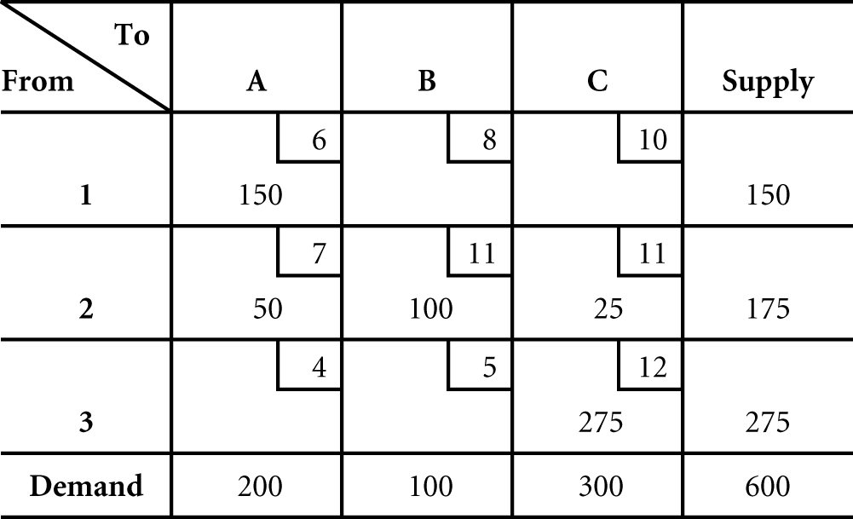
The initial solution is complete when all rim requirements are satisfied. Transportation cost is computed by evaluating the objective function:
Z = $6x_{1A} + 8x_{1B} + 10x_{1C} + 7x_{2A} + 11x_{2B} + 11x_{2C} + 4x_{3A} + 5x_{3B} + 12x_{3C}
= 6(150) + 8(0) + 10(0) + 7(50) + 11(100) + 11(25) + 4(0) + 5(0) + 12(275)
= $5,925
- LCM
In the minimum cell cost method as much as possible is allocated to the cell with the minimum cost followed by allocation to the feasible cell with minimum cost.
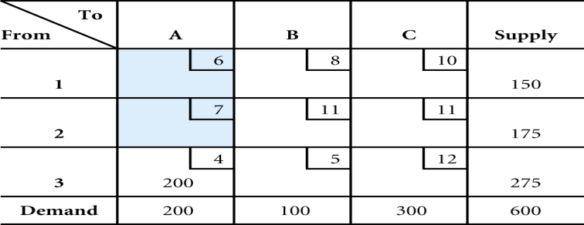
The initial minimum cell cost allocation
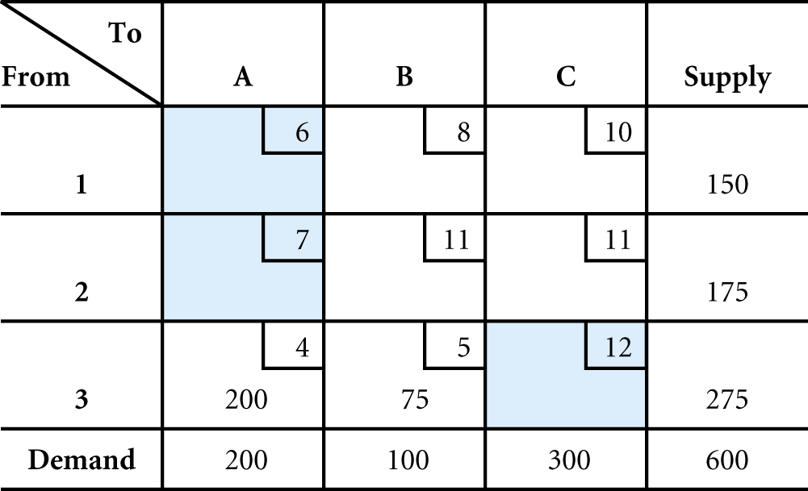 The second minimum cell cost allocation
The complete initial minimum cell cost solution;
Minimize Z = $6x_{1A} + 8x_{1B} + 10x_{1C} + 7x_{2A} + 11x_{2B} + 11x_{2C} + 4x_{3A} + 5x_{3B} + 12x_{3C}
6(o) +8(25) +10(125) +7(0) +11(0) +11(175) +4(200) +5(75) +12(0)
Total cost = $4,550.
The minimum cell cost method will provide a solution with a lower cost than the northwest corner solution because it considers cost in the allocation process.
- VAM
 | A | B | C | Supply | ROW DIFFERENCE
1 | 7 | 8 | 10  150 | 150 | 1 | 1 | 2 | - -
2 | 7  175 | 11 | 11 | 175 | 4 | - | - | - -
 | 4  25 | 5  100 | 12  150 | 275 250 150 | 1 | 1 | 7 | - -
Demand | 200  25 | 100 | 300  150
Column Difference | 3 | 3 | 1
Column Difference | 3  -  - | 3  3  - | 2  2  2
Min z = $7X1A+ 8X1B + 10X1C+ 7X2A+ 11X2B + 11X2C + 4X3A +5X3B + 12X3C
The initial cost of the problem is:
= 175×7+150×10+25×4+100×5+150×12
= $ 5,125
Example 2: A construction company wants cement at three of its project sites P1, P2 and P3. It procures cement from four plants C1, C2, C3 and C4. Transportation costs per ton, capacities and requirements are as follows:

 | P1 | P2 | P3 | Capacity(tons)
C1 | $5 | $8 | $12 | 300
C2 | 7 | 6 | 10 | 600
C3 | 13 | 4 | 9 | 700
C4 | 10 | 13 | 11 | 400
Requirement | 700 | 400 | 800
Required:
- Construct the linear programming model that represents the problem (both the objective function and model constraints).
- Compute the initial basic feasible solution of the transportation cost of the problem using North West Corner Method (NWCM).
- Compute the initial basic feasible solution of the transportation cost of the problem using Least Cost Method (LCM).
- Compute the initial basic feasible solution of the transportation cost of the problem using Vogel’s Approximation Method (VAM).
Solution:

Min Z = $5X11 + 8X12 + 12X13 + 7X21+ 6X22 + 10X23 + 13X31+4X32 + 9X33 + 10X41 + 13X42 + 11X43
S.T X11 + X12 + X13 = 300
X21 + X22+ X23 = 600 Supply Constraint
X31 + X32 + X33 = 700
X11 + X21+ X31 = 700
X12 + X22 + X32 = 500 Demand Constraint
X13 + X23 + X33 = 800
- NWCM
The cell (C1, P1) is the NWC cell in the given transportation table. The rim values for row C1 and column P1 are compared. The smaller of two, i.e. 300 is assign as the first allocation. This means that 300 units of commodity are to be transported from plant C1 to project site P1. However, this allocation leaves a supply of 700 – 300 = 400 unit of commodity at C1.
Move vertically and allocated as much as possible to cell (C2, P1). The rim value for column P1 is 400 and for row C2 is 600. The smaller of the two, i.e. 400, is placed in the cell.
Proceeding to column P2, the rim value for column P2 is 500 and for row C2 is 200. The smaller of the two, i.e. 200, is placed in the cell.
Proceeding to column P3, the rim value for column P3 is 800 and for row C3 is 400. The smaller of the two, i.e. 400, is placed in the cell.
Now, the rim value for column P3 is 400 which are balanced by the rim value of row C4 that is 400. Hence, the allocation is over.
 | P1 | P2 | P3 | Capacity(tons)
C1 | 5  (300) | 8 | 12 | 300
C2 | 7  (400) | 6  (200) | 10 | 600
C3 | 13 | 4  (300) | 9  (400) | 700
C4 | 10 | 13 | 11  (400) | 400
Requirement | 700 | 500 | 800
The total transportation cost of the initial solution derived by the NWCM is obtained by multiplying the quantity in the occupied sales with the corresponding unit cost and adding. Thus, the initial total transportation cost of the problem is;
Total cost = 300 x 5 + 400 x 7 + 200 x 6 + 300 x 4 + 400 x 9 + 400 x 11
= $14,700
- LCM
The cell (C3, P2) contain the lowest transportation cost in the given transportation table, the rim values for row C3 and column P2 are compared. The smaller of two, i.e. 500 is assign as the first allocation. This means that 500 units of commodity are to be transported from plant C3 to project site P2. However, this allocation leaves a supply of 700 – 500 = 200 unit of commodity at C3.
Now, search for the least cost in table without considering P2 because the rim value of P2 is zero. The lowest transportation cost is at cell (C1, P1) the rim values for row C1 and column P1 is compared. The smaller of two, i.e. 300 is assigned. However, this allocation leaves a supply of 700 – 300 = 400 unit of commodity at P1.
Now, search for the least cost in table without considering column P2 and row C1 because the rim value of P2 and C1 is zero. The lowest transportation cost is at cell (C2, P1) the rim values for row C2 and column P1 is compared. The smaller of two, i.e. 400 is assigned. However, this allocation leaves a supply of 600 – 400 = 200 unit of commodity at c2. Now, the rim value for row C2, C3, and C4 are respectively 200, 200 and400 which is balanced by the rim value of column P3 that is 800. The complete allocation of the LCM is as follows;
 | P1 | P2 | P3 | Capacity(tons)
C1 | 5  (300) | 8 | 12 | 300
C2 | 7  (400) | 6 | 10  (200) | 600
C3 | 13 | 4  (500) | 9  (200) | 700
C4 | 10 | 13 | 11  (400) | 400
Requirement | 700 | 500 | 800
In the above Solution we have, the total transportation cost of the initial solution derived by the “Least Cost Method” is obtained by multiplying the quantity in the occupied sales with the corresponding unit cost and adding. Thus the total initial transportation cost of the solution is-:
Total Cost = (C1, P1) + (C2, P1) + (C2, P3) + (C3, P2) + (C4, P3)
= 300 X 5 + 400 X 7 + 200 X 10 + 500 X 4 + 200X 9 + 400 X 11
= 1500 + 2800 + 2000 + 2000 +1800 + 4400
= $ 14,500
- VAM
Firstly, we will find the difference for the two lowest entries for each row (C1, C2, C3, and C4) and each column (P1, P2, and P3).
Secondly, we select row C3 because it has largest difference. In C3, the least value is 4.
Then, assign the maximum possible number 500 to the cell so that it exhausted the column P2 completely.
Thirdly, we will find the difference for lowest two entries of the remaining rows and columns. Then, we select the row C1 because it has largest difference. In C1, find the least value is 5 after that assign the maximum possible number 300 to the cell so that it exhausted the row C1 completely.
Fourthly, we will find the remaining rows and columns the difference for two lowest entries as we did above. After that we select the row C3, because it has largest difference. In C3, the least value is 9. And then, assign the maximum possible number 200 to the cell so that it exhausted the Row C3 completely.
Finally, we will find the difference for lowest two entries for each rows and columns of the remaining. Hence, we select row C2, because it has largest difference. In C7, the least value is 4. Thus, we assign the maximum possible number i.e. 400 to the cell so that it exhausted the column P1 completely.
By continuous doing this process we will assign all unit to the cell and will find the minimum initial transportation cost.
 | P1 | P2 | P3 | CAPACITY | ROW DIFFERENCE
C1 | 5  300 | 8 | 12 | 300 | 3 | 7 | - | -
C2 | 7  400 | 6 | 10  200 | 600 200 | 1 | 3 | 3 | 3
C3 | 13 | 4  500 | 9  200 | 700 200 | 5 | 4 | 4 | -
C4 | 10 | 13 | 11  400 | 400 | 1 | 1 | 1 | 1
Requirement | 700 400 | 500 | 800 600 | 2000
Column Difference | 2 | 2 | 1
Column Difference | 2 | - | 1
Column Difference | 3 | - | 1
Column Difference | 3 | - | 1
Total initial cost of VAM = C1×P1+C2×P1+C2×P3+C3×P2+C3×P3+ C4×P3
= 300×5+400×7+200×10+500×4+200×9+400×11
= 1500+2800+2000+2000+1800+4400
= $ 14,500

Test the Initial Solutions for Optimality
Once the initial feasible solution is reached, the next step is to test that solution for optimality. An optimal solution is one where there is no other set of transportation routes that will further reduce the total transportation cost. Thus, we will have to evaluate each unoccupied cell in the transportation table in terms of opportunity of reducing total transportation cost.
- Stepping-Stone Solution Method
This method determines if there is a cell with no allocation that would reduce cost if used.
Characteristics of Stepping-Stone
- We always start with an empty cell and form a closed path of cells that presently have allocations
- It is possible to skip over both unused and used cells
- In any row or column there must be exactly one addition and one subtraction
- The constraints of the problem cannot be violated, feasibility must be maintained
Example1: Given the initial feasible solution of our foregoing example 1, Test for optimality to compute How many tons of wheat to transport from each grain elevator to each mill on a monthly basis in order to minimize the total cost of transportation using:
        - NWCM
        - LCM
        - VAM
Solution:
- NWCM
Here our starting solution to test optimality is the NWCM i.e., $5925. See the table below:
 | A | B | C | Capacity(tons)
1 | 6  150 | 8 | 10 | 150
2 | 7  50 | 11  100 | 11  25 | 175
C3 | 4 | 5 | 12  275 | 275
Requirement | 200 | 100 | 300 | 600/600
Your remember that the initial solution of the transportation cost used by NWCM is
Z = $6x_{1A} + 8x_{1B} + 10x_{1C} + 7x_{2A} + 11x_{2B} + 11x_{2C} + 4x_{3A} + 5x_{3B} + 12x_{3C}
= 6(150) + 8(0) + 10(0) + 7(50) + 11(100) + 11(25) + 4(0) + 5(0) + 12(275)
= $5,925
Now we are going to test whether the currently empty cells would reduced the total cost or not if they are allocated.
Therefore, we have four empty cells to be tested. These are X1B, X1C, X3A, and X3B.
Then, allocate one unit of ton to each one of the empty cell turn by turn to identify the cell with potential cost reduction.

Testing all empty cells
Testing All Empty Cells |  | Interpretation of the result
Path | Net change
X1B→X1A→X2A→X2B | +8-6+7-11 = -$2 |  | A unit allocation to cell X1B reduce total cost by $2
X1C→X2C→X2A→X1A | +10-11+7-6 = $0 |  | A unit allocation to cell X1C does not affect the cost
X3A→X3C→X2C→X2A | +4-12+11-7 = -$4 |  | A unit allocation to cell X3A reduce cost by $4
X3B→X3C→X2C→X2B | +5-12+11-11 = -$7 |  | A unit allocation to cell X3B reduce total cost by $7
Then, the variable with the highest cost reduction must be selected as entering variable. So, without violating the rim requirement of the table, we have to reallocate as much as possible to it. Similar to simplex method, when there is entering variable a leaving variable is mandatory.
Accordingly, we add 100 tons of wheat to X3B and X2C and subtract 100 from the X2B and XX3C respectively. Hence, the entering variable is X3B whereas the leaving one is X2B.
After the change has been made, the transportation table is given as follows:
 | A | B | C | Capacity(tons)
1 | 6  (150) | 8 | 10 | 150
2 | 7  (50) | 11 | 11  (125) | 175
3 | 4 | 5  (100) | 12  (175) | 275
Requirement | 200 | 100 | 300 | 600/600
After the change, the total cost is as follows:
Z = $6x_{1A} + 8x_{1B} + 10x_{1C} + 7x_{2A} + 11x_{2B} + 11x_{2C} + 4x_{3A} + 5x_{3B} + 12x_{3C}
= 6(150) + 8(0) + 10(0) + 7(50) + 11(0) + 11(125) + 4(0) + 5(100) + 12(175)
= $5,225
Now, we have to check again whether $5225 is optimal solution or not by applying the same procedure as above.
Testing all empty cells again
Testing All Empty Cells |  | Interpretation of the result
Path | Net change | Interpretation of the result
X1B→X1A→X2A→X2C  →X3C→X3B | +8-6+7-11+12-5 = +$5 | A unit allocation to cell X1B increases total cost by $5
X1C→X2C→X2A→X1A | +10-11+7-6 = $0 | A unit allocation to cell X1C does not affect the cost
X3A→X3C→X2C→X2A | +4-12+11-7 = -$4 | A unit allocation to cell X3A reduce cost by $4
X2C→X2C→X3C→X3B | +11-11 +12-5 = +$7 | A unit allocation to cell X2C increase total cost by $7
Still we have an empty cell that reduces the total cost of the transportation. This cell is X3A.
So, the maximum amount that we can reallocate the cell of the entering variable is 50 tons because if we use more than 50, the allocation value of the cell X2A will be negative in which there is no negative product that transport from sources 2 to destination A. in general, there is no negative products.
In this case entering variable is X3A whereas the leaving one is X2A.
After the change has been made and allocated accordingly, the transportation table is as below:
 | A | B | C | Capacity(tons)
1 | 6  150 | 8 | 10 | 150
2 | 7 | 11 | 11  175 | 175
3 | 4  50 | 5  100 | 12  125 | 275
Requirement | 200 | 100 | 300 | 600/600
After the second iteration has been made, the total cost transportation cost is as below:
Minimize Z = $6x1A + 8x1B + 10x1C + 7x2A + 11x2B + 11x2C + 4x3A + 5x3B + 12x3C
= 6(150) + 8(o) + 10(0) + 7(0) + 11(0) + 11(175) + 4(50) + 5(100) + 12(125)
Total cost = $5,025
Testing All Empty Cells |  | Interpretation of the result
Path | Net change | Interpretation of the result
X1B→X1A→X3A→X3B | +8-6+4-5= +$1 | A unit allocation to cell X1B increases total cost by $1
X1C→X3C→X3A→X1A | +10-12+4-6 = -$4 | A unit allocation to cell X1C decrease cost by $4
X2A→X2C→X3C→X3A | +7-11+12-4 = +$4 | A unit allocation to cell X2A increase cost by $4
X2B→X3B→X3A→X2A | +11-5 +4-7 = +$2 | A unit allocation to cell X2B increase total cost by $2
Still the optimal solution has not been reached because the net effect of the empty cell X1C is negative. The negative four net effect of the cell indicates that if we allocate a unit of ton of wheat the total cost will be decrease by $4.
Therefore, add 125 to X1C and X3A and subtract the same amount of products (tons of wheat) from X3C and X1A respectively. After this change has been introduced into the transportation table, the total cost is given below:
 | A | B | C | Capacity(tons)
1 | 6  25 | 8 | 10  125 | 150
2 | 7 | 11 | 11  175 | 175
3 | 4  175 | 5  100 | 12 | 275
Requirement | 200 | 100 | 300 | 600/600
Minimize Z = $6x1A + 8x1B + 10x1C + 7x2A + 11x2B + 11x2C + 4x3A + 5x3B + 12x3C
= 6(25) + 8(o) + 10(125) + 7(0) + 11(0) + 11(175) + 4(175) + 5(100) + 12(0)
Total cost = $4,525
To make sure the optimal solution is reached, we have to test all empty cells as we did above.
Testing All Empty Cells |  | Interpretation of the result
Path | Net change | Interpretation of the result
X1B→X3B→X3A→X1A | +8-5+4-6= +$1 | A unit allocation to cell X1B is increases total cost by $1
X2A→X2C→X1C→X1A | +7-11+10-6 = $0 | A unit allocation to cell X1C is neither decrease nor increase the cost
X2B→X3B→X3A→X1A | +11-5+4-6 = +$4 | A unit allocation to cell X2A is increase cost by $4
X3C→X3A→X1A→X1C | +12-4 + 6-10 = +$4 | A unit allocation to cell X2B is increase total cost by $4
Now the optimal solution has been reached because there is an empty cell that can reduce the total transportation. You can see the above table, all the net effect of the empty cells are positive and zero. The net effect on the transportation cost of the empty cell X2A is zero. This implies the problem has multiple optimal solutions. When at least one empty cell has a zero net effect on the optimal transportation table, the problem has a multiple optimal solution.
Hence, the optimal solution of the problem is summarized in the table blow:
From ( source) | To( destination) | Amount shipped( tons) | Total cost in dollar
1 | A | 25 | 25 X 6 = 150
1 | C | 125 | 125 X 10 =1250
2 | C | 175 | 175 X 11 = 1925
3 | A | 175 | 175 X 4 =700
3 | B | 100 | 500 x 5 = 500
Total |  |  | $4525
- Least Cost Method (LCM)
The complete initial minimum cell cost solution is
Minimize Z = $6x1A + 8x1B + 10x1C + 7x2A + 11x2B + 11x2C + 4x3A + 5x3B + 12x3C
6(o) + 8(25)+10(125)+7(0)+11(0)+11(175)+4(200)+5(75)+12(0)
Total cost = $4,550.
The basic solution principle in a transportation problem is to determine whether transportation route no presently being used (an empty cell) would result in a lower total cost if it were used.
In this tableau there are four empty cells. So, our first task is to evaluate theses empty cells to see whether the use of any of them would reduce total cost. If we find such a route we will allocate as much as to it.
First let us consider allocating one tone of wheat to cell X1A.
If one tone is allocated to X1A: cost increase by $6 (transportation cost for cell X1A) and the supply and demand increase by 1.
 | A | B | C | Capacity(tons)
1 | 6(+1) | 8( 25-1) | 10 (125) | 151
2 | 7 | 11 | 11(175) | 175
C3 | 4(200-1) | 5(75+1) | 12 | 275
Requirement | 201 | 100 | 300 | 600/600
This is allocation of one tone to cell X1A.
The constraints of the problem cannot be violated, and feasibility must be maintained.
If we add one tone to cell X1A, we must subtract one tone from another allocation along that row.
A requirement of this solution method is that units can only be added to and subtract from cells that already have allocations.
Now let us review the increase and decrease in cost resulting from this process
Cost increase by $6 at cell X1A
Reduced cost by $8 at cell X1B
Increased cost by $5 at X3B
Reduced cost by $4 at cell X3A
In brief,
X1A → X1B→ X3B→X3A
+$6 - $8 + $5 - $4 = -$1
An empty cell that will reduce cost is a potential entering variable.
For each one ton allocation to cell X1A, total cost will be reduced by $1. This indicates that the initial solution is not optimal.
In order to identify the appropriate entering variable, the remaining empty cell must be tested as cell X1A was.
Allocation of one tone to X2A
 | A | B | C | Capacity(tons)
1 | 6 | 8( 25-1) | 10 (125+1) | 151
2 | 7(+1) | 11 | 11(175-1) | 175
3 | 4(200-1) | 5(75+1) | 12 | 275
Requirement | 201 | 100 | 300 | 600/600
Stepping stone path for cell X2A
= X2A → X2C→ X1C→ X1B→ X3B→ X3A
= +$7 - $11 +$ 10 - $8 + $5 - $4 = -$1
Negative one is the net effect of the allocation. So the negative sign indicates the net increase in cost.
Stepping stone path for cellX2B
 | A | B | C | Capacity(tons)
1 | 6 | 8( 25-1) | 10 (125+1) | 151
2 | 7 | 11(+1) | 11(175-1) | 175
3 | 4(200) | 5(75) | 12 | 275
Requirement | 201 | 100 | 300 | 600/600
Path Net effect on total cost
X2b→ X2C→ X1C→ X1B +$11 - $11 + $10 - $8 = + $2
This implies that if a unit of tone allocated to cell X2B, the cost would increase by 2.
Stepping stone for cell X3C
 | A | B | C | Capacity(tons)
1 | 6 | 8( 25+1) | 10 (125-1) | 151
2 | 7 | 11 | 11(175) | 175
3 | 4(200) | 5(75-1) | 12(+1) | 275
Requirement | 201 | 100 | 300 | 600/600
Path Net effect on the total cost
= X3C → X1C→ X1B→ X3B +$12 - $10 + $8 - $5 = +$5
If one unit allocated to cell X3C, the cost would increase by $5.
After all empty cells are evaluated; the one with the highest cost reduction potential is the entering variable.
Stepping –stone for cell X1A
 | A | B | C | Capacity(tons)
1 | 6(+1) | 8( 25-1) | 10 (125) | 151
2 | 7 | 11 | 11(175) | 175
3 | 4(200-1) | 5(75+1) | 12 | 275
Requirement | 201 | 100 | 300 | 600/600
According to our path there is 25 tons to reallocate to cell X1A. Therefore, 25 tons are added to X1A, subtracted from X1B, added to X3B and subtract from X3A.
Hence, X1A is the entering variable whereas X1B is a leaving variable similar to simplex method.
 | A | B | C | Capacity(tons)
1 | 6(25) | 8 | 10 (125) | 151
2 | 7 | 11 | 11(175) | 175
3 | 4(175) | 5(100) | 12 | 275
Requirement | 201 | 100 | 300 | 600/600
Now, we must check to see whether or not the solution is in fact optimal. We do this by plotting the paths for the unused routes as we did earlier in the above.
Therefore, the result is positive except zero cost for cell X2A.
Therefore, the stepping stone for cell X1A is the optimal solution
Basic variable amount transported destinations
X1A 25 tones A
X1C 125 tones C
X2C 175 tones C
X3A 175 tones A
X3B 100 tones B
Z = $6(25) + $8(0) + $10 (125) + $11 (0) + $11 ( 175) + $4(175) +5(100) +$12 ( 0)
= $ 4525
But allocating to cell X2A would neither decrease nor increase the total cost. This indicates that the problem has multiple optimal solutions.
Thus, X2A could be entered into the solution and there would not be a change in the minimum cost of $4525.
Alternative optimal solutions
 | A | B | C | Capacity(tons)
1 | 6 | 8 | 10 (150) | 151
2 | 7(25) | 11 | 11(150) | 175
3 | 4(175) | 5(100) | 12 | 275
Requirement | 201 | 100 | 300 | 600/600
Basic variable amount transported destinations
X2A 25 tones A
X1C 150 tones C
X3A 175 tones A
X3B 100 tones B
X2C 100 tones C
Z = $7(25) + $8(0) + $10 (150) + $11 (0) + $11 (150) + $4(175) +5(100) +$12 (0)
= $ 4525
- VAM
Test the optimality of the problem based on the initial solution of VAM
The following table shows the allocation the product to the destination based on the VAM.
 | A | B | C | Supply
1 | 6 | 8 | 10  150 | 150
2 | 7  175 | 11 | 11 | 175
3 | 4  25 | 5  100 | 12  150 | 275
Demand | 200 | 100 | 300 | 600
Min z = $6X1A+ 8X1B + 10X1C+ 7X2A+ 11X2B + 11X2C + 4X3A +5X3B + 12X3C
Thus, our starting solution is:
= 175×7+150×10+25×4+100×5+150×12
= $ 5,125
Here we have four empty cells to test whether any one or all will reduce the initial transportation cost if we allocate to them.
These empty cells are:
X1A, X1B, X2B, and X2C
Testing all empty cells
Testing All Empty Cells |  | Interpretation of the result
Path | Net change | Interpretation of the result
X1A→X1C→X3C→X3A | +6-10+12-4 = +$4 | A unit allocation to cell X1A boost total cost by $4
X1B→X1C→X3C→X3B | +8-10+12-5 = +$3 | A unit allocation to cell X1B boost total cost by $3
X2B→X2A→X3A→X3B | +11-7+4-5 = +$2 | A unit allocation to cell X2B boost total cost by $2
X2C→X3C→X3A→X2A | +11-12+4-7 = -$4 | A unit allocation to cell X2C reduce total cost by $4
From this, what we can understand is that the initial solution of the problem is not optimal because allocation to cell X2C would reduce the initial cost. Thus, as much as possible we have to allocate to X2C without violating the rim requirements of the demand and supply.
The amount of tons we can allocate to X2C is 150 because the closed path touches three allocated cells. The cell with the smallest positive the allocated has to be taken to allocate to X2C.
When we allocate 150 to X2C, we should subtract and add the same amount from and to the cell with minus and plus sign respectively.
See tableau below:
 | A | B | C | Supply
1 | 6 | 8 | 10  150 | 150
2 | 7  25 | 11 | 11  150 | 175
3 | 4  175 | 5  100 | 12 | 275
Demand | 200 | 100 | 300 | 600
Basic variable amount transported destinations
X2A 25 tones A
X1C 150 tones C
X3A 175 tones A
X3B 100 tones B
X2C 100 tones C
Z = $7(25) + $8(0) + $10 (150) + $11 (0) + $11 (150) + $4(175) +5(100) +$12 ( 0)
= $ 4525
Now, we must check again to see whether or not the solution is in fact, optimal. So, let us recomputed the total transportation cost:

 | A | B | C | Supply
1 | 6  25 | 8 | 10  125 | 150
2 | 7 | 11 | 11  175 | 175
3 | 4  175 | 5  100 | 12 | 275
Demand | 200 | 100 | 300 | 600

Testing All Empty Cells |  | Interpretation of the result
Path | Net change | Interpretation of the result
X1A→X1C→X2C→X2A | +6-10+11-7 = +$0 | A unit allocation to cell X1A is nether increase nor decrease the total cost
X1B→X1C→X2C→X2A→X3A→X3B | +8-10+11-7+4-5= +$1 | A unit allocation to cell X1B boost total cost by $1
X2B→X2A→X3A→X3B | +11-7+4-5 = +$3 | A unit allocation to cell X2B boost total cost by $3
X3C→X2C→X2A→X3A | +12-11+7-4 = +$4 | A unit allocation to cell X2C boost total cost by $4
Allocating to cell X1A would neither increase nor decrease the total cost. This indicates that the problem has multiple optimal solutions.
Thus, X1A could enter into the solution and there would not be a change in the total cost of $4525
To see the alternative solutions of the problem is, allocate as much as possible to cell X1A without violating the rim requirement of the transportation table.
According to our path, there is 25 tons to reallocate to cell X1A. Therefore, 25 tons are added to X1A, subtract form X1B, added to X2C and subtract from X2A.
As in the case of simplex method, we can also have leaving and entering variable when we solving transportation problem.
Therefore, in the first alternative optimal solution:
X2C is the entering variable whereas X3C is leaving variable similar to simplex method.
In the second alternative optimal solution:
X1A is the entering variable whereas X2A is leaving variable
Summary
From ( source) | To( destination) | Amount shipped( tons) | Total cost in dollar
1 | A | 25 | 25 X 6 = 150
1 | C | 125 | 125 X 10 =1250
2 | C | 175 | 175 X 11 = 1925
3 | A | 175 | 175 X 4 =700
3 | B | 100 | 500 x 5 = 500
Total |  |  | $4525

Modified Distribution Method (MODI)
- MODI is a modified version of the stepping-stone methods
- Individual cell cost changes are determined mathematically without identifying all of the stepping-stone paths for the empty cells.
- In general, Modified Distribution Method (MODI method) is used for testing the optimality of the existing initial feasible solution.
Example2: using MODI, test the initial feasible solution of our previous example 2. Use the following initial basic feasible as starting solution.
- North West Corner Method
Solution: The initial basic feasible solution of the problem using NWCM is already computed above. Just to remember, it is as below:
 | VP1=  P1 | VP2=  P2 | VP3=  P3 | Capacity(tons)
U1= C1 | 5  (300) | 8 | 12 | 300
U2= C2 | 7  (400) | 6  (200) | 10 | 600
U3= C3 | 13 | 4  (300) | 9  (400) | 700
U4= C4 | 10 | 13 | 11  (400) | 400
Requirement | 700 | 500 | 800
The total transportation cost of the initial solution derived by the NWCM is $14,700 in which we will use as our tentative solution to find the optional one.
- Ui and Vj are computed for all cells with allocations by using the following formula:
Ui + Vj = Cij
Where Cij is a unit transportation cost for ij cells
Then, the equations are:
U1 + VP1 = 5------------------------------------------------------------------------------------------1
U2 + VP1 = 7------------------------------------------------------------------------------------------2
U2 + VP2 = 6------------------------------------------------------------------------------------------3
U3 + VP2 = 4------------------------------------------------------------------------------------------4
U3 + VP3 = 9------------------------------------------------------------------------------------------5
U4 + VP3 = 11----------------------------------------------------------------------------------------6
To solve these equations, it is necessary to assign a value of zero to only one of the unknown value of the variables.
If we let the value of U1 = 0, we can solve for all the remaining.
U1 + VP1 = 5, U1= 0, 0 + VP1 = 5, VP1 = 5 ----------------------------------------------------1
U2 + VP1 = 7, VP1 = 5, U2 + 5 = 7, U2 = 2------------------------------------------------------2
U2 + VP2 = 6, U2= 2, 2 + VP2 = 6, VP2 = 4-----------------------------------------------------3
U3 + VP2 = 4, VP2 = 4, U3+ 4= 4, U3 =0--------------------------------------------------------4
U3 + VP3 = 9, U3 = 0, 0 + VP3 = 9, VP3 = 9 ---------------------------------------------------5
U4 + VP3 = 11, VP3 =9, U4 + 9= 11, U4 = 2----------------------------------------------------6
Now all Ui and Vj values can be substituted into the tableau.
 | VP1=5  P1 | VP2=4  P2 | VP3=9  P3 | Capacity(tons)
U1= 0 C1 | 5  (300) | 8 | 12 | 300
U2= 2 C2 | 7  (400) | 6  (200) | 10 | 600
U3= 0 C3 | 13 | 4  (300) | 9  (400) | 700
U4= 2 C4 | 10 | 13 | 11  (400) | 400
Requirement | 700 | 500 | 800
We use the following formula to evaluate all empty cells:
Cij – Uij – Vj = Kij
Where Kij= the cost decrease or increase that would occur by allocating to a cell
KC1P2 = CC1P2 - U1 - VP2: KC1P2 = 8 - 0 - 4 = $4 (increase cost per unit allocation)
KC1P3 = CC1P3 - U1 - VP3:KC1P3 = 12 - 0 – 9 = +$3(increase cost per unit allocation)
KC2P3 = CC2P3 - U2 – VP3: KC2P3 = 10- 2 – 9 = -$1(increase cost per unit allocation)
KC3P1 = CC3VP1 - U3 – VP1: KC3P1= 13- 0- 5 = +$8(increase cost per unit allocation)
KC4P1 = CC4VP1 - U4 - VP1: KC4P1 = 10 – 2 – 5 = +$3(increase cost per unit allocation)
KC4P2 = CC4VP2 - U4 - VP2: KC4P2 = 13- 2-4 =+$7(increase cost per unit allocation)
After all empty cells are evaluated the one with the greatest cost reduction potential is the entering variable. In other words, our starting solution is not optimal because we have an empty cell that will be reduced the cost by $1 per unit allocation.
Now, we have to reallocate as much as possible to cell X2P3.
According to our path, 200 units of products must be added to X2P3 and X3P2 and subtracted from X2P2 and X3P3 respectively.
See the table below:
 | VP1=5  P1 | VP2=4  P2 | VP3=9  P3 | Capacity(tons)
U1= 0 C1 | 5  (300) | 8 | 12 | 300
U2= 2 C2 | 7  (400) | 6 | 10  (200) | 600
U3= 0 C3 | 13 | 4  (500) | 9  (200) | 700
U4= 2 C4 | 10 | 13 | 11  (400) | 400
Requirement | 700 | 500 | 800
Min z = 300×5+400×7+200×10+500×4+200×9+400×11
= 1500+2800+2000+2000+1800+4400
= $14,500
But we do not know whether the optimal solution has been reached or not. So we need to proceed until all the net change in cost become positive.

 | VP1=5  P1 | VP2=4  P2 | VP3=9  P3 | Capacity(tons)
U1= 0 C1 | 5  (300) | 8 | 12 | 300
U2= 2 C2 | 7  (400) | 6 | 10  (200) | 600
U3= 0 C3 | 13 | 4  (500) | 9  (200) | 700
U4= 2 C4 | 10 | 13 | 11  (400) | 400
Requirement | 700 | 500 | 800
As we did before above, we should follow same procedure.
The value of all Ui and Vj must recomputed for all cells with allocations by using the following formula: Ui + Vj = Cij
Then, the equations are:
U1 + VP1 = 5-----------------------------------------------------------------------------------------1
U2 + VP1 = 7-----------------------------------------------------------------------------------------2
U2 + VP3 = 10----------------------------------------------------------------------------------------3
U3 + VP2 = 4-----------------------------------------------------------------------------------------4
U3 + VP3 = 9-----------------------------------------------------------------------------------------5
U4 + VP3 = 11----------------------------------------------------------------------------------------6
To solve these equations, it is necessary to assign a value of zero to only one of the unknown value of the variables.
If we let the value of U1 = 0, we can solve for all the remaining.
U1 + VP1 = 5, U1= 0, 0 + VP1 = 5, VP1 = 5 ----------------------------------------------------1
U2 + VP1 = 7, VP1 = 5, U2 + 5 = 7, U2 = 2------------------------------------------------------2
U2 + VP3 = 10, U2= 2, 2 + VP3 = 10, VP3 = 8--------------------------------------------------3
U3 + VP2 = 4 (solve equation 5 first), U3 + VP2 = 4, U3= 1, 1 + VP2= 4, VP2 = 3------4
U3 + VP3 = 9, VP3 = 8, U3 + 8 = 9, U3 = 1 (now back to equation 4) ---------------------5
U4 + VP3 = 11, VP3 =8, U4 + 8= 11, U4 = 3----------------------------------------------------6
N.B: the 5th equation had to be solved before the 4th one could be solved.
Now all Ui and Vj values can be substituted into the tableau. We use the following formula to evaluate all empty cells:
Cij – Uij – Vj = Kij
Where Kij= the cost decrease or increase that would occur by allocating to a cell
KC1P2 = CC1P2 - U1 - VP2: KC1P2 = 8 - 0 - 3 = $5 (increase cost per unit allocation)
KC1P3 = CC1P3 - U1 - VP3:KC1P3 = 12 - 0 - 8 = 4(increase cost per unit allocation)
KC2P2 = CC2P2 - U2 - VP2: KC2P2 = 6- 2 – 3 = 1(increase cost per unit allocation)
KC3P1 = CC3VP1 - U3 – VP1: KC3P1= 13- 1- 5 = 7(increase cost per unit allocation)
KC4P1 = CC4VP1 - U4 - VP1: KC4P1 = 10 – 3 – 5 = 2(increase cost per unit allocation)
KC4P2 = CC4VP2 - U4 - VP2: KC4P2 = 13- 3-3 = 7(increase cost per unit allocation)
Since none of these values is negative, the solution is optimal.
Therefore, the answer is summarised in the table below:
Sources (from) | Destination( to) | Amount shipped | Cost in dollar
Plant C1 | Project site 1 | 300 | 300 x5 = 1500
Plant C2 | Project site 1 | 400 | 400 x 7 = 2800
Plant C2 | Project site 3 | 200 | 200 x 10 = 2000
Plant C3 | Project site 2 | 500 | 500 x 4 = 2000
Plant C3 | Project site 3 | 200 | 200 x 9 = 1800
Plant C4 | Project site 3 | 400 | 400 x 11 = 4400
Total Cost |  |  | $14,500
- Least Cost Method
Solution:
Here in this case, our starting solution is LCM. So, the initial feasible solution of the problem is as below:
Min Z = C1×P1+C2×P1+C2×P3+C3×P2+C3×P3+C4×P3
= 300×5+400×7+200×10+500×4+200×9+400×11
= 1500+2800+2000+2000+1800+4400
= $14,500
Test whether this initial cost is optimality or not:
 | V1=--------  P1 | V2:-------  P2 | V3:------  P3 | Capacity(tons)
U1:___ C1 | 5  300 | 8 | 12 | 300
U2:___ C2 | 7  400 | 6 | 10  200 | 600
U3:___ C3 | 13 | 4  500 | 9  200 | 700
U4:___ C4 | 10 | 13 | 11  400 | 400
Requirement | 700 | 500 | 800 | 2000
Unfortunately, both the initial feasible solution of the VAM and LCM are same i.e., $14,500. So, the initial solution of the LCM would be optimal as in the case of VAM.
Step 1- R+C–1 = Filled cell
4+3–1 = 6 (BALANCED MATRIX)
Step 2- For filled cell
Let R1= 0
R1+C1 = TC 0+C1 = 5 C1 = 5
R2+C1 = TC R2+5 = 7 R2 = 2
R2+C3 = TC 2+C3 = 10 C3 =8
R3+C3 = TC R3+8 = 9 R3 = 1
R3+C2 =TC 1+C2 = 4 C2 = 3
R4+C3 = TC R4+8 = 11 R4 =3
Step 3- For unfilled cell (Find sign)
TC–(R1+C2) = 8–(0+3) = 5
TC–(R1+C3) = 12-(0+8) = 4
TC–(R2+C2) = 6–(2+3) = 1
TC–(R3+C1) = 13–(1+5) = 7
TC–(R4+C1) = 10–(3+5) = 2
TC–(R4+C2) = 13–(3+3) = 7
Since none of these values is negative, the solution is optimal. Therefore, the initial feasible solution of the problem is optimal.
Summary:
Sources (from) | Destination( to) | Amount shipped | Cost in dollar
Plant C1 | Project site 1 | 300 | 300 x5 = 1500
Plant C2 | Project site 1 | 400 | 400 x 7 = 2800
Plant C2 | Project site 3 | 200 | 200 x 10 = 2000
Plant C3 | Project site 2 | 500 | 500 x 4 = 2000
Plant C3 | Project site 3 | 200 | 200 x 9 = 1800
Plant C4 | Project site 3 | 400 | 400 x 11 = 4400
Total Cost |  |  | $14,500
- Vogel-s Approximation Method (VAM)
Solution:
As you remember, the initial cost of the transportation problem using VAM is
Min Z = C1×P1+C2×P1+C2×P3+C3×P2+C3×P3+C4×P3
= 300×5+400×7+200×10+500×4+200×9+400×11
= 1500+2800+2000+2000+1800+4400
= $14,500
Test whether this initial cost is optimality or not:
 | V1=--------  P1 | V2:-------  P2 | V3:------  P3 | Capacity(tons)
U1:___ C1 | 5  300 | 8 | 12 | 300
U2:___ C2 | 7  400 | 6 | 10  200 | 600
U3:___ C3 | 13 | 4  500 | 9  200 | 700
U4:___ C4 | 10 | 13 | 11  400 | 400
Requirement | 700 | 500 | 800 | 2000
- The extra-left hand column with the Ui symbols represent the row value that must be computed in MODI
- the extra-top row with Vj symbols represent the row values that must be computed in MODI
- Ui and Vj are computed for all cells with allocations by using the following formula:
Ui + Vj = Cij
Where Cij is a unit transportation cost for ij cells
Then, the equations are:
U1 + VP1 = 5---------------------------------------------------------------------------------------1
U2 + VP1 = 7---------------------------------------------------------------------------------------2
U2 + VP3 = 10--------------------------------------------------------------------------------------3
U3 + VP2 = 4----------------------------------------------------------------------------------------4
U3 + VP3 = 9-----------------------------------------------------------------------------------------5
U4 + VP3 = 11---------------------------------------------------------------------------------------6
To solve these equations, it is necessary to assign a value of zero to only one of the unknown value of the variables.
If we let the value of U1 = 0, we can solve for all the remaining.
U1 + VP1 = 5, U1= 0, 0 + VP1 = 5, VP1 = 5 ----------------------------------------------------1
U2 + VP1 = 7, VP1 = 5, U2 + 5 = 7, U2 = 2------------------------------------------------------2
U2 + VP3 = 10, U2= 2, 2 + VP3 = 10, VP3 = 8--------------------------------------------------3
U3 + VP2 = 4 (solve equation 5 first), U3 + VP2 = 4, U3= 1, 1 + VP2= 4, VP2 = 3------4
U3 + VP3 = 9, VP3 = 8, U3 + 8 = 9, U3 = 1 (now back to equation 4) ---------------------5
U4 + VP3 = 11, VP3 =8, U4 + 8= 11, U4 = 3----------------------------------------------------6
N.B: the 5th equation had to be solved before the 4th one could be solved.
Now all Ui and Vj values can be substituted into the tableau.
 | VP1= 5  P1 | VP2= 3  P2 | VP3= 8  P3 | Capacity(tons)
U1= 0 C1 | 5  300 | 8 | 12 | 300
U2=2 C2 | 7  400 | 6 | 10  200 | 600
U3= 1 C3 | 13 | 4  500 | 9  200 | 700
U4 =3 C4 | 10 | 13 | 11  400 | 400
Requirement | 700 | 500 | 800 | 2000
We use the following formula to evaluate all empty cells:
Cij – Uij – Vj = Kij
Where Kij= the cost decrease or increase that would occur by allocating to a cell
KC1P2 = CC1P2 - U1 - VP2: KC1P2 = 8 - 0 - 3 = $5 (increase cost per unit allocation)
KC1P3 = CC1P3 - U1 - VP3:KC1P3 = 12 - 0 - 8 = 4(increase cost per unit allocation)
KC2P2 = CC2P2 - U2 - VP2: KC2P2 = 6- 2 – 3 = 1(increase cost per unit allocation)
KC3P1 = CC3VP1 - U3 – VP1: KC3P1= 13- 1- 5 = 7(increase cost per unit allocation)
KC4P1 = CC4VP1 - U4 - VP1: KC4P1 = 10 – 3 – 5 = 2(increase cost per unit allocation)
KC4P2 = CC4VP2 - U4 - VP2: KC4P2 = 13- 3-3 = 7(increase cost per unit allocation)
Since none of these values is negative, the solution is optimal.
Therefore, the initial feasible solution of the problem is optimal.
Summary:
Sources (from) | Destination( to) | Amount shipped | Cost in dollar
Plant C1 | Project site 1 | 300 | 300 x5 = 1500
Plant C2 | Project site 1 | 400 | 400 x 7 = 2800
Plant C2 | Project site 3 | 200 | 200 x 10 = 2000
Plant C3 | Project site 2 | 500 | 500 x 4 = 2000
Plant C3 | Project site 3 | 200 | 200 x 9 = 1800
Plant C4 | Project site 3 | 400 | 400 x 11 = 4400
    - Unbalanced Transportation problem
Transportation problems that have the supply and demand equal is a balanced transportation problem. In other words requirements for the rows must equal the requirements for the columns. An Unbalanced transportation problem is that in which the supply and demand are unequal. There are 2 possibilities that make the problem unbalanced which are
Aggregate supply exceeds the aggregate demand
Aggregate demand exceeds the aggregate supply
2 Possibilities That Make the Problem Unbalanced

- Aggregate demand exceeds the aggregate supply.
Such problems are called unbalanced problems. It is necessary to balance them before they are solved.
Example1: The following table gives the cost of transportation, the availabilities and requirements of an organization:
Ware House |  | Demand Points |  |  |  | Available Capacity
Ware House |  | A | B | C | D | Available Capacity
Ware House | W₁ | 10 | 20 | 20 | 15 | 50
Ware House | W₂ | 15 | 40 | 15 | 35 | 100
Ware House | W₃ | 25 | 30 | 40 | 50 | 150
Requirements |  | 25 | 115 | 60 | 30
Required: find the optimal solution of the above problem
Solution:
In the above problem total demand is less than total supply by (300-230) 70 units.
Step 1: So, we will create a new demand point and name this as “DUMMY”.
Step 2: Assume Transportation cost as to be “Zero” and write in DUMMY column in place of Transportation cost.
Step 3: Write the difference of total demand and supply in the required column cell.
 | A | B | C | D | DUMMY | CAPACITY
W₁ | 10 | 20 | 20 | 15 | 0 | 50
W₂ | 15 | 40 | 15 | 35 | 0 | 100
W₃ | 25 | 30 | 40 | 50 | 0 | 150
 | 25 | 115 | 60 | 30 | 70 | 300
Step 4: Apply method of basic feasible solution (By Vogel’s Approximation Method).
 | A | B | C | D | DUMMY | CAPACITY | P₁ | P₂ | P₃ | P₄ | P₅
W₁ | 10  (20) | 20 | 20 | 15  (30) | 0 | 50 | 10 | 5 | 10 | - | -
W₂ | 15  (5) | 40  (35) | 15  (60) | 35 | 0 | 100 | 5 | 0 | 0 | 0 | 25
W₃ | 25 | 30  (80) | 40 | 50 | 0  (70) | 150 | 30 | 5 | 5 | 5 | 5
 | 25 | 115 | 60 | 30 | 70 | 300
P₁ | 5 | 10 | 5 | 20 | 0
P₂ | 5 | 10 | 5 | 20 | -
P₃ | 5 | 10 | 5 | - | -
P₄ | 10 | 10 | 25 | - | -
P₅ | 10 | 10 | - | - | -
Total Cost =10×20+40×35+15×30+15×5+40×35+15×60+30×80
=200+1400+450+75+1400+900+2400
= Birr 6825
Step 5: Now, we will test this solution for optimality.
 |  | C₁= 15 | C₂= 30 | C₃= 15 | C₄= 25 | C₅= 0
 |  | A | B | C | D | DUMMY | CAPACITY
R₁= -10 | W₁ | 10 | 20 (20) | 20 | 15 (30) | 0 | 50
R₂= 0 | W₂ | 15 (25) | 40 | 15 (60) | 35 | 0 (15) | 100
R₃= 0 | W₃ | 25 | 30 (95) | 40 | 50 | 0 (55) | 150
 |  | 25 | 115 | 60 | 30 | 70 | 300
The Optimal Cost for above sum
= 20×20+15×30+15×25+15×60+30×95
= 400+450+375+900+2850 = Birr 4975
3.2. Assignment Problems
What is an assignment?
Suppose there are ‘n’ jobs to be performed and ‘n’ persons are available for doing these jobs. Assume each person can do each job at a time with a varying degree of efficiency. Let C_{ij} be the cost of i^{th} person assigned to j^{th} job. Then the problem is to find an assignment so that the total cost for performing all jobs is minimal. Such problems are known as assignment problems. These problems may consist of assigning men to offices, classes to the rooms or problems to the research team etc.
Imagine, if in a printing press there is one machine and one operator is there to operate. How would you employ the worker? Your immediate answer will be, the available operator will operate the machine.
Again suppose there are two machines in the press and two operators are engaged at different rates to operate them. Which operator should operate which machine for maximising profit? Similarly, if there are n machines available and n persons are engaged at different rates to operate them. Which operator should be assigned to which machine to ensure maximum efficiency?
While answering the above questions, we have to think about the interest of the press, so we have to find such an assignment by which the press gets maximum profit on minimum investment. Such problems are known as assignment problems. Hence, the objective is to assign a number of jobs to the equal number of persons at a minimum cost or maximum profit.
Algorithm for Assignment Problem (Hungarian Method)
In order to find the proper assignment, it is essential for us to know the Hungarian method. This method is dependent upon two vital theorems, stated as below.
Theorem 1: If a constant is added (or subtracted) to every element of any row (or column) of the cost matrix [C_{ij}] in an assignment problem then an assignment which minimises the total cost for the new matrix will also minimize the total cost matrix.
Theorem 2: If all C_{ij} ≥ 0 and there exists a solution
Cost matrix: Cij= C11 C12 C13 … c1n
C21 C22 C23 … c2n
.
.
.
Cn1 Cn2 Cn3 … Cnn
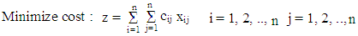
Subject to restrictions of the form
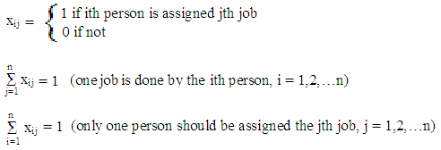
Where x_{ij} denotes that j^{th} job is to be assigned to the i^{th} person.
Then this solution is an optimal solution, i.e., minimizes z.
The computational procedure of the Hungarian method is given as under:
Step I.
- Row Reduction: Subtract the minimum of each row of the effectiveness matrix, from all the elements of the respective rows (Row reduced matrix).
- Column Reduction: After completion of row reduction, subtract the minimum entry of each column from all the entries of the respective column.
Step II. Zero assignment:
- Starting with first row of the matrix received in first step, examine the rows one by one until a row containing exactly one zero is found. Then an experimental assignment indicated by ‘ ’ is marked to that zero. Now cross all the zeros in the column in which the assignment is made. This procedure should be adopted for each row assignment.
- When the set of rows has been completely examined, an identical procedure is applied successively to columns.
Starting with column 1, examine all columns until a column containing exactly one zero is found. Then make an experimental assignment in that position and cross other zeros in the row in which the assignment was made. Continue these successive operations on rows and columns until all zeros have either been assigned or crossed-out.
Now there are two possibilities:
- Either all the zeros are assigned or crossed out, i.e., we get the maximal assignment. Or
- At least two zeros are remained by assignment or by crossing out in each row or column. In this situation we try to exclude some of the zeros by trial and error method.
This completes the second step. After this step, we can get two situations.
- Total assigned zero’s = n where n = number of rows or columns in the matrix
The assignment is optimal.
- Total assigned zero’s < n
Use step III and onwards.
Step III. Draw of minimum lines to cover zeros
In order to cover all the zeros at least once you may adopt the following procedure.
- Marks () to all rows in which the assignment has not been done.
- See the position of zero in marked () row and then mark () to the corresponding column.
- See the marked () column and find the position of assigned zeros and then mark () to the corresponding rows which are not marked till now.
- Repeat the procedure (ii) and (iii) till the completion of marking.
- Draw the lines through unmarked rows and marked columns.
Note: If the above method does not work then make an arbitrary assignment and then follow step IV
Step IV. Select the smallest element from the uncovered elements
- Subtract this smallest element from all those elements which are not covered.
- Add this smallest element to all those elements which are at the intersection of two lines.
Step V: Thus we have increased the number of zero’s.
Now, modify the matrix with the help of step II and find the required assignment.
You will gain insight into this topic after the following subsequent examples;
Example 1: The Department Head of Management in Sheba University College has four subordinates and four tasks that have to be performed. Subordinates differ in efficiency and tasks differ in their intrinsic difficulty. Time each man would take to perform each task is given in the effectiveness matrix below.
Tasks |  |  | Subordinates
Tasks |  | I |  | II | III | IV
Tasks | A | 8 |  | 26 | 17 | 11
Tasks | B | 13 |  | 28 | 4 | 26
Tasks | C | 38 |  | 19 | 18 | 15
 | D | 19 |  | 26 | 24 | 10
Required
- Find the optimum assignments that minimize cost
- Compute the total man-hours
- Does the problem have multiple solutions? Explain.
Solution:

Step 1: Row Reduced Matrix Step 2: Column Reduced Matrix
0 | 14 | 9 | 3
  0 | 18 | 9 | 3
  9 | 24 | 0 | 22
  23 | 4 | 3 | 0
  9 | 16 | 14 | 0
9 | 20 | 0 | 22
23 | 0 | 3 | 0
9 | 12 | 14 | 0

Step 3: Check for optimality by encircled a single zero in each row and column. If the number of encircled zero are same as the number of rows or columns, the solution is optimal if not we need to proceed.
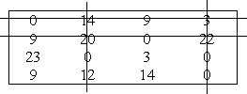
N(number of lines) = ( number of row or column) , N(4) = n(4)
Since N = n, we move on to zero assignment
Zero assignment
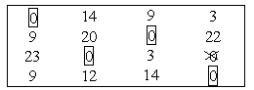
Since number of unique assignment = number of rows or columns, the optimal solution has been reached.
        - Total man-hours = 8 + 4 + 19 + 10 = 41 hours
        - Has no optimal solution. It is unique solution because there is no even one alternative zero to be encircled.
Example 2: A car hire company has one car at each of five depots a, b, c, d and e. a customer requires a car in each town namely A, B, C, D and E. Distance (kms) between depots (origins) and towns (destinations) are given in the following distance matrix:
 | A | B | c | d | e
A | 160 | 130 | 175 | 190 | 200
B | 135 | 120 | 130 | 160 | 175
C | 140 | 110 | 155 | 170 | 185
D | 50 | 50 | 80 | 80 | 110
E | 55 | 35 | 70 | 80 | 105
Required:
- Find the optimum assignments that minimize cost
- Compute the total man-hours
- Does the problem have multiple solutions? Explain.
Solution:
- Step 1: Row Reduced Matrix
30 | 0 | 45 | 60 | 70
15 | 0 | 10 | 40 | 55
30 | 0 | 45 | 60 | 75
0 | 0 | 30 | 30 | 60
20 | 0 | 35 | 45 | 70
Step3: Check for optimality by encircled a single zero from each row and column. 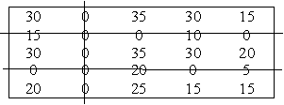
Step 2: Column Reduction Since we cover all zeros with three straight lines, the unique solutions at this stage.
30 | 0 | 35 | 30 | 15
15 | 0 | 0 | 10 | 0
30 | 0 | 35 | 30 | 20
0 | 0 | 20 | 0 | 5
20 | 0 | 25 | 15 | 15

Step 4: cover all zeros with a min straight lines
          - Select the minimum element from all the uncovered zeros i.e. 15.
          - Subtract the element from all uncovered zeros
          - Add this element to the intersection line of the lines
15 | 0 | 20 | 15 | 0
15 | 0 | 0 | 10 | 0
15 | 0 | 20 | 15 | 5
0 | 0 | 20 | 0 | 5
5 | 0 | 10 | 0 | 0
15 | 0 | 20  0 | 15 | 0
15  0 | 0 | 0 | 10 | 0
15  0 | 0 | 20 | 15 | 5
0 | 0 | 20 | 0  0 | 5
5 | 0 | 10 | 0 | 0
Check optimality
0

The optimal solution has been reached because we encircled a single zero at each row and column.
4 | 15 | 0 | 16
10 | 18 | 0 | 24
3 | 13 | 0 | 19
7 | 16 | 0 | 18
N = n i.e. 5 = 5, so no need to proceed.
Route | A-e | B-c | C-b | D-a | E-d
Distance | 200 | 130 | 110 | 50 | 80

- Minimum distance travelled = 200 + 130 + 110 + 50 + 80 = 570 kilo meters
Example 3: Solve the assignment problem whose effectiveness matrix is given in the table
 | 1 | 2 | 3 | 4
A | 49 | 60 | 45 | 61
B | 55 | 63 | 45 | 69
C | 52 | 62 | 49 | 68
D | 55 | 64 | 48 | 66

Solution
Row-Reduced Matrix I Modified Matrix
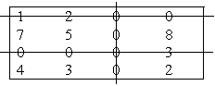
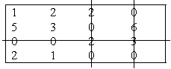
N < n i.e 3 < 4, so II modified matrix N < n i.e 3 < 4
II Modified Matrix III Modified matrix
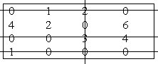
Since N = n, we move on to zero assignment
Zero assignment
Multiple optimal assignments exists

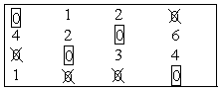
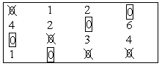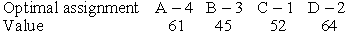
Solution-I-

Solution-II-

Total cost = 49 + 45 + 62 + 66 = 222 units Minimum cost = 61 + 45 + 52 + 64 = 222 units

Part I: Exercises on chapter four
Multiple Choices
              - Transportation problem is basically a:
- Maximisation model C. Transhipment problem
- Minimisation model D. Iconic model
- The column, which is introduced in the matrix to balance the rim requirements, is known as:
- Key column C. Slack column
- Idle column D. Dummy Column
- The row, which is introduced in the matrix to balance the rim requirement, is known as:
- Key row C. Dummy row
- Idle row D. Slack row
- One of the differences between the Resource allocation model and Transportation Model is:
- The coefficients of problem variables in Resource allocation model may be any number and in transportation model it must be either zeros or ones
- The coefficients of problem variable in Resource allocation model must be either zeros or ones and in Transportation model they may be any number
- In both models they must be either zeros or ones only
- In both models they may be any number
- To convert the transportation problem into a maximisation model we have to:
- write the inverse of the matrix,
- Multiply the rim requirements by –1
- To multiply the matrix by –1
- We cannot convert the transportation problem into a maximisation problem, as it is basically a minimisation problem
- In a transportation problem where the demand or requirement is equal to the available resource is known as:
- Balanced transportation problem
- Regular transportation problem
- Resource allocation transportation problem
- Simple transportation model
- The total number of allocation in a basic feasible solution of transportation problem of m × n size is equal to:
- m × n C. m + n +1
- (m / n ) – 1 D. m + n – 1
- When the total allocations in a transportation model of m x n size is not equals to m + n – 1 the situation is known as:
- Unbalanced situation C. Degeneracy
- Tie situation D. None of the above
- The opportunity cost of a row in a transportation problem is obtained by:
- Deducting the smallest element in the row from all other elements of the row
- Adding the smallest element in the row to all other elements of the row
- Deducting the smallest element in the row from the next highest element of the row
- Deducting the smallest element in the row from the highest element in that row
- In Northwest corner method the allocations are made:
- Starting from the left hand side top corner
- Starting from the right hand side top corner
- Starting from the lowest cost cell
- Starting from the lowest requirement and satisfying first
- VAM stands for:
- Value added method C. Vogel Adam method
- Value assessment method D. Vogel’s approximation method
- MODI stands for:
- Modern distribution C. Modified distribution method
- Mendel's distribution method D. Model index method
- In the optimal solution, more than one empty cells have their opportunity cost as zero, it indicates:
- The solution is not optimal C. Something wrong in the solution
- The problem has alternate solution D. The problem will cycle
- In case the cost elements of one or two cells are not given in the problem, it means:
- The given problem is wrong
- We can allocate zeros to those cells
- Allocate very high cost element to those cells
- To assume that the route connected by those cells are not available
- To solve degeneracy in the transportation problem we have to:
- Put allocation in one of the empty cells as zero
- Put a small element epsilon in any one of the empty cells
- Allocate the smallest element epsilon in such a cell, which will not form a closed loop with other loaded cells
- Allocate the smallest element epsilon in such a cell, which will form a closed loop with other loaded cells
- A problem where the produce of a factory is stored in warehouses and then they are transported to various demand points as and when the demand arises is known as
- Transhipment problem C. Storing and transport problem
- Warehouse problem D. None of the above
- Implied Cost in transportation problem sets (in the existing program):
- The lowest limit for the empty cell beyond which it is not advisable to include in the programme
- The highest limit for the empty cell beyond which it is not advisable to include in the programme
- The opportunity cost of the empty cell
- None of the above
- In transportation model, the opportunity cost is given by
- Implied cost + Actual cost of the cell C. Implied cost – Actual cost of the cell
- Actual cost of the cell – Implied cost D. Implied cost × Actual cost of the cell
- If ui and vj are row and column numbers respectively, then the implied cost is given by:
- ui + vj C. ui × vj
- ui – vj D. ui / vj
- If a transportation problem has an alternate solution, then the other alternate solutions are derived by: (Given that the two matricides of alternate solutions are A and B, and d is any positive fraction number)
- A + (1 – d) × B C. dA + Db
- A ( 1 – d) + B D. dA + (1 – d) × B
- Assignment Problem is basically a
- Maximisation Problem C. Transportation Problem
- Minimisation Problem D. Primal problem
- The Assignment Problem is solved by:
- Simplex method C. Vector method
- Graphical method D. Hungarian method
- In Index method of solving assignment problem:
- The whole matrix is divided by smallest element
- The smallest element is subtracted from whole matrix
- Each row or column is divided by smallest element
- The whole matrix is multiplied by -1
- In Hungarian method of solving assignment problem, the row opportunity cost matrix is obtained by:
- Dividing each row by the elements of the row above it
- Subtracting the elements of the row from the elements of the row above it
- Subtracting the smallest element from all other elements of the row
- Subtracting all the elements of the row from the highest element in the matrix
- The property of total opportunity cost matrix is
- It will have zero as elements of one diagonal
- It will have zero as the elements of both diagonals
- It will have at least one zero in each column and each row
- It will not have zeros as its elements
- The horizontal and vertical lines drawn to cover all zeros of total opportunity matrix must be:
- Equal to each other,
- Equal to m × n (where m and n are number of rows and columns)
- m + n (where m and n are number of rows and columns)
- Number of rows or columns
- The assignment matrix is always a:
- Rectangular matrix
- Square matrix
- Identity matrix
- None of the above
- To balance the assignment matrix we have to:
- Open a Dummy row
- Open a Dummy column
- Open either a dummy row or column depending on the situation
- You cannot balance the assignment matrix
- To convert the assignment problem into a maximization problem:
- Deduct smallest element in the matrix from all other elements
- All elements of the matrix are deducted from the highest element in the matrix
- Deduct smallest element in any row from all other elements of the row
- Deduct all elements of the row from highest element in that row
- The similarity between Assignment Problem and Transportation Problem is:
- Both are rectangular matrices
- Both are square matrices
- Both can be solved by graphical method
- Both have objective function and non-negativity constraints
- The following statement applies to both transportation model and assignment model:
- The inequalities of both problems are related to one type of resource
- Both use VAM for getting basic feasible solution
- Both are tested by MODI method for optimality
- Both have objective function, structural constraint and non-negativity constraints
- To test whether allocations can be made or not (in assignment problem), minimum number of horizontal and vertical lines are drawn. In case the lines drawn is not equal to the number of rows (or columns), to get additional zeros, the following operation is done:
- Add smallest element of the uncovered cells to the elements to the line
- Subtract smallest element of uncovered rows from all other elements of uncovered cells
- Subtract the smallest element from the next highest number in the element
- Subtract the smallest element from the element at the intersection of horizontal and vertical lines
- The total opportunity cost matrix is obtained by doing:
- Row operation on row opportunity cost matrix
- Column operation on row opportunity cost matrix
- Column operation on column opportunity cost matrix
- None of the above
- The assignment problem will have alternate solutions:
- when total opportunity cost matrix has at least one zero in each row and column
- When all rows have two zeros
- When there is a tie between zero opportunity cost cells
- If two diagonal elements are zeros
- The following character dictates that assignment matrix is a square matrix:
- The allocations in assignment problem are one to one
- Because we find row opportunity cost matrix
- Because we find column opportunity matrix
- Because make allocations, one has to draw horizontal and Vertical lines
- When we try to solve assignment problem by transportation algorithm the following difficulty arises:
- There will be a tie while making allocations
- The problem will get alternate solutions
- The problem degenerates and we have to use epsilon to solve degeneracy
- We cannot solve the assignment problem by transportation algorithm
Part II: Workout Questions

A manufacturing firm must produce a product in sufficient quantity to meet contractual sales in next four months. The production capacity and unit cost of production vary from month to month. The product produced in any month may be held for sale in later months but at an estimated storage cost of Re.1 per unit per month. No storage cost is incurred for goods sold in the same month in which they are produced. There is no opening inventory and none is desired at the end of fourth month. The necessary details are given in the following table:

Month | Contractual  Sales | Max.  Production | Unit cost of  Production
1 | 20 | 40 | 14
2 | 30 | 50 | 16
3 | 50 | 30 | 15
4 | 40 | 50 | 17
Required: How much should the firm produce each month to minimize total cost?
            - A company has four manufacturing plants and five warehouses. Each plant manufactures the same product which is sold to different warehouse at different prices. The details are given below.
Plants | 1 | 2 | 3 | 4
Manufacturing cost | 12 | 10 | 8 | 7
Raw material cost | 8 | 7 | 7 | 5
Capacity | 100 | 200 | 120 | 80

Warehouses | Transportation Cost |  |  |  | Demand | Sales  Price
Warehouses | 1 | 2 | 3 | 4 | Demand | Sales  Price
A | 4 | 7 | 4 | 3 | 80 | 30
B | 8 | 9 | 7 | 8 | 120 | 32
C | 2 | 7 | 6 | 10 | 150 | 28
D | 10 | 7 | 5 | 8 | 70 | 34
E | 2 | 5 | 8 | 9 | 90 | 30
Required:
Formulate the above as a transportation problem to maximize profit and obtain the optimal transportation schedule.
The following table gives all the necessary information on the available supply to each warehouse, the requirement of each customer and unit transportation cost from warehouse to each customer:
Warehouse | Customer |  |  |  | Available
 | 8 | 9 | 6 | 3 | 18  20  18
 | 6 | 11 | 5 | 10 | 18  20  18
 | 3 | 8 | 7 | 9 | 18  20  18
Required | 15 | 16 | 12 | 13 | 56
Required: Find optimal transportation schedule

Part I:Answers to the multiple choice Questions
1. B 11. D 21. B 31. D
2. D 12. C 22. D 32. B
3. C 13. B 23. C 33. B
4. A 14. D 24. C 34. C
5. C 15. C 25. C 35. A
6. A 16. A 26. D 36. C
7. D 17. B 27. B
8. C 18. B 28. C
9. C 19. A 29. B
10. A 20. D 30. D

CHAPTER FOUR
- DECISION THEORY
  - Definition of Decision Theory
The success or failure of an individual or organization experiences, depends upon the ability to make appropriate decision. For making appropriate decision it requires certain course of action or strategies which should be feasible (possible) and viable (exists) in nature. Decision theory provides an analytical and systematic approach to depict the expected result of a situation when alternative managerial actions and outcomes are compared.
Decision theory is the combination of descriptive and prescriptive business modelling approach i.e., it is concerned with identifying the best decision to take, assuming an ideal decision maker who is fully informed, able to compute with perfect accuracy, and fully rational. The practical application of this prescriptive approach (how people actually make decisions) is called decision analysis, and aimed at finding tools, methodologies and software to help people make better decisions which can be classified as a degree of knowledge. The knowledge of degree is divided into four categories which are given below:-
  - Characteristics of Problem Formulation
- Decision alternatives: In this case, N numbers of alternatives are available with the decision maker whenever the decision is made. These alternatives may depend on the previous decisions made. These alternatives are also called courses of action which are under control and known to decision maker.
- States of nature: These are the future conditions ( also known as consequences, events, or scenarios) which are not under the control of decision maker. A state of nature can be inflation, a weather condition, a political development etc. it usually is not determined by an action of an individual or an organization. But it may identify through some technique such as scenario analysis. Ex- stakeholders, long-time managers.
- Payoff: A numerical outcome resulting from each possible combination of alternatives and states of nature is called payoff. The payoff values are always conditional values because of unknown states of nature. The payoff is measured within a specified period (e.g. after one year). This period is sometimes called decision horizon. Payoff can be measured in terms of money market share, or other measures.
- Pay off table: A tabular arrangement of these conditional outcomes (profit or loss values) is known as payoff matrix. To construct a payoff matrix, the decision alternatives (courses of action or strategies) and states of nature are represented in the tabular form as below:

States of nature(events) | Decision alternative ( courses of action)
States of nature(events) | A₁ | A₂ | A₃ | …… | A_{M}
E₁ | A₁₁ | A₁₂ | A₁₃ | …… | A1_{m}
E₂ | A₂₁ | A₂₂ | A₂₃ | …… | A2_{m}
E₃ | A₃₁ | A₃₂ | A₃₃ | …… | A3_{m}
….. | ….. | …… | ….. | …… | ……
E_{N} | A_{n}1 | A_{n}2 | A_{n}3 | …… | A_{mn}
    - Steps in Decision Theory Approach
- Identify and define the problem
- Listing of all possible future events, called states of nature. Such events are not under control of decision maker.
- Identification of all the courses of action which are available to the decision-maker.
- Evaluating the alternatives such as, cost effectiveness, performance, quality, output, profit.
- Expressing the pay-offs resulting from each pair of course of action and state of nature.
- Choosing an appropriate course of action from the given list on the basis of some criterion that result in the optimal pay-off.
- The next step is to implement the decision.

  - Types of Decision Making Environments
    - Decision Making Under Certainty:
In this type the decision maker has the perfect information about the consequences of every course of action or alternatives with certainty. Definitely he selects an alternative that gives the maximum return (pay-off) for the given state of nature. For ex- one has choices either to purchase national saving certificate, Indira Vikas Patra or deposit in national saving scheme. Obviously he will invest in one the scheme which will give him the assured return. In these decision models only one possible state of nature exists.
    - Decision-Making Under Risk
In this type, the decision maker has less information about the certainty of the consequence of every course of action because he is not sure about the return. In these decision model more than one state of nature exists for which he makes an assumption of the probability with each state of nature which will occur. For ex- probability of getting head in the toss of a coin is 50%.
    - Decision-Making Under Uncertainty
In this type, the decision-maker is unable to predict the probabilities of the various states of nature which will occur. Here the possible states of nature are known but still there is a less information than the decision under risk. For ex- The probability that Mr. Y will be the captain of the Indian cricket team for coming 10 years from now is not known.
    - Decision-Making Under Conflict
In this type, the consequences of each act of the decision maker are influenced by the acts of opponent. An example of this is the situation of conflict involving two or more competitors marketing the same product. The technique used to solve this category is the game theory.
    - Decision under Risk
As it already explained above, it is a probabilistic decision situation, in which more than one state of nature exists and the decision maker has sufficient information to assign probability values to the likely occurrence of each of these states. Knowing the probability distribution of the states of nature, the best decision is to select the course of action which has the largest expected payoff value. The expected (average) payoff of an alternative is the sum of all possible payoffs of that alternative weighted by the probabilities of those payoffs occurring.
The most widely used criterion for evaluating various courses of action under risk:
- Expected Monetary Value (EMV) or Expected utility.
- Expected opportunity Loss (EOL).
- Expected value of Perfect Information (EVPI)
      - Expected Monetary Value (EMV)
The expected value (EMV) for a given course is the weighted sum of possible payoffs for each alternative. It is obtained by summing the payoffs for each course of action multiplied by the probabilities associated with each state of nature. The expected (or mean) value is the long-run average value that result if the decision were repeated a large number of times.
Steps for calculating EMV: The various steps involved in the calculation of EMV are as follow:
- Construct a payoff matrix listing all possible courses of action and states of nature. Enter the conditional payoff values associated with each possible combination of course of action and state of nature along with probabilities of the occurrence of each state of nature.
- Calculate the EMV for each course of action by multiplying the conditional payoffs by the associated probabilities and add these weighted values for each course of action.
- Select the course of action that yields the optimal EMV.
      - Expected Opportunity Loss (EOL)
An alternative approach to maximizing expected monetary value (EMV) is to minimize the expected opportunity loss (EOL) also called expected value of regret. The EOL is defined as the difference between the highest profit (highest payoffs) for a state of nature and the actual profit obtained for the particular course of action taken. In other words, EOL is the amount of payoff that is lost by not selecting the course of action that has greatest payoff for the state of nature that actually occurs. The course of action due to which EOL is minimum is recommended.
Since EOL is an alternative decision criterion for decision making under risk, therefore the results will always be the same as those obtained by EMV criterion. Thus only one of the two methods should be applied to reach to a decision. It is stated as follows:
Steps for calculating EOL: The steps which are involved in the calculation of EOL are as follows:
- Prepare a conditional profit table for each course of action and state of nature combination along with the associated probabilities.
- For each state of nature calculate the conditional opportunity loss (COL) values by subtracting each payoff from the maximum payoff for that outcome.
- Calculate EOL for each course of action by multiplying the probability of each state of nature with the COL value and then adding the values.
- Select a course of action for which the EOL value is minimum
      - Expected Value of Perfect Information (EVPI)
In these decisions making under risk each state of nature as associated with the probability of its occurrence. Perfect information about the future demand would remove uncertainty for the problem. With these perfect information the decision maker would know in advance exactly about the future demand and he will be able to select a course of action that yields the desired payoff for whatever state of nature that actually occurs.
EVPI represents the maximum amount the decision maker has to pay to get to this additional information about the occurrence of various events.
EVPI = (expected profit with perfect information)- (expected profit without perfect information).
Example1: A shopkeeper buys apple for Rs 20/kg and sells them for Rs 30/kg. The past records of the sales are as follows:
Number of customers: 50 80 100 120 150
Number of Days: 20 30 20 10 20
Answer: Profit = Selling price – Cost price.
= 30-20, = 10
Probability | Demand | Supply
Probability | Demand | 50 | 80 | 100 | 120 | 150
20/100= 0.20 | 50 | 500 | -100 | -500 | -900 | -1500
30/100= 0.30 | 80 | 500 | 800 | 400 | 0 | -600
20/100= 0.20 | 100 | 500 | 800 | 1000 | 600 | 0
10/100= 0.10 | 120 | 500 | 800 | 1000 | 1200 | 600
20/100= 0.20 | 150 | 500 | 800 | 1000 | 1200 | 1500
Total : |  | 2500 | 3100 | 2900 | 2100 | 0
Maximum value : |  | 500 | 800 | 1000 | 1200 | 1500
Minimum value : |  | 500 | -100 | -500 | -900 | -1500
Maxi max: 1500 out of all maximum values.
Maxi min: 500 out of all minimum values.
Laplace:
2500/5 | 3100/5 | 2900/5 | 2100/5 | 0/5
= 500 | = 620 | = 580 | = 420 | = 0
= 620 in 80 units
Step 1: Write the demand & probability in column and supply in row.
Step 2: Calculate the Expected Pay off table (probability × pay off)
 |  | Supply
Probability | Demand | 50 | 80 | 100 | 120 | 150
20/100= 0.20 | 50 | 100 | -20 | -100 | -180 | -300
30/100= 0.30 | 80 | 150 | 240 | 120 | 0 | -180
20/100= 0.20 | 100 | 100 | 160 | 200 | 120 | 0
10/100= 0.10 | 120 | 50 | 80 | 100 | 120 | 60
20/100= 0.20 | 150 | 100 | 160  620A | 200 | 240 | 300
Total |  | 500 | 620 | 520 | 300 | -120
Expected monetary value (EMV): 620 (the highest one among the total).
Expected profit on perfect information (EPPI): (100+240+200+120+300) = 960.
Expected value of perfect competition (EVPI): 960 – 620 = 340.
Expected opportunity loss table: Deduct the highest number from expected payoff table from each row.
Probability | Demand | Supply
Probability | Demand | 50 | 80 | 100 | 120 | 150
20/100= 0.20 | 50 | 0 | 120 | 200 | 280 | 400
30/100= 0.30 | 80 | 90 | 0 | 120 | 240 | 420
20/100= 0.20 | 100 | 100 | 40 | 0 | 80 | 200
10/100= 0.10 | 120 | 70 | 40 | 20 | 0 | 60
20/100= 0.20 | 150 | 200 | 140  340 | 100 | 60 | 0
Total |  | 460 | 340 | 440 | 660 | 1080
Expected opportunity loss table will be 340, the minimum among all total.
Expected value of perfect information (EVPI) = Expected opportunity of loss table (EOL).
    - Decision Making Under Uncertainty
In the absence of information about the probability of any state of nature occurring, the decision-maker must arrive at a decision only on the actual conditional pay-offs values, together with a policy. There are several different criteria of decision making in these situation. The criteria are as follows:-
- Optimism (Maximax or Minimin) criterion.
- Pessimism (Maximin or Minimax) criterion.
- Equal probabilities (Laplace) criterion.
- Coefficient of optimism (hurweiz) criterion.
- Regret (salvage) criterion.
- Optimism criterion: In this criterion the decision-maker always looks for the maximum possible profit (Maximax) or lowest possible (Minimin).Therefore he selects the alternatives that maximum of the maxima (or minimum of the minima) pay-offs. The methods are as follows:
- Find the maximum (or minimum) payoff values corresponding to each alternative courses of action.
- Select the alternative with the best anticipated payoff value i.e., maximum profit and minimum profit.
Examples 2: Based on the following information, which strategy should the company adopt?
Strategies
States of nature | _{S1} | _{S2} | _{S3}
P₁ | 2,00,000 | 5,00,000 | 3,00,000
P₂ | 4,00,000 | 1,50,000 | 9,00,000
P₃ | 0 | 4,50,000 | 7,00,000
Strategies
States of nature | _{S1} | _{S2} | _{S3}
P₁ | 2,00,000 | 5,00,000 | 3,00,000
P₂ | 4,00,000 | 1,50,000 | 9,00,000
P₃ | 0 | 4,50,000 | 7,00,000
Column maximum | 4,00,000 | 5,00,000 | 9,00,000
.
Maximax
Answer: The maximum of column maxima is 9, 00,000
Hence the company should adopt strategy _{S3.}
- Pessimism criterion: in this criterion the decision-maker ensures that he should not
earn no less (or pay no more) than some specified amount. Thus, he selects the alternative that represents the maximum of the minima payoff in case of profits. The methods are as follows :
- Find the minimum (or maximum in case of profits) payoff values in case of loss (or cost) data corresponding to each alternative.
- Select an alternative with the best anticipated payoff value (maximum for profit and minimum for loss or cost).
Examples 3:
Strategies
States of nature | _{S1} | _{S2} | _{S3}
P₁ | 2,00,000 | 5,00,000 | 3,00,000
P₂ | 4,00,000 | 1,50,000 | 9,00,000
P₃ | 0 | 4,50,000 | 7,00,000
Solution:-
Strategies
States of nature | _{S1} | _{S2} | _{S3}
P₁ | 2,00,000 | 5,00,000 | 3,00,000
P₂ | 4,00,000 | 1,50,000 | 9,00,000
P₃ | 0 | 4,50,000 | 7,00,000
Column minimum | 0 | 1,50,000 | 3,00,000
Maximin
The row with the maximum value is the answer
i.e., 3, 00,000
- Equal probabilities (Laplace) criterion: The probabilities of states of nature are not known, so it is assumed that all states of nature will occur with equal probability. As states of nature are mutually exclusive and collectively exhaustive, so the probability of each of these must be 1/ (number of states of nature). The methods are as follows:-
  - Assign equal probability value to each state of nature by using the formula:
= 1/ (number of states of nature).
  - Calculate the expected (or average) payoff for each alternative (course of action) by adding all the payoffs and dividing by the number of possible states of nature or by applying the formula:
= (probability of state of nature) *(payoff value for combination of alternative, and state of nature)
  - Selected the best expected payoff value (maximum profit and minimum cost).
Strategy | Expected return
S1 | 2,00,000 + 4,00,000 + 0 = 6,00,000/3= 2,00,000
S2 | 5,00,000 + 1,50,000 + 4,50,000 = 11,00,000/3 = 3,66,666
S3 | 3,00,000 + 9,00,000 + 7,00,000 = 19,00,000/3 =6,33,333
Since the largest expected return is from strategy _{S3.} The executive must select strategy _{S3.}
    - Coefficient of optimism (Hurwitz) criterion: In this criterion a decision maker should
neither be completely optimistic nor of pessimistic. It should be a mixture of both. Hurwitz, who suggested this criterion, introduced the idea of coefficient of optimism (denoted by α) to measure the degree of optimism. This coefficient lies between 0 and 1 represents a complete pessimistic attitude about future and 1 a complete optimistic attitude about future. Thus if α is the coefficient of optimistic, then (1-α) will represent the coefficient of pessimism.
Hurwicz approach suggests that the decision maker must select an alternative that maximizes
    - (criterion of realism) =α (maximum in column)+ (1-α) minimum in column.
The methods are as follows:
- Decide the coefficient of optimism α and then coefficient of pessimism(1 – α)
- For each alternative select the largest and the lowest payoff value and multiply these with α and (1-α) values, respectively. Then calculate the weighted average, H by using above formula.
- Select an alternative with best anticipated weighted average payoff value.
Example 4: Let the degree of optimism being 0.7.
Strategies
States of nature | _{S1} | _{S2} | _{S3}
P₁ | 2,00,000 | 5,00,000 | 3,00,000
P₂ | 4,00,000 | 1,50,000 | 9,00,000
P₃ | 0 | 4,50,000 | 7,00,000
Strategies
States of nature | Maximum pay off (i) | Minimum pay off (ii) | H =α(i) +(1-α) (ii)
P₁ | 5,00,000 | 2,00,000 | 0.7×5,00,000 +0.3×2,00,000=4,10,000
P₂ | 9,00,000 | 1,50,000 | 0.7×9,00,000 +0.3×1,50,000=6,75,000
P₃ | 7,00,000 | 0 | 0.7×7,00,000+0.3×0=4,90,000
The maximum value of H = 6, 75,000
- Regret (savage) criterion: In this, criterion is also known as opportunity loss decision criterion or minimax regret decision criterion because decision maker feels regret after adopting a wrong course of action resulting in an opportunity loss of payoff. Thus he always intends minimize this regret. The method is as follows:
- Find the best payoff corresponding to each state of nature.
- Subtract all other entries (payoff values) in that row from this value.
- For each course of action identify the worst or maximum regret table . Record this number in a new row.
- Select the course of action with the smallest anticipated opportunity- loss value.
Examples 5:
Strategies
States of nature | _{S1} | _{S2} | _{S3}
P₁ | 2,00,000 | 5,00,000 | 3,00,000
P₂ | 4,00,000 | 1,50,000 | 9,00,000
P₃ | 0 | 4,50,000 | 7,00,000
Solution:-
Strategies
States of nature | _{S1} | _{S2} | _{S3}
P₁ | 5,00,000-2,00,000=3,00,000 | 5,00,000-5,00,000=0 | 5,00,000-3,00,000=2,00,000
P₂ | 9,00,000-4,00,000=5,00,000 | 9,00,000-1,50,000=7,50,000 | 9,00,000-9,00,000=0
P₃ | 7,00,000-0=7,00,000 | 7,00,000-4,50,000=2,50,000 | 7,00,000-7,00,000=0
Column Maximum | 7,00,000 | 7,50,000 | 2,00,000
MiniMax Regret
Part I: Multiple Choice Questions on Chapter Four

  - Which one of the following is/are important steps in decision making approach?
- List all the alternatives C. Construct a payoff table E. All
- Identify the expected future events D. Select optimum criterion F. None
  - Quantitative method used for Decision making under uncertainty includes all except;
- Criterion of optimism C. Minimax regret criterion E. Laplace criterion
- Criterion of pessimism. D. Criterion of realism. F. All G. None
  - Of the following one is not a quantitative methods used in Decision making under risk:
- Expected value criterion C. Expected value of perfect information E. All
- Expected opportunity loss criterion D. Use of incremental analysis F. None
  - All the following senesces are true except:
- In decision making under risk, more than one states of nature exist
- In decision making under risk, there is enough information available to assign probability to each of the possible states.
- In decision making under uncertainty, more than one state of nature exists
- In decision making under uncertainty, there is enough information about the various states and sufficient knowledge to assign probabilities to them.
- All F. None
Part II: Work Out Problem
            - Bereket Gebreyohannes is considering the possibility of opening a small dress shop on around the gate of Sheba University College Avenue, a few blocks from garad building. He has located a good mall that attracts students. His options are to open a small shop, a medium-sized shop, or no shop at all. The market for a dress shop can be good, average or bad. The probabilities for these three probabilities are 0.2 for a good market, 0.5 for an average market, and 0.3 for a bad market. The net profit or loss for the medium-sized or small shops for the various market conditions are given below. Building no shop at all yields no loss and no gain. What you recommend?

Alternatives | Good market  ( $) | Average market  ($) | Bad market  ( $)
Small shop  Medium shop  No shop | 75,000  100,000  0 | 25,000  35,000  0 | -40,000  -60,00  0
        - Cal Bender and Becky Addison have known each other since high school. Two years ago, they entered the same university and today they are taking undergraduate courses in a business school. Both hope to graduate with degrees in finance. In an attempt to make extra money and to use some of the knowledge gained from their business courses, Cal and Becky have decided to look into to look into the possibility of starting a small company that would provide typing services to students who needed term pares or other reports typed in a professional manner. Using a systems approach, Cal and Becky have identified three strategies. Strategy 1 is to invest in a fairly expensive microcomputer system with a high-quality laser printer. In a favorable market, they should be able to obtain a net profit of $10,000 over the next two years. If the market is unfavorable, they can lose $8,000. Strategy 2 is to purchase a less expensive system. With a favorable market, they could incur a loss of $4,000. Their final strategy, strategy 3, is to do nothing. Cal is basically a risk taker, while Becky tries to avoid risk.
- What type of decision procedure should cal use? What would Cal’s decision be?
- What type of decision maker is Becky? What decision would Becky make?
- If Cal and Becky were indifferent to risk, what type of decision approach should they use? What would you recommend if this were the case?

Part I: Answer for the multiple choice questions

1. E 2. G 3. F 4. D

Part II: Answers

            - The problem can be developing a payoff table that contains all alternatives, states of nature and probability values. The expected monetary value (EMV) for each alternative is also computed. See the following table.
Payoff table:
EMV (small shop) = (0.2) x ($75,000) + (0.5) x ($25000) + (0.3) x ($-40,000)
Alternatives | Good  market  ( $) | Average  market  ($) | Bad  market  ( $) | EMV  $
Small shop | 75,000 | 25,000 | -40,000 | 15,500
Medium shop | 100,000 | 35,000 | -60,000 | 19,500
No shop | 0 | 0 | 0 | 0
Probabilities | 0.2 | 0.5 | 0.3
= 15,500
EMV (Medium-Sized Shop) = (0.2) x ($100,000) + (0.5) x ($ 35,000) + (0.3) x ($-60,000)
= 19,500
EMV (No shop) = (0.2) x ($0) + (0.5) x ($0) + (0.3) x ($0)
=$0
As can be seen, the best decision is to build the medium-sized shop. The EMV for this alternative is $19,500.
    - The problem is one of decision making under uncertainty. Before answering the specific questions, a decision table should be developed showing the alternatives, state of nature, and related consequence.
Alternatives | Favourable Market ($) | Unfavorable Market ($)
Strategy 1 | 10,000 | -8,000
Strategy 2 | 8,000 | -4,000
Strategy 3 | 0 | 0
- Since Cal is a risk taker, he should use the maximax decision criteria. This approach selects the row that has the highest or maximum value. The $10,000 value, which is the maximum value from the table, is in row 1. Thus, Cal’s decision is to select strategy 1, which is an optimistic decision approach.
- Becky should use the maximin decision criteria. The minimum or worst outcome for each row, or strategy, is identified. These outcomes are -$8,000 for strategy 1, -$4,000 for strategy 2, and $0 for strategy 3. The maximum of these values is selected. Thus, Becky would select strategy 3, which reflects a pessimistic decision approach.
- If Cal and Becky are indifferent to risk, they should use the equality likely approach. This approach selects the alternative that maximizes the row averages. The row average for strategy 2 is $2,000, and the row average for strategy 3 is $0. Thus, using the equally likely approach, the decision is to select strategy 2, which maximizes the row averages.

CHAPTER FIVE
NETWORK MODELS
  - Introduction
  - Definition of Project Management
Project management is the science (and art) of organizing the components of a project, whether the project is development of a new product, the launch of a new service, a marketing campaign, or a wedding. A project is not something that's part of normal business operations. It's typically created once, it's temporary, and it's specific. As one expert notes, "It has a beginning and an end." A project consumes resources (whether people, cash, materials, or time), and it has funding limits.
  - Project Management Basics
No matter what the type of project, project management typically follows the same pattern:
- Definition 2. Planning 3. Execution 4. Control and 5. Closure
  - Defining the Project
In this stage the project manager defines what the project is and what the users hope to achieve by undertaking the project. This phase also includes a list of project deliverables, the outcome of a specific set of activities. The project manager works with the business sponsor or manager who wants to have the project implemented and other stakeholders -- those who have a vested interest in the outcome of the project.
  - Planning the Project
Define all project activities. In this stage, the project manager lists all activities or tasks, how the tasks are related, how long each task will take, and how each tasks is tied to a specific deadline. This phase also allows the project manager to define relationships between tasks, so that, for example, if one task is x number of days late, the project tasks related to it will also reflect a comparable delay. Likewise, the project manager can set milestones, dates by which important aspects of the project need to be met.
Define requirements for completing the project. In this stage, the project manager identifies how many people (often referred to as "resources") and how much expense ("cost") is involved in the project, as well as any other requirements that are necessary for completing the project. The project manager will also need to manage assumptions and risks related to the project. The project manager will also want to identify project constraints. Constraints typically relate to schedule, resources, budget, and scope. A change in one constraint will typically affect the other constraints. For example, a budget constraint may affect the number of people who can work on the project, thereby imposing a resource constraint. Likewise, if additional features are added as part of project scope, that could affect scheduling, resources, and budget.
  - Executing the Project
Build the project team. In this phase, the project manager knows how many resources and how much budget she has to work with for the project. The project manager then assigns those resources and allocates budget to various tasks in the project. Now the work of the project begins.
  - Controlling the Project
The project manager is in charge of updating the project plans to reflect actual time elapsed for each task. By keeping up with the details of progress, the project manager is able to understand how well the project is progressing overall. A product such as Microsoft Project facilitates the administrative aspects of project management.
  - Closure of the Project
In this stage, the project manager and business owner pull together the project team and those who have an interest in the outcome of the project (stakeholders) to analyze the final outcome of the project.
  - Time, Money, Scope
Frequently, people refer to project management as having three components: time, money, and scope. Reducing or increasing any one of the three will probably have an impact on the other two. If a company reduces the amount of time it can spend on a project, that will affect the scope (what can be included in the project) as well as the cost (since additional people or resources may be required to meet the abbreviated schedule).
  - Project Portfolio Management
Recent trends in project management include project portfolio management (PPM). PPM is a move by organizations to get control over numerous projects by evaluating how well each project aligns with strategic goals and quantifying its value. An organization will typically be working on multiple projects, each resulting in potentially differing amounts of return or value. The company or agency may decide to eliminate those projects with a lower return in order to dedicate greater resources to the remaining projects or in order to preserve the projects with the highest return or value.
  - Network Diagram Representation
In a network representation of a project certain definitions are used. These are;
        - Activity
Any individual operation which utilizes resources and has an end and a beginning is called activity. An arrow is commonly used to represent an activity with its head indicating the direction of progress in the project. These are classified into four categories
- Predecessor activity – Activities that must be completed immediately prior to the start of another activity are called predecessor activities.
- Successor activity – Activities that cannot be started until one or more of other activities are completed but immediately succeed them are called successor activities.
- Concurrent activity – Activities which can be accomplished concurrently are known as concurrent activities. It may be noted that an activity can be a predecessor or a successor to an event or it may be concurrent with one or more of other activities.
- Dummy activity – An activity which does not consume any kind of resource but merely depicts the technological dependence is called a dummy activity. The dummy activity is inserted in the network to clarify the activity pattern in the following two situations
- To make activities with common starting and finishing points distinguishable
- To identify and maintain the proper precedence relationship between activities that is not connected by events.
For example1: consider a situation where A and B are concurrent activities. C is dependent on A and D is dependent on A and B both. Such a situation can be handled by using a dummy activity as shown in the figure.
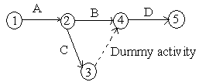
    - Event
An event represents a point in time signifying the completion of some activities and the beginning of new ones. This is usually represented by a circle in a network which is also called a node or connector.
The events are classified in to three categories
- Merge event – When more than one activity comes and joins an event such an event is known as merge event.
- Burst event – When more than one activity leaves an event such an event is known as burst event.
- Merge and Burst event – An activity may be merge and burst event at the same time as with respect to some activities it can be a merge event and with respect to some other activities it may be a burst event.
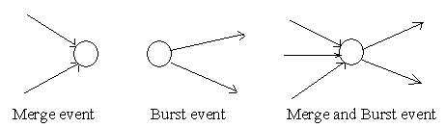
    - Sequencing
The first prerequisite in the development of network is to maintain the precedence relationships. In order to make a network, the following points should be taken into considerations
- What job or jobs precede it?
- What job or jobs could run concurrently?
- What job or jobs follow it?
- What controls the start and finish of a job?
Since all further calculations are based on the network, it is necessary that a network be drawn with full care.
  - Rules for Drawing Network Diagram
Rule 1
Each activity is represented by one and only one arrow in the network
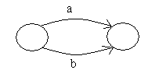

Rule 2
No two activities can be identified by the same end events
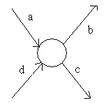
Rule 3
In order to ensure the correct precedence relationship in the arrow diagram, following questions must be checked whenever any activity is added to the network
- What activity must be completed immediately before this activity can start?
- What activities must follow this activity?
- What activities must occur simultaneously with this activity?
In case of large network, it is essential that certain good habits be practiced to draw an easy to follow network
- Try to avoid arrows which cross each other
- Use straight arrows
- Do not attempt to represent duration of activity by its arrow length
- Use arrows from left to right. Avoid mixing two directions, vertical and standing arrows may be used if necessary.
- Use dummies freely in rough draft but final network should not have any redundant dummies.
- The network has only one entry point called start event and one point of emergence called the end event.
The three types of errors are most commonly observed in drawing network diagrams
        - Dangling
To disconnect an activity before the completion of all activities in a network diagram is known as dangling. As shown in the figure activities (5 – 10) and (6 – 7) are not the last activities in the network. So the diagram is wrong and indicates the error of dangling
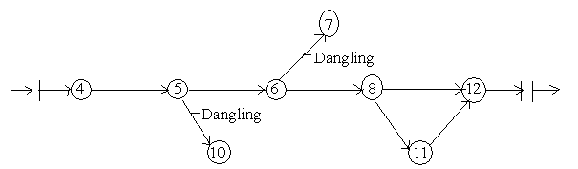
        - Looping or Cycling
Looping error is also known as cycling error in a network diagram. Drawing an endless loop in a network is known as error of looping as shown in the following figure.
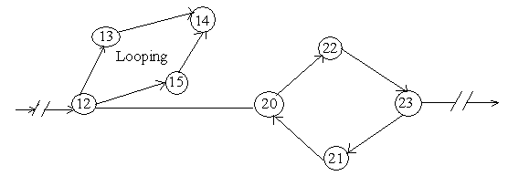
        - Redundancy
Unnecessarily inserting the dummy activity in network logic is known as the error of redundancy as shown in the following diagram
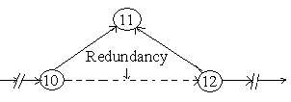
  - Program Evaluation Review Techniques and Critical Path Method
The methods are essentially network-oriented techniques using the same principle. PERT and CPM are basically time-oriented methods in the sense that they both lead to determination of a time schedule for the project. The significant difference between two approaches is that the time estimates for the different activities in CPM were assumed to be deterministic while in PERT these are described probabilistically. These techniques are referred as project scheduling techniques.
- In CPM activities are shown as a network of precedence relationships using activity-on-node network construction
- Single estimate of activity time
- Deterministic activity times
This method used in Production management: for the jobs of repetitive in nature where the activity time estimates can be predicted with considerable certainty due to the existence of past experience.
- In PERT activities are shown as a network of precedence relationships using activity-on-arrow network construction
- Multiple time estimates
- Probabilistic activity times
This method is used in project management: for non-repetitive jobs (research and development work), where the time and cost estimates tend to be quite uncertain. This technique uses probabilistic time estimates.
Benefits of PERT/CPM
- Useful at many stages of project management
- Mathematically simple
- Give critical path and slack time
- Provide project documentation
- Useful in monitoring costs
Limitations of PERT/CPM
- Clearly defined, independent and stable activities
- Specified precedence relationships
- Over emphasis on critical paths 7.6.
  - Applications of CPM / PERT: These methods have been applied to a wide variety of problems in industries and have found acceptance even in government organizations.
These include:
- Construction of a dam or a canal system in a region
- Construction of a building or highway
- Maintenance or overhaul of airplanes or oil refinery
- Space flight
- Cost control of a project using PERT / COST
- Designing a prototype of a machine
- Development of supersonic planes

7.6.1. The Framework for PERT and CPM
Essentially, there are six steps which are common to both the techniques. The procedure is listed below:
- Define the Project and all of its significant activities or tasks. The Project (made up of several tasks) should have only a single start activity and a single finish activity.
- Develop the relationships among the activities. Decide which activities must precede and which must follow others.
- Draw the "Network" connecting all the activities. Each Activity should have unique event numbers. Dummy arrows are used where required to avoid giving the same numbering to two activities.
- Assign time and/or cost estimates to each activity
- Compute the longest time path through the network. This is called the critical path.
- Use the Network to help plan, schedule, and monitor and control the project.
The Key Concept used by CPM/PERT is that a small set of activities, which make up the longest path through the activity network control the entire project. If these "critical" activities could be identified and assigned to responsible persons, management resources could be optimally used by concentrating on the few activities which determine the fate of the entire project.
Non-critical activities can be re-planned, rescheduled and resources for them can be reallocated flexibly, without affecting the whole project.
Five useful questions to ask when preparing an activity network are:
- Is this a Start Activity?
- Is this a Finish Activity?
- What Activity Precedes this?
- What Activity Follows this?
- What Activity is Concurrent with this?
    - Advantages and Disadvantages of CMP/PERT
- PERT/CPM has the following advantages
- A PERT/CPM chart explicitly defines and makes visible dependencies (precedence relationships) between the elements,
- PERT/CPM facilitates identification of the critical path and makes this visible,
- PERT/CPM facilitates identification of early start, late start, and slack for each activity,
- PERT/CPM provides for potentially reduced project duration due to better understanding of dependencies leading to improved overlapping of activities and tasks where feasible.
- PERT/CPM has the following disadvantages:
- There can be potentially hundreds or thousands of activities and individual dependency relationships,
- The network charts tend to be large and unwieldy requiring several pages to print and requiring special size paper,
- The lack of a timeframe on most PERT/CPM charts makes it harder to show status although colours can help (e.g., specific colour for completed nodes),
- When the PERT/CPM charts become unwieldy, they are no longer used to manage the project.
    - Critical Path in Network Analysis
      - Basic Scheduling Computations
The notations used are
(i, j) = Activity with tail event i and head event j
Ei = Earliest occurrence time of event i
Lj = Latest allowable occurrence time of event j
Dij = Estimated completion time of activity (i, j)
(Es)ij = Earliest starting time of activity (i, j)
(Ef)ij = Earliest finishing time of activity (i, j)
(Ls)ij = Latest starting time of activity (i, j)
(Lf)ij = Latest finishing time of activity (i, j)
The procedure is as follows
- Determination of Earliest time (Ej): Forward Pass computation
Step 1: The computation begins from the start node and move towards the end node. For easiness, the forward pass computation starts by assuming the earliest occurrence time of zero for the initial project event.
Step 2
- Earliest starting time of activity (i, j) is the earliest event time of the tail end event i.e. (Es)ij = Ei
- Earliest finish time of activity (i, j) is the earliest starting time + the activity time i.e. (Ef)ij = (Es)ij + Dij or (Ef)ij = Ei + Dij
- Earliest event time for event j is the maximum of the earliest finish times of all activities ending in to that event i.e. Ej = max [(Ef)ij for all immediate predecessor of (i, j)] or Ej =max [Ei + Dij]
- Backward Pass computation (for latest allowable time)
Step 1: For ending event assume E = L. Remember that all E’s have been computed by forward pass computations.
Step 2: Latest finish time for activity (i, j) is equal to the latest event time of event j i.e. (Lf)
ij = Lj
Step 3: Latest starting time of activity (i, j) = the latest completion time of (i, j) – the activity time or (Ls)ij =(Lf)ij - Dij or (Ls)ij = Lj - Dij
Step 4: Latest event time for event ‘i’ is the minimum of the latest start time of all activities originating from that event i.e. Li = min [(Ls)ij for all immediate successor of (i, j)] = min [(Lf)ij - Dij] = min [Lj - Dij]
- Determination of floats and slack times
There are three kinds of floats
Total float – The amount of time by which the completion of an activity could be delayed beyond the earliest expected completion time without affecting the overall project duration time.
Mathematically
(Tf)ij = (Latest start – Earliest start) for activity ( i – j)
(Tf)ij = (Ls)ij - (Es)ij or (Tf)ij = (Lj - Dij) - Ei
Free float – The time by which the completion of an activity can be delayed beyond the earliest finish time without affecting the earliest start of a subsequent activity.
Mathematically
(Ff)ij = (Earliest time for event j – Earliest time for event i) – Activity time for ( i, j)
(Ff)ij = (Ej - Ei) - Dij
Independent float – The amount of time by which the start of an activity can be delayed without effecting the earliest start time of any immediately following activities, assuming that the preceding activity has finished at its latest finish time.
Mathematically
(If)ij = (Ej - Li) - Dij
The negative independent float is always taken as zero.
Event slack - It is defined as the difference between the latest event and earliest event times.
Mathematically
Head event slack = Lj – Ej, Tail event slack = Li - Ei
- Determination of critical path
Critical event – The events with zero slack times are called critical events. In other words the event i is said to be critical if Ei = Li
Critical activity – The activities with zero total float are known as critical activities. In other words an activity is said to be critical if a delay in its start will cause a further delay in the completion date of the entire project.
Critical path – The sequence of critical activities in a network is called critical path. The critical path is the longest path in the network from the starting event to ending event and defines the minimum time required to complete the project.
Example1. Construct the network diagram for the following activity data:
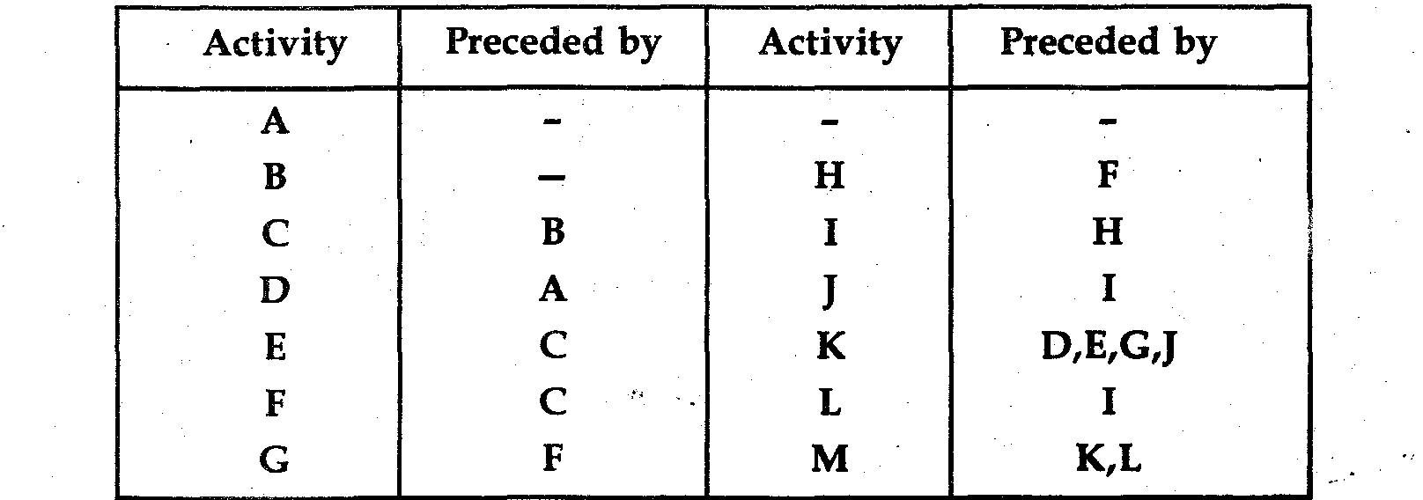
Solution Network:
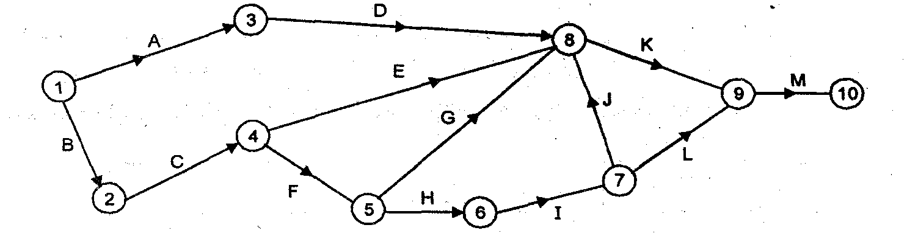
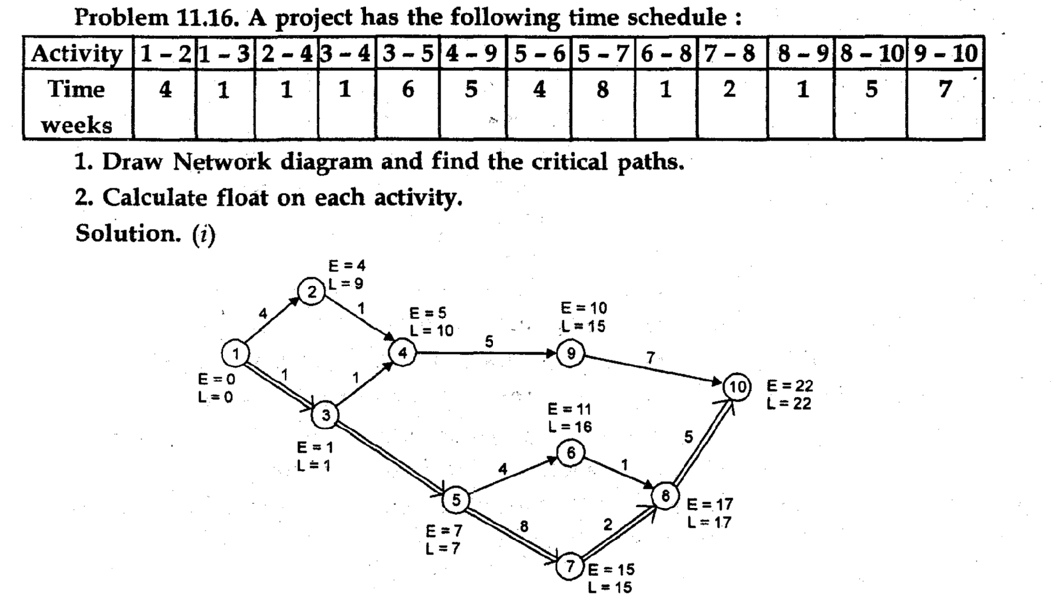
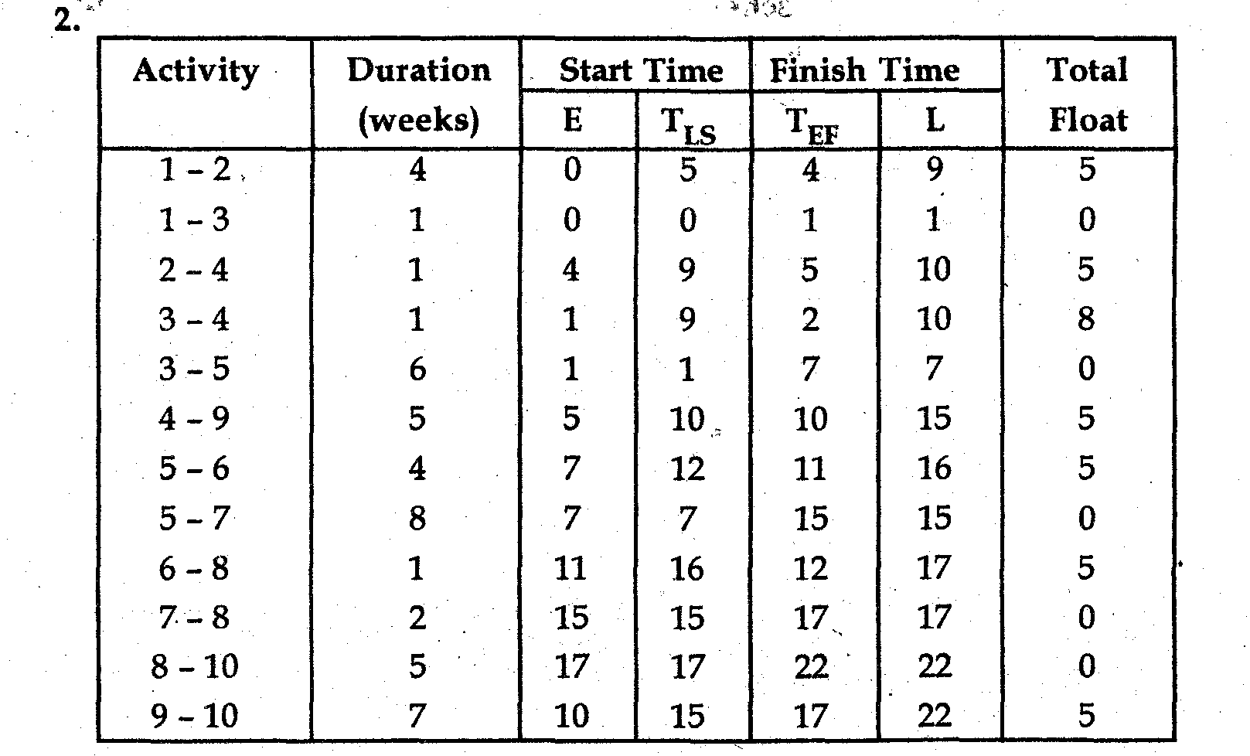
Critical path 1—3—5—7—8—10 with project duration of 22 weeks
    - Program Evaluation Review Technique
One of the shortcomings of CPM is the assumption that the durations of activities are deterministic, i.e., known with certainty. PERT assumes that the duration of each activity is a random variable with known mean and standard variation, and derives a Probability distribution for the project completion time.
Assumption of PERT
- the duration of an activity is a random variable with BETA distribution
- the durations of the activities are statistically independent
- the critical path (computed assuming expected values of the durations) always requires a longer total time than any other path
- The Central Limit Theorem can be applied so that the sum of the durations of the activities on the critical path has approximately a NORMAL distribution. The Beta distribution is un-modal with finite endpoints
  - a probability distribution traditionally used in CPM/PERT
Mean (expected time): t = a + 4m + b Where
6 a = optimistic estimate
m = most likely time estimate
b = pessimistic time estimate
Variance: $S^{2}$ = $\frac{{\left(b−a\right)}^{2}}{6}$
Standard Deviation S = ${\left(\frac{{\left(b−a\right)}^{2}}{6}\right)}^{1/2}$

P(time)
P(time)
P(time)
Time
a
m
t
b
a
m
t
b
m = t
Time
Time
b
a

Example1:
The time estimate for the activities of a PERT network are given below
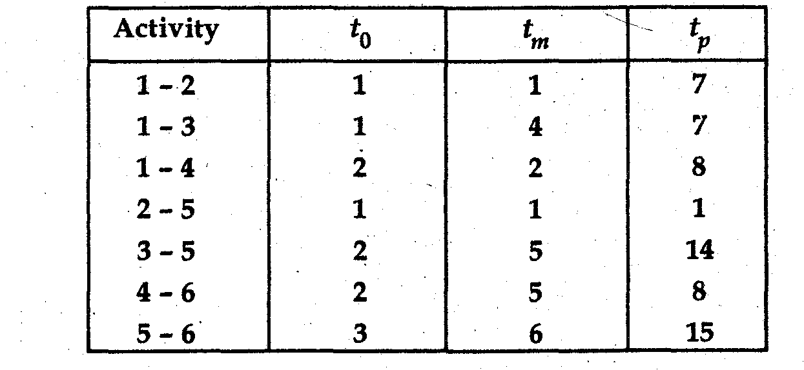
- Draw the project network and identify all paths through it.
- Determine the expected project length.
- Calculate the standard deviation and variance of the project length.
- What is the probability that the project will be completed?
- At least 4 weeks earlier than expected time.
- No more than 4 weeks later than expected time.
- The probability that the project will be completed on schedule if the schedule completion time is 20 weeks.
- What should be the scheduled completion time for the probability of completion to be 90%.
Solution
- Network
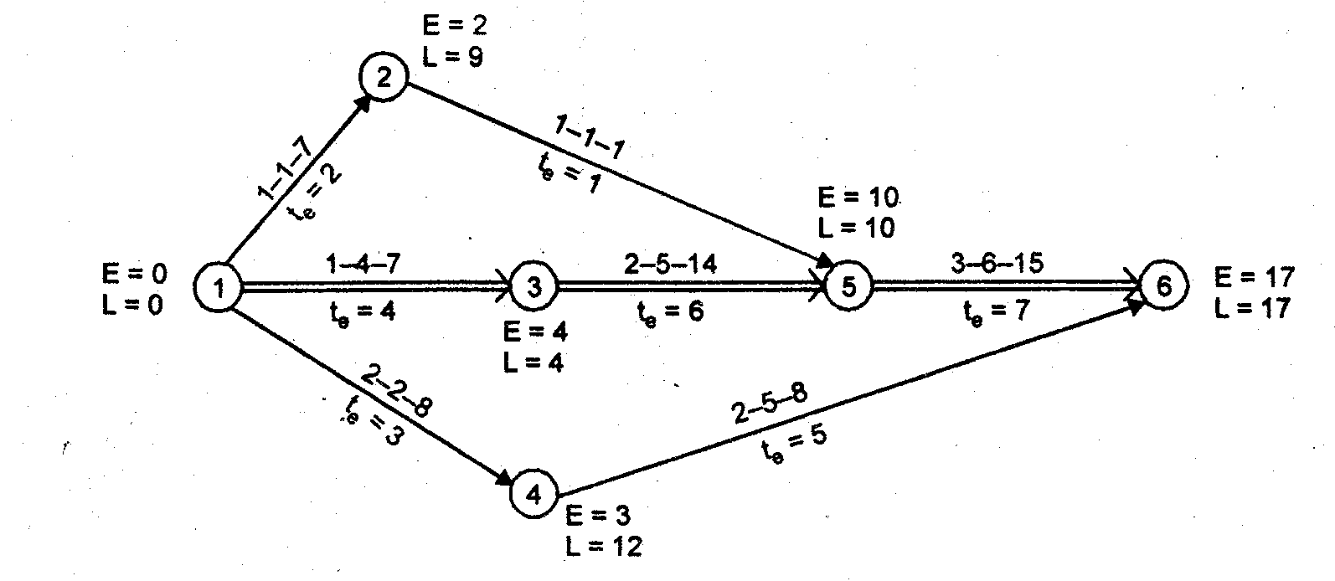
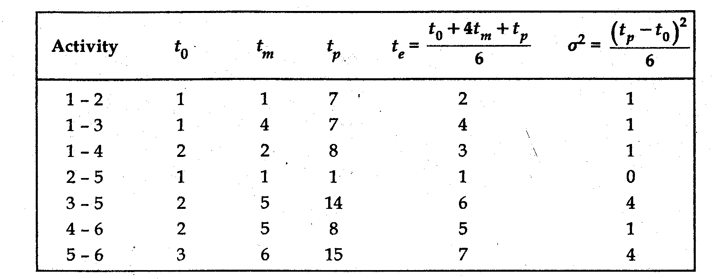
- Critical path—1 —3—5—6
Project duration = 17 weeks.
- Variance of the project length is the sum of the variance of the activities on the critical.
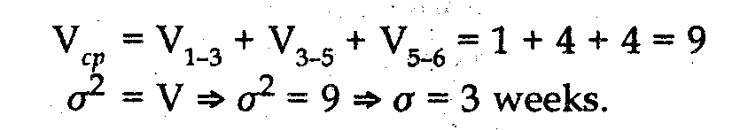
- I. Probability that the project will be completed at least 4 week earlier than expected time
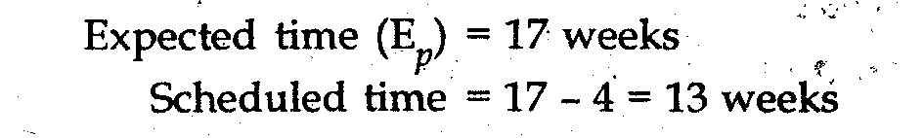
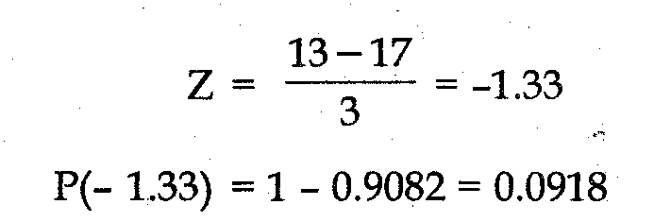
Therefore, the probability of finishing the project at least 4 week earlier than the expected time is 9.18%
- Probability that the project will be completed at least 4 weeks later than expected time
Expected time = 17 weeks
Scheduled time =17+ 4 =21 weeks
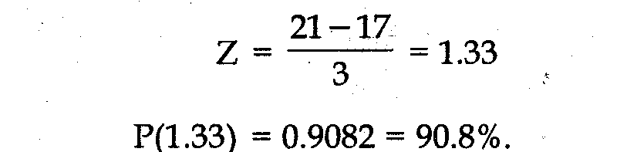
- Scheduled time = 20 weeks

F. Value of Z for P = 0.9 is 1.28 (from probability table)
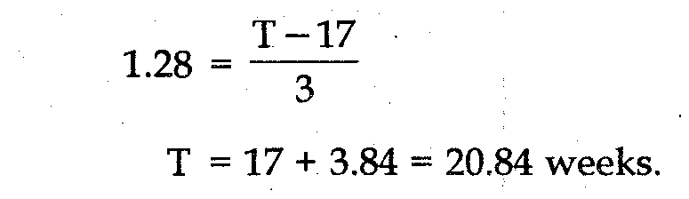
  - Project Crashing
CPM Model
The PERT model was developed for projects characterized by uncertainty and the CPM model was developed for projects which are relatively risk free. While both the approaches begin with the development of the network and a focus on the critical path, the PERT approach is probabilistic and the CPM approach is deterministic. This does not, however, mean that in CPM analysis we work with single time estimates. In fact, the principal focus of CPM analysis is on variables in activity times as a result of changes in resource assignments. These variables are planned and related to resource assignments and are not caused by random factors beyond the control of management as in the case of PERT analysis. The main thrust of CPM analysis is on time-cost relationships and it seeks to determine total cost.
Assumptions
The usual assumptions underlying CPM analysis are:
    - The costs associated with a project can be divided into two components: direct costs and indirect costs consist. Direct costs are incurred on direct material and direct labor. Indirect costs consist of overhead items like indirect supplies, rent, insurance, managerial service, etc.
    - Activities of the project can be expedited by crashing which involves employing more resources.
    - Crashing reduces time but enhances direct costs because of factors like overtime payments, extra payments, and wastage. The relationship between time and direct activity cost can reasonably be approximated by a downward sloping straight line
    - Crashing Procedure
Given the above assumptions, CPM analysis seeks to examine the consequences of crashing on total cost (direct and indirect costs). Since the behavior of indirect project cost is well defined, the bulk of CPM analysis is concerned with the relationship between total direct cost and project duration. The procedure used in this respect is generally as follows:
- Obtain the critical path in the normal network. Determine the project duration and direct cost.
- Examine the cost-time slope of activities on the critical path obtained and crash the activity which has the least slope.
- Construct the new critical path after crashing as per step
- Determine project duration and cost.
- Repeat steps II and III till activities on the critical path (which may change every time) are crashed.
Example1: The table given below shows all the cost-time information for the project i.e. Crash Cost, Normal Cost, Crash Time and Normal Time.
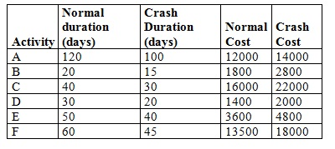
- Construct the network diagram that represents the given data.
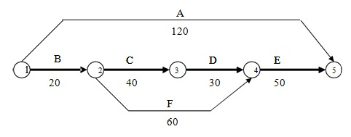
The network diagram above gives the normal durations for each activity to be completed under normal conditions without crashing.
Required: crash the project to complete within 110 days
Solution: First calculate the slopes of individual activities.
Slopes which show the crash cost per unit duration (days, weeks etc) for individual activities are calculated as:
Slope = (Crash Cost –Normal Cost) / (Normal Time-Crash Time)
Hence for individual activities this crash cost per unit duration comes out to be as below;
Activities | A | B | C | D | E | F
∆Cost | 2000 | 1000 | 6000 | 600 | 1,200 | 4500
∆Time | 20 | 5 | 10 | 10 | 10 | 15
Slope=∆cost/∆time | $100/day | $2000/day | $600/day | $60/day | $120/day | $300/day
  - Normal Cost of the Project: Normal cost of the project is the sum of normal costs of all the individual activities. In the given example the normal cost comes out to be $48,300.
  - Normal Duration of the Project: Normal duration of the project is the sum of the durations of all the individual activities on critical path. The normal duration of the given project under normal conditions is 140 days.

Solution:

Step 1: The only critical activity with the least crash cost per day is D. So we will crash it first. Before crashing make sure that:
- Firstly, the activity should not be crashed more than the allowed crash time limit
- Secondly, the activity should be crashed by duration such that it does not make the overall project duration lesser than any other path. It might create other critical paths but the activity should itself always remain on the critical path.
Crashing D by 10 days results as shown below;
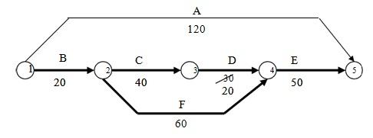
Crashing D by 10 days
Overall project duration is now reduced to 130 days and there are two critical paths now (B→F→E and B→C→D→E).
Total Project Cost is now Normal Cost $48,300 plus crash cost of D for 10 days (60 * 10 = $600). Thus, making a total of $48,900

Step 2: The next activity to be crashed would be the activity E, since it has the least crash-cost per day (slope) i.e. $120 of any of the activities on the two critical paths. Activity E can be crashed by a total of 10 days. Crashing the activity E by 10 days will cost an additional (120×10) = $1200.
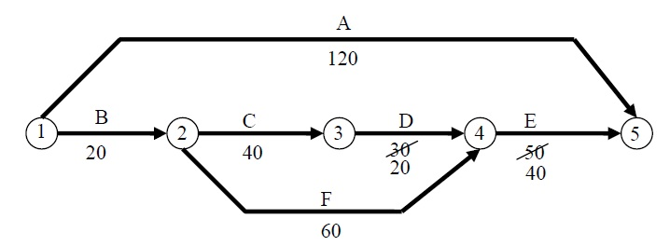
Crashing E by 10 Days
The total cost is now $(48,900+1200) = $50,100
Total duration is 120 days
There three critical paths in total i.e., (A, B→C→D→E and B→F→E)

Step 3 -This step involves crashing on multiple critical paths

This step involves a more thorough analysis of the available crashing options and selecting the most feasible one. To achieve an overall reduction in the project duration, multiple activities must be crashed. The following options are available:
Option 1: Crash A and B each by 5 days having total crash cost of $300/day
Option 2: Crash A, C & F each by 10 days having crash cost of $1000/day
The feasible one is obviously option 1 hence, A and B are crashed by 5 days.
Each costing ( 5×300) = $1500
Total project cost is now = $50,100 + $1500 = $51,600
Total project duration = 115 days
Critical paths are still the same three.
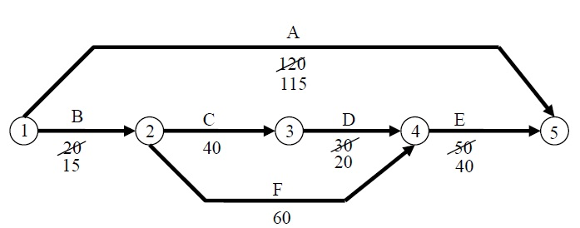
Crashing Multiple Critical Paths

Final Step in crashing: The final step in this example is to crash the schedule by 5 more days. For this step the available options are very limited. As we go further with crashing the crash cost per day increases. The only available crashing options are A, C and F all by 5 days because all other activities have met their maximum crashing limits and they cannot be crashed any more.

The total crashing cost for 5 days of A, C and F is calculated to be 5 x 1000 = $5,000
The total cost of the project to completed in 110 days comes out to be = $56,600
And the final network diagram appears to be as follows:
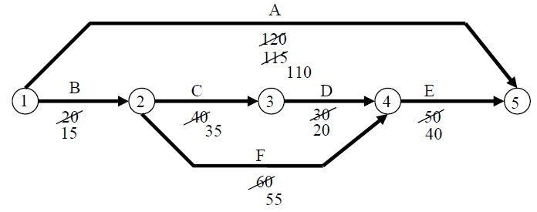
Final Step in Crashing
For example2: The following table gives the activities in a construction project and other relevant information.
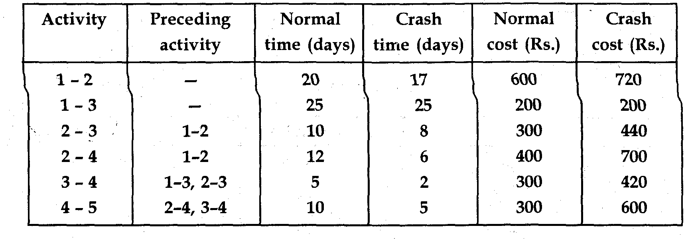
Required:
- Draw activity network of the project.
- Find total float and free float of each activity.
- Using the above information “Crash” or shorten the activity step by step until the shortest duration is reached.
Solution
- Activity Network.
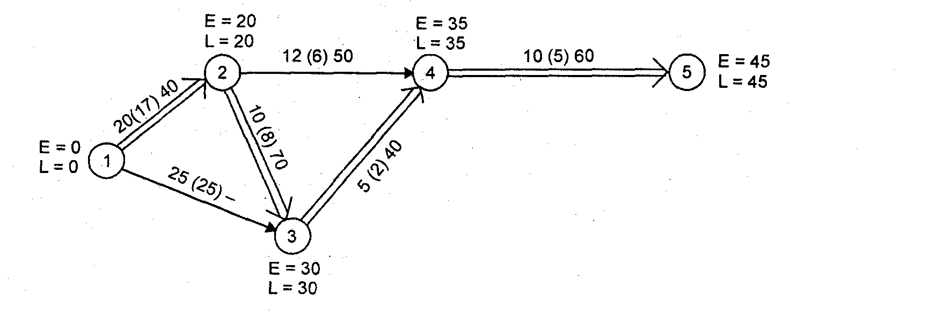

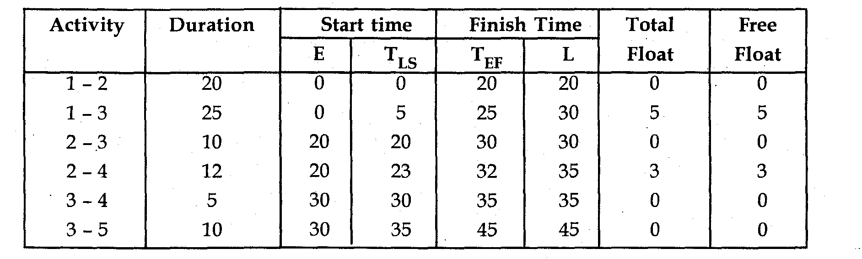
Free float = Total float - Head event slack.
Critical path 1---2---3---4---3---5
- Crashing
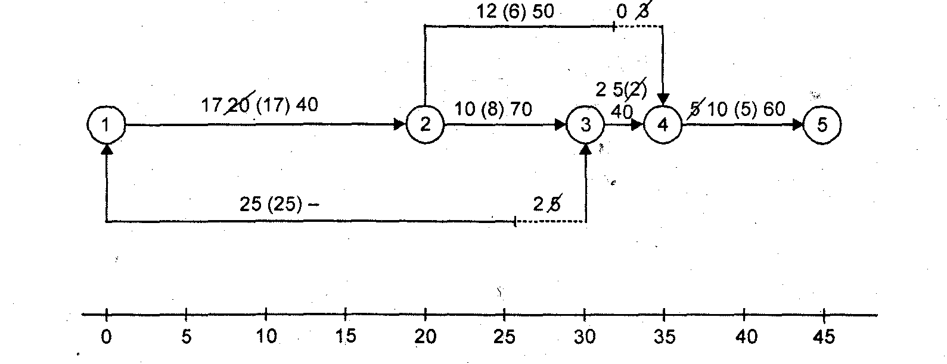
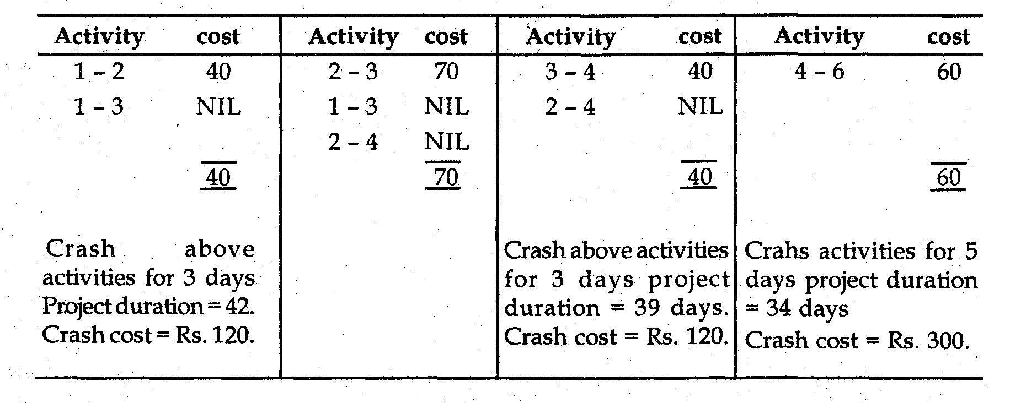
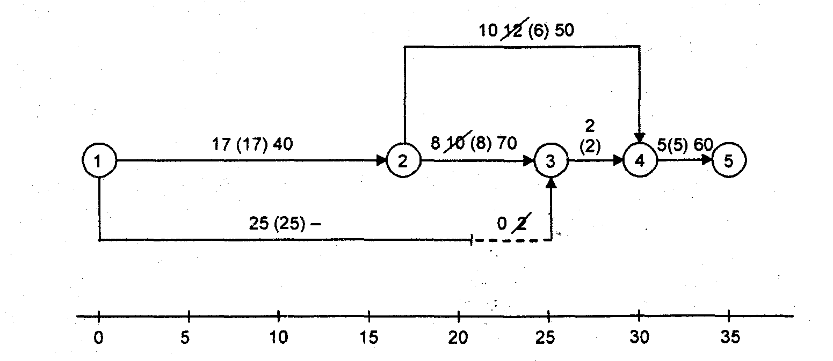
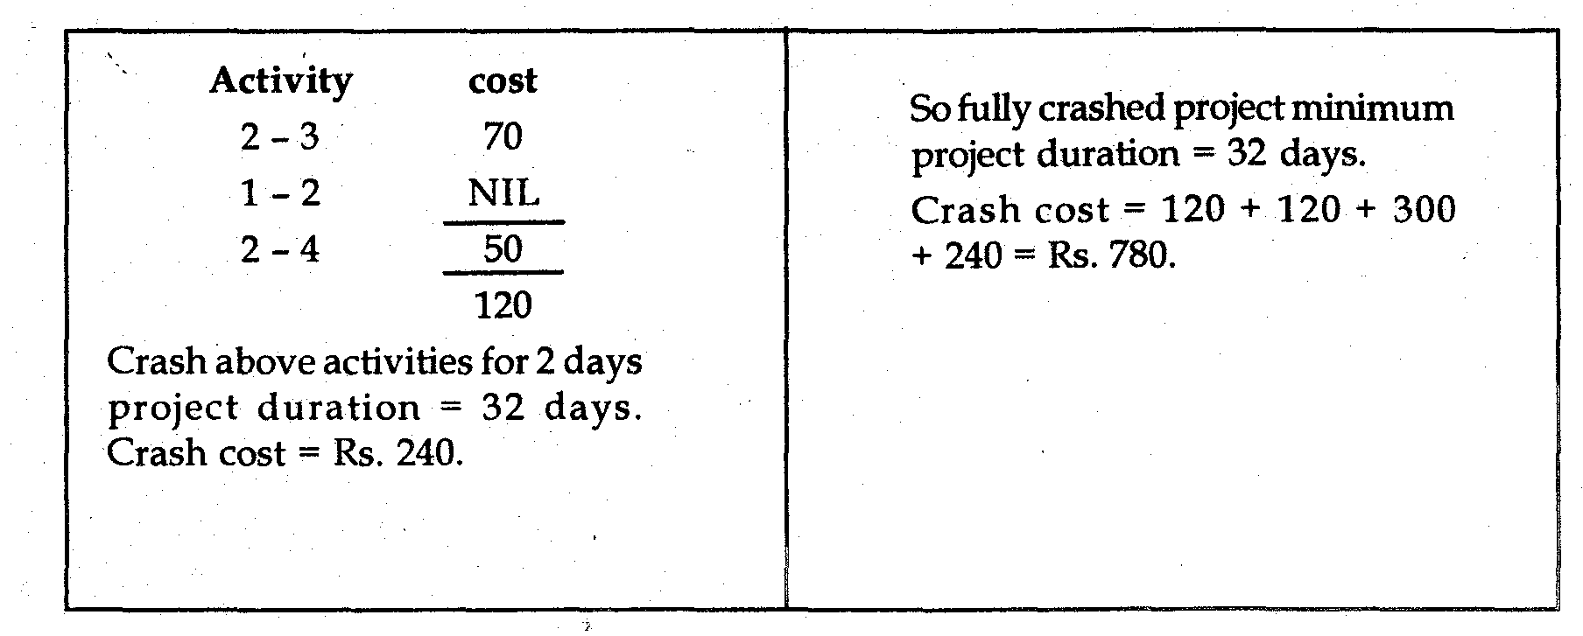
Example 3: The activities of a project are tabulated below with immediate predecessors and normal and crash time cost.
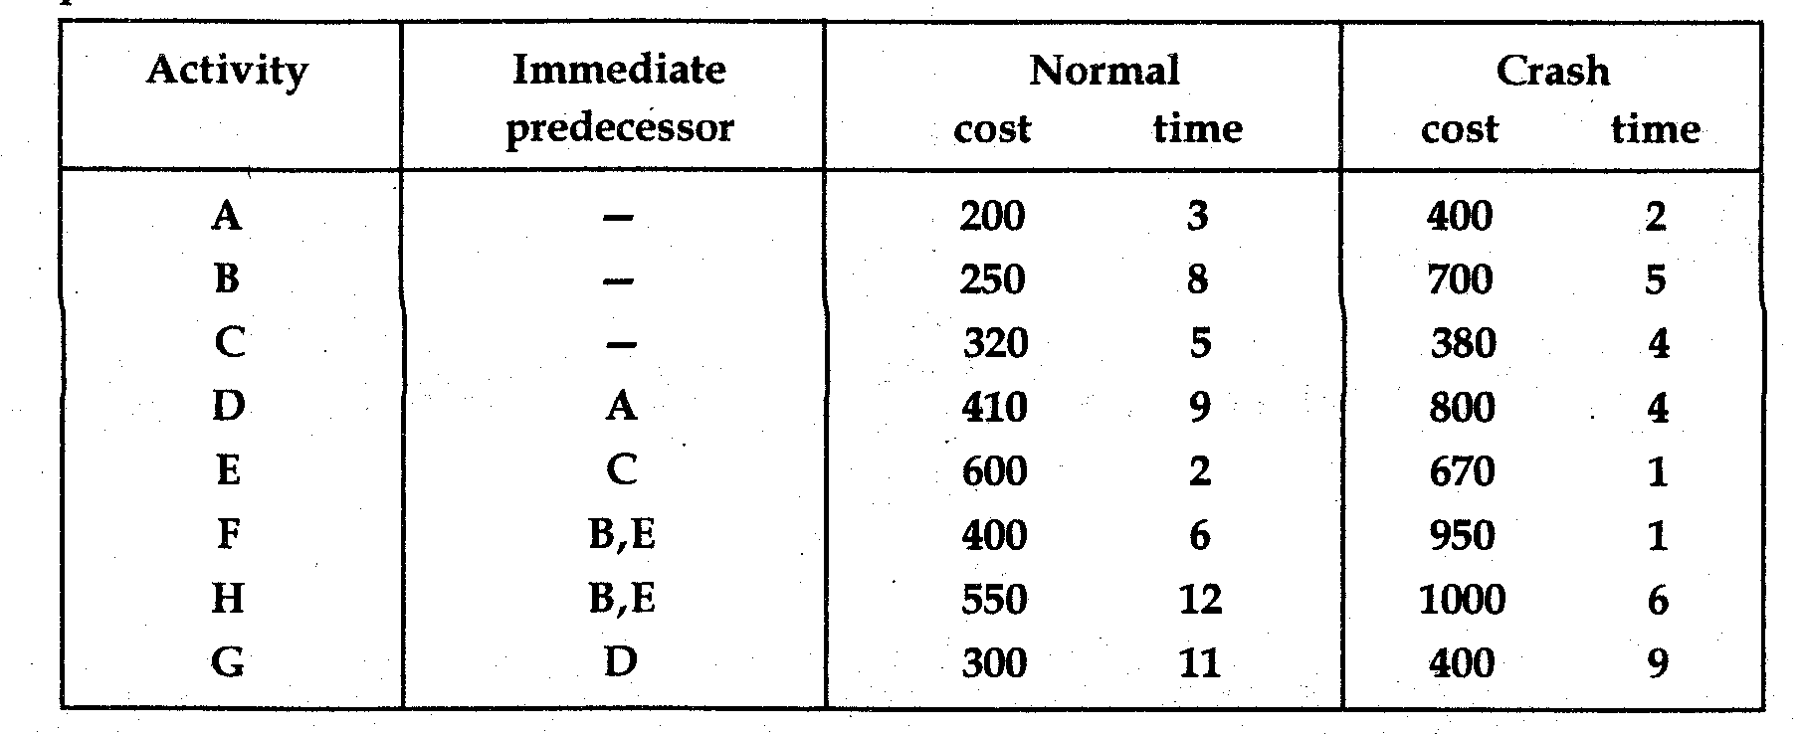
- Draw the network corresponding to normal time
- Determine the critical path and normal duration and cost of project, if the indirect cost per day is Rs. 8.
- Suitably reduce the activities so that the normal duration may be reduced by 2 days at minimum cost also find the project cost for this shortened duration.
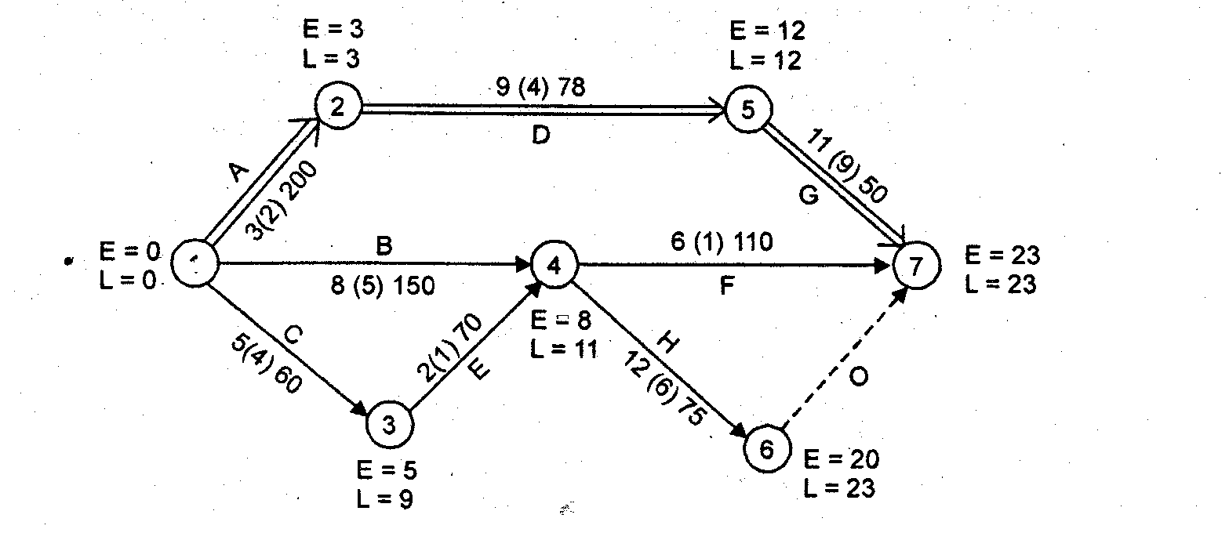
Solution

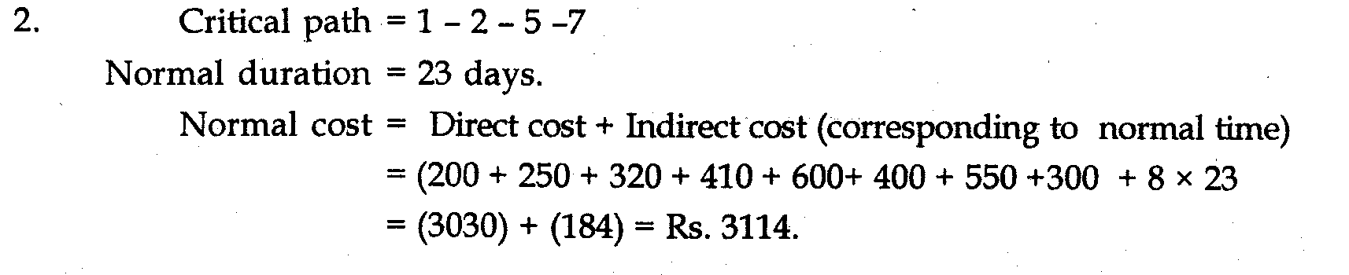
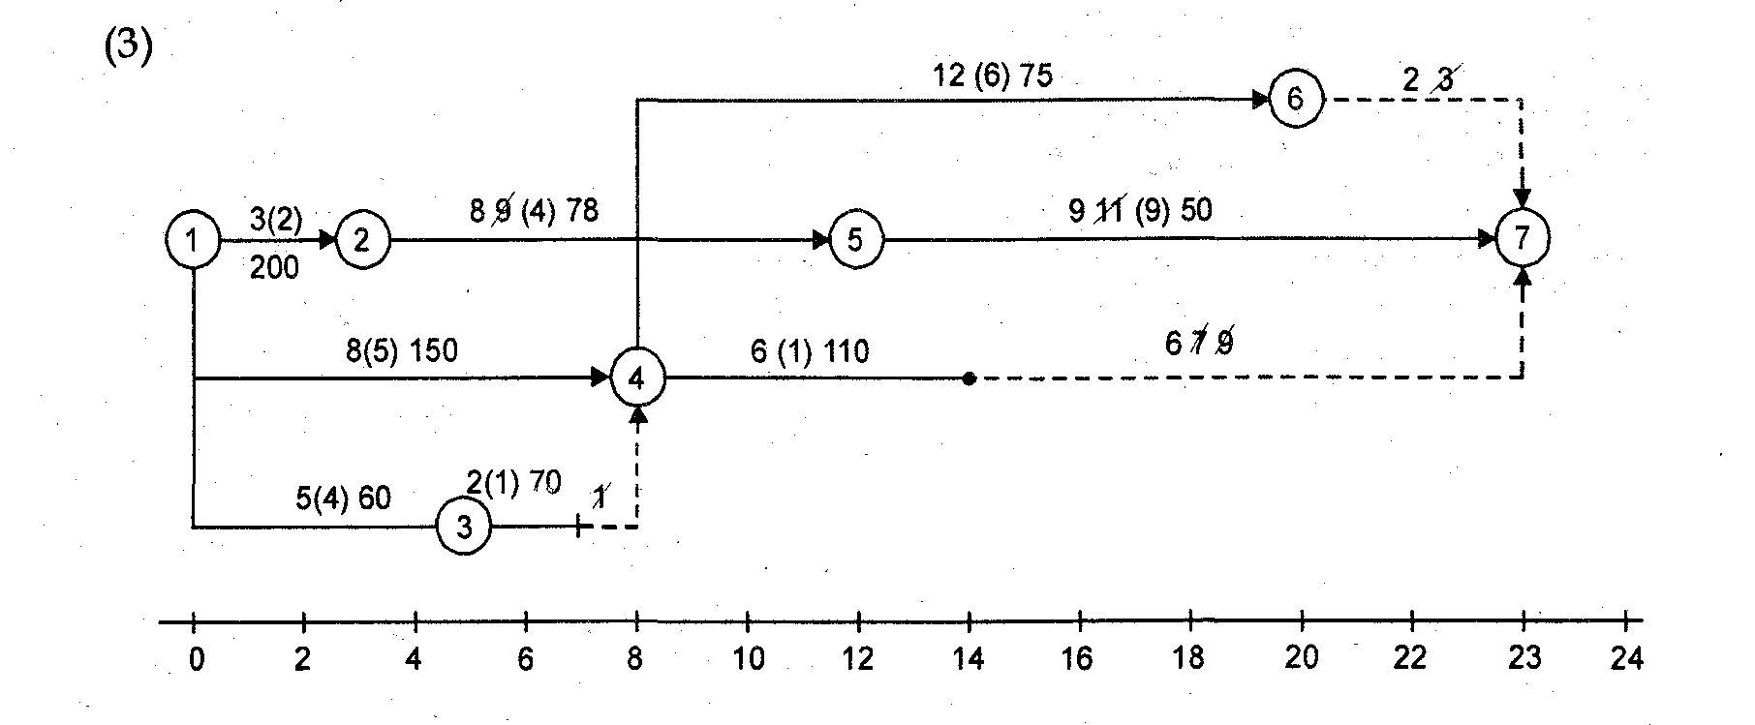
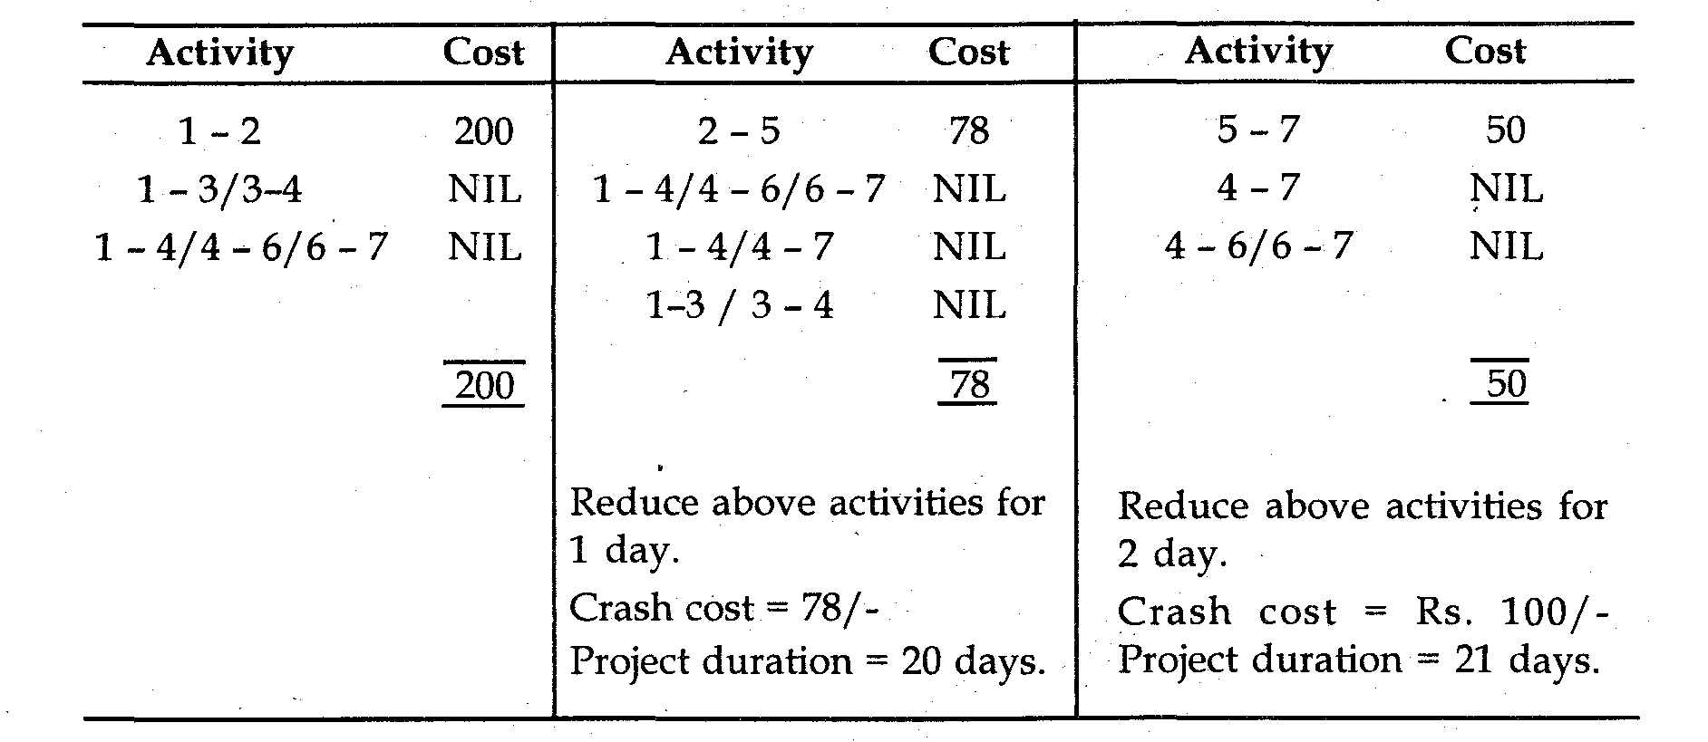
Total project cost for reducing 3 days duration.
= Direct cost + indirect cost + crash cost
= 3030 + 160 + 178 = Rs. 3368.
Example 4: Consider the PERT network given below and determine the float of each activity and identify the critical path if the scheduled completion time for the project is 20 weeks.
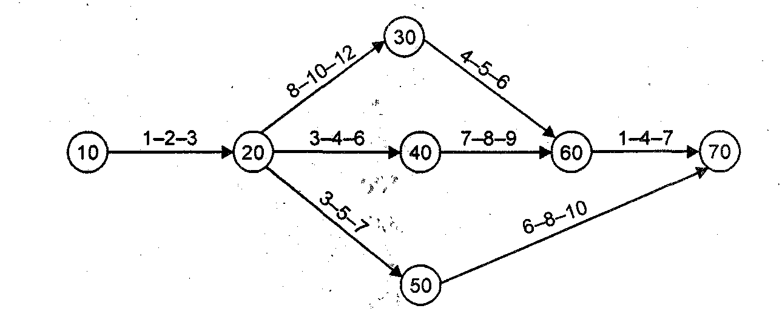
Solution
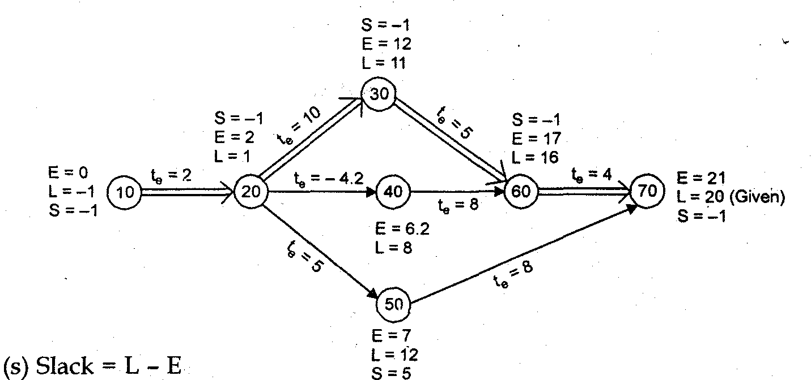
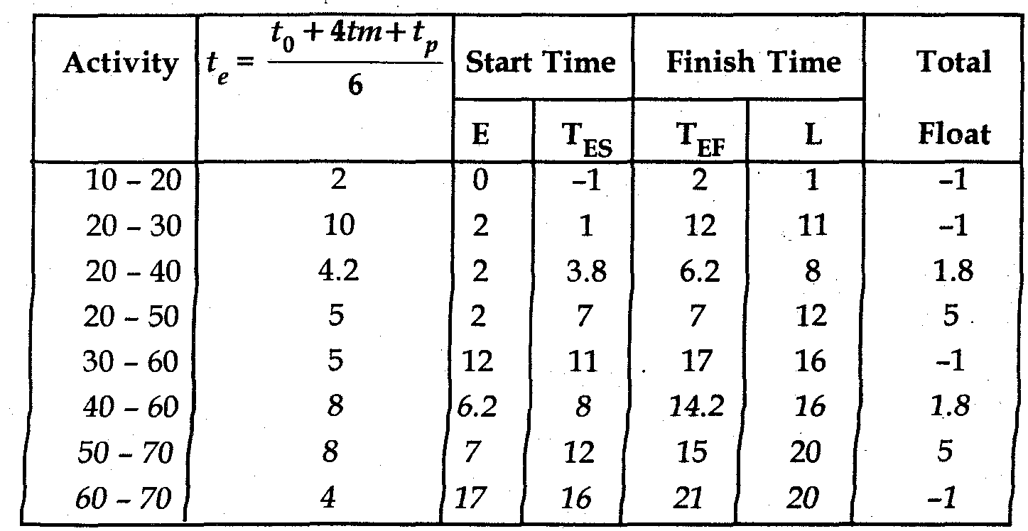
Critical path 10 - 20- 30 - 60 — 70
Example 4: Table below show jobs, their normal time and cost estimates for cost and crash time the project.
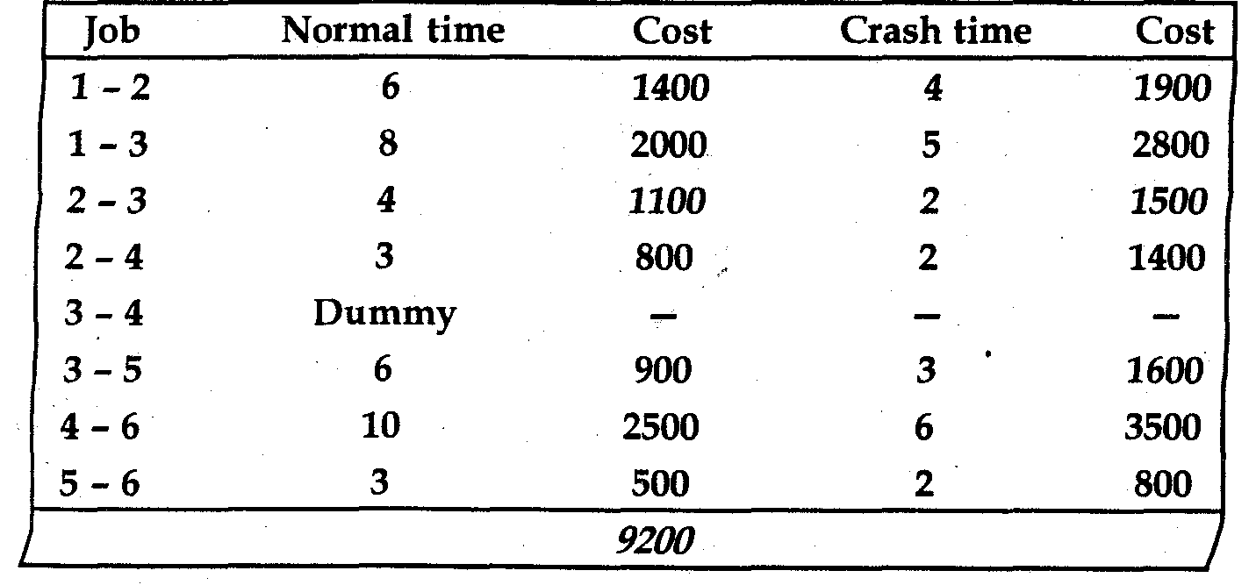
Indirect cost for the project is Rs. 300 per day.
- Draw the network of the project.
- What is normal duration and cost of the project’
- If all activities are crashed, what will be the minimum project duration and corresponding cost?
- Find the optimum duration and minimum project cost

Solution (A):
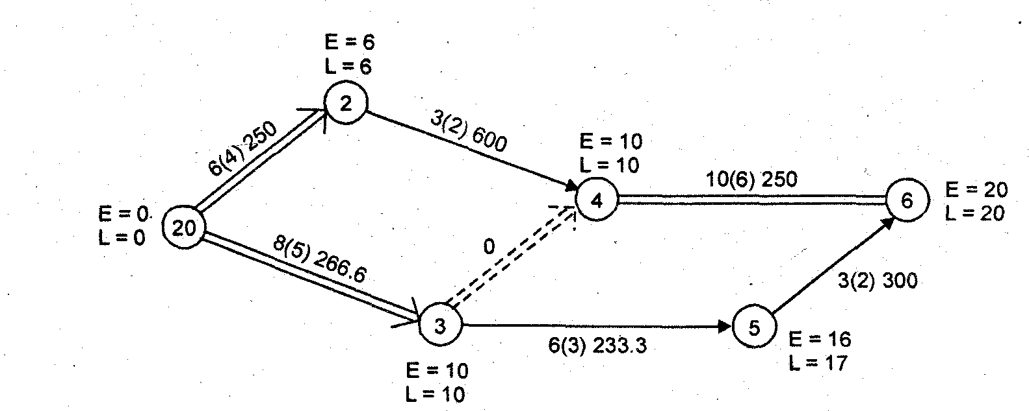
(B). Critical path I — 2— 3 — 4 — 6
Normal duration of project = 20 days
Normal cost of project = Rs 9200.
(C) Crashing
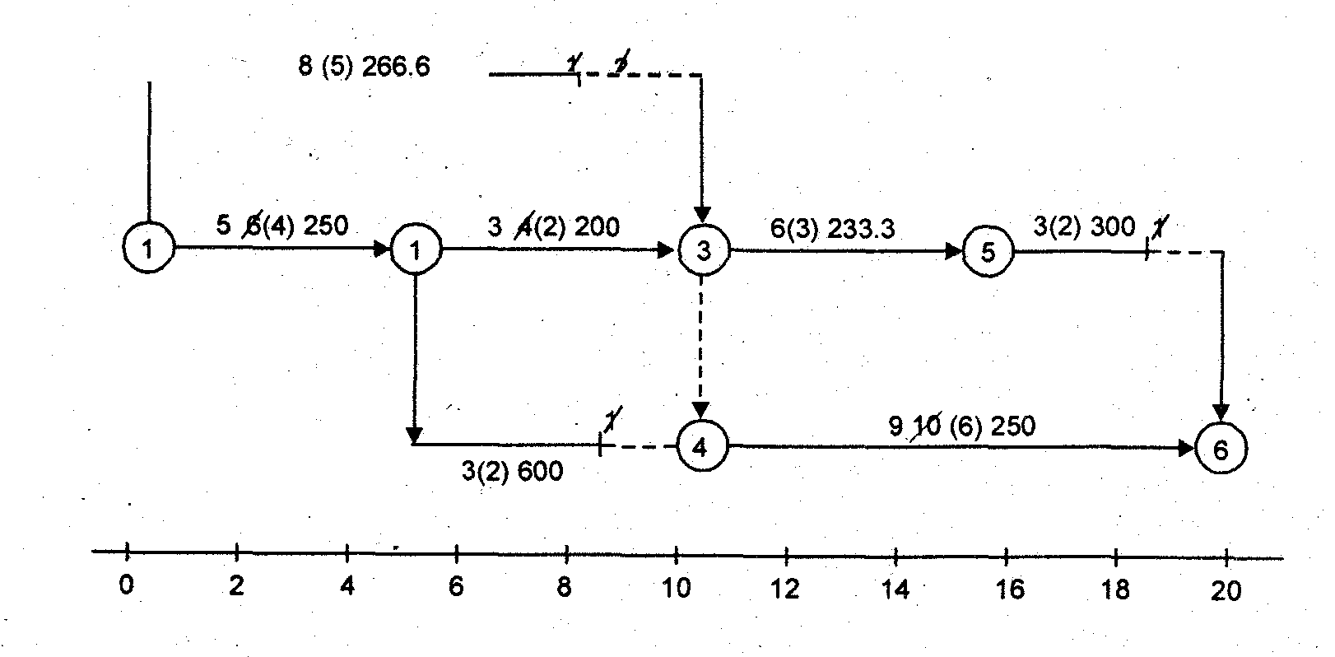
Crash following activities one day
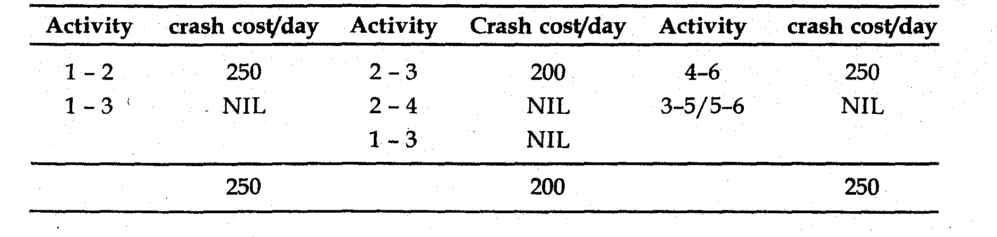
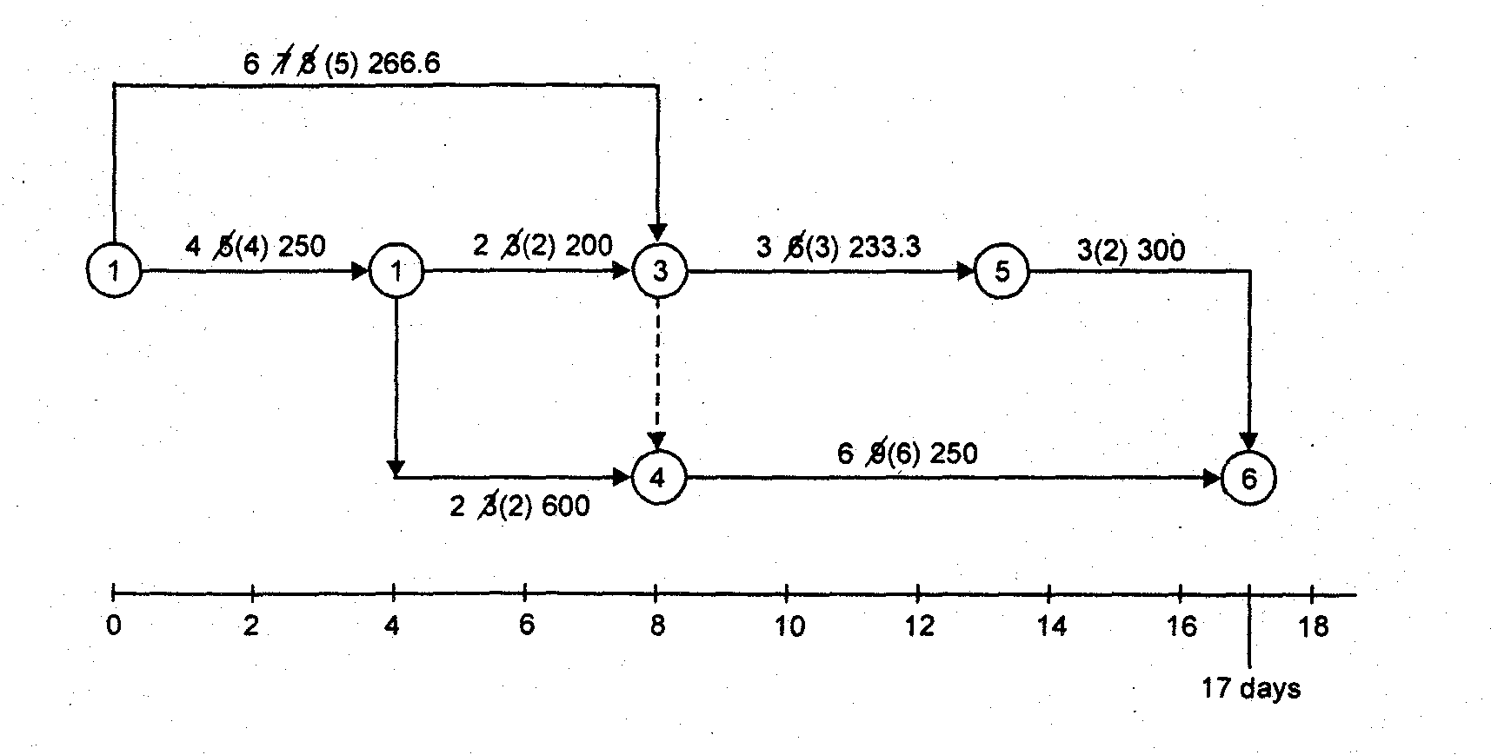
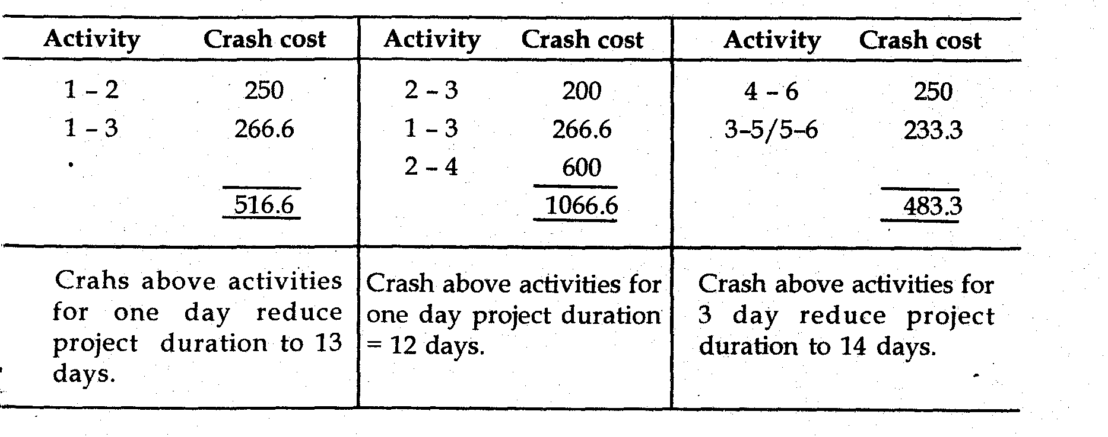
(D). Minimum project duration is 12 days
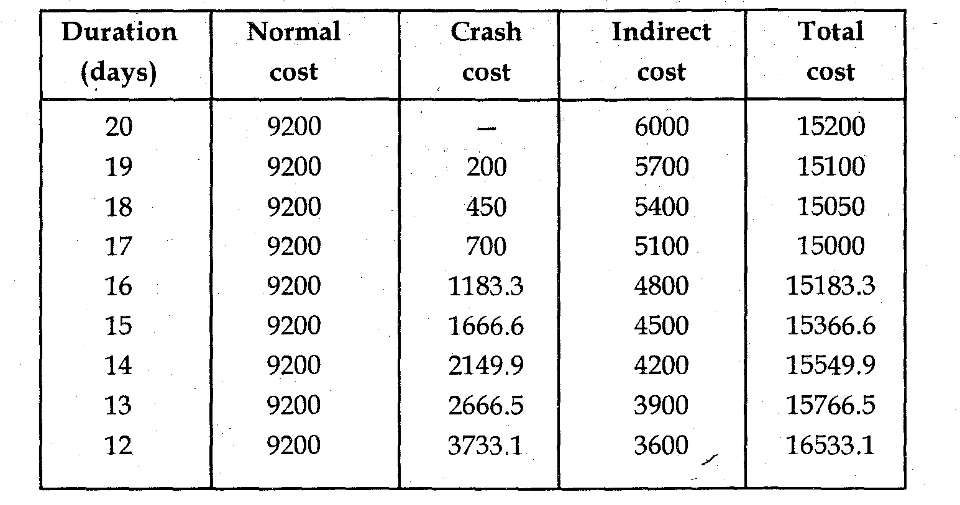
Cost corresponding to minimum project duration 16533.1
Minimum cost of project 15000
Optimum duration = 12 days
Part I: Multiple Choice Questions

      - CPM is:
        - Activity oriented (CPM network is built on the basis of activities)
        - A deterministic model
        - places dual emphasis on project time as well as cost and finds the trade-off between project time and project cost
        - primarily used for projects which are repetitive in nature and comparatively small in size
        - All F. None
      - PERT is:
- Event oriented.
- A probabilistic model.
- Primarily concerned with time only.
- Used for large one time research and development type of projects
- All F. None
      - _____is the minimum time by which the project may be completed.
- Crashed project time C. Normal cost time E. All
- Optimal project time D. Normal time F. None
      - The time corresponding to minimum project cost for completion of the project is known as________.
- Crashed project time C. Normal cost time E. All
- Optimal project time D. Normal time F. None
      - ____________ is the cost associated when the project completed with normal time.
- Crashed project time C. Normal cost E. All
- Optimal project time D. Normal time F. None
      - The cost associated when the project completed with crash time is known as _______.
- Crashed project time C. Crashed cost E. Indirect cost G. All
- Allowable crash time D. Normal cost F. Direct cost H. None
- Critical path is the path containing;
- Critical Activities D. An activity with positive delayed of the whole project
- Zero Float E. A and B
- Noncritical Activities F. C and D G. ALL H. None
- An activity which only determines the dependency of one activity on the other, but does not consume any time is called;
- Dangling C. Dummy E. All
- Looping D. Event F. None
- The disconnection of an activity before the completion of all the activities in a network diagram is known as;
- Dangling C. Dummy E. All
- Looping D. Event F. None
- The beginning and end points of an activity are called;
- Events C. Dangling E. A and B
- Nodes D. Activity F. All G. None
- ________ is physically identifiable part of a project which requires time and resources for its execution.
- Dummy C. activity E. Event G. All
- Activity D. Project F. Budget H. None
- The deliberate reduction of activity normal time by puffing an extra effort is called;
- Crashing of project C. Extension of project E. A and B
- Duration of project D. Broking of project F. A and C G. A and D
- Activities that must be completed immediately prior to the start of another activity are called;
- Predecessor activities C. Concurrent activity
- Successor activity D. None
- Activities that cannot be started until one or more of other activities are completed but immediately succeed them are called:
- Successor activities B. Predecessor activities C. Concurrent activities D. None
- Activities which can be accomplished concurrently are known as:
- Concurrent activities C. Successor activities
- Predecessor activities D. All E. None
- One of the following is not a rule of drawing network diagram. Which one?
- Each activity is represented by one and only one arrow in the network
- No two activities can be identified by the same end events
- Use arrows from left to right
- Numbering of nodes should from left to right and top to down
- Use dummies freely in rough draft but final network should not have any redundant dummies. F. All G. None
- One of the following does not shows Benefit of PERT or and CPM:
- Useful at many stages of project management D. Provide project documentation
- Mathematically simple E. Useful in monitoring costs
- Give critical path and slack time F. All G. None
- Limitations of PERT and or CPM is
- Clearly defined, independent and stable activities
- Specified precedence relationships
- Over emphasis on critical paths D. All E. None
- Which is true?
- Costs associated with a project can be divided into two components (direct costs and indirect costs)
- Direct costs are incurred on direct material and direct labor
- Indirect costs consist of overhead items like indirect supplies, rent, insurance, managerial service
- Crashing project reduces time and cost
- The relationship between time and cost is inversely in project crashing
- All G. None
- To crash a project, first we have to;
- Obtain the critical path in the normal network diagram
- Determine the project duration and direct cost
- Determine allowable crash time of each activity
- Examine the cost-time slope of activities on the critical path obtained
- Construct the new critical path after crashing
- All except C G. All except E H. None

Part II: Essay Questions
    - Define what critical path and critical activities mean.
    - Differentiate between slack and float
    - Enlist four types of floats used in network analysis.
    - What do you mean by dummy activity?
    - Define dangling and looping in net-work models.
    - Differentiate between event and activity.
Part II: WORKOUT PROBLEMS
      - The following table gives the activities in a construction project and other relevant information.
- Draw activity network of the project.
- Find total float and free float of each activity.
- Using the above information “Crash” or shorten the activity step by step until the shortest duration is reached.

Part I: Multiple Choices Answers
1. E 2. E 3. A 4. B 5. D
6. C 7. E 8. C 9. A 10. E
11. B 12. A 13. A 14. A 15. A
16. G 17. G 18. D 19. D 20. G
PART II: Answers to the Workout Questions

Free float = Total float - Head event slack. Critical path 1→ 2→ 3→ 4→5
- Crashing
CHAPTER SIX
GAME THEORY

Game Theory - An Overview
Competition can be an important decision-making factor. The strategies taken by other organizations or individuals can dramatically affect the outcome of our decisions. Today, business cannot make important decisions without considering what other organizations or individuals are doing or might do. For example, in an automobile industry the strategies of competitors to introduce certain models with certain features can dramatically affect the profitability of other carmakers.
6.1. Definitions of Game Theory
Game theory is one way to consider the impact of the strategies of others on our strategies and outcomes. A game is a contest involving two or more decision makers, each of whom wants to win. Game theory is the study of how optimal strategies are formulated in conflict.
The study of game theory dates back to 1944, when John von Neumann and Oscar Morgenstern published their classic book, Theory of Games and Economic Behavior. Since then, game theory has been used by army generals to plan war strategies, by union negotiators and managers in collective bargaining, and by businesses of all types to determine the best strategies given a competitive business environment.
Game theory continues to be important today. In 1994, John Harsanui, John Nash, and Reinhard Selten jointly received the Nobel Prize in Economics from the Royal Swedish Academy of Sciences. In their classic work, these individuals developed the notion of non-cooperative game theory. After the work of John von Neumann, Nash developed the concepts of the Nash equilibrium and the Nash bargaining problem, which are the cornerstones of modern game theory.
Game models are classified by the number of players, the sum of all payoffs, and the number of strategies employed. Due to the mathematical complexity of game theory, we limit the analysis in this module to games that are two person and zero sum.
A two-person game is one in which only two parties can play as in the case of a union and a company in a bargaining session. For simplicity, X and Y represent the two game players. Zero sum means that the sum of losses for one player must equal the sum of gains for the other player. Thus, if X wins 20 points or dollars, Y loses 20 points or dollars. With any zero-sum game, the sum of the gains for one player is always equal to the sum of the losses for the other player. When you sum the gains and losses for both players, the result is zero hence the name zero-sum games. For example, in football match one team wins and the other losses.
A game is non-zero sum if players’ interests are not always in direct conflict, so that there are opportunities for both to gain. For example, when both players choose do not confess in prisoners’ dilemma, they both gain relative to both choosing confess.

Assumptions of Game Theories
- Payoffs are known and fixed. People treat expected payoffs the same as certain payoffs (they are risk neutral).
- Example, a risk neutral person is indifferent between $25 for certain or a 25% chance of earning $100 and a 75% of earning $0.
- We can relax this assumption to capture risk averse behaviour.
- All players behave rationally
- They understand and seek to maximize their own payoffs
- They are flawless in calculating which actions will maximize their payoffs
- The rules of the game are common knowledge.
- Each player knows the set of players, strategies and payoffs from all possible contributions of strategies: call this information ‘X’
- Common knowledge means that each player knows that all players know that all players know that all players know ‘X’ and so on…ad infinitum.

Language of Games
To introduce the notation used in game theory, let us consider a simple game. Suppose there are only two lighting fixture stores, X and Y, in Urbana, Illinois. (This is called a duopoly.) The respective market shares have been stable up until now, but the situation may change. The daughter of the owner of store X has just completed her MBA and has developed two distinct advertising strategies, one using radio spots and the other newspaper ads. Upon hearing this, the owner of store Y also proceeds to prepare radio and newspaper ads.
The 2 x 2 payoff matrix given in table below shows what will happen to current market shares if both stores begin advertising. By convention, payoffs are shown only for the first game player, X in this case. Y’s payoffs will just be the negative of each number. For this game, there are only two strategies being used by each player. If store Y had a third strategy, we would be dealing with a 2 x 3 payoff matrix.
Store X’s Payoff Matrix
Game Player Y’s Strategies
Y₁ Y₂
(Use Radio) (Use newspaper)
Game player X₁ (Use Radio) 3 5
X’s strategy X₂ (Use newspaper) 1 -2

A positive number in the above table means that X wins and Y loses. A negative number means that Y wins and X loses. It is obvious from the table that the game favours competitor X, since all values are positive except one. If the game had favoured player Y, the values in the table would have been negative. In other words, the game is biased against Y. However, since Y must play the game, he or she will play to minimize total losses. To do this, Player Y would use the minimax criterion which is our next topic.
Game Outcomes

Store X’s Store Y’s Outcome (% Change
Strategy Strategy in Market Share)
X₁ (use radio) Y₁ (use radio) X wins 3and Y loses 3
X₁ (use radio) Y₂ (use newspaper) X wins 5and Y loses 5
X₂ (use newspaper) Y₁ (use radio) X wins 1 and Y loses 1
X² (use newspaper) Y₂ (use newspaper) X loses 2 and Y wins 2

For two-person, zero-sum games, there is a logical approach to finding the solution: In a zero sum game, each person should choose the strategy that minimizes the maximum loss, called the minimax criterion. This is identical to maximizing one’s minimum gains, so for one player, this could be called the maximin criterion.
Let us use the example at hand to illustrate the minimax criterion. This is a two person zero-sum game with the strategies for player Y given as the columns of the table. The values are gains for player X and losses for player Y. Player Y is looking at a maximum loss of 3 if strategy Y₁ is selected and a maximum loss of 5 if strategy Y₂ is selected. Thus, Player Y should select strategy Y₁, which results in a maximum loss of 3 (the minimum of the maximum possible losses). This is called the upper value of the game.
In considering the maximin strategy for player X (whose strategies correspond to the rows of the table), let us look at the minimum payoff for each row. The payoffs are +3 for strategy X₁ and -2 for strategy X_{2.} The maximum of these minimums is +3, which means strategy X₁, will be selected. This value (+3) is called the lower value of the game. If the upper and lower values of a game are the same, this number is called the value of the game, and equilibrium or saddle point condition exists.
Minimax Solution
Saddle point

Game player Y’s Strategy
Y1 Y2
(Use radio) (Use newspaper)
Gameplayer
X’s Minimum
Strategies
X1 (Use radio) 3 5 3

X2 (Use newspaper) 1 -2 -2 Max of mini
Maximum 3 5

Mini of Max
The value of the game is 3 because this is the value for both the upper and lower values. The value of the game is the average or expected game outcome if the game is played an infinite number of times. In implementing the minimax strategy, player Y will find the maximum value in each column and select the minimum of these maximums. In implementing the maximin strategy, player X will find the minimum value in each row and select the maximum of these minimums. When a saddle point is present, this approach will result in pure strategies for each player. Otherwise, the solution to the game will involve mixed strategies. These concepts are discussed in the following sections.

Pure strategy
When a saddle point is present, the strategy each player should follow will always be the same regardless of the other player’s strategy. This is called a pure strategy. A saddle point is a situation in which both players are facing pure strategies.
Using minimax criterion, we saw that the game in the table had a saddle point and thus is an example of a pure strategy game. It is beneficial for player X and for player Y to always choose one strategy. Simple logic would lead us to this same conclusion. Player X will always select X₁, since the payoffs for X₁are better than the payoffs for X2, regardless of what player Y does. Knowing that player X will select X₁, player Y will always select strategy Y₁and only lose 3 rather than 5. Note that the saddle point in this example, 3, is the largest number in its column and the smallest number in its row. This is true of all saddle points.
Example 2 of a Pure Strategy Game;
Game Player Y’s Strategies
Y1 Y2
Game player X1 10 6
X’s strategy X2 -12 2

Given the above information:

- Determine the optimal strategy
- Optimal strategy of X
- Optimal strategy of Y
- The game value
- Determine whether the game is deterministic or nondeterministic
Solutions
Minimax Criterion
Game Player Y’s Strategies
Y₁ Y₂ Minimum row number
Game player X₁ 10 6
X’s strategy X₂ -12 2 -12
Maximum column number 10

6
6

As it has been shown in the table above, the problem has a saddle point (equilibrium) i.e. the upper and lower value is 6.
- I. The optimal strategy of X is X1 and
II. The optimal strategy of Y is Y2
- The game value is 6 because it is the lowest number in its row and the highest number in its column.
- The game is deterministic. When a saddle point or equilibrium condition exits, it is called deterministic game.

Mixed Strategies
When there is no saddle point, player will play each strategy for a certain percentage of the time. This is called a mixed strategy game. The most common way to solve a mixed strategy game is to use the expected gain and loss approach. The goal of this approach is for a player to play each strategy a particular percentage of the time so that the expected value of the game does not depend upon what the opponent does. This only occur if the expected value of each strategy is the same
Consider the game shown the following table. There is saddle point, so this will be a mixed strategy game. Player Y must determine the percentage of the time to play strategy Y₁ and the percentage of the time to play strategy Y₂. Let P be the percentage of time that player Y chooses strategy Y₁ and 1-p be the percentage of time that player Y chooses strategy Y₂. We must weight the payoffs by these percentages to compute the expected gain for each of the different strategies that player X may chooses.
For example, if player X chooses strategy X₁, then p percent of the time the payoff for Y will be 4 and 1-p percent of the time the payoff will be 2, as shown in the table below. Similarly, if player X chooses strategy X₂, then p percent of the time the payoff for Y will be 1, and 1-p percent of the time the payoff will be 10.
Game Table for Mixed Strategy game;
Player Y’s Strategies
Y₁ Y₂
Player X’s strategy X1 4 2
X₂ 1 10

Game table for Mixed Strategy Game with percentages (P, Q) shown
Y₁ Y₂ Expected Gain
X₁ Q 4 2 4P +2 (1-P)
X₂ 1-Q 1 10 1P +10 (1-P)
Expected Gain 4Q + 1(1-Q) 2Q + 10 (1-Q)

If these expected values are the same, then the expected value for player Y will not depend on the strategy chosen by X. Therefore, to solve this, we set these two expected values equal as follows.

4P +2(1-p) = 1p +10(1-p)
Solving this for P, we have P= 8/11
and 1-p=1-8/11 =3/11
Thus, 8/11 and 3/11 indicate how often player Y will choose strategy Y₁ and Y₂ respectively. The expected value computed with these percentages is
1p+10(1-p) = 1(8/11) + 10(3/11) =3.46
Performing a similar analysis for player X, we let Q be the percentage of the time that strategy X₁ is played and 1-Q be the percentage of the time that strategy X₂ is played. Using these, we compute the expected gain shown in the table above. We set these equal, as follows:
4Q +1(1-Q) = 2Q+10(1-Q)
Solving for Q, we get Q = 9/11
and 1-Q = 2/11
Thus, 9/11 and 2/11 indicate how often player X will choose strategies X₁ and X₂ respectively. The expected gains with these probabilities will also be 38/11 or 3.46

Dominance
The principle of dominance can be used to reduce the size of games by eliminating strategies that would never be played. A strategy for a player is said to be dominated if the player can always do as well or better playing another strategy. Any dominated strategy can be eliminated from the game. In other words, a strategy can be eliminated if all its game’s outcomes are the same or worse than the corresponding game outcomes of another strategy.
Using the principle of dominance, we reduce the size of the following game:
Y₁ Y₂
X₁ 4 3
X₂ 2 20
X₃ 1 1

In this game, x₃ will never be played because x can always do better by playing x₁ or x₂. The new game is
Y₁ Y₂
X₁ 4 3
X₂ 2 20

Y₁ Y₂ Y₃ Y₄
X₁ -5 4 6 -3
X₂ -2 6 2 -20
Here is another example,

In this game, Y never plays Y₂ and Y₃ because Y always does better playing Y₁ and Y₄.
The new game is;
Y₁ Y₄
X₁ -5 -3
X₂ -2 -20

SUMMARY
Game theory is the study of how optimal strategies are formulated in conflict. Because of the mathematical complexities of game theory, this module is limited to two-person and zero sum games. A two-person game allows only two people or two groups to be involved in the game. Zero sum means that the sum of the losses for one player must equal the sum of the gains for the other player. The overall sum of the losses and gains for both players, in other words, must be zero.
Depending on the actual payoffs in the game and the size of the game, a number of solution techniques can be used. In a pure strategy game, strategies for the players can be obtained without making any calculations. When there is not a pure strategy, also called a saddle point, for both players, it is necessary to use other techniques, such as the mixed strategy approach, dominance, and a computer solution for games larger than 2 x 2.

Important Elements of Game Theory
- Dominance A procedure that is used to reduce the size of the game.
- Minimax Criterion A criterion that minimizes one’s maximum losses. This is another way of solving a pure strategy game.
- Mixed Strategy Game A game in which the optimal strategy for both players involves playing more than one strategy over time. Each strategy is played a given percentage of the time.
- Pure Strategy A game in which both players will always play just one strategy.
- Saddle Point Game A game that has a pure strategy.
- Two-Person Game A game that has only two players.
- Value of the Game The expected winnings of the game if the game is played a large number of times.
- Zero-Sum Game A game in which the losses for one player equal the gains for the other player.

Part I: Multiple Choice Questions
        - If the value of the game is zero, then the game is known as:
- Fair strategy C. Pure game
- Mixed strategy D. Pure strategy
  - The games with saddle points are :
- Probabilistic in nature C. Stochastic in nature
- Normative in nature D. Deterministic in nature
  - When Minimax and Maximin criteria matches, then
- Fair game exist C. Mixed strategy exists
- Unfair game is exists D. Saddle point exists
  - When the game is played on a predetermined course of action, which does not change throughout game, then the game is said to be
- Pure strategy game C. Mixed strategy game
- Fair strategy game D. Unsteady game
  - If the losses of player A are the gains of the player B, then the game is known as:
- Fair game C. Nonzero sum game
- Unfair game D. Zero sum game
  - Identify the wrong statement:
- Game without saddle point is probabilistic
- Game with saddle point will have pure strategies,
- Game with saddle point cannot be solved by dominance rule
- Game without saddle point uses mixed strategies
  - In a two-person zero sum game, the following does not hold correct:
- Row player is always a loser C. Column player always minimizes losses
- Column player is always a winner D. If one loses, the other gains
  - If a two-person zero sum game is converted to a Linear Programming Problem,
- Number of variables must be two only,
- There will be no objective function,
- If row player represents Primal problem, Column player represents Dual problem,
- Number of constraints are two only
  - In case there is no saddle point in a game then the game is
- Deterministic game C. Mixed strategy game
- Fair game D. Multiplayer game
  - When there is dominance in a game then
- Least of the row ≥ highest of another row
- Least of the row ≤ highest of another row,
- Every element of a row ≥ corresponding element of another row,
- Every element of the row ≤ corresponding element of another row
  - When the game is not having a saddle point, then the following method is used to solve the game
- Linear Programming method C. Algebraic method
- Minimax and maximin criteria D. Graphical method
  - Consider the matrix given, which is a pay off matrix of a game. Identify the dominance in it
 | B
A |  | X | Y | Z
A | P | 1 | 7 | 3
A | Q | 5 | 6 | 4
A | R | 7 | 2 | 0
- P dominates Q C. Q dominates R
- Y dominates Z D. Z dominates Y
  - Identify the unfair game:
C D
A -5 +10
B +5 -10
C D
A 0 0
B 0 0
C.

C D
A 1 -1
B -1 1
C D
A 1 0
B 0 1
D.
B.

  - If there are more than two persons in a game then the game is known as:
- Nonzero sum game C. Multiplayer game
- Open game D. Big game
  - A competitive situation is known as:
- Competition C. Game
- Marketing D. None of the above
  - One of the assumptions in the game theory is:
- All players act rationally and intelligently C. Loser acts intelligently
- Winner alone acts rationally D. Both the players believe in luck
  - A play is played when:
- The manager gives green signal
- Each player chooses one of his courses of action simultaneously
- The player who comes to the place first says that he will start the game,
- The late comer says that he starts the game
  - The list of courses of action with each player is
- Number of strategies with each player need not be same C. Finite
- Number of strategies with each player must be same D. None of the above
  - A game involving ‘n’ persons is known as
- Multimember game C. n-person game
- Multiplayer game D. Not a game.

Part I: Answer to Multiple Choice Questions
 | - C | - D | - D | - C | - D
 | - C | - D | - A | - A | - A
 | - A | - B | - B | - D | - B
 | - B | 17.B | 18. C | 19. B
Part II: Answer to the Workout Questions
- Value of THE game = 14
- Value of THE game = 16
- Value of the Game = 15.31
- Value of THE game = 4
- Value of THE game = 5.28

